Title: Physiological Substrate Stiffness Reveals Post-Transcriptional Regulation of Piezo1-Akt-eNOS Signaling in Human Umbilical Endothelial Cells
Patricio Morales-Rosales1,2, Matías Carrasco1, Andrés Utrera3, Claudio García-Herrera3, Duvan Henao2, Bernardo Krause1
¹Institute of Health Sciences, Universidad O’Higgins, Chile
²Institute of Engineering Sciences, Universidad O’Higgins, Chile
³Mechanical Engineering Department, Universidad de Santiago de Chile, Chile
⁴Centro UOH de Bioingenieria (CUBI), Universidad O’Higgins, Chile
Correspondence: Dr. Bernardo J. Krause
Institute of Health Sciences
Universidad O’Higgins
Email: bernardo.krause@uoh.cl
Orcid ID 0000-0002-3563-6143

Abstract

Keywords: Mechanotransduction, fetal growth restriction, arterial-venous endothelial, vascular biomechanics
Introduction
Mechanical stimuli regulate core endothelial cell (EC) functions (e.g., nitric oxide production, cell morphology, mechanosensitive signaling). [1–4] Among these stimuli, the stiffness of the subendothelial matrix modulates EC morphology, adhesion, and transcriptional responses. [1,5–8] However, the stiffness values used in in vitro studies vary widely, from 1 kPa to several hundred kPa, [1,5,8,9] reflecting the absence of a clear criterion for selecting the elastic modulus range that represents the physiological mechanical environment of the vascular wall. This variability is not arbitrary. Blood vessels exhibit a hyperelastic behavior characterized by a J-shaped stress-strain curve, [10–13] in which the apparent stiffness increases progressively as crimped collagen fibers are recruited under load. [10,12–14] As a result, the elastic modulus is not a fixed property but depends on the level of deformation at which it is evaluated and on the experimental protocol used, [15,16] making it difficult to define a single reference value for in vitro studies.
A physiologically grounded approach to define this range can be obtained by integrating the passive and active mechanical responses of the vascular tissue. Under vasoactive stimuli, vascular smooth muscle generates an active component represented by an inverted parabola whose peak coincides with the transition region of the passive stress-stretch curve, defining the stretch range over which the vessel operates physiologically. [17–20] This framework has been proposed as a strategy to estimate stiffness ranges that represent in vivo mechanical environment [17,19] and forms the methodological basis of the present study. Crucially, this biomechanical homeostasis is disrupted in pregnancy complications such as Fetal Growth Restriction (FGR), where umbilical and fetoplacental vessels undergo structural remodeling and pathological stiffening. [12,21] Within this context, the mechanosensitive ion channel Piezo1 has emerged as a key regulator in vascular ECs: its activation by substrate stiffness triggers calcium entry, which in turn promotes nitric oxide production through the Akt/eNOS signaling cascade. [22–24] However, the specific contribution of Piezo1 to stiffness-dependent transcriptional regulation in umbilical ECs has not been directly evaluated, and gene expression profiles obtained on standard rigid culture plates, whose stiffness exceeds that of the vascular environment by several orders of magnitude, [1,6–8] may not reflect the physiological transcriptional state of these cells. This is particularly relevant given that different EC types display distinct transcriptional identities whose differential sensitivity to substrate stiffness remains poorly characterized. [1,25,26]
Therefore, this study aimed to (i) identify the stiffness zones of the umbilical artery under physiological and non-physiological stretch conditions; (ii) determine the transcriptional influence of substrates derived from this biomechanical characterization in both umbilical vein and artery ECs, compared to a supra-physiological control; (iii) evaluate the stiffness-dependent regulation of genes associated with control and FGR-related ranges; and (iv) assess the specific contribution of Piezo1 through selective pharmacological activation and inhibition.
Methods
Ethical approval
The research protocol was approved by the corresponding ethics committee of the Universidad de O’Higgins (Protocol number 041-2024) and conducted in accordance with the Declaration of Helsinki. Written informed consent was obtained from all those who agreed to participate.
Active stress characterization
The active contractile response of the umbilical artery was assessed through wire myography experiments performed on isolated arterial segments obtained from six human umbilical arteries from control pregnancies. All experiments followed the Mulvany-Halpern normalization procedure [27]. This method has been extensively validated for the characterization of active response in isolated preparations. [19,20]. The circumferential stretch at each step was defined as the ratio of the instantaneous segment length $λ=L/L_{0}$ where $L$ is the instantaneous length of the arterial segment and $L_{0}$ is the reference length. The active Cauchy stress was calculated from the recorded active tension $\left(T_{a}\right)$in mN as follows: $σ_{a}=\frac{T_{a}⋅λ}{2⋅a_{0}⋅e_{0}}$ kPa, where $a_{0}= 1.5 [mm]$ is the internal radius of the arterial ring segment and $e_{0}= 0.25 [mm]$ is the wall thickness at the reference state, both obtained from geometric measurements performed during normalization. The term $2⋅a_{0}⋅e_{0}$ represents the cross-sectional area of the arterial wall at the reference configuration, and multiplication by $λ$ converts the nominal stress to the true Cauchy stress in the deformed configuration [19].
From the mean active stress curve, the stretch range over which active stress reached at least 90% of its peak value was determined analytically by solving the quadratic equation derived from the mean fitted polynomial. This criterion provided an objective, non-arbitrary definition of three mechanical analysis zones: a sub-physiological zone (below the lower threshold), a zone of maximum contractile activity (between both thresholds), and a supra-physiological zone (above the upper threshold). These zones were subsequently used as the functional reference for the passive arterial wall characterization.
Passive stress characterization
The passive mechanical response of the umbilical artery was characterized using the ring tensile test, following the methodology previously described by Cañas et al., [12,17]. Ring-shaped arterial specimens of approximately 2 mm in length were obtained from umbilical arteries of control (n = 5) and FGR (n = 5) pregnancies and subjected to circumferential elongation using two stainless steel pins. All tests were performed immediately after dissection, with the specimens immersed in physiological saline solution at 37 $±$ 0.5 ºC. During the test, the instantaneous force (F, in N) and pin displacement ($Δ$, in mm) were recorded. Before each test, the initial vessel dimensions, internal diameter $(d)$, wall thickness $(t)$, and segment length $(L)$ were measured using a calibrated optical system. The mean Cauchy stress at each grid point was computed as the arithmetic mean of the five individual interpolated values, and the associated uncertainty was expressed as the SEM computed point-wise across specimens.
The passive mechanical behavior of the arterial wall was described using the hyperelastic model proposed by Demiray [28]. The strain energy density function is defined as: $W=\frac{a}{b}\left[exp\left(\frac{b}{2}\left(I_{1}-3\right)\right)-1\right]$ where $a$ kPa is a stress-like parameter that governs the initial stiffness of the tissue, $b$ [dimensionless] controls the nonlinear stiffening at larger deformations, and $I_{1}=tr\left(C\right)$ is the first invariant of the right Cauchy-Green deformation tensor $C=F^{T}F$. For the uniaxial loading condition of the ring tensile test, the resulting Cauchy stress-stretch relationship takes the following analytical from: $σ_{p}=a\left(λ^{2}-\frac{1}{λ}\right)exp\left(\frac{b}{2}\left(λ^{2}+\frac{2}{λ}-3\right)\right)$ kPa. Following a group-level fitting approach consistent with previous studies [17], a single pair of parameters was assigned per experimental group: $a=0.014$ kPa and $b=1.0$ for the control group, and $a=0.020$ kPa and $b=1.4$ for the FGR group. The model was evaluated over the common stretch grid of each group to obtain the representative passive stress-stretch curve.
Based on the three zones defined from the mean active stress curve described above, the apparent modulus was estimated within each zone from the Demiray passive stress-stretch curve. For each zone $j$, a linear function was fitted to the stress-stretch data points of the Demiray curve falling within that zone by ordinary least squares: $σ_{p}(λ)\sim E_{j}⋅λ+c_{j}$ kPa where $E_{j}$ is the slope of the linear fit and $c_{j}$ is the intercept.
Cell culture
Human umbilical vein endothelial cells (HUVECs; Lonza, Basel, Switzerland; Cat. No. C2519A) and human umbilical artery endothelial cells (HUAECs; ScienCell Research Laboratories, Carlsbad, CA, U.S.A; Cat. No. 8010) were cultured in EGM-2 Endothelial Cell Growth Basal Medium-2 (Lonza; Cat. No. CC-3156) supplemented with EGM-2 Endothelial SingleQuots Kit (Lonza; Cat. No. CC-4176). Cells were maintained in a humidified atmosphere at 37 °C and 5% CO₂. All experiments were performed using cells between passages 3 and 4. Cells were seeded onto commercial culture plates (CytoSoft® Elastic Moduli – Sigma Aldrich) at stiffness levels defined in the biomechanical characterization, as well as standard plastic culture plates, and maintained under standard culture conditions until confluence was reached.
Isolation of RNA & qPCR
The isolation of RNA was performed using the E.Z.N.A Total RNA Kit I (Omega Bio-tek, Cat. No. R6834) according to the manufacturer's instructions. RNA concentration was measured using the Qubit RNA Broad Range (BR) [1] (Invitrogen, Thermo Fisher Scientific; Cat. No. Q10210). Additionally, purity of RNA was assessed using a NanoDrop One Spectrophotometer (Thermo Fisher Scientific, Waltham, MA, USA) through the 260/280 nm absorbance ratio, with acceptable values ranging from 1.8-2.0. qPCR analysis was performed by reverse transcribing 500 ng of total RNA into cDNA using the OneScript Plus cDNA Synthesis Kit (Applied Biological Materials; Cat. No. G236). Subsequent real-time PCR was conducted using the KiCqStart SYBR Green qPCR ReadyMix (Sigma-Aldrich; Cat. No. KCQS02) on a CFX96 Real-Time PCR Detection System (Bio-Rad Laboratories, Hercules, CA, USA). The thermal cycling conditions consisted of an initial denaturation at 95 °C for 5 min, followed by 40 cycles of denaturation at 95 °C for 5 s, annealing at 58 °C for 15 s, and extension at 72 °C for 15 s. A final melt curve was performed from 65 °C to 95 °C with 0.5 °C increments every 5 s to ensure primer specificity. Finally, relative mRNA levels were calculated using the 2-ΔΔCT method (Livak & Schmittgen, 2001-[34]) and normalized to the geometric mean of two internal reference genes 18S and RPLP2. All primer sequences used are listed in Table X+2.
Nanopore RNAseq
Transcript profiling was performed on cardiomyocyte whole RNA extracts using long-read sequencing (Oxford Nanopore Technology;ONT) following the protocols suggested by the provider (available at: https://community.nanoporetech.com/docs/prepare/library_prep_protocols/pcr-cdna-barcoding-kit-sqk-pcb111-24). Briefly, endothelial cells were lysed and RNA was and 200 ng of RNA from each sample was then reverse transcribed for library preparation using the PCR-cDNA Barcoding kit (SQK-PCB114.24). Barcoded cDNA from 16 samples were pooled and loaded into two PromethION Flow Cells (R10.4.1 M version). for sequencing for 72 hours. Raw nanopore sequencing data (FAST5 format) were base-called using Dorado (ONT, version 0.5.0) with the model rna004_130bps_hac@v3 and the SQK-RNA002 sequencing kit, and preprocessed as described (Krause et al 2026). Transcript‑level count tables generated by wf-transcriptomes (containing columns for gene_id, transcript_id, and per‑sample counts) were aggregated to gene‑level abundance matrices using a custom Shiny application (R version 4.2). The resulting gene‑level count table was exported as a CSV file for downstream differential expression analysis using DGE and DTU.
Differential Gene Expression (DGE)
Differential gene expression analysis (DGE) was performed using TCC‑GUI, a graphical interface for the TCC R/Bioconductor package (Sun et al., 2013; Su et al., 2019). Prior to analysis, genes with fewer than 5 counts across all samples were removed. The DGE analysis was carried out using the iterative DEGES (Differentially Expressed Gene Elimination Strategy) normalization. The pipeline was configured as follows: DESeq2 was used for both the normalization and the DEG identification steps, with the number of DEGES iterations set to 3 and the proportion of genes flagged as potential DEGs for elimination at each iteration set to 0.05 (i.e., 5% of genes). After the iterative normalization, differential expression was tested using the negative binomial generalized linear model framework of DESeq2 (Love et al., 2014). Genes with a Benjamini‑Hochberg adjusted p‑value (FDR) < 0.05 were considered differentially expressed. Pairwise comparisons were performed, and for each comparison, log2 fold changes and FDR‑adjusted p‑values were extracted for all genes.
Differential Transcript Usage (DTU)
Differential transcript usage (DTU) was assessed using the DRIMSeq package (version 1.24.0) in R (version 4.2). The input data consisted of the transcript‑level count matrix, containing columns for gene_id, transcript_id, and per‑sample raw read counts. A sample metadata file specifying sample_id and group_id (experimental condition) was prepared in CSV format. Transcripts with low counts were filtered prior to analysis: only transcripts with at least 10 reads in at least 3 samples were retained. The count matrix and metadata were combined into a dmDSdata object. A design matrix was constructed using the formula ~ group_id, where group_id represented the experimental groups (e.g., control vs. treatment). The DRIMSeq workflow proceeded as follows: first, precision parameters were estimated using dmPrecision() with the same design matrix; second, a Dirichlet‑multinomial model was fitted using dmFit(); third, a likelihood ratio test was performed with dmTest() using the coefficient of interest (coef = 2) to identify transcripts with significant differential usage between groups. Results were extracted at the transcript (feature) level, providing for each transcript the log‑likelihood ratio statistic (lr), degrees of freedom (df), raw p‑value, and false discovery rate (FDR) adjusted using the Benjamini‑Hochberg method (adj_pvalue). Fold changes for transcript usage were calculated as the log2 ratio of mean transcript proportions between the comparison and reference groups, where proportions were defined as transcript counts divided by total gene counts per sample. Transcripts with an FDR < 0.05 were considered significantly differentially used.
Functional Enrichment of DGE
Gene Ontology (GO) enrichment analysis was performed using DEVEA (Su et al., 2023), an R/Shiny (version 4.2) application for differential expression visualization and enrichment analysis, installed and executed locally. The input for DEVEA consisted of tab-separated text files containing three columns: gene symbol, log2 fold change, and adjusted p-value. These files were generated from the TCC-GUI output as follows: genes with a q-value < 0.1 were selected from each pairwise comparison and sorted by ascending q-value. Gene identifiers in Ensembl format (ENSG) were converted to gene symbols using Ensembl BioMart (Smedley et al., 2015). The resulting gene symbol, fold change (m.value), and q-value columns were exported as tab-delimited text files. Rows containing missing values, zeros, or non-numeric entries were removed using a custom AWK script prior to upload. In DEVEA, the species was set to Human and the gene annotation to symbol.
Functional Enrichment and Qualitative Analysis of DTU
Downstream functional analyses were performed using a custom Shiny application (R version 4.2) that integrated the clusterProfiler, biomaRt, IsoformSwitchAnalyzeR, and DOSE packages. The input was the transcript‑level DRIMSeq results, containing transcript identifiers and adjusted p‑values (FDR). Transcript Ensembl IDs were stripped of version suffixes (e.g., “.x”) and mapped to Ensembl gene IDs and external gene symbols using the biomaRt package. Only transcripts with a valid gene mapping were retained for further analysis. For gene‑set enrichment analysis, the set of expressed genes was defined as all genes that had at least one mapped transcript in the input table.
To assess isoform‑level switching events (i.e. isoform switch analysis), an integrated workflow based on IsoformSwitchAnalyzeR was implemented. A switchAnalyzeRlist object was constructed from the transcript count matrix, sample metadata (including condition), and the DTU test results. Isoform switches were identified using the isoformSwitchTestDEXSeq function, with a minimum dIF (difference in isoform fraction) threshold of 0.1. For each significant switch, the predicted functional consequences were analysed, including changes in protein domains, open reading frame (ORF) length, signal peptides, transmembrane domains, and nonsense‑mediated decay (NMD) susceptibility. These predictions were performed using the analyzeSwitchConsequences function, optionally with external sequence prediction when internet access was available.
Jess
Protein expression and phosphorylation levels of Piezo1, p-eNOS (Ser¹¹⁷⁷)/eNOS and p-Akt(Ser⁴⁷³)/Akt were determined using the Jess Simple Western system (ProteinSimple, Bio-Techne). Briefly, protein samples were diluted in sample buffer 0.1x and 4 parts of these were combined with 1 part of 5x Fluorescent Master Mix to reach a final concentration of 2.0 µg for Piezo1 analysis and 0.4 µg for determination of eNOS and Akt. Samples were denatured at 95 °C for 5 min and kept on ice until loading into the 66-440 kDa and 12-230 kDa separation modules, respectively. [2] Primary antibodies were diluted in Antibody Diluent 2 (ProteinSimple) and prepared according to the following ratios: anti-Piezo1 (1:20; Invitrogen, Cat. No. PA5-72974), anti-eNOS (1:100; Invitrogen, Cat. No. PA1-037), anti-phospho-eNOS (Ser¹¹⁷⁷) (1:100; R&D Systems, Cat. No. MAB9028), anti-pan Akt (1:50; Invitrogen, Cat. No. MA5-14916) and anti-phospho-Akt (Ser⁴⁷³) (1:50, Cell Signaling Technology, Cat. No 9271). Data were analyzed using Compass for SW software (ProteinSimple - agregar versión), and protein levels were quantified by the area under the peak. Phosphorylation levels were expressed as the ratio of the phosphorylated protein peak area to the total protein peak area.
Statistical analysis
All values were expressed as a mean ± statistical standard error of the mean (S.E.M), where n indicates the number of individual cultures. Comparisons between the two groups were performed by non-parametric U Mann-Whitney test. Statistical comparisons between conditions and cell types were performed by Two-way ANOVA as appropriate. If the ANOVA demonstrated a significant interaction between variables, post hoc analyses were performed by the false discovery rate (FDR). Principal component (PCA) and principal coordinate (PCoA) analyses waere performed on variance-stabilizing transformation (VST)-transformed gene and transcript expression data to assess global patterns of sample similarity and identify clustering according to experimental group. To statistically validate the separation of samples observed in the PCA space, differences in multivariate expression profiles among experimental groups were assessed using permutational multivariate analysis of variance (PERMANOVA. Pairwise PERMANOVA post hoc comparisons were subsequently performed between groups (FDR < 0.05) and homogeneity of multivariate dispersion was additionally assessed using PERMDISP to determine whether significant PERMANOVA results could be attributed to differences in within-group dispersion rather than differences in group centroids.
In all analyses, P< 0.05 was considered to represent statistical significance. All statistical analyses for RNA-seq and enrichment analysis were conducted using R-Studio, and qPCR and protein levels using GraphPad Prism 11.0 (GraphPad Software Inc., CA).
Results
Physiological stretch regions in human umbilical arteries
To define a physiological range of substrate stiffness for in vitro experiments, the active and passive mechanical responses of the human umbilical artery were characterized. The mean active stress curve showed an inverted parabolic profile with zones, namely Zone 1 ($λ<1.45$, sub-physiological), Zone 2 ($λ \sim 1.45-1.85$, zone of maximum contractile activity), and Zone 3 ($λ>1.85$, supra-physiological). These zones overlapped with the passive stress-stretch curves of control and FGR umbilical arteries, both described by the Demiray hyperelastic model (Figure 1A). The passive stress of FGR arteries was consistently higher than that of control arteries across the full stretch range, indicating increased passive stiffness under pathological condition (Figure 1B).
Physiological stiffness levels result in arterial-venous transcriptional differences in cultured endothelial cells
Based on biomechanical characterization of the umbilical artery, 64 kPa was selected to represent physiological basal stiffness. PCA showed two clusters defined by cell identity which were further resolved in four clusters by PCoA by cell identity and substrate stiffness (Figure 2A). Differential gene expression also followed this pattern, with 666 DEGs on plastic and 2,043 DEGs at 64 kPa, between HUVEC and HUAEC. Within each cell type, stiffness regulated 53 genes in HUVEC, and 405 in HUAEC (Figure 2B). Gene Ontology Cellular Component enrichment (Figure 2C-D) showed that stiffness-responsive genes in both cell types converged on overlapping terms (i.e. cytoplasm, extracellular space, vesicles, and exosomes), although the enrichment magnitude was substantially larger in HUAEC.
Physiological stiffness regulates cell-contact related transcript variants in EC
To confirm if transcriptional changes were reflected on transcript variants, differential transcript usage (DTU) analysis on long-read sequencing data was performed. Like gene profiling, based on transcript variant levels PCA showed two clusters defined by cell identity, and four clusters by PCoA defined by cell identity and substrate stiffness (Figure 3A). Cross-cell comparison on plastic showed only 11 differential transcripts, but 2,865 at 64 kPa (Figure 3B). In contrast to DEG, DTU showed a higher number of transcript differentially used in HUVEC at different stiffness levels (434 DTU) compared to HUAEC (119 DTU).
For HUAEC at 64 kPa versus plastic, altered transcripts enriched for cytosolic and ribosomal subunit terms, ribonucleoprotein complexes, and anchoring junctions (Figure 3C). The isoforms exhibiting the largest fraction changes (dIF 0.79 to 0.49) included numerous ribosomal proteins, redox regulators, and exosome markers, with domain loss and transmembrane changes as the main consequences (Figure 3C). HUVEC exposed to different stiffness levels showed enrichment for the same ontological categories but with gene counts exceeding those in HUAEC (Figure 3E), but with a higher number of terms. The top isoform shifts (dIF 0.78 to 0.60) centered on ribosomal, with domain gain and open reading frame lengthening as the main consequences (Figure 3F).
Transcript variants contribute to arterial-venous heterogeneity
Considering the combined changes observed at DGE and DTU between HUAEC and HUVEC, and based on previously validated cross-platform arterial-venous transcriptional markers, the representation of arterio-venous markers was analyzed. About 72 out of 84 arterio-venous genes showed a consistent differential expression between vein and arterial endothelial cells, in both 64kPa and 4GPa plates (New Figure 4A), showing a high correlation, consistency and agreement relative to the reference data (New Figure 4B). To further address the contribution of transcript variants to endothelial diversity, genes specifically regulated by alternative splicing, and those with mixed transcriptional regulation were characterized in HUVEC and HUAEC exposed to physiological stiffness levels. A total of 153 genes showed only regulation at transcript variants, comprising 326 transcripts, meanwhile 610 were regulated at both gene and transcript levels comprising a total of 2,145 transcripts (New Figure 4C). About 50% of genes regulated by alternative splicing had 4 or more variants differentially regulated (New Figure 4D).
Further characterization of the consequences of DTU on endothelial phenotypic diversity showed that domain loss appeared as predominant functional consequence, followed by ORF lengthening (New Figure 4E old Figure 3H). Most transcript variants were downregulated in HUVEC relative to HUAEC (Suppl Table). These trait was shared among DTU previously described arterio-venous DEG, new DEG with a high number of transcript variants, and genes only regulated at transcript variant level (Figure 4F).
Considering that DTU may impact also on miRNA-mediated posttranscriptional regulation, changes in mRNA-miRNA interactions were analyzed. Around 13,570 mRNA-miRNA highly conserved interactions (≥0.7) were predicted to occur among DTU, with a high proportion of gain (10,935) relative to loss (2,635) of binding sites (New Figure 4I). These events were associated with 499 miRNAs, each one targeting a range of 15 to 53 transcripts (New Figure 4J). A high proportion of targeted sequences found in DTU were associated to miRNA previously described as key regulators of endothelial idendity and function (Figure 4I).
Differential regulation of stiffness-responsive genes and the Piezo1-eNOS-Akt pathway in arterial and venous EC
To validate stiffness-related transcriptional signature found, candidate genes from DEG analysis were evaluated by RT-qPCR. The analysis identified both shared and arterio-venous-specific transcripts (Old 4 now 5 Figure 4A-B). Four genes, MT1X, PTGR1, CCL2, and MT1E, found in DEG were confirmed as stiffness-responsive genes in both HUVEC and HUAEC. Additionally, HUVEC exhibited downregulation of PEX11B and MT2A.
As readouts of the activation of the endothelial mechanosensing pathways, Piezo1 and eNOS were also evaluated, with no changes in their transcripts. Nonetheless, protein levels revealed a consistent and cell-type-dependent regulation of the Piezo1/AKT/eNOS pathway (Old 4 now 5 Figure 4C). Both cell types showed reduced Piezo1, along with its downstream signaling effectors (p-AKT^{Ser473}, p-eNOS^{Ser1177}) at physiological stiffness levels (Old 4 now 5 Figure 4D-4E).
Discussion
This study aimed to determine whether physiological substrate stiffness, derived from biomechanical characterization of the human umbilical artery, regulates endothelial mechanotransduction through mechanisms distinct from those observed on rigid plastic. In this regard, stiffness differentially modulated gene expression and transcript usage in a cell-type-dependent manner, with arterial cells exhibiting greater transcriptional sensitivity, whereas venous cells display more pronounced isoform switching, revealing that endothelial cells from distinct vascular origins employ fundamentally different transcriptional strategies to respond to the same mechanical cue.
The biomechanical characterization presented here addresses a specific methodological gap in endothelial cell mechanobiology: substrate stiffness values used in in vitro studies vary widely, from 1 kPa to several hundred kPa, without a shared criterion for selecting a range that reflects the physiological mechanical environment of the vessel [1,5,8,9]. The approach used here, integrating the active and passive mechanical responses of the same arterial segments, follows a strategy previously applied in guinea pig carotid and umbilical arteries [17,19,20]: the active stress curve reaches its maximum within the stretch interval where the passive curve transitions from a compliant to stiff regime, marking the physiological operating range of the vessel. In the human umbilical artery, consistent with the J-shaped hyperelastic behavior reported for other muscular arteries [10,13]. The zone-based apparent elastic modulus increased by roughly an order of magnitude from Zone 1 to Zone 3 in both control and FGR arteries, reflecting the progressive recruitment of collagen fibers as the vessel wall is stretched beyond the elastin-dominated regime [13]. This biomechanical characterization provided the foundation for selecting 64 kPa as a physiologically relevant substrate stiffness for subsequent endothelial cell experiments, rather than relying on arbitrary values.
The transcriptional profiling revealed that cell identity, not substrate stiffness, is the dominant axis of transcriptional variation in umbilical endothelial cells. HUVEC and HUAEC clustered separately regardless of substrate condition, and the number of genes distinguishing the two cell types exceeded, by one to two orders of magnitude, the number of genes changed by stiffness within either cell type. This dominance of cell identity over culture condition is consistent with a prior meta-analysis of transcriptomic and DNA methylation data from umbilical and placental endothelial cells, which reported clear segregation of endothelial cells by arterio-venous origin independent of the specific dataset or platform [39]. Within that dominant hierarchy, the asymmetry between cell types, HUAEC responding at eight times more loci than HUVEC to the same change in substrate stiffness—represents a more specific and less expected finding.
A plausible explanation for this asymmetry lies in the physiological role of matrix stiffness sensing in establishing and maintaining arterial identity. Matrix stiffness has been shown to regulate Notch signaling activity in endothelial cells [2], and Notch is the canonical pathway that specifies and maintains arterial, as opposed to venous, endothelial identity [40,41]. If arterial endothelial cells rely more heavily on mechanosensitive Notch activity to sustain their transcriptional identity, a change in substrate stiffness would be expected to perturb a correspondingly larger fraction of their transcriptome than in venous cells, whose identity program depends less directly on this mechanosensitive input. To examine this possibility directly, the stiffness-responsive DEG list in HUAEC was screened for canonical Notch receptors, ligands and transcriptional targets; none reached significance, even at a relaxed threshold. This absence does not rule out a contribution of Notch signaling to the observed asymmetry, since Notch pathway activity is governed primarily by ligand-receptor engagement and proteolytic receptor cleavage rather than by transcriptional changes in the pathway's own components [41], an uncoupling directly analogous to the transcript-protein discordance described below for Piezo1, Akt and eNOS.
The convergence of stiffness-responsive genes on extracellular vesicle, exosome and membrane-bounded organelle terms in both cell types points to substrate stiffness acting on a defined cellular program, the endothelial secretory and vesicular trafficking machinery, rather than producing a generic stress response. Direct evidence for stiffness-dependent regulation of vesicle secretion in endothelial cells remains limited, but a recent study in mammary and cardiac fibroblasts showed that substrate stiffness modulates the size and proteomic cargo of secreted extracellular vesicles through p53 and thioredoxin dependent mechanotransduction pathways [43], indicating that this link between matrix mechanics and vesicular trafficking is not restricted to a single cell type. This is also compatible with previous reports that culturing endothelial cells away from rigid plastic and onto more compliant, native-like substrates shifts their transcriptome and proteome towards a differentiation state closer to that of native, non-cultured cells [6].
The inverse relationship between DGE and DTU sensitivity, HUAEC responding more at the gene-expression level and HUVEC responding more at the transcript-usage level, suggests that the two cell types rely on different molecular strategies to accommodate the same change in substrate stiffness. Alternative splicing in the endothelium is not restricted to chemical or growth-factor signaling; mechanical stimuli, including shear stress, are established regulators of splicing decisions in endothelial cells, acting through pathways distinct from those controlling transcription initiation [44]. This indicates that non-physiological culture stiffness does not mask arterial-venous identity equally at every level of transcriptional regulation: splicing-level identity appears considerably more sensitive to being erased by rigid substrates than gene-expression-level identity. A transcript-usage-only survey performed on standard plastic would have found almost no distinction between these two cell types, potentially leading to the mistaken conclusion that arterial and venous identity is not encoded at the level of transcript usage at all.
The recurrence of CD63 and GABARAPL2 among the transcripts with the largest isoform-fraction change across all three comparisons points to a small set of genes whose isoform usage responds to stiffness independently of cell type. CD63, an established exosome marker, and GABARAPL2, an autophagosome and exosome-associated gene, extend the vesicular trafficking signal already identified at the gene-expression level to the post-transcriptional level, indicating that this program is regulated by substrate stiffness through at least two independent molecular layers. The presence of MYL6 among the top isoform switches in both within-cell-type comparisons is also consistent with the cytoskeletal and contractile apparatus, the direct mechanical interface between the cell and its substrate, being a specific target of stiffness-induced isoform switching [45].
Physiological substrate stiffness reduced Piezo1, p-eNOS and p-Akt at the protein level, without a corresponding change in Piezo1 or eNOS transcript abundance. This discordance indicates that substrate stiffness regulates this mechanotransduction axis mainly at the post-transcriptional or post-translational level. However, this discordance does not reflect a single uniform mechanism: for Piezo1, the affected variable is total protein abundance, consistent with regulation at the level of translation or protein turnover, whereas for Akt and eNOS the affected variable is the phosphorylated fraction relative to total protein, consistent with regulation at the level of kinase/phosphatase signaling rather than protein synthesis or degradation. Reduced substrate stiffness has been shown to increase autophagic flux in endothelial cells [46]; endothelial autophagy is therefore a plausible route through which the abundance of specific proteins could be modulated without a parallel change in their transcript levels. Piezo1 protein stability has also been shown to be regulated through ubiquitination and proteasomal degradation, at least for channelopathy-associated variants [47], demonstrating that this channel possesses an established route for post-translational turnover control.
The interaction pattern found for Piezo1, a significant divergence between HUVEC and HUAEC at 64 kPa without a corresponding difference on plastic, is qualitatively different from the pattern found for p-eNOS and p-Akt, where the arterial-venous difference was already present on plastic and simply persisted at 64 kPa. This distinction suggests that the arterial-venous divergence in Piezo1 protein is not a constitutive feature of these cells but is specifically unmasked by exposure to physiological stiffness, whereas the higher baseline phosphorylation of eNOS and Akt in HUAEC reflects a difference already present under standard cultured conditions. For p-eNOS and p-Akt, the parallel reduction of both markers at 64 kPa is compatible with reduced activity of the upstream PI3K-Akt-eNOS signaling axis under physiological stiffness, consistent with the broader principle that rigid substrates promote integrin and focal adhesion kinase-dependent activation of PI3K-Akt signaling in endothelial cells [48,49]. One specificity of the present data should be noted: p-AktSer473, the site measured here, has been reported not to regulate p-eNOS directly, a role instead attributed mainly to p-Akt at Thr308 [50]. The parallel reduction of p-AktSer473 and p-eNOS observed here is therefore best interpreted as two concordant readouts of reduced activity within the same signaling network under physiological stiffness.
The biomechanical characterization revealed that FGR umbilical arteries showed a consistent trend toward higher stiffness across all three zones, although this difference did not reach statistical significance, likely due to the well-documented heterogeneity of FGR itself [12,38] combined with the moderate sample size. If the post-transcriptional regulation of Piezo1, Akt and eNOS described here also operates in vivo, a non-physiological stiffer arterial wall in FGR could be expected to alter this same axis at the protein level even in the absence of a detectable change in the corresponding transcripts. This hypothesis would require direct testing in FGR-derived tissue or cells. More broadly, the present findings suggest that the mechanical environment of the vessel wall, and its disruption in pathological conditions, may regulate endothelial function through mechanisms that are largely invisible to transcriptomic approaches, emphasizing the need for multi-layered molecular characterization in studies of vascular dysfunction.
Conclusion
This study establishes that anchoring substrate stiffness to physiologically derived mechanical parameters reveal substantial post-transcriptional regulation of the Piezo1-Akt-eNOS mechanotransduction axis in human umbilical endothelial cells, a layer of control that is undetectable at the transcript level and would be missed entirely on standard rigid culture substrates. The arterial-venous asymmetry in both transcriptional and protein-level responses to physiological stiffness highlights the importance of preserving cell-type-specific mechanical environments in in vitro studies of endothelial function. These findings have implications for understanding vascular mechanobiology in both physiological and pathological contexts, including pregnancy complications associated with altered vascular stiffness.

References
[1] Bastounis, E. E., Yeh, Y.-T., and Theriot, J. A., 2019, “Subendothelial Stiffness Alters Endothelial Cell Traction Force Generation While Exerting a Minimal Effect on the Transcriptome,” Sci. Rep., 9(1), p. 18209.
[2] Kretschmer, M., Mamistvalov, R., Sprinzak, D., Vollmar, A. M., and Zahler, S., 2023, “Matrix Stiffness Regulates Notch Signaling Activity in Endothelial Cells,” J. Cell Sci., 136(2). https://doi.org/10.1242/jcs.260442.
[3] Dessalles, C. A., Leclech, C., Castagnino, A., and Barakat, A. I., 2021, “Integration of Substrate- and Flow-Derived Stresses in Endothelial Cell Mechanobiology,” Commun. Biol., 4(1), p. 764.
[4] Zhou, S.-W., Wang, J., Chen, S.-Y., Ren, K.-F., Wang, Y.-X., and Ji, J., 2022, “The Substrate Stiffness at Physiological Range Significantly Modulates Vascular Cell Behavior,” Colloids Surf. B Biointerfaces, 214(112483), p. 112483.
[5] Zhang, C., Han, X., Xu, J., and Zhou, Y., 2022, “Matrix Stiffness-Induced Transcriptome Alterations and Regulatory Mechanisms Revealed by RNA-Seq in Endothelial Cells,” J. Biomater. Nanobiotechnol., 13(03), pp. 61–79.
[6] Feil, G., Horres, R., Schulte, J., Mack, A. F., Petzoldt, S., Arnold, C., Meng, C., Jost, L., Boxleitner, J., Kiessling-Wolf, N., Serbest, E., Helm, D., Kuster, B., Hartmann, I., Korff, T., and Hahne, H., 2017, “Bacterial Cellulose Shifts Transcriptome and Proteome of Cultured Endothelial Cells towards Native Differentiation,” Mol. Cell. Proteomics, 16(9), pp. 1563–1577.
[7] Zamani, M., Cheng, Y.-H., Charbonier, F., Gupta, V. K., Mayer, A. T., Trevino, A. E., Quertermous, T., Chaudhuri, O., Cahan, P., and Huang, N. F., 2022, “Single-Cell Transcriptomic Census of Endothelial Changes Induced by Matrix Stiffness and the Association with Atherosclerosis,” Adv. Funct. Mater., 32(47), p. 2203069.
[8] Pei, H., Li, L., Liu, K., Wang, W., Jiang, B., Li, Y., and Zuo, L., 2019, “Effects of Substrate Stiffness on the Biological Behavior of Human Umbilical Vein Endothelial Cells,” bioRxiv. https://doi.org/10.1101/803312.
[9] Chandra Sekar, N., Aguilera Suarez, S., Nguyen, N., Lai, A., Thurgood, P., Zhou, Y., Chheang, C., Needham, S., Pirogova, E., Peter, K., Khoshmanesh, K., and Baratchi, S., 2023, “Studying the Synergistic Effect of Substrate Stiffness and Cyclic Stretch Level on Endothelial Cells Using an Elastomeric Cell Culture Chamber,” ACS Appl. Mater. Interfaces, 15(4), pp. 4863–4872.
[10] Shadwick, R. E., 1999, “Mechanical Design in Arteries,” J. Exp. Biol., 202(Pt 23), pp. 3305–3313.
[11] Utrera, A., Navarrete, Á., González-Candia, A., García-Herrera, C., and Herrera, E. A., 2022, “Biomechanical and Structural Responses of the Aorta to Intermittent Hypobaric Hypoxia in a Rat Model,” Sci. Rep., 12(1), p. 3790.
[12] Cañas, D., Herrera, E. A., García-Herrera, C., Celentano, D., and Krause, B. J., 2017, “Fetal Growth Restriction Induces Heterogeneous Effects on Vascular Biomechanical and Functional Properties in Guinea Pigs (Cavia Porcellus),” Front. Physiol., 8, p. 144.
[13] Wagenseil, J. E., and Mecham, R. P., 2009, “Vascular Extracellular Matrix and Arterial Mechanics,” Physiol. Rev., 89(3), pp. 957–989.
[14] Danpinid, A., Luo, J., Vappou, J., Terdtoon, P., and Konofagou, E. E., 2010, “In Vivo Characterization of the Aortic Wall Stress-Strain Relationship,” Ultrasonics, 50(7), pp. 654–665.
[15] Mahutga, R. R., Schoephoerster, C. T., and Barocas, V. H., 2021, “The Ring-Pull Assay for Mechanical Properties of Fibrous Soft Tissues - an Analysis of the Uniaxial Approximation and a Correction for Nonlinear Thick-Walled Tissues,” Exp. Mech., 61(1), pp. 53–66.
[16] Karimi, A., and Navidbakhsh, M., 2014, “A Comparative Study on the Uniaxial Mechanical Properties of the Umbilical Vein and Umbilical Artery Using Different Stress-Strain Definitions,” Australas. Phys. Eng. Sci. Med., 37(4), pp. 645–654.
[17] Cañas, D., García-Herrera, C. M., Herrera, E. A., Celentano, D. J., and Krause, B. J., 2018, “Mechanical Characterization of Arteries Affected by Fetal Growth Restriction in Guinea Pigs (Cavia Porcellus),” J. Mech. Behav. Biomed. Mater., 88, pp. 92–101.
[18] Inostroza, M., Utrera, A., García-Herrera, C. M., Rivera, E., Celentano, D. J., and Herrera, E. A., 2023, “Analysis of the Geometrical Influence of Ring-Opening Samples on Arterial Circumferential Residual Stress Reconstruction,” Front. Bioeng. Biotechnol., 11, p. 1233939.
[19] Navarrete, Á., Varela, P., López, M., García-Herrera, C. M., Celentano, D. J., and Krause, B., 2022, “Characterization of the Active Response of a Guinea Pig Carotid Artery,” Front. Bioeng. Biotechnol., 10, p. 924019.
[20] Delaey, C., Boussery, K., and Van de Voorde, J., 2002, “Contractility Studies on Isolated Bovine Choroidal Small Arteries: Determination of the Active and Passive Wall Tension-Internal Circumference Relation,” Exp. Eye Res., 75(3), pp. 243–248.
[21] Arenas, G. A., Navarrete, Á., Gonzalez, J. M., Utrera, A., García-Herrera, C., and Krause, B. J., 2026, “Mechanical Characterization of Human Umbilical and Chorionic Plate Arteries Affected by Fetal Growth Restriction,” PNAS Nexus, 5(5). https://doi.org/10.1093/pnasnexus/pgag158.
[22] Wang, S., Chennupati, R., Kaur, H., Iring, A., Wettschureck, N., and Offermanns, S., 2016, “Endothelial Cation Channel PIEZO1 Controls Blood Pressure by Mediating Flow-Induced ATP Release,” J. Clin. Invest., 126(12), pp. 4527–4536.
[23] Lai, A., Zhou, Y., Thurgood, P., Chheang, C., Chandra Sekar, N., Nguyen, N., Peter, K., Khoshmanesh, K., and Baratchi, S., 2023, “Endothelial Response to the Combined Biomechanics of Vessel Stiffness and Shear Stress Is Regulated via Piezo1,” ACS Appl. Mater. Interfaces, 15(51), pp. 59103–59116.
[24] Porto Ribeiro, T., Barbeau, S., Baudrimont, I., Vacher, P., Freund-Michel, V., Cardouat, G., Berger, P., Guibert, C., Ducret, T., and Quignard, J.-F., 2022, “Piezo1 Channel Activation Reverses Pulmonary Artery Vasoconstriction in an Early Rat Model of Pulmonary Hypertension: The Role of Ca2+ Influx and Akt-eNOS Pathway,” Cells, 11(15), p. 2349.
[25] Cleuren, A. C. A., van der Ent, M. A., Jiang, H., Hunker, K. L., Yee, A., Siemieniak, D. R., Molema, G., Aird, W. C., Ganesh, S. K., and Ginsburg, D., 2019, “The in Vivo Endothelial Cell Translatome Is Highly Heterogeneous across Vascular Beds,” Proc. Natl. Acad. Sci. U. S. A., 116(47), pp. 23618–23624.
[26] Xue, C., Zhang, T., Xie, X., Zhang, Q., Zhang, S., Zhu, B., Lin, Y., and Cai, X., 2017, “Substrate Stiffness Regulates Arterial-Venous Differentiation of Endothelial Progenitor Cells via the Ras/Mek Pathway,” Biochim. Biophys. Acta Mol. Cell Res., 1864(10), pp. 1799–1808.
[27] Mulvany, M. J., and Halpern, W., 1977, “Contractile Properties of Small Arterial Resistance Vessels in Spontaneously Hypertensive and Normotensive Rats,” Circ. Res., 41(1), pp. 19–26.
[28] Demiray, H., 1972, “A Note on the Elasticity of Soft Biological Tissues,” J. Biomech., 5(3), pp. 309–311.
[29] Syed, S., Karadaghy, A., and Zustiak, S., 2015, “Simple Polyacrylamide-Based Multiwell Stiffness Assay for the Study of Stiffness-Dependent Cell Responses,” J. Vis. Exp., (97). https://doi.org/10.3791/52643.
[30] Denisin, A. K., and Pruitt, B. L., 2016, “Tuning the Range of Polyacrylamide Gel Stiffness for Mechanobiology Applications,” ACS Appl. Mater. Interfaces, 8(34), pp. 21893–21902.
[31] Stanton, A. E., Tong, X., and Yang, F., 2019, “Varying Solvent Type Modulates Collagen Coating and Stem Cell Mechanotransduction on Hydrogel Substrates,” APL Bioeng., 3(3), p. 036108.
[32] Coelho, N. M., González-García, C., Planell, J. A., Salmerón-Sánchez, M., and Altankov, G., 2010, “Different Assembly of Type IV Collagen on Hydrophilic and Hydrophobic Substrata Alters Endothelial Cells Interaction,” Eur. Cell. Mater., 19, pp. 262–272.
[33] Yeoh, O. H., 1993, “Some Forms of the Strain Energy Function for Rubber,” Rubber Chem. Technol., 66(5), pp. 754–771.
[34] Livak, K. J., and Schmittgen, T. D., 2001, “Analysis of Relative Gene Expression Data Using Real-Time Quantitative PCR and the 2(-Delta Delta C(T)) Method,” Methods, 25(4), pp. 402–408.
[35] Riquelme-Perez, M., Perez-Sanz, F., Deleuze, J.-F., Escartin, C., Bonnet, E., and Brohard, S., 2022, “DEVEA: An Interactive Shiny Application for Differential Expression Analysis, Data Visualization and Enrichment Analysis of Transcriptomics Data,” F1000Res., 11, p. 711.
[36] Evans, E. L., Cuthbertson, K., Endesh, N., Rode, B., Blythe, N. M., Hyman, A. J., Hall, S. J., Gaunt, H. J., Ludlow, M. J., Foster, R., and Beech, D. J., 2018, “Yoda1 Analogue (Dooku1) Which Antagonizes Yoda1-Evoked Activation of Piezo1 and Aortic Relaxation,” Br. J. Pharmacol., 175(10), pp. 1744–1759.
[37] Bae, C., Sachs, F., and Gottlieb, P. A., 2011, “The Mechanosensitive Ion Channel Piezo1 Is Inhibited by the Peptide GsMTx4,” Biochemistry, 50(29), pp. 6295–6300.
[38] Miranda, J., Paules, C., Noell, G., Youssef, L., Paternina-Caicedo, A., Crovetto, F., Cañellas, N., Garcia-Martín, M. L., Amigó, N., Eixarch, E., Faner, R., Figueras, F., Simões, R. V., Crispi, F., and Gratacós, E., 2023, “Similarity Network Fusion to Identify Phenotypes of Small-for-Gestational-Age Fetuses,” iScience, 26(9), p. 107620.
[39] Arenas, G. A., Santander, N., and Krause, B. J., 2022, “Transcriptional and Epigenomic Markers of the Arterial-Venous and Micro/macro-Vascular Endothelial Heterogeneity within the Umbilical-Placental Bed,” Int. J. Mol. Sci., 23(19), p. 11873.
[40] Wolf, K., Hu, H., Isaji, T., and Dardik, A., 2019, “Molecular Identity of Arteries, Veins, and Lymphatics,” J. Vasc. Surg., 69(1), pp. 253–262.
[41] Mack, J. J., and Iruela-Arispe, M. L., 2018, “NOTCH Regulation of the Endothelial Cell Phenotype,” Curr. Opin. Hematol., 25(3), pp. 212–218.
[42] Vega-Tapia, F., Peñaloza, E., and Krause, B. J., 2021, “Specific Arterio-Venous Transcriptomic and ncRNA-RNA Interactions in Human Umbilical Endothelial Cells: A Meta-Analysis,” iScience, 24(6), p. 102675.
[43] Yang, J., Celebi, L. E., Hawthorne, L., Ozcebe, S. G., and Zorlutuna, P., 2025, “Substrate Stiffness Modulates Fibroblast Extracellular Vesicle Secretion via Mechanotransduction Pathways,” Small, 21(45), p. e05261.
[44] Di Matteo, A., Belloni, E., Pradella, D., Cappelletto, A., Volf, N., Zacchigna, S., and Ghigna, C., 2020, “Alternative Splicing in Endothelial Cells: Novel Therapeutic Opportunities in Cancer Angiogenesis,” J. Exp. Clin. Cancer Res., 39(1), p. 275.
[45] Discher, D. E., Janmey, P., and Wang, Y.-L., 2005, “Tissue Cells Feel and Respond to the Stiffness of Their Substrate,” Science, 310(5751), pp. 1139–1143.
[46] Hu, M., Jia, F., Huang, W.-P., Li, X., Hu, D.-F., Wang, J., Ren, K.-F., Fu, G.-S., Wang, Y.-B., and Ji, J., 2021, “Substrate Stiffness Differentially Impacts Autophagy of Endothelial Cells and Smooth Muscle Cells,” Bioact. Mater., 6(5), pp. 1413–1422.
[47] Zhou, Z., Li, J. V., Martinac, B., and Cox, C. D., 2021, “Loss-of-Function Piezo1 Mutations Display Altered Stability Driven by Ubiquitination and Proteasomal Degradation,” Front. Pharmacol., 12, p. 766416.
[48] Lu, Q., and Rounds, S., 2012, “Focal Adhesion Kinase and Endothelial Cell Apoptosis,” Microvasc. Res., 83(1), pp. 56–63.
[49] Husain, A., Khadka, A., Ehrlicher, A., Saint-Geniez, M., and Krishnan, R., 2022, “Substrate Stiffening Promotes VEGF-A Functions via the PI3K/Akt/mTOR Pathway,” Biochem. Biophys. Res. Commun., 586, pp. 27–33.
[50] Liang, X.-X., Wang, R.-Y., Guo, Y.-Z., Cheng, Z., Lv, D.-Y., Luo, M.-H., He, A., Luo, S.-X., and Xia, Y., 2021, “Phosphorylation of Akt at Thr308 Regulates P-eNOS Ser1177 during Physiological Conditions,” FEBS Open Bio, 11(7), pp. 1953–1964.

Tables

Table X. Target formulation parameters for polyacrylamide hydrogels.
Gel | Target modulus kPa | %$T$ | %AAm | %Bis | %$C$ | Inflection point %$C$
Gel 1 | ~64 | 12.3 | 12.0 | 0.30 | 2.44 | 5% (for 10% $T$)
Gel 2 | ~140 | 15.5 | 15.0 | 0.50 | 2.23 | 7% (for 15% $T$)
Gel 3 | ~220 | 20.7 | 20.0 | 0.65 | 3.15 | 8% (for 20% $T$)

Table X+1. Volumes (µL) of each component per 5000 µL of gel precursor solution.
Component | Stock | Gel 1 (~64 kPa) | Gel 2 (~140 kPa) | Gel 3 (~220 kPa)
AAm/Bis 29:1 | 30% | 1500 | 2500 | 3250
AAm pure | 40% | 412.5 | 62.5 | 144
Distilled water | - | 3055 | 2405 | 1573.5
APS | 10% | 25 | 25 | 25
TEMED | pure | 7.5 | 7.5 | 7.5
Total | - | 5000 | 5000 | 5000

Table X+2. Primer sequences used for qPCR analysis
Gene | Primer | 5’- to 3’
eNOS | Forward | CCAGTCAGCCAAAGTCACCAT
 | Reverse | GTCTCGGAGCCATACAGGATT
Piezo1 | Forward | GCAGTTCATCAGCCAGTACA
 | Reverse | TGCTTCTCGTTGGCATAC
RPLP2 | Forward | GCGCCAAGGACATCAAGAAG
 | Reverse | CCAGCAGGTACACTGGCAA
18S | Forward | GTCCCTGCCCTTTGTACACACCG
 | Reverse | CCGCAGGTTCACCTACGGAAACC
MT2A | Forward | GACTCTAGCCGCCTCTTCAG
 | Reverse | TCTTTACATCTGGGAGCGGG
MT1X | Forward | GCTGCGTGTTTTCCTCTTGA
 | Reverse | CTGACGTCCCTTTGCAGATG
CCL2 | Forward | GCAGCAAGTGTCCCAAAGAA
 | Reverse | TTGGGTTGTGGAGTGAGTGT
PTGR1 | Forward | AAGCTTTGTTCCTCACCGTG
 | Reverse | AGTGGTATTGTGTCTGGCCA
IFI27 | Forward | GTCCTCCATAGCAGCCAAGA
 | Reverse | GGGAGCTAGTAGAACCTCGC
MSMP | Forward | CACCTGTCTGCATCCTGTTG
 | Reverse | AGTTTAGCTGGAGTGGGGAG
MT1E | Forward | CTTTGCTCGAAATGGACCCC
 | Reverse | GGAGAAGAGCTGTTCCCACA
PEX11B | Forward | CCTGAGCCTTGGAAGAAAGC
 | Reverse | GTCACAGGCGAAGTACAAGG

Figure legends
Figure 1. Biomechanical characterization of human umbilical arterials and zone-based apparent elastic modulus. (A) Mean active Cauchy stress-stretch curve (left axis, open squares $±$ SEM) from six human umbilical artery preparations, overlaid with mean passive Cauchy stress-stretch curves for control (open circles $±$ SEM, gray shading) and FGR (filled circles $±$ SEM, dark shading) umbilical arteries (right axis), described by the Demiray hyperelastic model. Vertical dashed lines mark the lower (λ = 1.45) and upper (λ = 1.85) thresholds from the 90% peak criterion of the active stress curve, defining Zone 1 (sub-physiological), Zone 2 (maximum contractile activity), and Zone 3 (supra-physiological). n = 6 active stress preparations; passive: control n = 5, FGR n = 5. (B) Apparent elastic modulus (E, kPa) for control (white bars) and FGR (dark bars) umbilical arteries in each mechanical zone, estimated by linear regression of the Demiray passive stress-stretch curve. Values are mean $±$ SEM (n = 5 per group). Statistical comparison: Mann-Whitney U test, two-tailed, α = 0.05; ns: not significant.
Figure 2. Differential gene expression (DGE) and functional enrichment in HUVEC and HUAEC cultured at 64 kPa or on tissue culture plastic. (A) PCA and PCoA projection of normalized gene counts for all samples, colored by cell type (HUAEC red dots; HUVEC blue dots) and substrate condition (64 kPa light colors; 4 GPa dark colors). (B) Number of differentially expressed genes (DEG) for each pairwise comparison (FDR < 0.05). (C-F) Gene Ontology (Cellular Component) enrichment of DEGs, analyzed with DEVEA, for (C) HUAEC 64 kPa vs 4 GPa, (D) HUVEC 64 kPa vs 4 GPa. Dot size represents the number of DEGs annotated to each term (gene count); dot color represents the FDR value, from red (lowest FDR, most significant) to blue (highest FDR, still < 0.05); x-axis shows the gene ratio (proportion of DEGs in the comparison annotated to each term).
Figure 3. Differential transcript usage (DTU) and isoform-level functional consequences in HUVEC and HUAEC cultured at 64 kPa or on tissue culture plastic. (A) PCA and PCoA projection of normalized transcript counts for all samples, colored by cell type (HUAEC red dots; HUVEC blue dots) and substrate condition (64 kPa light colors; 4 GPa dark colors). (B) Number of differentially used transcripts (DTU) for each pairwise comparison (FDR < 0.05). (C, E) Gene Ontology (Cellular Component) enrichment of transcripts with differential usage, analyzed with DEVEA, for (C) HUAEC 64 kPa vs 4 GPa, (E) HUVEC 64 kPa vs 4 GPa. Dot size, color and x-axis as in Figure 2C-F. (D, F) Isoform switch analysis (IsoformSwitchAnalyzeR) for the same three comparisons as in (C, E), respectively. Top: the 20 transcripts with the largest absolute difference in isoform fraction (dIF) among transcripts with significant differential usage (FDR < 0.05, DRIMSeq), ranked in descending order. Bottom left: proportion of these transcripts affected by each type of predicted functional consequence of the isoform switch (domain loss, transmembrane region affected, domain gain, ORF shortening, ORF lengthening, signal peptide affected, susceptibility to nonsense-mediated decay [NMD]). Bottom right: dot matrix indicating, for each transcript (columns, in the same order as the top panel), which functional consequence categories (rows) apply; connected dots indicate co-occurrence of multiple consequences within the same transcript.
Figure 4. Contribution of DTU to arterio-venous phenotype in HUAEC and HUVEC. (A) Scatter plot comparing actual vs. reference log₂ fold changes of arterial-venous differentially expressed genes (DEG) in HUVEC vs. HUAEC cultured at 64 kPa (circles) and 4 GPa (triangles) relative to reference arterial-venous markers. (B) Performance metrics between actual and reference arterial-venous DEGs at 64 kPa and 4 GPa. (C) Venn diagram showing the overlap between genes regulated mainly by alternative splicing (DTU only, n = 153), genes regulated by both transcriptional and alternative splicing mechanisms (n = 610), and genes regulated solely by transcriptional mechanisms (DGE only, n = 1386). (D) Number of genes as a function of the number of differential transcript usage (DTU) events per gene (left axis) and cumulative percentage of DTU contribution (right axis). (E) UpSet plot schematic illustrating transcript intersections between HUVEC and HUAEC at 64 kPa. (F) Differential transcript usage across representative gene groups: classic arterio-venous DEGs (HSBP1, IFI27, MALAT1, SAT1), DEG with top DTU scores (GAS5, NPEPPS, RPP21, RPS3A), and genes with top DTU scores without DGE (CALM1, CALM3, FKBP1A, GUK1) in HUVEC relative to HUAEC. Points represent individual transcript isoforms color-coded by regulatory direction (down-regulated in blue, up-regulated in red). (G) Scatter plot showing the relationship between the number of gain events and loss events per gene. Circle size indicates total events, and color intensity corresponds to proportion gain. (H) Target gene distribution and mean impact scores across specific microRNAs involved in post-transcriptional regulation. (I) Circos plot depicting predicted miRNA-mRNA interaction networks between key microRNAs (e.g., miR-33, miR-144, miR-259, miR-319, miR-320) and target genes linked to endothelial function and arterio-venous identity. Values represent mean and SEM where applicable. Statistical comparisons performed using DRIMSeq and DESeq2 workflows with FDR < 0.05.
Figure 5. RT-qPCR validation of candidate genes and protein-level quantification of Piezo1, eNOS and Akt in HUVEC and HUAEC cultured at 64 kPa or on tissue culture plastic. (A, B) Relative transcripts levels ($2^-ΔΔC_{T}$) of nine candidate genes in (A) HUVEC and (B) HUVEC, cultured on plastin (Control, open circles) or on 64 kPa substrates (closed circles). (C) Piezo1 protein level, quantified by capillary Western blot (Jess) and expressed relative HUVEC control, in HUVEC and HUAEC cultured on plastic (Control) or at 64 kPa. Representative lane images shown below each condition; numbers indicate approximate molecular weight (kDa). (D) Total Akt (Ser473, relative to total Akt) under the same conditions as (C), with representative lane images. (E) Total eNOS protein (relative to HUVEC control and p-eNOS/Ser1177, relative to total eNOS) under the same conditions as (C), with representative lane images. Data presented as mean $±$ SEM with individual data points; n = 4 per group; Mann-Whitney U test, two-tailed $α$ = 0.05; *p < 0.05.
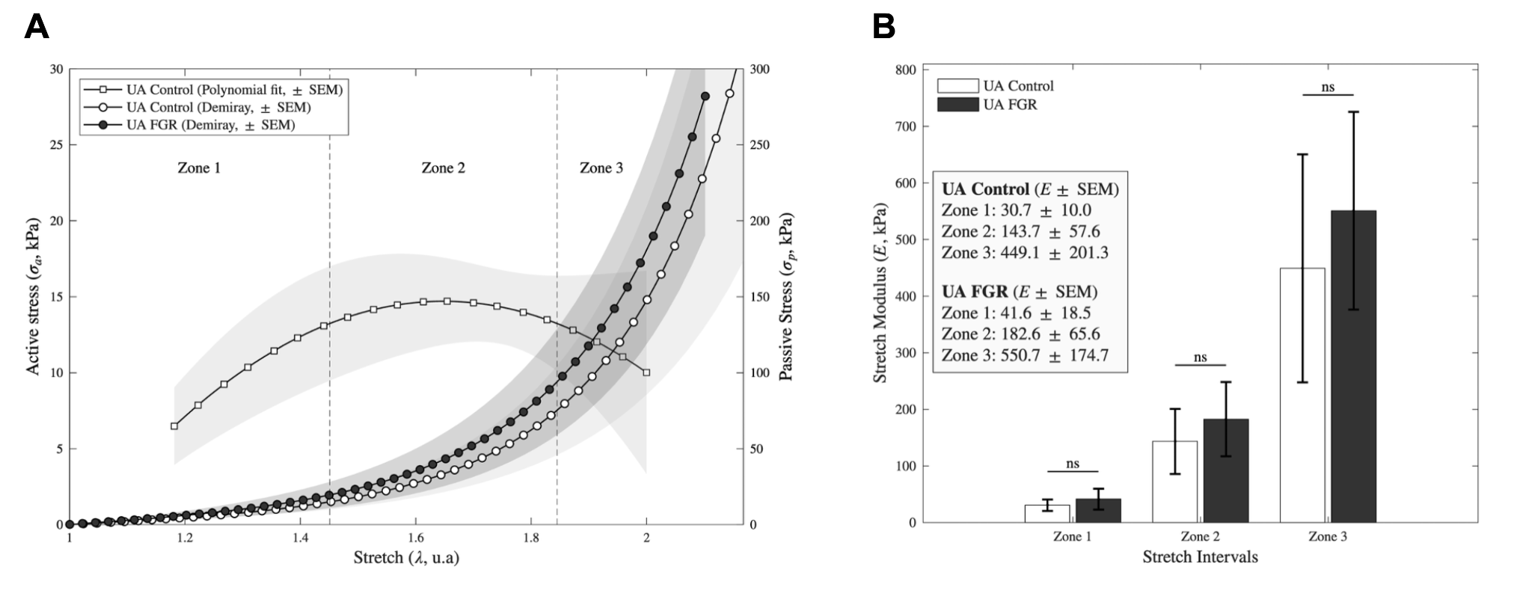

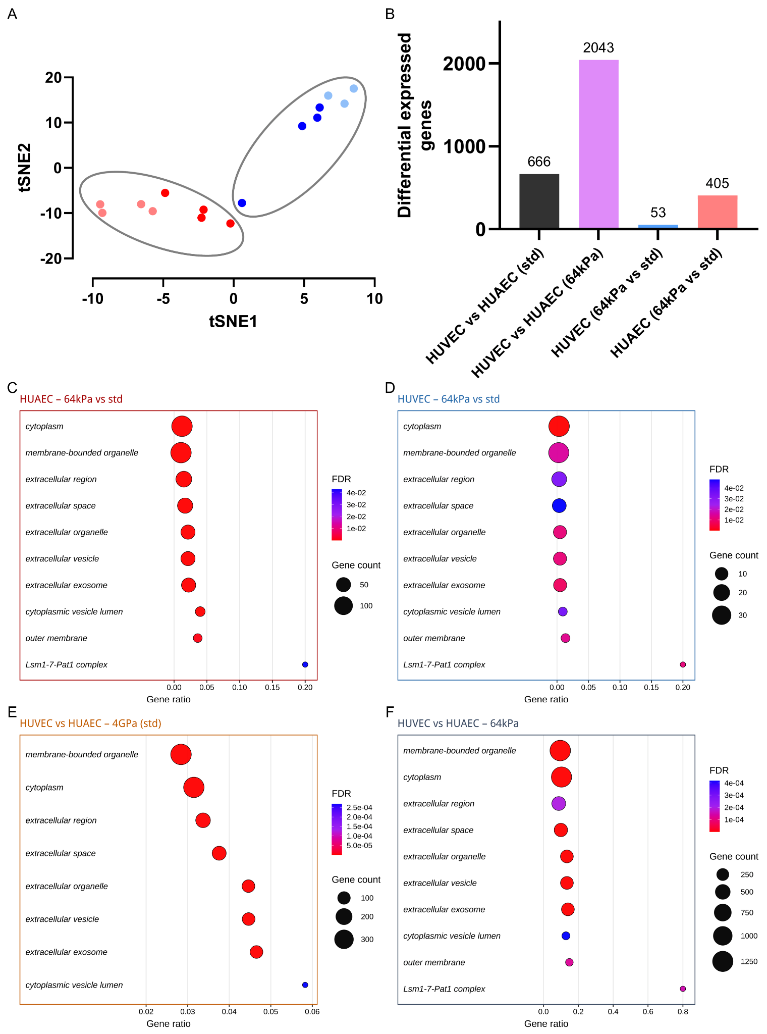
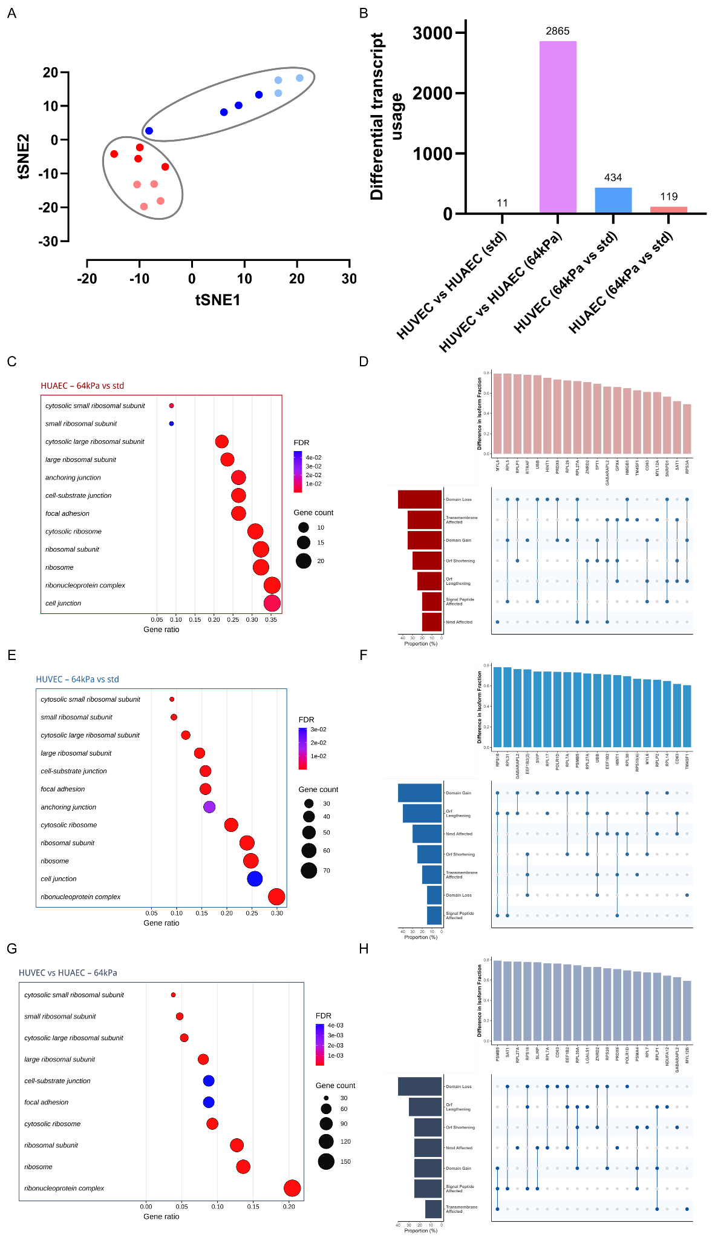

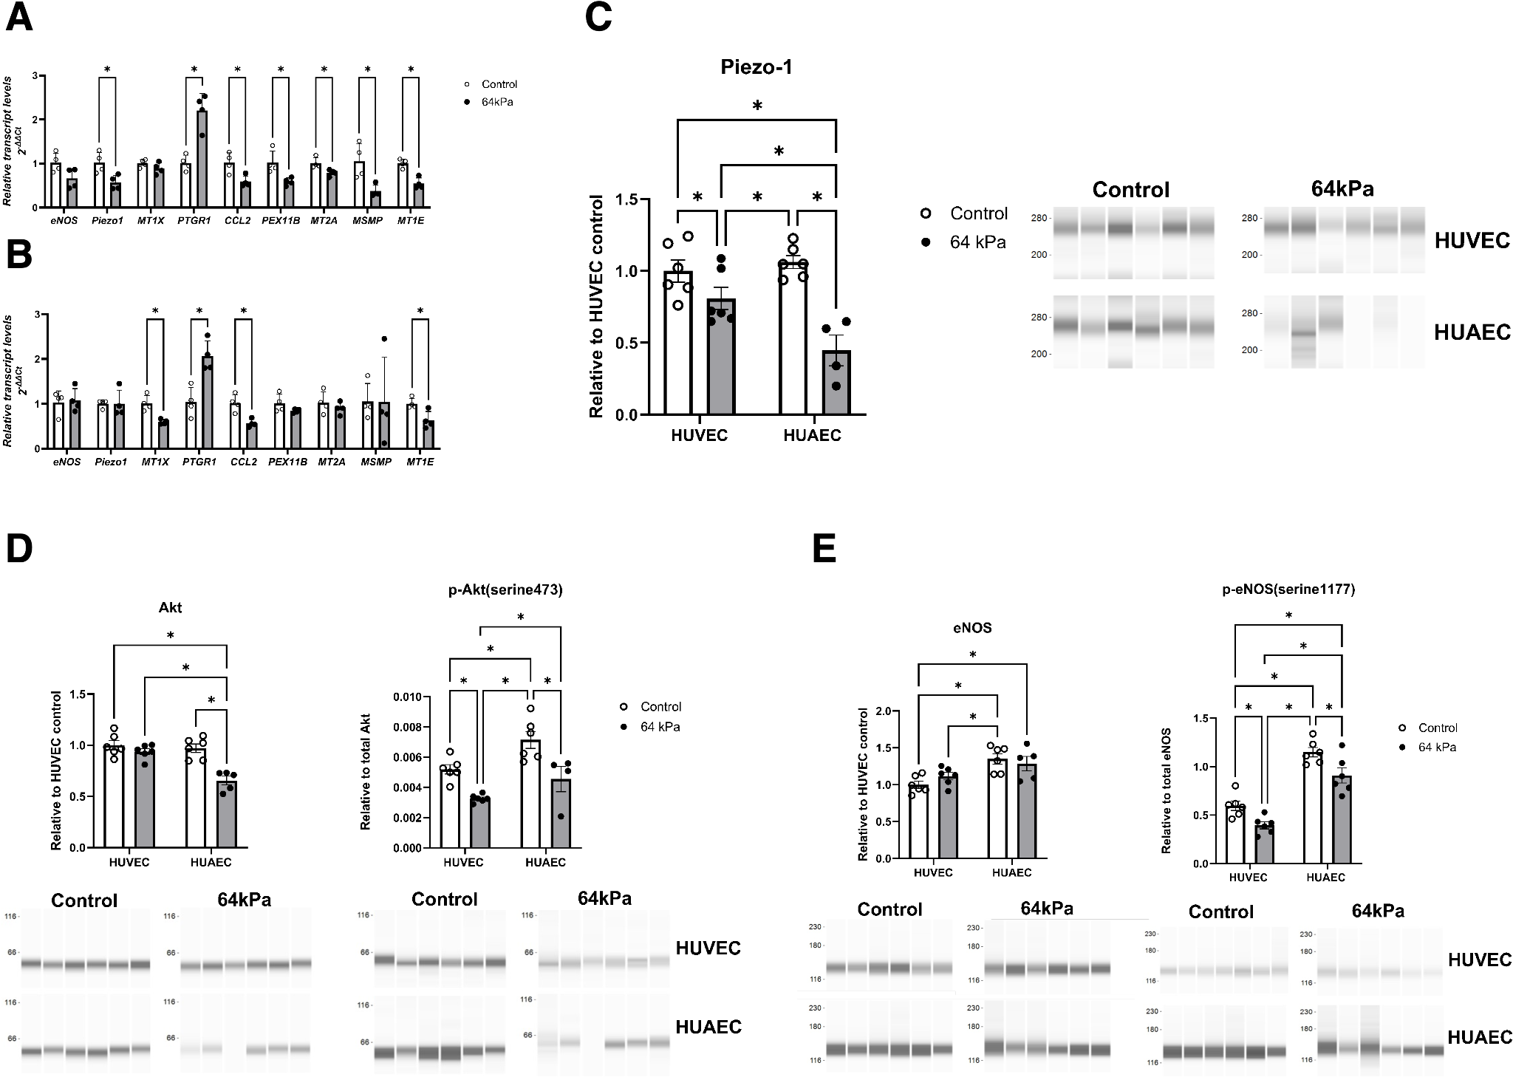

Tipo de artículo: Research Article
Extensión: Sin límite estricto de palabras, pero se recomienda no superar 5,000 palabras incluyendo el abstract, excluyendo referencias, tablas y figuras.
Abstract: Máximo 250 palabras. Debe indicar el problema principal, métodos, resultados y conclusiones. Sin abreviaturas innecesarias. Sin frases genéricas como "se discute la significancia de los resultados."
Keywords: 4 a 6 palabras clave que reflejen los temas principales del artículo.
Secciones del manuscrito (en este orden):

Título, abstract y keywords
Texto principal
Referencias
Tablas (cada una con título y notas al pie)
Leyendas de figuras
Supporting Information (si aplica, como archivo separado)

Página de título debe incluir:

Título informativo corto con las palabras clave principales, sin abreviaturas
Running title de menos de 50 caracteres
Nombres completos de los autores
Afiliaciones institucionales
Agradecimientos (en la Information Page para el proceso doble ciego)

Referencias — formato Wiley Chemistry-Material Sciences:

Numeradas consecutivamente en orden de aparición
Citadas en el texto con superíndice arábigo
Ejemplo journal: J. H. Burroughes, D. D. C. Bradley, ..., Nature 1990, 347, 539.
Sin restricción en el número de referencias

Figuras:

Sin límite estricto, pero 10 figuras/tablas son suficientes
Figuras en color se publican online sin costo
Se recomienda que gráficos lineales (curvas, histogramas) se entreguen en blanco y negro para que sean legibles si el lector imprime en blanco y negro

Tablas:

Autocontenidas, que complementen pero no dupliquen el texto
Leyendas concisas pero comprensibles sin referencia al texto
Todas las abreviaturas definidas en notas al pie
Símbolos de notas al pie: †, ‡, §, ¶ (en ese orden); *, **, *** reservados para P-values
Las medidas estadísticas (SD, SEM) deben identificarse en los encabezados de columna

Supporting Information: Los métodos detallados y datos experimentales o computacionales que respalden los hallazgos principales deben ir como Supporting Information (archivo separado).
Sección de Análisis Estadístico (obligatoria, al final de la sección experimental):
Debe describir explícitamente:

Preprocesamiento de datos (transformación, normalización, evaluación de outliers)
Presentación de datos (mean ± SD o SEM)
Tamaño de muestra/número de réplicas (n) para cada análisis
Métodos estadísticos usados (nombre del test, si es de una o dos colas, nivel alfa, P value, post-hoc si aplica, validez de supuestos del test elegido)
Software usado para el análisis estadístico

Leyendas de figuras y tablas deben incluir: n, P value, test estadístico específico, presentación de datos y significado del símbolo de significancia.
Estudios con humanos: Requiere declaración del comité de ética (IRB) que aprobó el estudio, confirmación de consentimiento informado, y confirmación de que el estudio cumple con la Declaración de Helsinki.
Experimentos con animales: Seguir las guías ARRIVE.
Conflicto de interés: Declaración obligatoria en el proceso de envío.
Licencia: CC BY (Creative Commons Attribution). El autor retiene el copyright.
Revisión doble ciego (desde abril 2025): Los agradecimientos deben ir en la Information Page, no en el cuerpo del manuscrito, para facilitar el anonimato.

