# Frontend Mentor - QR code component solution

This is a solution to the [QR code component challenge on Frontend Mentor] (https://www.frontendmentor.io/challenges/qr-code-component-iux_sIO_H).
Frontend Mentor challenges help you improve your coding skills by building realistic projects.

## Table of contents

- [Overview](#overview)
- [Screenshot](#screenshot)
- [Links](#links)
- [My process](#my-process)
- [Built with](#built-with)
- [What I learned](#what-i-learned)
- [Continued development](#continued-development)
- [Useful resources](#useful-resources)
- [Author](#author)
- [Acknowledgments](#acknowledgments)

## Overview

Design image containing a QR code to try to reproduce it as similar as possible.-

### Screenshot
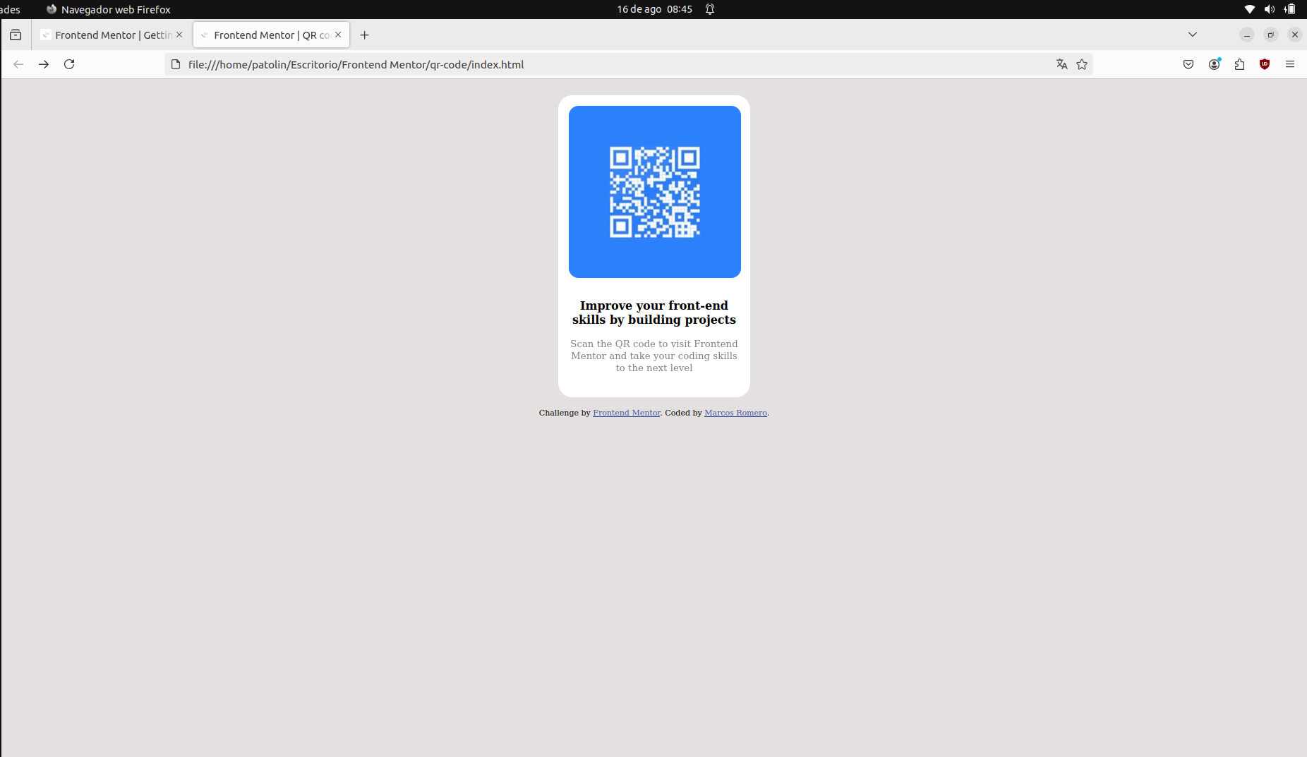
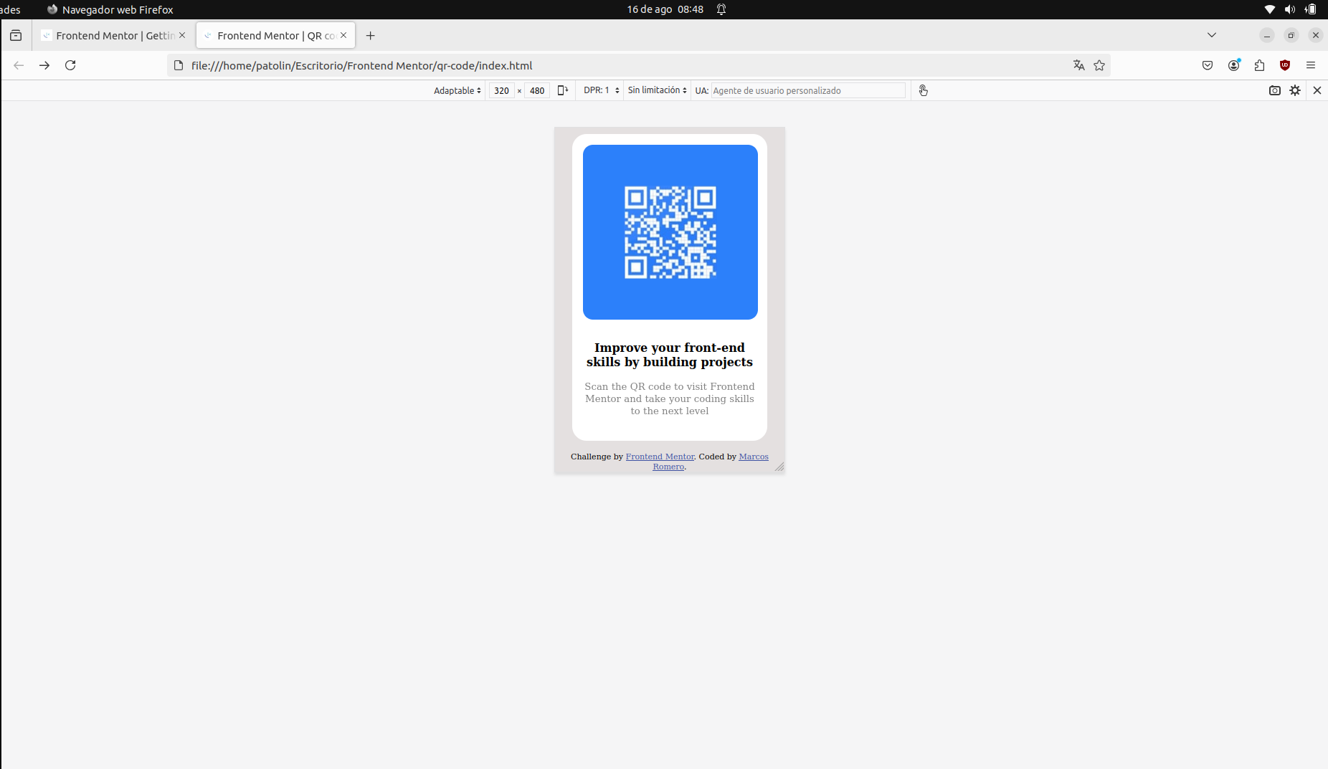

### Links

- Solution URL: https://github.com/Patolin3084/FrontendMentor_CodeQR/blob/main/index.html
- Live Site URL: https://patolin3084.github.io/FrontendMentor_CodeQR/

## My process

### Built with

- Semantic HTML5 markup
- CSS custom properties
- Flexbox

### What I learned

I have learned more about flex and how to organize the different elements of the design.-

### Continued development

What I need to continue developing the most is the ability to achieve responsive designs.

### Useful resources

This exercise helped me put into practice my first knowledge in WEB development and is very suitable for a learner who is at my level.

## Author

- Website – [Marcos Romero](https://github.com/Patolin3084)
- Frontend Mentor - [https://www.frontendmentor.io/profile/Patolin3084)

## Acknowledgments

I am starting out in the world of WEB development and it really attracts me a lot. I appreciate any type of advice or criticism towards my projects and their presentation.

