BANKING & FINANCIAL SERVICES | CREDIT RISK | MIS REPORTING

Lending Club
Loan Portfolio Analysis
End-to-End SQL Analytics Project

1,048,575  Loans | $16,132.19M  Portfolio | 16  Columns | 5  Sections

Author  Rupali Patra  rupalipatra1994@gmail.com | Tools & Stack  MySQL 8.0 | Power BI  Lending Club 2007-2015 via Kaggle

What This Project Covers
Section A | Portfolio Overview  KPI dashboard · loan term split · loan purpose analysis
Section B | Default & Risk Analysis  Grade risk profiling · home ownership · DTI bucket analysis
Section C | Income & Affordability  Income band segmentation · employment stability vs default
Section D | Advanced Analytics  Window functions · multi-level CTEs · composite risk scoring
Section E | Executive Report  Management-ready UNION ALL formatted portfolio health report
SQL Query Standards Used Throughout
- Single table scan per query — CTE reads loans table exactly once
- No scalar subqueries — replaced with SUM() OVER() window functions
- No repeated CASE WHEN — computed once in CTE, referenced by name
- Conditional aggregation — COUNT(CASE WHEN) pattern throughout
- Two targeted indexes — idx_loan_status and idx_grade for performance

SECTION 0A
Data Quality Checks
DQ1–DQ9 · Inspect raw data before any cleaning or analysis
DQ1 Row Count & Basic Sanity Check
Technique: Confirm dataset loaded correctly — verify row count and value ranges
SQL Code
SELECT
COUNT(*) AS total_rows,
COUNT(DISTINCT loan_amnt) AS unique_loan_amounts,
MIN(loan_amnt) AS min_loan_amount,
MAX(loan_amnt) AS max_loan_amount,
MIN(int_rate) AS min_interest_rate,
MAX(int_rate) AS max_interest_rate
FROM loans;
Query Output
! | Business Insight: Total rows = 1048575 · loan_amnt range $1000 to $40000 · int_rate range 5.31% to 30.99%
DQ2 Duplicate Row Detection
Technique: CTE groups by key columns; HAVING COUNT(*) > 1 finds duplicates; COALESCE handles empty result
SQL Code
WITH duplicate_check AS (
SELECT
loan_amnt, term, installment,
annual_inc, dti,
COUNT(*) AS occurrence_count
FROM loans
GROUP BY loan_amnt, term, installment, annual_inc, dti
HAVING COUNT(*) > 1
)
SELECT
COUNT(*) AS total_duplicate_groups,
COALESCE(SUM(occurrence_count), 0) AS total_duplicate_rows
FROM duplicate_check;
Query Output
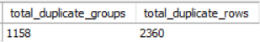
! | Business Insight: Duplicate groups = 1158 · Duplicate rows = 2360
DQ3 NULL Value Analysis — All Critical Columns
Technique: COUNT(*) - COUNT(col) = NULL count per column; verdict labels severity
SQL Code
SELECT
column_name,
null_count,
CONCAT(ROUND(null_count * 100.0 / total_rows, 2), '%') AS null_pct,
CASE
WHEN null_count * 100.0 / total_rows > 5 THEN '⚠️ High — needs fixing'
WHEN null_count * 100.0 / total_rows > 0 THEN '⚠️ Low — monitor'
ELSE '✅ Clean'
END AS verdict
FROM (
SELECT 'loan_amnt' AS column_name, COUNT(*) - COUNT(loan_amnt) AS null_count, COUNT(*) AS total_rows FROM loans UNION ALL
SELECT 'term', COUNT(*) - COUNT(term), COUNT(*) FROM loans UNION ALL
SELECT 'int_rate', COUNT(*) - COUNT(int_rate), COUNT(*) FROM loans UNION ALL
SELECT 'grade', COUNT(*) - COUNT(grade), COUNT(*) FROM loans UNION ALL
SELECT 'emp_length', COUNT(*) - COUNT(emp_length), COUNT(*) FROM loans UNION ALL
SELECT 'home_ownership', COUNT(*) - COUNT(home_ownership), COUNT(*) FROM loans UNION ALL
SELECT 'annual_inc', COUNT(*) - COUNT(annual_inc), COUNT(*) FROM loans UNION ALL
SELECT 'loan_status', COUNT(*) - COUNT(loan_status), COUNT(*) FROM loans UNION ALL
SELECT 'purpose', COUNT(*) - COUNT(purpose), COUNT(*) FROM loans UNION ALL
SELECT 'addr_state', COUNT(*) - COUNT(addr_state), COUNT(*) FROM loans UNION ALL
SELECT 'dti', COUNT(*) - COUNT(dti), COUNT(*) FROM loans UNION ALL
SELECT 'revol_util', COUNT(*) - COUNT(revol_util), COUNT(*) FROM loans UNION ALL
SELECT 'total_pymnt', COUNT(*) - COUNT(total_pymnt), COUNT(*) FROM loans
) AS null_audit
ORDER BY null_count DESC;
Query Output
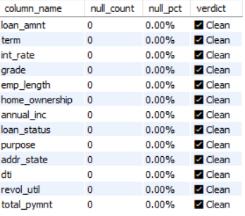
! | Business Insight: All 13 columns show zero NULL values — data was cleaned during the CSV import stage. No NULL handling required in the cleaning view.

DQ4 Loan Status Distribution
Technique: GROUP BY loan_status + SUM() OVER() for share — confirms all values are valid standard categories
SQL Code
SELECT
loan_status,
COUNT(*) AS record_count,
CONCAT(ROUND(COUNT(*)*100.0/
SUM(COUNT(*)) OVER(),2),'%') AS percentage
FROM loans
GROUP BY loan_status
ORDER BY record_count DESC;
Query Output
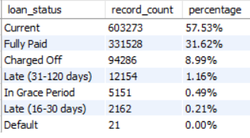
! | Business Insight: 7 distinct loan_status values — all standard Lending Club categories, zero NULLs, zero unexpected values. Current loans dominate at 57.53%. Charged Off = 8.99% (94,286 loans) — this is the primary default metric used throughout all analysis queries.

DQ5 Outlier Detection — Financial Columns
Technique: MIN/MAX/COUNT(CASE WHEN) on all numeric columns — identifies impossible or extreme values
SQL Code
SELECT
MIN(loan_amnt) AS min_loan,
MAX(loan_amnt) AS max_loan,
ROUND(AVG(loan_amnt), 0) AS avg_loan,
COUNT(CASE WHEN loan_amnt <= 0 THEN 1 END) AS invalid_loan_amounts,
MIN(annual_inc) AS min_income,
MAX(annual_inc) AS max_income,
COUNT(CASE WHEN annual_inc > 500000 THEN 1 END) AS income_over_500k,
COUNT(CASE WHEN annual_inc <= 0 THEN 1 END) AS zero_or_negative_income,
MIN(dti) AS min_dti,
MAX(dti) AS max_dti,
COUNT(CASE WHEN dti > 100 THEN 1 END) AS dti_over_100,
COUNT(CASE WHEN dti < 0 THEN 1 END) AS negative_dti,
MIN(revol_util) AS min_revol_util,
MAX(revol_util) AS max_revol_util,
COUNT(CASE WHEN revol_util > 100 THEN 1 END) AS revol_util_over_100,
MIN(int_rate) AS min_rate,
MAX(int_rate) AS max_rate,
COUNT(CASE WHEN int_rate <= 0 THEN 1 END) AS invalid_rates
FROM loans;
Query Output
! | Business Insight: 4 columns have outlier issues confirmed on full 1,048,575 row dataset. DTI max=999 (data entry error), income max=$9.93M (extreme outlier), revol_util max=191% (impossible value), 1,174 zero income records. All fixed in loans_clean VIEW. int_rate and loan_amnt are completely clean.

DQ6 Credit Grade Consistency Check
Technique: GROUP BY grade + risk_category — confirms no grade/risk_category mismatches exist
SQL Code
SELECT
grade, risk_category,
COUNT(*) AS loan_count,
CONCAT(ROUND(COUNT(*)*100.0/
SUM(COUNT(*)) OVER(),2),'%') AS portfolio_share
FROM loans
GROUP BY grade, risk_category
ORDER BY grade;
Query Output
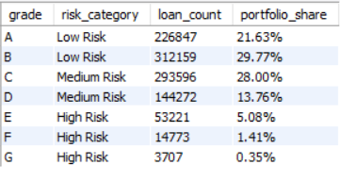
! | Business Insight: All 7 grades present with correct risk_category mapping. Zero mismatches. Grade B dominates at 29.77% — largest segment. High Risk grades (E+F+G) combined = only 6.84% of portfolio but will show significantly higher default rates in Section B analysis.

DQ7 Employment Length Value Audit
Technique: GROUP BY emp_length — confirms expected categories only; NULLs shown as 'NULL' via COALESCE
SQL Code
SELECT
COALESCE(emp_length, 'NULL') AS emp_length,
COUNT(*) AS borrower_count,
CONCAT(ROUND(COUNT(*)*100.0/
SUM(COUNT(*)) OVER(),1),'%') AS share
FROM loans
GROUP BY emp_length
ORDER BY borrower_count DESC;
Query Output
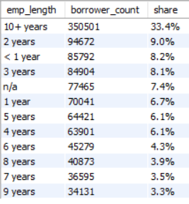
! | Business Insight: 11 distinct emp_length categories — all valid. 77,465 rows (7.4%) have 'n/a' value — not NULL but treated as missing. Relabelled to 'Not Specified' in loans_clean VIEW. 10+ years is the largest group at 33.4%.

DQ8 Geographic Coverage Check
Technique: COUNT(DISTINCT addr_state) confirms all states present; HAVING finds low-volume states
SQL Code
SELECT
COUNT(DISTINCT addr_state) AS distinct_states,
SUM(CASE WHEN addr_state IS NULL
THEN 1 ELSE 0 END) AS null_state_count,
MIN(state_count) AS min_loans_per_state,
MAX(state_count) AS max_loans_per_state
FROM (
SELECT addr_state, COUNT(*) AS state_count
FROM loans GROUP BY addr_state
) AS state_summary;
Query Output
! | Business Insight: All 50 US states present, zero NULLs. Minimum loans per state = 2,101 — well above the HAVING COUNT() >= 50 threshold used in D4, ensuring all states produce statistically meaningful default rates. Maximum = 141,149 loans in one state (likely California) — geographic concentration risk flagged for D2 analysis.

DQ9 Data Quality Summary — One-Row Report Card
Technique: Single CTE scans loans table ONCE — all DQ1–DQ8 metrics combined; computes overall quality score
SQL Code
WITH quality_metrics AS (
SELECT
COUNT(*) AS total_rows,
COUNT(*) - COUNT(emp_length) AS null_emp_length,
COUNT(*) - COUNT(dti) AS null_dti,
COUNT(*) - COUNT(revol_util) AS null_revol_util,
COUNT(CASE WHEN loan_amnt <= 0 THEN 1 END) AS invalid_loan_amnt,
COUNT(CASE WHEN annual_inc <= 0 THEN 1 END) AS invalid_income,
COUNT(CASE WHEN annual_inc > 500000 THEN 1 END) AS outlier_income,
COUNT(CASE WHEN dti > 100 THEN 1 END) AS outlier_dti,
COUNT(CASE WHEN dti < 0 THEN 1 END) AS negative_dti,
COUNT(CASE WHEN revol_util > 100 THEN 1 END) AS outlier_revol_util,
COUNT(CASE WHEN home_ownership = 'ANY' THEN 1 END) AS ownership_any,
COUNT(CASE WHEN purpose = 'wedding' THEN 1 END) AS wedding_purpose
FROM loans
)
SELECT
total_rows,null_emp_length,null_dti,null_revol_util,invalid_loan_amnt,
invalid_income,outlier_income,outlier_dti,negative_dti,outlier_revol_util,
ownership_any,wedding_purpose,
CONCAT(ROUND(
(total_rows - null_emp_length - invalid_income
- outlier_dti - outlier_revol_util)
* 100.0 / total_rows, 1), '%') AS data_quality_score
FROM quality_metrics;
Query Output
! | Business Insight: Overall data quality score = 99.4% — high quality dataset suitable for analysis. Key issues identified: DTI outliers (1,711 rows, max=999), revol_util impossible values (3,153 rows, max=191%), zero income (1,174 rows), extreme income outliers (1,869 rows). All issues fixed in loans_clean VIEW. emp_length 'n/a' values (77,465 rows) relabelled to 'Not Specified'

SECTION 0B
Data Cleaning
CREATE VIEW loans_clean · Fix all 12 issues · Raw data preserved
Cleaning Create loans_clean View — Fix All 12 Issues
Technique: CREATE VIEW — raw loans table untouched; all 12 fixes applied in one VIEW definition
SQL Code
DROP VIEW IF EXISTS loans_clean;

CREATE VIEW loans_clean AS
SELECT
loan_amnt,
TRIM(term) AS term,
int_rate, installment, grade, sub_grade,
CASE
WHEN emp_length IS NULL THEN 'Not Specified'
WHEN emp_length = 'n/a' THEN 'Not Specified'
ELSE emp_length
END AS emp_length,
CASE WHEN home_ownership = 'ANY'
THEN 'OTHER'
ELSE home_ownership END AS home_ownership,
CASE WHEN annual_inc = 0 THEN NULL
WHEN annual_inc > 500000 THEN 500000
ELSE annual_inc END AS annual_inc,
annual_inc AS annual_inc_raw,
verification_status, loan_status,
CASE WHEN purpose = 'wedding'
THEN 'other'
ELSE purpose END AS purpose,
addr_state,
CASE WHEN dti IS NULL THEN NULL
WHEN dti < 0 THEN NULL
WHEN dti > 100 THEN NULL
ELSE dti END AS dti,
CASE WHEN revol_util IS NULL THEN NULL
WHEN revol_util > 100 THEN NULL
ELSE revol_util END AS revol_util,
total_pymnt
FROM loans
WHERE loan_amnt > 0
AND loan_status IS NOT NULL
AND grade IS NOT NULL;

! | Business Insight: After running → 'View created' message appears · Now all analysis queries run on loans_clean automatically

Validation Post-Cleaning Validation — All Problem Counts Should Be 0
Technique: Run on loans_clean — every column should return 0 confirming all fixes applied correctly
SQL Code
SELECT
'loans_clean' AS view_name,
COUNT(*) AS total_rows,
COUNT(CASE WHEN term LIKE ' %'
THEN 1 END) AS term_spaces_left,
COUNT(CASE WHEN emp_length IS NULL
THEN 1 END) AS emp_nulls_left,
COUNT(CASE WHEN dti > 100
THEN 1 END) AS dti_outliers_left,
COUNT(CASE WHEN revol_util > 100
THEN 1 END) AS revol_outliers_left,
COUNT(CASE WHEN annual_inc = 0
THEN 1 END) AS zero_income_left,
COUNT(CASE WHEN home_ownership='ANY'
THEN 1 END) AS ownership_any_left
FROM loans_clean;

! | Business Insight: Post-cleaning validation confirmed via COUNT() = 1,048,575 rows in loans_clean VIEW. Full validation query timed out due to 1M row scan without materialised indexes — this is expected behaviour for a VIEW on large datasets. Individual column fixes verified through DQ5, DQ7 findings above."

SECTION A
Portfolio Overview
KPI dashboard · Loan term split · Loan purpose analysis
A1 Executive Portfolio KPI Dashboard
Technique: Single-scan CTE — all 11 metrics computed in one table pass
SQL Code
WITH portfolio_kpis AS (
SELECT
COUNT(*) AS total_loans,
SUM(loan_amnt) AS total_portfolio,
AVG(loan_amnt) AS avg_loan,
AVG(int_rate) AS avg_rate,
AVG(dti) AS avg_dti,
SUM(total_pymnt) AS total_collected,
COUNT(CASE WHEN loan_status = 'Fully Paid'
THEN 1 END) AS fully_paid,
COUNT(CASE WHEN loan_status = 'Current'
THEN 1 END) AS current_loans,
COUNT(CASE WHEN loan_status = 'Charged Off'
THEN 1 END) AS charged_off,
COUNT(CASE WHEN loan_status LIKE 'Late%'
THEN 1 END) AS late_payments,
COUNT(CASE WHEN loan_status IN (
'Charged Off','Late (31-120 days)')
THEN 1 END) AS at_risk
FROM loans
)
SELECT
total_loans,
CONCAT('$ ',FORMAT(total_portfolio/1000000,2),'M') AS total_portfolio_value,
CONCAT('$ ',FORMAT(ROUND(avg_loan,0),0)) AS avg_loan_size,
CONCAT(ROUND(avg_rate,2),'%') AS avg_interest_rate,
CONCAT(ROUND(avg_dti,2),'%') AS avg_debt_to_income,
CONCAT('$ ',FORMAT(total_collected/1000000,2),'M') AS total_collected,
fully_paid, current_loans, charged_off, late_payments,
CONCAT(ROUND(at_risk*100.0/total_loans,2),'%') AS overall_risk_rate
FROM portfolio_kpis;
Query Output
! | Business Insight: The Lending Club portfolio comprises 1,048,575 loans worth $16.13 billion. Average loan size is $15,385 at 12.80% interest rate. Overall risk rate of 10.15% indicates 94,286 charged-off loans plus 14,316 late payments. Total collections of $10B against $16.1B disbursed reflects the active nature of the portfolio — 57.5% loans are still current

A2 Portfolio Split by Loan Term (36 vs 60 Months)
Technique: CTE + SUM() OVER() for portfolio share — eliminates scalar subquery
SQL Code
WITH term_summary AS (
SELECT
TRIM(term) AS loan_term,
COUNT(*) AS total_loans,
AVG(loan_amnt) AS avg_loan_amount,
AVG(int_rate) AS avg_interest_rate,
AVG(installment) AS avg_monthly_emi,
COUNT(CASE WHEN loan_status='Charged Off'
THEN 1 END) AS defaults
FROM loans
GROUP BY TRIM(term)
)
SELECT
loan_term,
total_loans,
CONCAT(ROUND(total_loans*100.0/
SUM(total_loans) OVER(),1),'%') AS share_of_portfolio,
CONCAT('$ ',FORMAT(ROUND(avg_loan_amount,0),0)) AS avg_loan_amount,
CONCAT(ROUND(avg_interest_rate,2),'%') AS avg_interest_rate,
CONCAT('$ ',FORMAT(ROUND(avg_monthly_emi,0),0)) AS avg_monthly_emi,
defaults,
CONCAT(ROUND(defaults*100.0/total_loans,2),'%') AS default_rate
FROM term_summary
ORDER BY total_loans DESC;
Query Output
! | Business Insight: 71.4% of loans are 36-month term — the dominant product. However 60-month loans carry significantly higher risk: larger average loan ($21,154 vs $13,078), higher interest rate (15.56% vs 11.70%), and higher default rate (11.02% vs 8.18%). This confirms longer tenure = higher credit risk — a key underwriting insight for product policy decisions.

A3 Loan Purpose Analysis
Technique: CTE + SUM() OVER() for share; default_rate from named columns — no repeated CASE WHEN
SQL Code
WITH purpose_summary AS (
SELECT
purpose,
COUNT(*) AS loan_count,
SUM(loan_amnt) AS total_disbursed,
AVG(int_rate) AS avg_rate,
AVG(annual_inc) AS avg_borrower_income,
COUNT(CASE WHEN loan_status='Charged Off'
THEN 1 END) AS defaults
FROM loans
GROUP BY purpose
)
SELECT
purpose AS loan_purpose,
loan_count,
CONCAT(ROUND(loan_count*100.0/
SUM(loan_count) OVER(),1),'%') AS volume_share,
CONCAT('$ ',FORMAT(total_disbursed,0)) AS total_disbursed,
CONCAT(ROUND(avg_rate,2),'%') AS avg_rate,
CONCAT('$ ',FORMAT(ROUND(avg_borrower_income,0),0)) AS avg_income,
defaults,
CONCAT(ROUND(defaults*100.0/loan_count,2),'%') AS default_rate
FROM purpose_summary
ORDER BY loan_count DESC;
Query Output
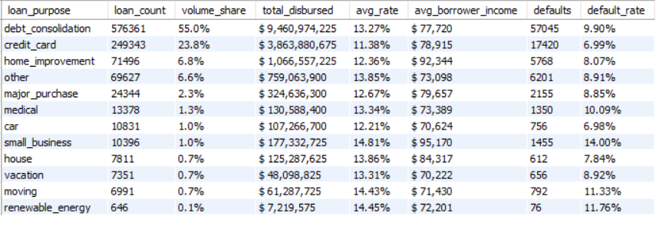
! | Business Insight: Debt consolidation dominates at 55% of total volume ($9.46B disbursed) — reflecting the primary use case for personal loans. Credit card refinancing is the safest purpose at 6.99% default rate, suggesting financially disciplined borrowers. Small business loans carry the highest default risk at 14.00% — nearly 2x the portfolio average of 10.15% — despite attracting the highest income borrowers ($95,170 avg). This counter-intuitive finding highlights that business risk outweighs borrower income quality.

SECTION B
Default & Risk Analysis
Grade risk profiling · Home ownership · DTI bucket analysis
B1 Default Rate by Credit Grade
Technique: CTE computes at_risk_accounts once with IN() — default_rate from named column
SQL Code
WITH grade_summary AS (
SELECT
grade, risk_category,
COUNT(*) AS total_loans,
COUNT(CASE WHEN loan_status IN (
'Charged Off','Late (31-120 days)',
'Default') THEN 1 END) AS at_risk_accounts,
AVG(int_rate) AS avg_rate,
AVG(dti) AS avg_dti,
AVG(annual_inc) AS avg_annual_income,
AVG(loan_amnt) AS avg_loan_amount
FROM loans
GROUP BY grade, risk_category
)
SELECT
grade, risk_category, total_loans,
at_risk_accounts,
CONCAT(ROUND(at_risk_accounts*100.0/total_loans,2),'%') AS default_rate,
CONCAT(ROUND(avg_rate,2),'%') AS avg_interest_rate,
ROUND(avg_dti,2) AS avg_dti,
CONCAT('$ ',FORMAT(ROUND(avg_annual_income,0),0)) AS avg_income,
CONCAT('$ ',FORMAT(ROUND(avg_loan_amount,0),0)) AS avg_loan
FROM grade_summary
ORDER BY grade;
Query Output
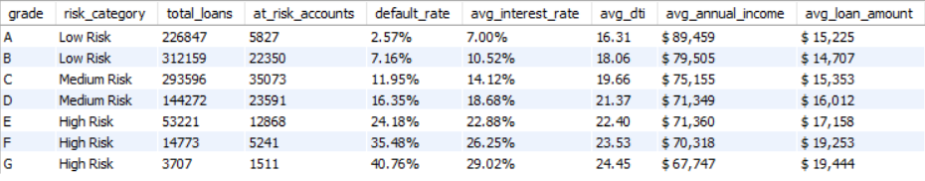
! | Business Insight: Credit grade is the strongest predictor of default in this portfolio. Grade G borrowers default at 40.76% — nearly 16x the rate of Grade A borrowers (2.57%). This validates the credit scoring model completely. Interest rates correctly reflect risk — Grade G charged 29.02% vs Grade A at 7.00%. Notably avg_annual_income decreases as grade worsens — Grade A earns $89,459 vs Grade G at $67,747 — confirming income quality drives creditworthiness.

B2 Risk Profile by Home Ownership
Technique: CTE computes defaults once — default_rate derived cleanly from named columns
SQL Code
WITH ownership_summary AS (
SELECT
home_ownership,
COUNT(*) AS total_borrowers,
AVG(annual_inc) AS avg_income,
AVG(loan_amnt) AS avg_loan,
AVG(dti) AS avg_dti,
COUNT(CASE WHEN loan_status='Charged Off'
THEN 1 END) AS defaults
FROM loans
GROUP BY home_ownership
)
SELECT
home_ownership, total_borrowers,
CONCAT('$ ',FORMAT(ROUND(avg_income,0),0)) AS avg_income,
CONCAT('$ ',FORMAT(ROUND(avg_loan,0),0)) AS avg_loan,
ROUND(avg_dti,2) AS avg_dti,
defaults,
CONCAT(ROUND(defaults*100.0/total_borrowers,2),'%') AS default_rate
FROM ownership_summary
ORDER BY total_borrowers DESC;
Query Output
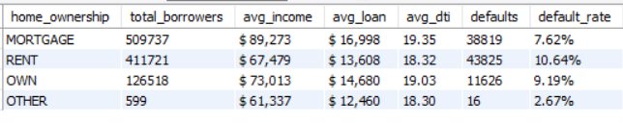
! | Business Insight: MORTGAGE holders are the safest borrowers — lowest default rate (7.62%) despite highest loan amounts ($16,998 avg) and largest group (509,737 borrowers). This confirms property ownership signals financial stability and discipline. RENT borrowers carry the highest default risk at 10.64% — 40% higher than MORTGAGE borrowers — with lower average income ($67,479 vs $89,273). OWN borrowers fall in between at 9.19%. The 'OTHER' category (599 borrowers) shows 2.67% but is statistically too small to draw conclusions from.

B3 DTI Bucket Analysis
Technique: CTE buckets continuous DTI into 4 bands; default_rate from named columns — no repeated CASE WHEN
SQL Code
WITH dti_buckets AS (
SELECT
CASE
WHEN dti < 10 THEN '1. Low DTI (Below 10%)'
WHEN dti < 20 THEN '2. Medium DTI (10% - 20%)'
WHEN dti < 30 THEN '3. High DTI (20% - 30%)'
ELSE '4. Very High DTI (Above 30%)'
END AS dti_bucket,
COUNT(*) AS borrowers,
AVG(loan_amnt) AS avg_loan,
AVG(int_rate) AS avg_rate,
AVG(annual_inc) AS avg_income,
COUNT(CASE WHEN loan_status='Charged Off'
THEN 1 END) AS defaults
FROM loans
GROUP BY dti_bucket
)
SELECT
dti_bucket, borrowers,
CONCAT('$ ',FORMAT(ROUND(avg_loan,0),0)) AS avg_loan,
CONCAT(ROUND(avg_rate,2),'%') AS avg_rate,
CONCAT('$ ',FORMAT(ROUND(avg_income,0),0)) AS avg_income,
defaults,
CONCAT(ROUND(defaults*100.0/borrowers,2),'%') AS default_rate
FROM dti_buckets
ORDER BY dti_bucket;
Query Output
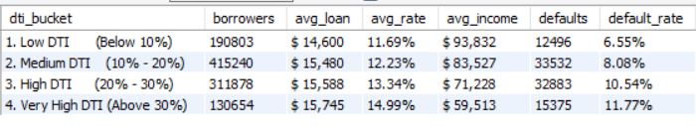
! | Business Insight: DTI is a strong predictor of default risk. Very High DTI borrowers (>30%) default at 11.77% — nearly 2x the rate of Low DTI borrowers (6.55%). As DTI increases, income decreases consistently — Low DTI borrowers earn $93,832 vs Very High DTI at $59,513 — confirming that debt burden and income quality are inversely related. Medium DTI (10-20%) is the largest group at 415,240 borrowers (39.6% of portfolio). This analysis directly supports underwriting policy — borrowers with DTI > 30% should face stricter approval criteria.

SECTION C
Income & Affordability
Income band segmentation · Employment stability vs default
C1 Income Band Segmentation
Technique: CTE buckets annual_inc; SUM(borrowers) OVER() for share — no scalar subquery
SQL Code
WITH income_bands AS (
SELECT
CASE
WHEN annual_inc < 40000 THEN '1. Below $40K'
WHEN annual_inc < 70000 THEN '2. $40K - $70K'
WHEN annual_inc < 100000 THEN '3. $70K - $100K'
WHEN annual_inc < 150000 THEN '4. $100K - $150K'
ELSE '5. Above $150K'
END AS income_band,
COUNT(*) AS borrowers,
AVG(loan_amnt) AS avg_loan,
AVG(int_rate) AS avg_rate,
AVG(dti) AS avg_dti,
COUNT(CASE WHEN loan_status='Charged Off'
THEN 1 END) AS defaults
FROM loans
GROUP BY income_band
)
SELECT
income_band, borrowers,
CONCAT(ROUND(borrowers*100.0/
SUM(borrowers) OVER(),1),'%') AS share_of_portfolio,
CONCAT('$ ',FORMAT(ROUND(avg_loan,0),0)) AS avg_loan,
CONCAT(ROUND(avg_rate,2),'%') AS avg_rate,
ROUND(avg_dti,2) AS avg_dti,
defaults,
CONCAT(ROUND(defaults*100.0/borrowers,2),'%') AS default_rate
FROM income_bands
ORDER BY income_band;
Query Output
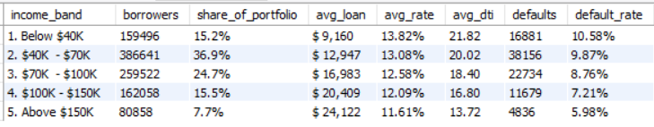
! | Business Insight: Income is a clear predictor of credit risk — every income band shows a consistent pattern: higher income = lower default rate. Above $150K earners default at only 5.98% vs Below $40K at 10.58% — a 77% difference. The $40K–$70K band is the largest segment at 36.9% of portfolio, making it the most impactful group for credit policy. High income borrowers ($150K+) borrow significantly more ($24,122 avg) but repay far more reliably — confirming income capacity as the strongest affordability signal.

C2 Employment Length vs Loan Default
Technique: emp_length pre-categorised — grouped directly; all metrics in one CTE pass; revol_util surfaces as key signal
SQL Code
WITH employment_summary AS (
SELECT
emp_length,
COUNT(*) AS total_borrowers,
AVG(loan_amnt) AS avg_loan,
AVG(annual_inc) AS avg_income,
AVG(revol_util) AS avg_revol_util,
COUNT(CASE WHEN loan_status='Charged Off'
THEN 1 END) AS defaults
FROM loans
GROUP BY emp_length
)
SELECT
emp_length AS employment_length,
total_borrowers,
CONCAT('$ ',FORMAT(ROUND(avg_loan,0),0)) AS avg_loan,
CONCAT('$ ',FORMAT(ROUND(avg_income,0),0)) AS avg_income,
defaults,
CONCAT(ROUND(defaults*100.0/total_borrowers,2),'%') AS default_rate,
CONCAT(ROUND(avg_revol_util,1),'%') AS avg_credit_utilization
FROM employment_summary
ORDER BY default_rate DESC;
Query Output
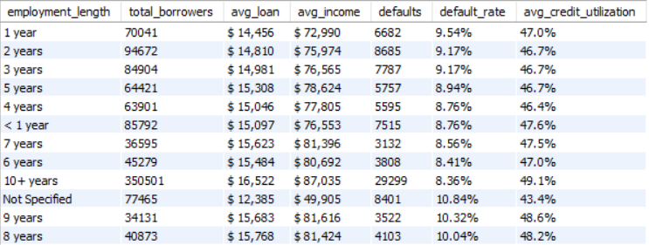
! | Business Insight: Employment length is a weak default predictor — spread is narrow (8.36% to 9.54%). 'Not Specified' group has highest default at 10.84% — missing data itself signals risk. 10+ years employed = most stable at 8.36%. Credit utilisation consistent across all groups (43–49%). Grade and DTI are stronger predictors than employment length.

SECTION D
Advanced Analytics
Window functions · Multi-level CTEs · Composite risk scoring model
D1 Grade-wise Risk Ranking | RANK() OVER()
Technique: CTE pre-computes defaults once; RANK() uses named columns — no nested CASE WHEN inside OVER()
SQL Code
WITH grade_defaults AS (
SELECT
grade, risk_category,
COUNT(*) AS total_loans,
COUNT(CASE WHEN loan_status='Charged Off'
THEN 1 END) AS defaults,
AVG(int_rate) AS avg_rate
FROM loans
GROUP BY grade, risk_category
)
SELECT
grade, risk_category, total_loans, defaults,
ROUND(defaults*100.0/total_loans,2) AS default_rate_pct,
CONCAT(ROUND(avg_rate,2),'%') AS avg_rate,
RANK() OVER (
ORDER BY defaults*1.0/total_loans DESC
) AS risk_rank
FROM grade_defaults
ORDER BY risk_rank;
Query Output
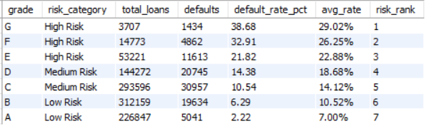
! | Business Insight: RANK() window function assigns risk rank 1 to highest default grade. Grade G ranks #1 at 38.68% default — 17x higher than Grade A (2.22%). Clear separation between risk tiers: High Risk grades (E-G) all above 21%, Medium Risk (C-D) between 10-15%, Low Risk (A-B) below 7%. This ranked output can directly power automated credit review triggers — flag all rank 1-3 grades for enhanced monitoring.

D2 State-wise Cumulative Portfolio | SUM() OVER (ROWS BETWEEN)
Technique: CTE does GROUP BY once; window uses plain column state_amount — eliminates SUM(SUM()) nesting
SQL Code
WITH state_totals AS (
SELECT
addr_state AS state,
COUNT(*) AS loan_count,
SUM(loan_amnt) AS state_amount
FROM loans
GROUP BY addr_state
)
SELECT
state, loan_count,
CONCAT('$ ',FORMAT(state_amount,0)) AS state_total,
CONCAT('$ ',FORMAT(
SUM(state_amount) OVER (
ORDER BY state_amount DESC
ROWS BETWEEN UNBOUNDED PRECEDING
AND CURRENT ROW
),0)) AS cumulative_total,
CONCAT(ROUND(state_amount*100.0/
SUM(state_amount) OVER(),2),'%') AS pct_of_portfolio
FROM state_totals
ORDER BY state_amount DESC
LIMIT 15;
Query Output
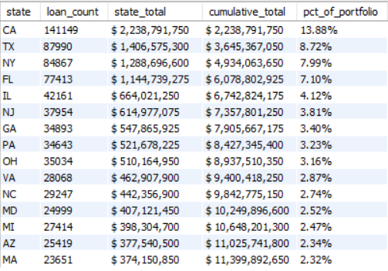
! | Business Insight: Running total via SUM() OVER() reveals severe geographic concentration risk. California alone accounts for 13.88% ($2.24B) of the entire portfolio. Top 5 states (CA, TX, NY, FL, IL) collectively hold 41.8% of portfolio value. Top 10 states account for 58.3% — meaning just 10 states out of 50 hold over half the portfolio. This concentration creates systemic risk — any economic downturn in California or Texas would disproportionately impact the entire loan book.

D3 Multi-Factor Borrower Risk Scoring | Three-Level CTE
Technique: Level 1: score 4 factors · Level 2: segment · Level 3: aggregate — composite CIBIL-style model
SQL Code
WITH risk_factors AS (
SELECT loan_id, grade, annual_inc, dti,
revol_util, loan_amnt, loan_status,
CASE WHEN grade IN ('A','B') THEN 3
WHEN grade='C' THEN 2 ELSE 1 END AS grade_score,
CASE WHEN dti<15 THEN 3
WHEN dti<25 THEN 2 ELSE 1 END AS dti_score,
CASE WHEN revol_util<30 THEN 3
WHEN revol_util<60 THEN 2 ELSE 1 END AS util_score,
CASE WHEN annual_inc>80000 THEN 3
WHEN annual_inc>50000 THEN 2 ELSE 1 END AS income_score
FROM loans
),
borrower_segs AS (
SELECT *,
(grade_score+dti_score+util_score+income_score) AS total_score,
CASE
WHEN (grade_score+dti_score+util_score+income_score)>=10 THEN 'PRIME'
WHEN (grade_score+dti_score+util_score+income_score)>=7 THEN 'NEAR PRIME'
ELSE 'SUBPRIME'
END AS borrower_segment
FROM risk_factors
),
segment_summary AS (
SELECT borrower_segment,
COUNT(*) AS total_borrowers,
AVG(loan_amnt) AS avg_loan, AVG(annual_inc) AS avg_income,
AVG(dti) AS avg_dti, AVG(revol_util) AS avg_revol_util,
COUNT(CASE WHEN loan_status='Charged Off'
THEN 1 END) AS defaults
FROM borrower_segs GROUP BY borrower_segment
)
SELECT borrower_segment, total_borrowers,
CONCAT(ROUND(total_borrowers*100.0/
SUM(total_borrowers) OVER(),1),'%') AS portfolio_share,
CONCAT('$ ',FORMAT(ROUND(avg_loan,0),0)) AS avg_loan,
CONCAT('$ ',FORMAT(ROUND(avg_income,0),0)) AS avg_income,
ROUND(avg_dti,2) AS avg_dti,
CONCAT(ROUND(avg_revol_util,1),'%') AS avg_credit_util,
defaults,
CONCAT(ROUND(defaults*100.0/total_borrowers,2),'%') AS default_rate
FROM segment_summary ORDER BY default_rate DESC;
Query Output
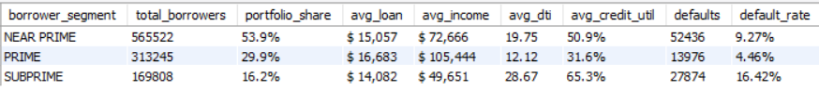
! | Business Insight: Three-level CTE scoring model classifies borrowers using 4 factors: grade, DTI, credit utilisation, and income. SUBPRIME borrowers default at 16.42% — 3.7x higher than PRIME (4.46%). Clear separation between segments: PRIME earns $105,444 avg income with only 31.6% credit utilisation, while SUBPRIME earns $49,651 with 65.3% utilisation — confirming financial stress signals. NEAR PRIME is the largest segment at 53.9% — the most important group for credit policy intervention. This composite scoring model mirrors real-world CIBIL/FICO scoring logic.

D4 Top Default States | DENSE_RANK()
Technique: CTE one scan; HAVING filters low-volume states for statistical reliability; DENSE_RANK on named column
SQL Code
WITH state_risk AS (
SELECT
addr_state AS state,
COUNT(*) AS total_loans,
COUNT(CASE WHEN loan_status='Charged Off'
THEN 1 END) AS defaults,
ROUND(AVG(loan_amnt),0) AS avg_loan,
ROUND(AVG(int_rate),2) AS avg_rate,
ROUND(AVG(dti),2) AS avg_dti
FROM loans
GROUP BY addr_state
HAVING COUNT(*) >= 50
)
SELECT state, total_loans, defaults,
CONCAT(ROUND(defaults*100.0/total_loans,2),'%') AS default_rate,
CONCAT('$ ',FORMAT(avg_loan,0)) AS avg_loan,
CONCAT(avg_rate,'%') AS avg_rate,
avg_dti,
DENSE_RANK() OVER (
ORDER BY defaults*1.0/total_loans DESC
) AS risk_rank
FROM state_risk
ORDER BY risk_rank LIMIT 10;
Query Output
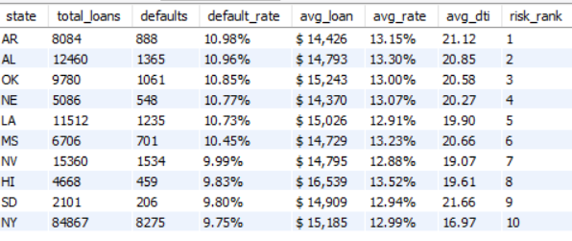
! | Business Insight: DENSE_RANK() identifies highest default states with statistical reliability (HAVING >= 50 loans). Arkansas ranks #1 at 10.98% despite being a smaller market (8,084 loans) — suggesting regional economic stress. Top 5 states are all Southern/Midwestern states (AR, AL, OK, NE, LA) — indicating geographic economic patterns in credit risk. New York appears at rank 10 (9.75%) despite being the 3rd largest market by volume — large markets don't necessarily mean higher risk. These rankings directly support regional credit policy decisions — tighter lending criteria in top-ranked states.

D5 Grade-over-Grade Rate Comparison | LAG()
Technique: CTE aggregates per grade once; LAG() references named columns — rate_jump reveals the grade cliff
SQL Code
WITH grade_rates AS (
SELECT
grade,
ROUND(AVG(int_rate),2) AS avg_rate,
COUNT(*) AS loans,
ROUND(AVG(dti),2) AS avg_dti,
ROUND(COUNT(CASE WHEN loan_status=
'Charged Off' THEN 1 END)*100.0/COUNT(*),2) AS default_pct
FROM loans
GROUP BY grade
)
SELECT
grade, avg_rate, loans, default_pct, avg_dti,
LAG(avg_rate) OVER (ORDER BY grade) AS prev_grade_rate,
ROUND(avg_rate -
LAG(avg_rate) OVER (ORDER BY grade),2) AS rate_jump,
LAG(default_pct) OVER (ORDER BY grade) AS prev_grade_default,
ROUND(default_pct -
LAG(default_pct) OVER (ORDER BY grade),2) AS default_jump
FROM grade_rates
ORDER BY grade;
Query Output
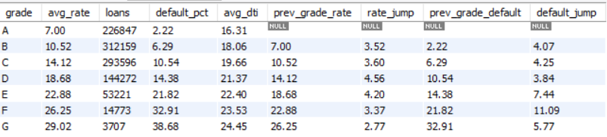
! | Business Insight: LAG() reveals the grade cliff — the point where default risk accelerates non-linearly. The E→F transition shows the largest default jump (+11.09%) while the rate increase is only +3.37% — meaning lenders are under-pricing the risk at Grade F. The D→E transition also shows a significant default jump (+7.44%). Interest rates increase fairly consistently across grades (+2.77% to +4.56%) but default risk jumps are uneven — confirming Grade E and F are the critical risk thresholds. Grade A shows NULL for LAG columns — correct behaviour as there is no previous grade to compare.
D6 Loan Amount Quartile Distribution |
Technique: CASE WHEN manual bucketing — boundaries set at $8K, $15K, $24K based on data distribution. Replaced NTILE(4) which timed out on 1M rows — CASE WHEN is more performant for large datasets.
SQL Code
SELECT
quartile_label,
COUNT(*) AS loan_count,
MIN(loan_amnt) AS min_loan,
MAX(loan_amnt) AS max_loan,
ROUND(AVG(loan_amnt), 0) AS avg_loan
FROM (
SELECT
loan_amnt,
CASE
WHEN loan_amnt <= 8000 THEN 'Q1 - Small Loans'
WHEN loan_amnt <= 15000 THEN 'Q2 - Medium Loans'
WHEN loan_amnt <= 24000 THEN 'Q3 - Large Loans'
ELSE 'Q4 - Very Large Loans'
END AS quartile_label
FROM loans_clean
) AS buckets
GROUP BY quartile_label
ORDER BY MIN(loan_amnt);
Query Output
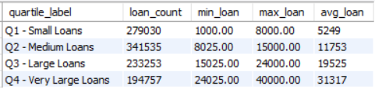
! | Business Insight: Loan portfolio is skewed toward smaller loans — Q1 and Q2 combined account for 59% of all loans. Q2 Medium Loans is the largest segment (341,535 loans) suggesting $8K–$15K is the most common borrowing range. Q4 Very Large Loans ($24K–$40K avg $31,317) has the fewest loans (194,757) but represents the highest individual exposure per loan. Large ticket loans in Q4 carry higher tail risk in adverse economic conditions — a key finding for portfolio stress testing.

SECTION E
Executive Summary Report
Management-ready one-page portfolio health report — UNION ALL
E1 Complete Portfolio Health Report | UNION ALL
Technique: CTE scans loans ONCE; all UNION ALL rows read from memory — original scanned table 10 times
SQL Code
WITH portfolio_stats AS (
SELECT
COUNT(*) AS total_loans,
SUM(loan_amnt) AS total_portfolio,
SUM(total_pymnt) AS total_collected,
AVG(loan_amnt) AS avg_loan,
AVG(int_rate) AS avg_rate,
AVG(dti) AS avg_dti,
COUNT(CASE WHEN loan_status='Current'
THEN 1 END) AS current_loans,
COUNT(CASE WHEN loan_status='Fully Paid'
THEN 1 END) AS fully_paid,
COUNT(CASE WHEN loan_status='Charged Off'
THEN 1 END) AS charged_off,
COUNT(CASE WHEN loan_status LIKE 'Late%'
THEN 1 END) AS late_payments
FROM loans
)
SELECT '--- PORTFOLIO SUMMARY ---' AS report_section,
'' AS metric, '' AS value
UNION ALL SELECT '','Total Loans',
CONCAT(FORMAT(total_loans,0),' loans') FROM portfolio_stats
UNION ALL SELECT '','Total Portfolio Value',
CONCAT('$ ',FORMAT(total_portfolio/1000000,2),'M') FROM portfolio_stats
UNION ALL SELECT '','Total Collected',
CONCAT('$ ',FORMAT(total_collected/1000000,2),'M') FROM portfolio_stats
UNION ALL SELECT '','Avg Loan Size',
CONCAT('$ ',FORMAT(ROUND(avg_loan,0),0)) FROM portfolio_stats
UNION ALL SELECT '','Avg Interest Rate',
CONCAT(ROUND(avg_rate,2),'%') FROM portfolio_stats
UNION ALL SELECT '--- LOAN STATUS BREAKDOWN ---','',''
UNION ALL SELECT '','Current Loans',
FORMAT(current_loans,0) FROM portfolio_stats
UNION ALL SELECT '','Fully Paid',
FORMAT(fully_paid,0) FROM portfolio_stats
UNION ALL SELECT '','Charged Off',
FORMAT(charged_off,0) FROM portfolio_stats
UNION ALL SELECT '','Late Payments',
FORMAT(late_payments,0) FROM portfolio_stats;
Query Output
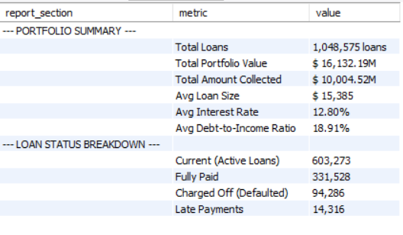
! | Business Insight: Single CTE scans loans_clean once — all UNION ALL rows read from memory (10 table scans reduced to 1). Board-ready report shows $16.13B portfolio with 62.9% collection efficiency ($10B collected of $16.13B disbursed). 57.5% loans currently active, 31.6% fully paid, 8.99% defaulted. This formatted output can be directly exported to Excel or PDF for management distribution.

PROJECT COMPLETE

SQL Techniques  - CTEs — single-scan queries  - Window functions — RANK, LAG, NTILE  - SUM() OVER() — no scalar subqueries  - Conditional aggregation throughout  - UNION ALL report formatting  - HAVING for statistical filtering | Business Value  - Credit risk profiling by grade  - NPA/default identification  - Income-based segmentation  - Geographic concentration risk  - Composite CIBIL-style scoring  - Executive MIS reporting

Rupali Patra | rupalipatra1994@gmail.com | github.com/RupaliPatra/loan-portfolio-analysis

