Q5:

Given the equation 

Find out the value of x

Solve:

On the left hand side, the coefficient of polynomial <1,1,-1> can be represented as . On the right hand side, the coefficient of polynomial <1,0,-1,2,-1> can be represented as . So that we can implemented the long polynomial division

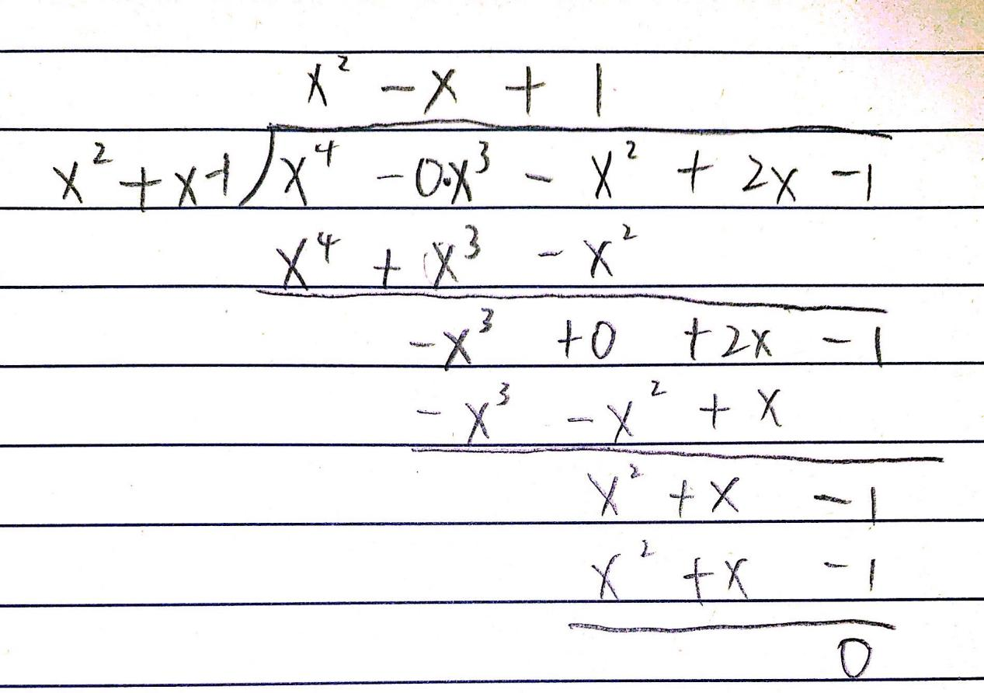

So that the answer should be “x” = 