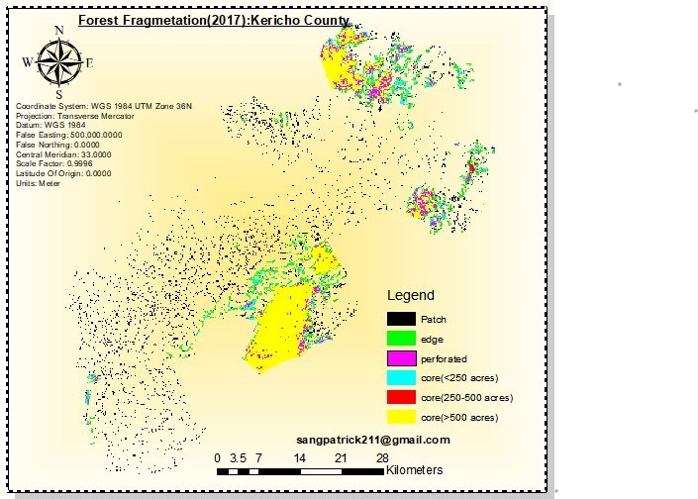

Mapping the transformation: Forest Fragmentation in Kericho County 2017-2023)

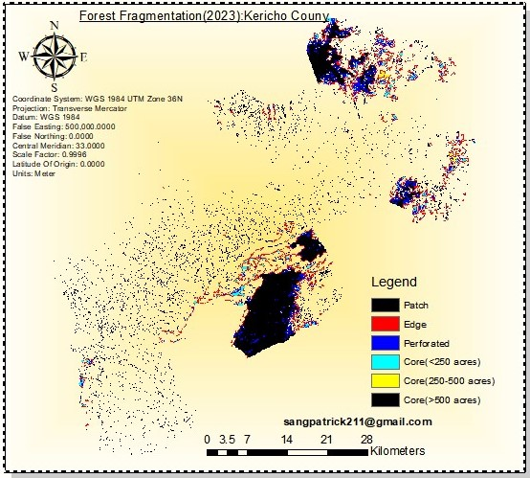

Forest fragmentation Kericho County(2023)