**Assessing Landscape Structure in Kericho County Using Landscape Metrics.**

(*Fragstat Analysis)*

**Introduction**

Landscapes are subject to alterations over time due to the continuous and intense human effects. Landscape metrics are used to investigate and carry out objective revies landscape structures and changes. Landscape structure expresses the spatial pattern of landscapes elements and connections between the different ecosystems as a measure, size and shape. Landscape structure has two qualities i.e composition and configuration. The composition is an attribute that is not spatial and cannot be measures ,it is the quality of landscape patches spread within the landscape. Landscape configuration on the other hand is the spatial characteristics; spatial distribution of land cover.

Landscape metrics are used to measure the complexity of landscape structure, therefore the characteristics of landscape easily perceived. The measurement of landscape structure is usually to assess the fragility emerging over time, determine the relationship among structural features, landscape function and landscape change and show the development of landscape.

**Study Area**

Kericho County is located in the Rift Valley region of Kenya. It is situated in the highlands and is known for its picturesque tea plantations and cool climate. The county is bordered by Bomet County to the north, Nakuru County to the east, Kisumu County to the west, and Nandi and Narok counties to the south. The county is predominantly rural, with agriculture, particularly tea farming, being the main economic activity. The major town in Kericho County is Kericho town, which serves as the administrative and commercial center of the county.

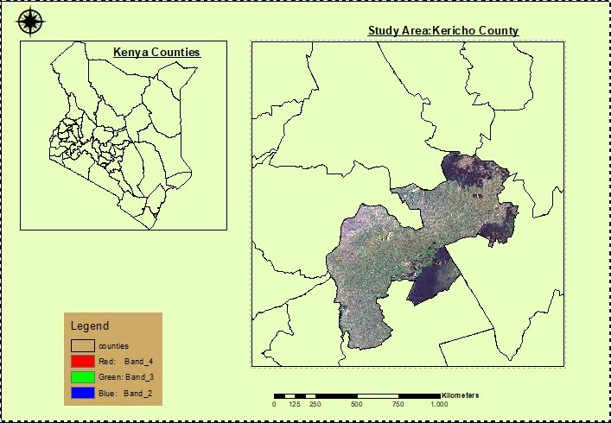

**2. | Materials and methods**

**2.1 | Data**

Satellite images of two different years(2013,2017,2023) were acquired from USGS Earth Explorer. The study has been carried out for the period 2013-2023.

|  |  |  |  |
| --- | --- | --- | --- |
| **s/No** | **Sensor Details** | **Date/Month/Year** | **Resolution** |
| **1** | **Landsat TM** | **10 April 2013** | **30m** |
| **2** | **Landsat TM** | **7th April 2023** | **30m** |

**2.2. | Image Classification**

Image classification is the process of labelling a pixel group of pixels based on its grey value. The study area was classified using supervised classification in ArcMap. The image was classified into four main categories i.e Forest, Agricultural Land, bare areas, built up areas and water. The purpose of the classification was to understand change of different land use pattern over the years.

**2.3 | Accuracy assessment**

Accuracy assessment is an important step in processing remotely sensed data. The accuracy was assessed through ground truthing using google earth software, thereafter overall accuracy, producer accuracy ,and user accuracy calculated, the results were found to be satisfactory.

**2.4. | Selection And calculation of spatial metrics**

Landscape metrics are algorithmic program that quantify specific spatial characteristics of patch es ,classes of patches or the entire landscape mosaic. There are many landscape metrics that have been developed to quantify landscape structure and spatial heterogeneity based on landscape composition and configurations.

The following parameters were calculated in Fragstat tool:

**Cover Area(CA):** Class Area, Changes can be identified over time with cover area.

**Number of patches(NUMP):** Number of patches. The patch number can be evaluated over time with NUMP.If NUMP value increases the fragmentation increases in the field and if the NUMP value decreases it is understood fragmentation decreases in the field.

**Mean Patch Size(MPS):**MPS is used to evaluate fragmentation. If MPS value increases the fragmentation increases in the field. If MPS value decreases then it means fragmentation decreases in the field.

**Total Edge(TE):** TE is used to determine important areas for wildlife .If TE values is high these areas are suitable for edge species.TE is used to identify suitable areas for edge species.

**Shannon Evenness Index(SEI):**SEI identifies to distribution(regular/irregular) of patches in the area. If SEI value is close to 1 it is understood patches distribution are regular in the field.

**Shannon Diversity Index(SDI):**SDI refers to the diversity of patches in the area if SDI value is zero it is understood area consist of singe patch. Distribution of patches can be identified in each other and field.

Class Area(CA) is a metric used to describe pattern ,which is also known as the total area i.e Total area covered by a landcover class in hectares .This shows how much of the landscape is comprised of a particular patch type .Cover area indicates the sum of areas(m2) of all patches corresponding patch type ,divided by 1000(to convert to hectares)

Area Weighted Mean shape index, is equivalent to sum across all the patches of the corresponding patch type of each patch perimeter(m)( divided by the square root of patch area(m2) adjusted by a constant to adjust for a circular standard(vector) multiplied by the patch area(m2)( divided by the total class area(sum of patch area for each patch of the corresponding patch types .

Largest Patch Index, equals the area(m2) of the largest patches of the corresponding patch type divided by total landscape area(m2) multiplied by 100(to convert to percentage ) i.e LPI is equal the percentage of landscape comprised of largest patch.

Patch Density, Is the measure of patches of a land cover class which specifies the density of fragmented urban units within a quantified area, Values of this indicator are affected by size of the pixel and also minimum mapping unit since this is significant factor for describing individual patches on a per unit area basis that facilitates comparisons among landscape of varying size.

The Number of Patches, it a measure of discontinuous urban areas or individual units in the landscape .Number of patches indicates the diversity or richness of the landscape ,it gives information of the extent of fragmentation of a patch type.

3**. | Results**

**3.1 | Land cover pattern analysis**

Areas occupied by each class were computed. In 2023 forest covers 263242509.2 m2(12.52%),agricultural Land covers 1616320767m2(76.85%), Built up Areas covers 144844029.9m2(6.89%) water 66942.0026 m2(0.003%) and bare land 78622076.63(3.74%)

|  |  |  |  |  |  |
| --- | --- | --- | --- | --- | --- |
| **classes** | **Area_2013 in square meters** | **Percentage** | **Percentage(%)** | **Area_2023_in square meters** | **Percentage(%)** |
| **Forest** | **424497572.517175** | **16.45** | **Forest** | **263242509.2** | **12.52** |
| **Agricultural Land** | **1214902555.58112** | **47.04** | **Agricultural Land** | **1616320767** | **76.85** |
| **Built up areas** | **38383294.9805761** | **1.49** | **Built up Areas** | **144844029.9** | **6.89** |
| **Water** | **1371671.04681387** | **0.05** | **Water** | **66942.0026** | **0.003** |
| **Bare land** | **903357494.806244** | **35.00** | **Bare land** | **78622076.63** | **3.74** |

The forest cover decreased in 2023 ,agricultural land and built-up areas increased in 2023 compared to in 2013,bare land decreased through conversion to other land uses.

**3.2 | Accuracy assessment**

The accuracy test was carried out to test the accuracy of the land cover generated from the supervised classification process ,the results of confusion matrix on land cover shows that in 2017 the kappa value is 81.50% and overall accuracy 83.78%,in 2023 the kappa is 89% while overall accuracy is 93% proving that the land cover data is reliable and therefore can be used for the analysis.

*Results: Kericho 2023 Supervised Classification (Accuracy& Kappa Coefficient)*

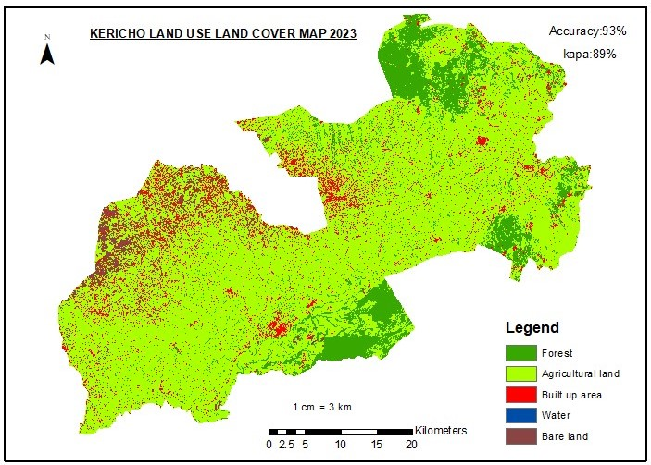

Confusion matrix calculation for kericho LULC 2023

|  |  |  |  |  |  |
| --- | --- | --- | --- | --- | --- |
|  | Forest | Tea | Built up | Water | Total(User) |
| Forest | 11 | 0 | 0 | 0 | 11 |
| Agricultural land | 0 | 7 | 0 | 0 | 7 |
| Built up | 1 | 2 | 9 | 0 | 12 |
| Water | 0 | 0 | 0 | 1 | 1 |
| Total(producer) | 12 | 9 | 9 | 1 | 31 |

**Overall Accuracy**=29/31*100=93%

**User Accuracy**

Forest=11/11*100=100%

Agricultural land=7/7*100=100%

Built up=9/12*100=75%

Water=1/1*100=100%

**Producer Accuracy**

Forest=11/12*100=91.66%

Agricultural land=7/9*100=77.77%

Built up=9/9*100=100%

Water=1/1*100=100%

**Kappa coefficient**

TS*TCS-sum(column Total*Row Total) X100

TS(TS)-sum(Colum Total*Row Total)

(28X31)-((11x11)+(7X7)+(9X12)+(1X1) X100

((12X11)+(9X7)+(9X12)+(1X1)

589/657*100=89.6499%

=89%

*Results: Supervised classification Kericho LULC 2013*

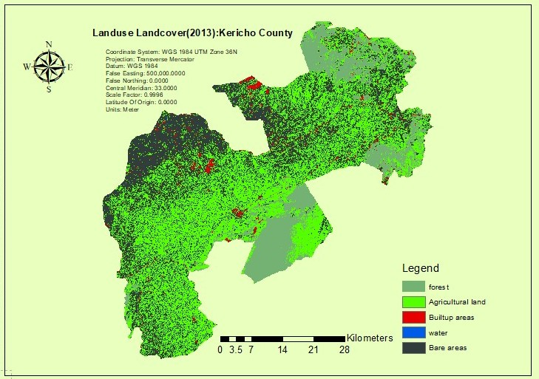

Confusion matrix calculation for LULC 2013

|  |  |  |  |  |  |  |
| --- | --- | --- | --- | --- | --- | --- |
|  | Forest | Agricultural land | Built up areas | Water | Bare land | Total(user) |
| Forest | 15 | 0 | 0 | 0 | 0 | 15 |
| Agricultural land | 0 | 23 | 0 | 0 | 1 | 24 |
| Built up areas | 1 | 4 | 6 | 0 | 0 | 11 |
| Water | 0 | 1 | 0 | 3 | 1 | 5 |
| Bare land | 0 | 4 | 0 | 0 | 15 | 19 |
| Total (producer) | 16 | 32 | 6 | 3 | 17 | 74 |

**Overall Accuracy**= Total Number of Correctly classified pixels (Diagonal)

Total number of Reference Pixels

62/74*100%=83.7837

=83.78%

**User Accuracy**= Number of correctly Classified pixels in Each Category

Total Number of correctly classified pixels (row total)

**User Accuracy**

Forest=15/15*100=100%

Agricultural Land=23/24*100=95.83%

Built up areas=6/11*100=54.55%

Water=3/5*100=60%

Bare land=15/19*100=78.95%

Producer Accuracy

Forest=15/16*100=

Agricultural Land=23/32*100=71.88%

Built up areas=6/6*100=100%

Water=3/3*100=100%

Bare Land=15/17=88.24%

Kappa

TS*TCS-sum(column Total*Row Total) X100

TS(TS)-sum(Column Total*Row Total)

(62*74)-((15*16)+(23*32)+(6*6)+(3*3)+(15*17)) X 100

5476-((16*15)+(32*24)+(6*11)+(3*5)+(17*19)

=81.50%

**3.3 | Landscape metric Analysis 2013**

|  |  |  |  |  |  |  |  |  |
| --- | --- | --- | --- | --- | --- | --- | --- | --- |
| **Class level** | **CA(ha)** | **TLA(ha)** | **NUMP** | **MPS(ha)** | **TE(m)** | **MSI** | **SEI** | **SDI** |
| **forest** | 42449.76 | - | **422** | 42449.76 | 5066165.27 | 69.36 | **-** | **-** |
| **Agricultural land** | 121490.26 | - | **449** | 121490.26 | 30126919.38 | 243.83 | **-** | **-** |
| **Built up areas** | 3838.33 | - | **249** | 3838.33 | 1895653.83 | 86.31 | **-** | **-** |
| **water** | 137.17 | - | **14** | 137.17 | 96763.38 | 23.31 | **-** | **-** |
| **Bare areas** | 90335.75 | - | **678** | 90335.75 | 26609855.77 | 249.75 | **-** | **-** |
| **Landscape metrics** | 258251.26 | 258251.26 | **1812** | 51650.25 | 63795357.63 | 134.51 | 0.67 | 1.09 |

*Calculation results for landscape metrics by year 2023 land use landcover*

**3.3 | Landscape metric Analysis 2023**

|  |  |  |  |  |  |  |  |  |
| --- | --- | --- | --- | --- | --- | --- | --- | --- |
| **Class level** | **CA(ha)** | **TLA(ha)** | **NUMP** | **MPS(ha)** | **TE(m)** | **MSI** | **SEI** | **SDI** |
| **forest** | 40140.43 | - | **731** | 40140.43 | 7822139.02 | 110.14 | **-** | **-** |
| **Agricultural land** | 189528.56 | - | **83** | 189528.56 | 19867339.16 | 128.74 | **-** | **-** |
| **Built up areas** | 5702.50 | - | **268** | 5702.50 | 2583160.83 | 96.50 | **-** | **-** |
| **water** | 7.24 | - | **1** | 7.24 | 2416.29 | 2.53 | **-** | **-** |
| **Bare areas** | 22870.58 | - | **780** | 22870.58 | 12444822.97 | 232.14 | **-** | **-** |
| **Landscape metrics** | 258249.31 | 258249.31 | 1863 | 51649.86 | 42719878.28 | 114.01 | 0.51 | 0.82 |

*Calculation of landscape metric results using 2023 landcover*

**Conclusion**

Landscape metrics were calculated for the year 2013 land use landcover and 2023landuse land

Cover. There is increase in agricultural areas and decrease in forest areas, Patches distribution is irregular in the area and the mean patch size slightly decreased over time therefore fragmentation increased. Total edge value for agricultural land especially the large tea plantations in Kericho county and forest are higher making the area favorable and appropriate for edge species.

***Patrick Kiplangat***