**Morphometric and Topo-hydrological Analysis and Prioritization of Sub Watersheds in River Yala Catchment using SWPT(sub watershed prioritization tool)**

I**ntroduction**

The sub watershed prioritization necessitates ranking of different areas of a river basin based on their needs to management of soil and water resources to ensure optimal allocation of resources to critical sub watersheds. The prioritization of sub watershed requires geospatial statistical techniques to analyze morphometric and topo hydrological factors. In this study sub watershed prioritization tool was used(SWPT) a tool applicable where there are no gauged data and data scarce watersheds. The tool uses Weighted sum analysis ad considers morphometric parameters in the relief, area, and linear aspect for analysis using only Digital Elevation Model(DEM).The prioritization process also incorporates topo-hydrological parameters such as stream power index(SPI),Topographic wetness index(TWI), and sediment Transport index(STI) in prioritization of sub watersheds.

**2. | Material and methods**

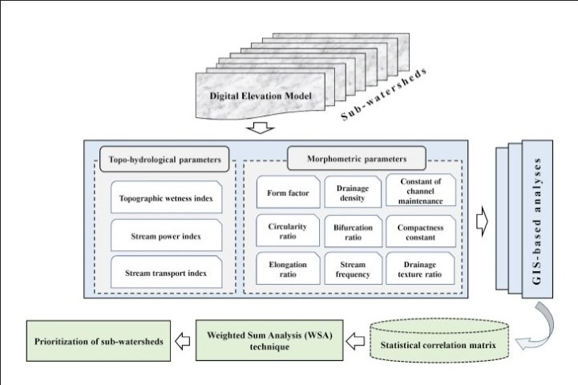

**2.1 | Study Area**

The Yala river basin is located in western parts of Kenya and drain into Lake Victoria in Siaya County ,River Yala originates in Nandi Escarpment in Rift Valley and flows west for 219 kilometers to its Mouth in Lake Victoria .River Yala has an average discharge of 27.4 cubic meters per second.

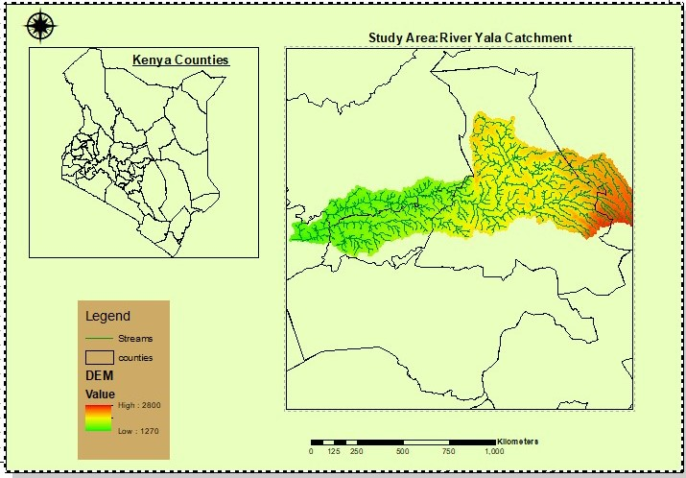

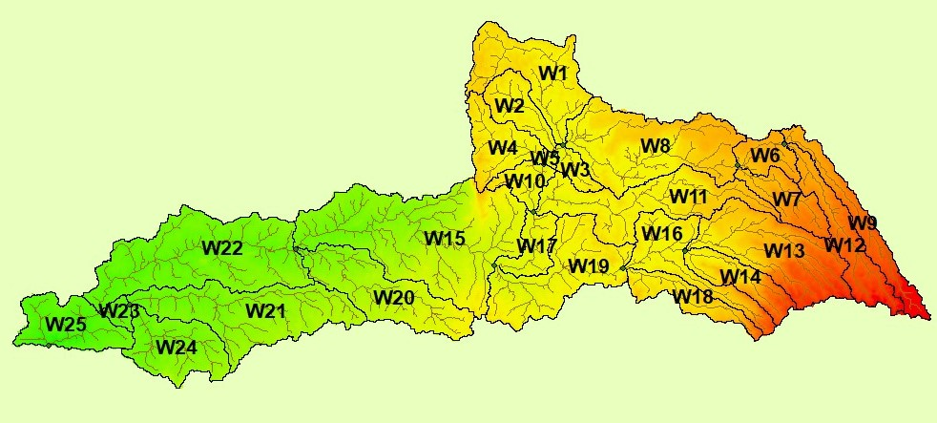

**2.2. | Methodology**

3. **Results**

**3.1 Morphometric and topo hydrological parameters**

**The results of morphometric parameters are shown in the table below**

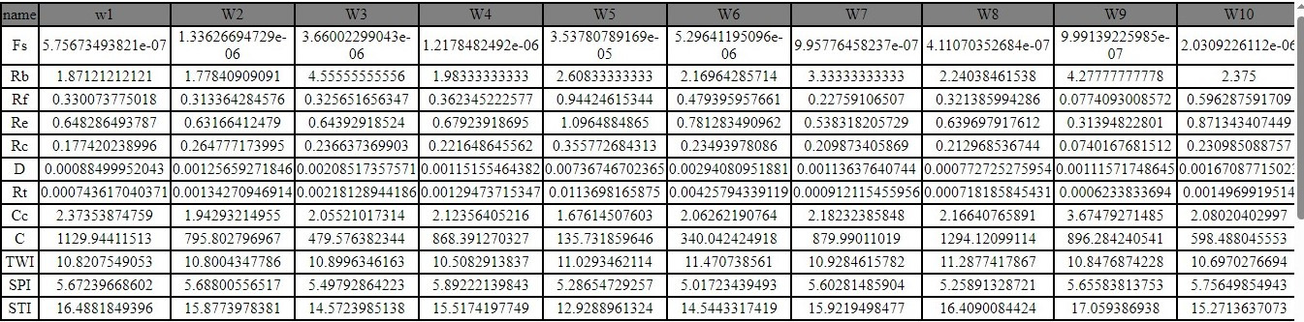

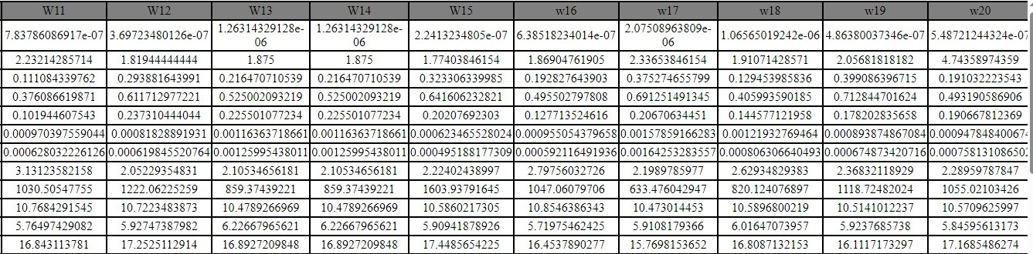

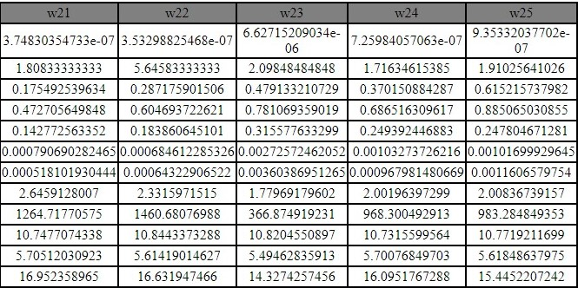

**3.3 Prioritization of sub watersheds**

The correlation matrix obtained by the weighted sum analysis of morphometric characteristics for sub watershed is shown in the table below.

**Fs:**Frequency of streams, Rb: Bifurcation ratio, **Re:**Elongation ratio, **Rc:**Circularity ratio factor **D**:drainage density,**Rt**:Drainage texture,**Cc**:compactness coefficient **C:**channel maintainance,**TWI:**Topographic wetness index,**SPI**:Stream power index,**STI**:sediment transport index.

The sub watersheds are ranked ,and the most susceptible sub watershed to erosion and runoff is ranked number 1 and the list susceptible sub watershed ranked the last one. In the study area the most susceptible sub watershed is sub watershed SW15 and he list is sub watershed SW5.The correlation results are shown in the table below.

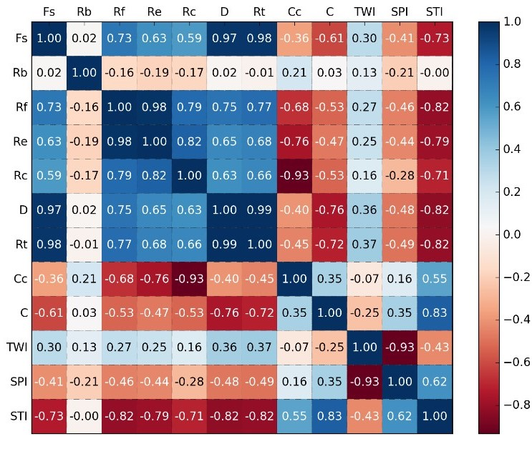

The prioritization of sub watershed is done based on the compound parameter values (CPV)whereby sub watershed with lowest CPV is given first priority and other sub watershed ranked in this manner.

***Prioritization and ranking of sub watersheds***

|  |  |  |
| --- | --- | --- |
| Name | Prioritization | Priority |
| w1 | -131.204982395 | 6 |
| W2 | -93.0227712357 | 19 |
| W3 | -56.615001147 | 21 |
| W4 | -101.269334126 | 15 |
| W5 | -16.9554215344 | 25 |
| W6 | -40.6867207874 | 24 |
| W7 | -102.571628239 | 14 |
| W8 | -149.718744886 | 3 |
| W9 | -104.877730744 | 13 |
| W10 | -70.3523427803 | 20 |
| W11 | -120.162781478 | 10 |
| W12 | -141.841788771 | 5 |
| W13 | -100.613594873 | 16 |
| W14 | -100.613594873 | 17 |
| W15 | -185.356916916 | 1 |
| w16 | -121.893533845 | 9 |
| w17 | -74.5775605468 | 22 |
| w18 | -96.2117100444 | 18 |
| w19 | -129.883525185 | 7 |
| w20 | -122.736979012 | 8 |
| w21 | -146.75145876 | 4 |
| w22 | -168.644719697 | 2 |
| w23 | -43.7872820849 | 23 |
| w24 | -112.688091686 | 12 |
| w25 | -114.150397973 | 11 |



*Diagram showing the location of sub watersheds*

**Conclusion.**

The sub watershed prioritization tool (SWPT) was successfully applied in River Yala Catchment and is able to prioritize sub watersheds that requires interventions in terms of Soil and water management and implementation of best management practice.