**Rainfall-Runoff Modelling and Prioritization Of Sub Watersheds For Conservation in River Yala Basin Using SWAT Model**.

**1.| Introduction**

Soil and water conservation practices are vital in the effective watershed management and the impact of each practice is dependent on the site ,therefore identification of areas that should have priority in terms of conservation is key for effective management of watersheds. In this study SWAT model is used to model streamflow and sediment yield and identifying areas with excessive sediment yield and surface runoff for the purpose of soil and water conservation and implementation of best management practices.

2**. | Data and Methodologies**

**2.1. | study watershed**

The Yala river basin is located in western parts of Kenya and drain into Lake Victoria in Siaya County ,River Yala originates in Nandi Escarpment in Rift Valley and flows west for 219 kilometers to its Mouth in Lake Victoria .River Yala has an average discharge of 27.4 cubic meters per second.

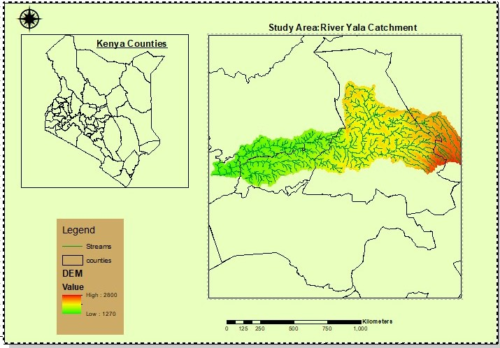

**2.2. | SWAT Model**

The Soil and Water assessment tool was developed by the United States Department of Agriculture Agricultural Research Service .SWAT model is physically based ,conceptual and long-term river basin simulation model. The model has spatially distributed parameters operating on daily time step. SWAT model is used to quantify the impact of land management practices on water, sediments and agricultural chemical yields in large and complex watersheds with varying soils ,land uses and management conditions over a long period of time.

SWAT incorporates the effects of weather ,surface runoff ,evapotranspiration ,irrigation, sediment transport ,ground water flow ,crop growth ,nutrient yielding ,pesticide yielding and water routing and long-term effects of varying agricultural management practices. Runoff is estimated separately for each sub basin from daily rainfall using the daily rainfall using modified SCS-CN and Green-Apt methods .Sediment yield is estimated using modified Universal Soil Loss Equation (MUSLE).

Watershed is partitioned into sub basins that are divided into many homogenous hydrologic response units with unique combinations of land cover ,soil and topographic conditions .The hydrological component of the model calculates a soil-water balance at each time step based on the daily amounts of precipitation ,runoff, evapotranspiration ,percolation and baseflow .The simulations of sediment yield are computed with MUSLE at hru level and summarized in each sub basin, simulated variables are then routed through the stream network to the watershed outlet

2**.3 | Data Preparation**

***2*.3.1.| Weather data**

The Meteorological stations(13) falling within and around the study area was used to obtain the relative humidity , temperature(maximum and minimum), wind speed, solar radiation datasets, then local weather generator (WGN) was created based on these stations and incorporated in the SWAT Weather Database

**2.3.2 | Soil data**

SWAT model requires physicochemical properties such as the soil texture ,hydraulic conductivity ,available water content ,bulk density and organic carbon content for each soil type .The soil data were obtained from FAO and harmonized Soil database of the world.

The soil types found in the River Yala basin Included :

|  |  |  |  |
| --- | --- | --- | --- |
| **Soil Type** | **Soil Name from SWAT Database** | **Area in ha** | **Percentage(%)** |
| **Fo48-2ab-42** | **Ornithic Ferasols** | **3.716051** | **0.001576** |
| **Bh14-3c-466** | **Humic Cambisols** | **11115.754568** | **4.71527** |
| **Nh2-2c-848** | **Humic Nitisols** | **224620.136481** | **95.2832** |
|  |  |  |  |

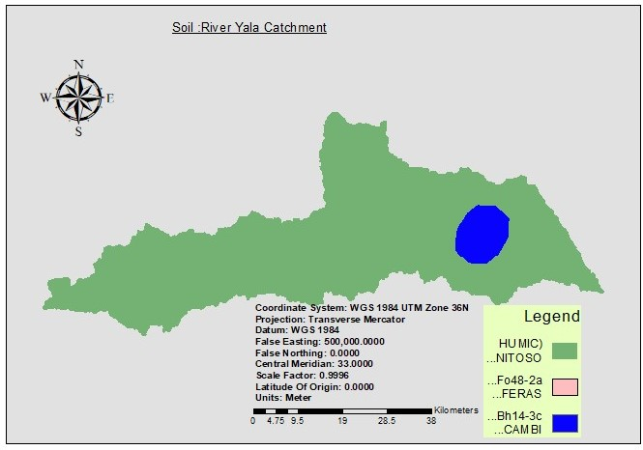

**2 3.3 . | Digital Elevation Model**

DEM describes the elevation of any point in a given area at a specific spatial resolution. The DEM was downloaded from ASTER GDEM (advanced Spaceborne Thermal Emission and Reflection Radiometer Global Digital Elevation Model with 30m spatial resolution).The digital Elevation model was used to delineate boundary of watershed and analyze the drainage patterns of land surface terrain and deriving terrain parameters.

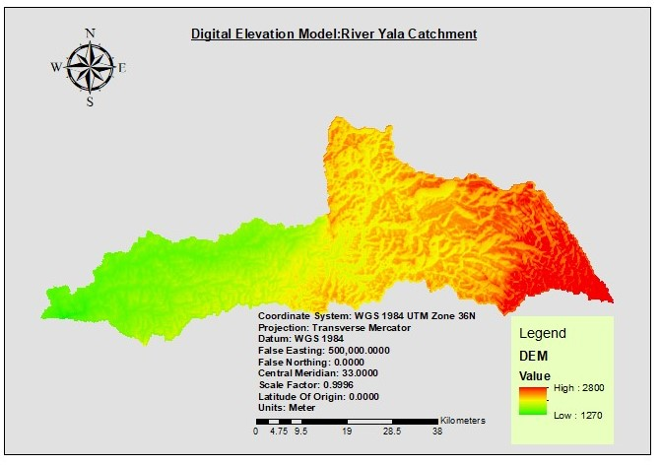

**2.3.4. | Land use /land cover data**

Land use affect surface erosion ,runoff and evapotranspiration.Landuse map of the area was obtained from ESRI ,it was for 2020 to better represent the simulation period which was from 2010-2022

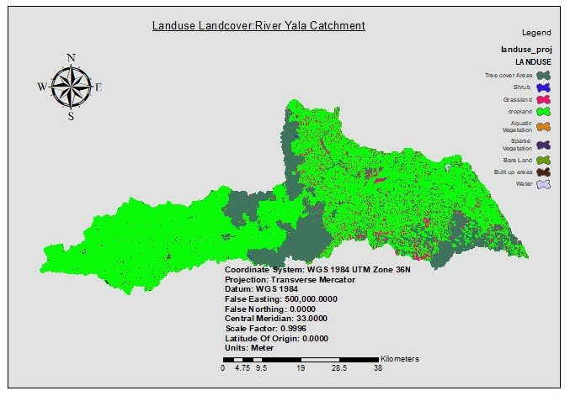

|  |  |  |
| --- | --- | --- |
| **LANDUSE** | **AREA(ha)** | **%** |
| **Shrub** | **158.133987** | **0.066767** |
| **Sparse Vegetation** | **1.824094** | **0.00077** |
| **Aquatic Vegetation** | **41.789803** | **0.017644** |
| **Bare Land** | **13.336348** | **0.005631** |
| **Built up areas** | **1015.497331** | **0.428761** |
| **Cropland** | **175697.618018** | **74.182572** |
| **Grassland** | **11267.417079** | **4.757298** |
| **Forest cover** | **48531.370225** | **20.490784** |
| **Water** | **117.885275** | **0.049773** |

*Hydrological data*

The observation data ,discharge was obtained from stations() near the whole watershed outlet, (from GEOGLOWS portal )which was later calibrated and validated using discharge data from subbasin (25) of SWATCUP program

*SWAT model set up*

The Arc swat 10.7 interface was used for setup and parametrization of the model. DEM was loaded into the Arc swat to delineate the area of interest and create the stream networks In the area of study. The land use, and soil data of the study area which where in raster format and were overlaid to obtain a unique combination of land use,soil,and slope classes in each sub basin, Multiple HRUs with 30% land use ,30% soil and 20%elevation threshold were used .

The daily weather data were prepared in text format(.txt) and imported into the model

* **2.3 SWAT model , sensitivity analysis, calibration and validation**

Manual a calibration using sensitive parameters related to streamflow were employed in this study. In the calibration process model parameters were subjected to adjustments to obtain model results that best corresponds to the measured datasets. The calibration was done on a monthly time-step from January 2012 to December 2017.

In the validation process , the model was operated with input parameters set in the calibration process and results compared against set of observed data to evaluate the perform validation period was from 2018-2022 with 2-year warm up period.The model evaluation was based on on the coefficient of determination(R2) and the Nash-Sutcliffe efficiency performance Evaluations standards.

For calibration the parameters SCS_CN (SCS curve umber for moisture condition)SOL_AWC,SOL_K,REVAMP,SURLAG,GW_DELAY.gw,CH_K2,CN2,R_OV_N,ALPHA_BF(Baseflow factor and manning’s value for main channel(CH_K2) were among the sensitive parameters.

**3.RESULTS**

**3.1Watershed delineation**

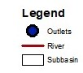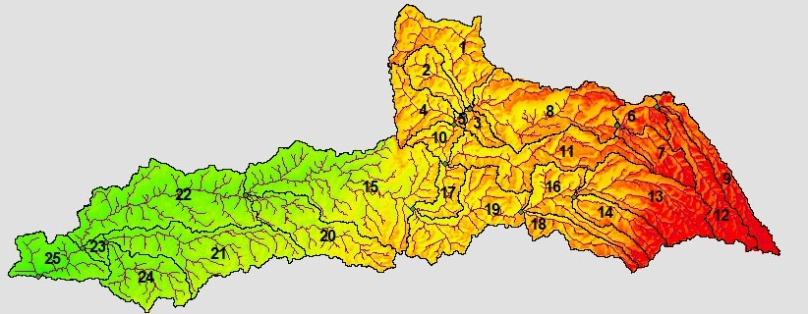

**3.2.Calibration**

The sensitive streamflow parameters were used for the manual calibration and the calculated values of R2 and NS were 0.62 and 0.601769 respectively indicating good agreement between observed and simulated stream flow.

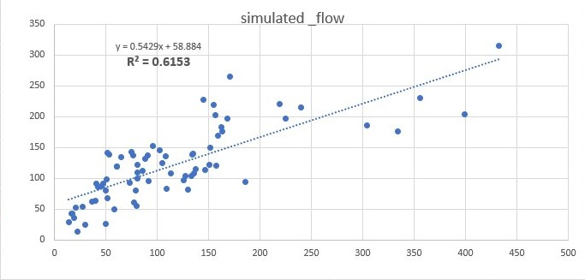

*Monthly observed and simulated flow for validation period*

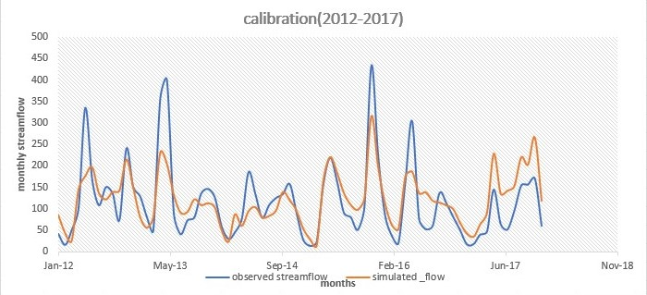

**3.3 .Validation**

The model was run with similar input parameters as during the calibration process .and the result compared to the other remaining observed data to assess model performance.During validation period the R2 and NS values were 0.60 and 0.855254 respectively ,and were within the criterion 0f R2 greater than or equal to 0.6 and NS greater than or equal to 0.5.

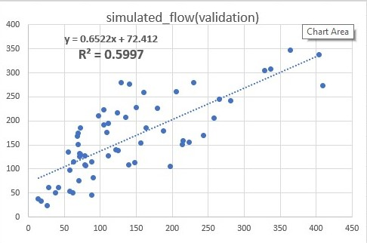

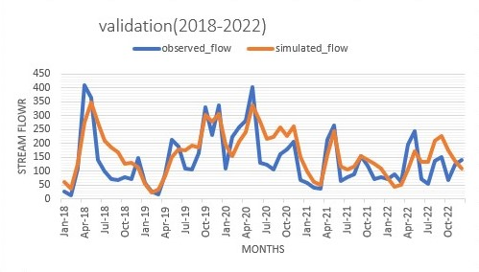

*Monthly observed and simulated flow for validation period*

|  |  |  |  |  |  |
| --- | --- | --- | --- | --- | --- |
| **Criteria** | **Calibration(2012-2017** | **Validation(2018-2022)** | **Standard values(Neitsch.,et al.,2005)** | **remark** |  |
| NS | 0.601769 | 0.855254 | Greater Than or equal 0.5 | Best fit |  |
| R2 | 0.62 | 0.60 | Greater Than or equal 0.6 | Best fit |  |

**3.4 Sub basin level surface runoff and sediment yield and sub watershed prioritization.**

Sub basins 1 and 2 produced the largest runoff while subbasin 22,21

20,19,18,17,16,15,13,14,12,11,10,9,7,6 produced least runoff .The steep slopes resulted in peak runoff from the watershed. Surface runoff is fundamental for an effective watershed management program for conservation and development of natural resources(Degefie and Bewket,2011).

Sub watershed 1 and 2 produced the largest sediment yield while 17 produced the least sediment yield, sediment yield in the other remaining sub watersheds were moderate.

The prioritization of sun watershed was then done on the comparison of sediment yield compared to the sub watershed area as shown in the table below:

|  |  |  |
| --- | --- | --- |
| **Subbasin** | **Comparison(sediment yield/sub watershed area)** | **Priority** |
| **Sub 15** | **30333.73721122100** | **1** |
| **sub22** | **22637.18430088800** | **2** |
| **sub8** | **17998.60975990300** | **3** |
| **Sub 21** | **16800.22792201200** | **4** |
| **Sub 13** | **14873.44430783600** | **5** |
| **Sub 11** | **13933.19982001800** | **6** |
| **Sub 19** | **13563.49874758800** | **7** |
| **Sub 20** | **12567.21863793000** | **8** |
| **sub1** | **11807.02207942400** | **9** |
| **sub24** | **8945.19335692500** | **10** |
| **sub16** | **8450.30339197200** | **11** |
| **sub12** | **7907.09067187900** | **12** |
| **sub25** | **7796.56249165300** | **12** |
| **Sub 9** | **6602.81664080900** | **14** |
| **Sub 4** | **6402.05119042900** | **15** |
| **sub14** | **5535.52715177700** | **16** |
| **sub-7** | **5017.92284845200** | **17** |
| **sub18** | **4964.82296915000** | **18** |
| **Sub 2** | **4783.36973155000** | **19** |
| **Sub 17** | **3807.04129412500** | **20** |
| **Sub 6** | **3453.53873078200** | **21** |
| **Sub 10** | **2946.35367651100** | **22** |
| **Sub 3** | **1878.51036667600** | **23** |
| **Sub 23** | **1170.17172204200** | **24** |
| **Sub 5** | **360.17316518100** | **25** |
|  | |  |
|  | |  |
| The implementation of best management practice and soil conservation measures should be practiced in sub basin 15 ,22,8 and 21 and to minimize sediment yield .Soil erosion conservation measures such as cover cropping ,and also the soil erosion control structures such as terraces ,vegetated waterways should be established in the sub basin | |  |
|  | |  |
|  | |  |
|  | |  |
|  | |  |
|  | |  |
|  | |  |
|  | |  |
|  | |  |
|  | |  |
|  | |  |
|  | |  |
|  | |  |
|  | |  |
|  | |  |
|  | |  |
|  | |  |
|  | |  |
|  | |  |
|  | |  |
|  | |  |
|  | |  |
|  | |  |
|  | |  |
|  | |  |
|  | |  |

The implementation of best management practice and soil conservation measures should be practiced in sub basin 15 ,22,8 and 21 and to minimize sediment yield .Soil erosion conservation measures such as cover cropping ,and also the soil erosion control structures such as terraces ,vegetated waterways should be established in the sub basin

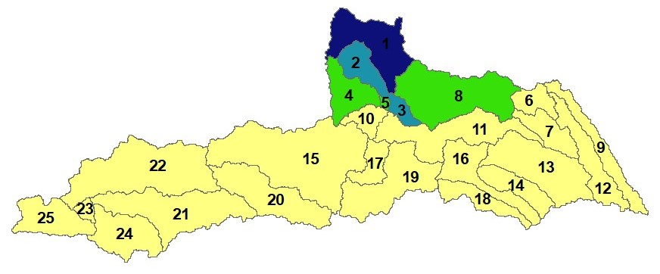 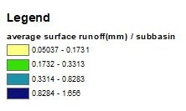

***Sub watershed surface runoff***

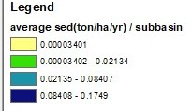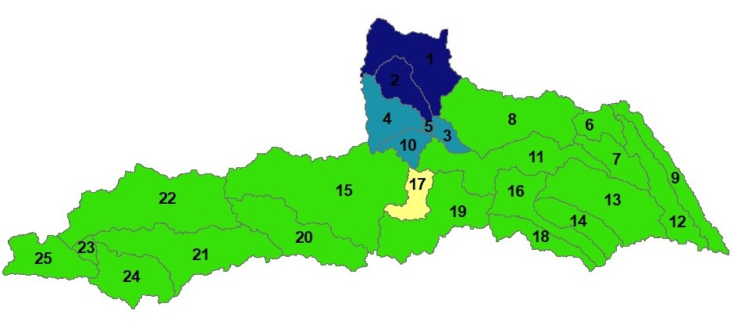

*Sub watershed sediment yield*

**CONCLUSION**

The study tried to show the performance of SWAT model for estimating streamflow and sediment yield for the prioritization of areas within the basin by identifying areas with huge sediment yield therefore assist I the implementation of soil conservation and management practices.