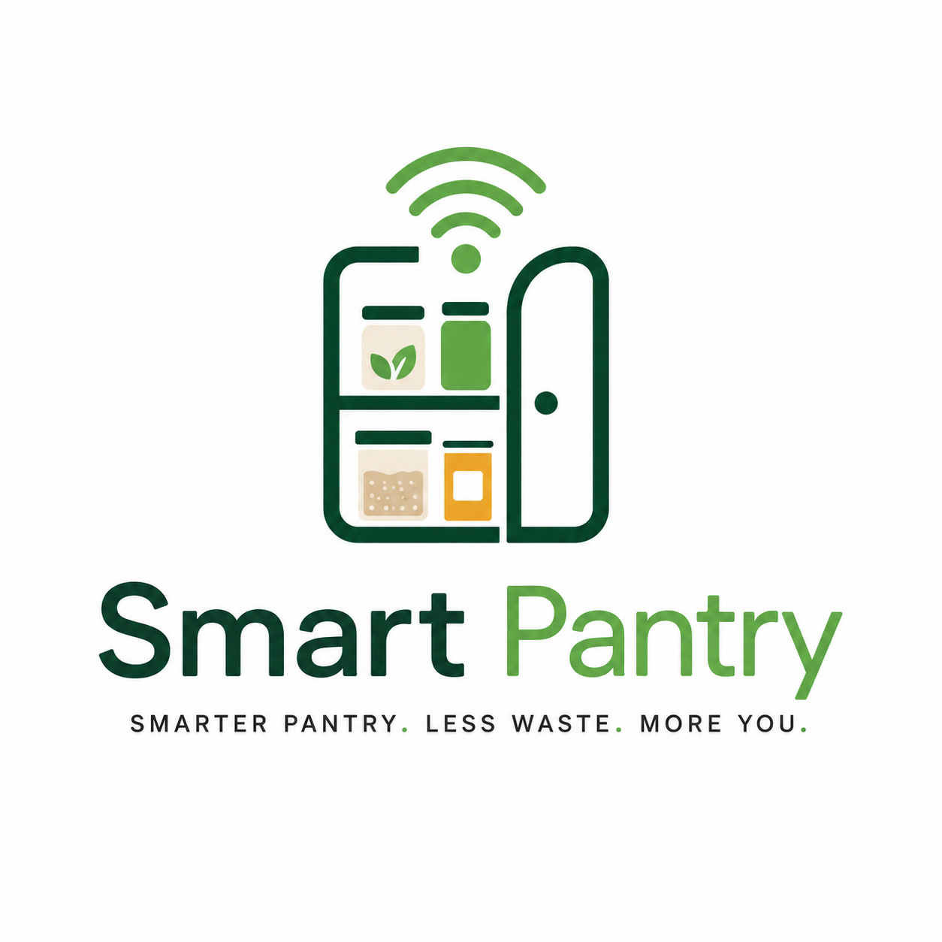
Smart Pantry
High Level Design Document - Draft 2
Patrice Jones
CSMS Degree Program
Full Sail University
June 7, 2026

Smarter pantry. Less waste. More you.

Table of Contents
1. Introduction 3
1.1 Project Concept / Pitch 3
1.2 Technical Design Goals 3
1.3 Development APIs / Programming Languages 3
1.4 Development Standards / Cold-Start Procedures 4
2. Advisor / Committee Feedback Integration 4
3. Project Functionality 5
3.1 User Modes 5
3.2 Main Mechanics / Sub Mechanics 5
3.3 AI Module(s) 5
3.4 Machine Learning Support Layer 6
3.5 User Interface / Inputs / Sensors 6
3.6 Graphics / Animation / Video 6
3.7 Audio 6
3.8 Networking 7
3.9 Databases / Server-Side Technology 7
3.10 Localization Plan 7
3.11 Custom Topics 7
3.12 Additional Technical Information 7
4. Mockups / Flowcharts 7-9
5. Production Documentation 10
5.1 Feature List 10
5.2 Master Task List 10-11
6. Development Roadmap 11
7. Verification and Validation (V&V) 11-12
8. Risk Areas and Backup Plans 12
9. References 12

1. Introduction

1.1 Project Concept / Pitch
Smart Pantry helps people use what they already have before food gets forgotten, wasted, or bought twice.
Smart Pantry is a web-based pantry awareness and meal recommendation system. The application lets participants track food items, edit pantry amounts, view expiration alerts, get practical meal recommendations, record what they actually used, and complete pre-study and post-study surveys. The goal is not to make a plain recipe app. The goal is to build a research-ready pantry tool that can measure whether the system improves pantry awareness, recommendation usefulness, and ingredient utilization.
This Draft 2 version keeps the stronger technical direction from the original high-level design document while updating the scope to match the current working application. The older draft focused heavily on a single-user pantry recommendation MVP with future multi-user support. The current version has moved forward into participant accounts, admin access, user-specific data separation, study metrics, cleaned recipe dataset integration, Smart Score ranking, and a local testing workflow that can later move to Supabase and Streamlit deployment.

1.2 Technical Design Goal(s)
- Build a working web app that supports participant login, individual pantry records, profile preferences, pre-study and post-study surveys, meal recommendations, and admin study metrics.
- Design an explainable recommendation engine that uses pantry match, expiration urgency, substitutions, allergies/preferences, recipe practicality, and nutrition data instead of only basic ingredient matching.
- Use a cleaned recipe and nutrition dataset so the app does not depend on a small hard-coded recipe list or the original large CSV during normal testing.
- Use a Random Forest model as a support layer for nutrition and practicality scoring while keeping the visible Smart Score understandable to users and defensible to the committee.
- Collect enough structured study data to support the thesis question: whether Smart Pantry improves pantry awareness, recommendation usefulness, and ingredient utilization compared to traditional methods and previous app experiences.
- Keep the participant side simple and friendly while keeping research-heavy data in the admin dashboard.
The most challenging part of this project is connecting several smaller systems into one complete workflow. Pantry management, recipe data, recommendation scoring, survey responses, user accounts, admin metrics, and future deployment all have to work together. This is also why the project is valuable from a graduate-level development standpoint: it is not only about building pages, it is about building a system that can collect and explain evidence.

1.3 Development APIs / Programming Languages
Tool / API | Use in Smart Pantry
Python 3.11+ | Core application language used for Streamlit pages, recommendation logic, data processing, and model training.
Streamlit | Web application framework used for the participant UI, admin dashboard, forms, tables, charts, and local testing.
SQLite | Local prototype database for user accounts, pantry items, surveys, recommendation logs, and usage logs.
Supabase / PostgreSQL | Planned final deployment database for online participant testing and persistent study data. Supabase is not part of the current local phase yet.
Pandas | Used to process the cleaned recipe dataset, survey exports, admin metrics, and CSV data.
scikit-learn | Used for Random Forest support model training and nutrition/practicality scoring.
joblib | Used to load and save the recommendation_model.pkl file.
Matplotlib / Streamlit charts | Used for pie charts and admin/dashboard visualizations.
GitHub / Git Bash | Used for version control, backups, and deployment preparation.
Visual Studio Code | Primary development environment.
Possible later API additions include USDA FoodData Central or a recipe API if the cleaned local dataset is not enough. These are future options and are not required for the current Draft 2 scope.

1.4 Development Standards / Cold-Start Procedures
The project is organized around the working app folder because that is how the current prototype is launched. The stable local version is the v28 checkpoint.
SmartPantry/
app/
main.py
database.py
train_model.py
prepare_recipes.py
requirements.txt
SmartPantry_logo.png
data/
smart_pantry_recipes_clean.csv
ml/
recommendation_model.pkl
Cold-start steps for another developer:
- Clone or copy the project folder and open it in Visual Studio Code.
- Create and activate a Python virtual environment.
- Install dependencies using: pip install -r app/requirements.txt.
- Confirm app/data/smart_pantry_recipes_clean.csv exists.
- Confirm app/ml/recommendation_model.pkl exists or run python app/train_model.py to recreate it.
- Launch the app with: streamlit run app/main.py.
- Create a test participant account, add pantry items, and confirm Meal Recommendations loads from the cleaned dataset.
Development standards include keeping participant-facing language simple, storing research data through database functions instead of ad hoc files, avoiding exposed admin credentials, maintaining user_id separation for participant data, and saving stable working versions before major changes.

2. Advisor / Committee Feedback Integration
This section records the committee and advisor feedback from the proposal presentation and follow-up notes, then shows how each concern was integrated into the current Smart Pantry design. I kept the original technical direction around the recommendation engine, dataset processing, database planning, and V&V, but updated the design so the project is more measurable, more research-ready, and more realistic for participant testing.
Committee/advisor feedback from presentation | How the feedback was integrated
Advisor / committee overall: The project needed to move from a broad food-waste claim to measurable study outcomes. | The scope now focuses on pantry awareness, recommendation usefulness, and ingredient utilization. The app collects pre/post survey data, recommendation logs, ingredient usage logs, and expired/discarded records.
Ahmed Al Zaidy: The hypothesis needed to be more measurable, and the study needed a clearer participant plan. | The hypothesis now connects to pre/post survey scores and app usage data. The study plan targets roughly 30 participants and includes pre-study, app-use, and post-study collection.
Oleg Kachirski: The system needed clearer algorithm detail, baseline comparison, and quantitative evidence instead of only saying the app is intelligent. | The document now separates the baseline method, Smart Score, ML support layer, V&V tests, and Study Metrics dashboard so results can be evaluated quantitatively.
Gary Alvarez: Manual pantry entry and participant adoption were risk areas, and the project needed to show why users would keep using it. | The app now uses editable pantry tables, simple quantity entry, optional-seasoning logic, friendly UI language, category charts, and grocery list ideas to reduce participant friction.
Michael Jaweed: The technical implementation needed to explain the model, database connection, and how the web version would support study data. | The design now explains Streamlit, SQLite for local testing, planned Supabase/PostgreSQL deployment, user_id separation, Random Forest support scoring, and admin exports.
Committee discussion: The recommendation system should not depend on strange or unrealistic recipes from a raw dataset. | The project now uses prepare_recipes.py to generate smart_pantry_recipes_clean.csv, cleans recipe names, ignores basic seasonings, prioritizes everyday meals, and loads the smaller dataset for performance.
Committee discussion: The project needed comparison against traditional methods and existing pantry/recipe tools. | The pre/post surveys now ask about previous pantry tracking methods, grocery apps, recipe apps, and comparison to the participant's previous method.
Advisor / resubmission requirement: The revised design document needed to address scope, timeline, milestones, and V&V more clearly. | The feature list, master task list, roadmap, risks, backup plans, and V&V criteria were rebuilt around the current v28 local version and the planned Supabase phase.

3. Project Functionality

3.1 User Modes
Smart Pantry now supports two user modes: participant and admin. This is a major update from the original single-user MVP direction. The participant mode is the study-facing experience. The admin mode is the researcher-facing experience used to review study data and export results.
Mode | Functionality
Participant | Create/login account, complete surveys, manage profile preferences, add/edit pantry items, view dashboard, receive recommendations, mark meals/ingredients used, view simple history.
Admin / Researcher | View participant records, pantry data, survey results, recommendation logs, ingredient usage, Study Metrics, Outcome Summary, exports, and evidence needed for thesis analysis.
Future Household Mode | Possible later mode for multiple family members sharing the same pantry. Not part of the current local v28 scope.

3.2 Main Mechanics / Sub Mechanics
Mechanic | Description
Pantry inventory management | Participants add, edit, categorize, and update pantry items with quantity, unit, container type, and expiration date.
Expiration awareness | Items are labeled as Use immediately, Warning: Use Soon, or Plan ahead based on days remaining.
Pantry category breakdown | Home page pie chart shows category distribution so users can see what type of food they have.
Future grocery list ideas | Shows item names only, grouped by use/replace soon, restock soon, and helpful for more meals; participants can add their own items.
Recommendation matching | Compares cleaned recipe main ingredients against the participant pantry while ignoring common seasonings.
Substitution matching | Suggests possible substitutions when the participant has a similar item but not the exact ingredient.
Allergy/preference checking | Checks recipes against allergies, disliked ingredients, meal type preferences, and cuisine preferences.
Usage tracking | Participants can mark a meal as made, enter actual amounts used, record ingredients used elsewhere, or mark items discarded.
Recommendation history | Shows participant-safe colored history cards while full details remain in admin data.
Study metrics | Admin dashboard converts raw logs and surveys into measurable outcome evidence.

3.3 AI Module(s)
The AI component is the explainable decision layer behind the Smart Score. It is not a black-box chatbot and it does not invent meals from nothing. It combines structured data, pantry rules, user preferences, and recipe quality signals to decide which meals should appear first.
- Ingredient normalization handles plural/singular differences and simpler name matching.
- Optional staples such as salt, pepper, oil, garlic powder, paprika, and general seasoning blends are not treated as required ingredients.
- Recipe cleaning removes or lowers the priority of unusual recipe names and impractical meals.
- Smart Score uses pantry match, expiration urgency, substitutions, profile preferences, nutrition/practicality, and ML support when available.
- Recommendation categories separate meals users can make now from meals that are close but need substitutions.

3.4 Machine Learning Support Layer
The machine learning component is a support layer, not the full recommendation system. A Random Forest model is trained from the cleaned recipe dataset using structured recipe features such as calories, protein, carbs, fat, ingredient count, and everyday fit score. The trained model is saved as recommendation_model.pkl and loaded in the app when available.
The reason this design is stronger is that the app still works and remains explainable even if the model file is missing. The model adds a nutrition/practicality signal to the Smart Score, while the main recommendation logic remains transparent enough to defend during the committee review. Random Forest was selected because the data is tabular, the model can handle mixed numeric signals, and feature contribution can be discussed more easily than a deep learning model at this stage [7].

Recommendation score pseudocode
For each recipe in cleaned dataset:
normalize recipe ingredients
remove optional seasonings
compare ingredients against participant pantry
identify exact matches, substitutions, and missing items
check expiration dates for matched pantry items
check allergies, dislikes, meal preferences, and cuisine preferences
calculate Smart Score:
pantry match score
+ expiration urgency score
+ substitution score
+ preference score
+ nutrition/practicality score
+ ML support score if model exists
place recipe into the correct recommendation tab
save participant actions to database when used, saved, skipped, or discarded

3.5 User Interface / Inputs / Sensors
The user interface is a Streamlit web app with a green-to-blue sidebar and a blue-to-green page background. The goal is to keep the participant side friendly and low-pressure while still collecting research-grade data in the background. Participants interact using standard keyboard, mouse, forms, dropdowns, editable tables, buttons, tabs, and charts. No physical sensors are required in the current version.
The main pages are Home, Profile, Pre-Study Survey, My Pantry, Meal Recommendations, Recommendation History, Post-Study Survey, Admin Dashboard, and Logout. The Home page summarizes pantry status with survey metrics, a pie chart color key, expiration alerts, and a future grocery list. The Recommendation page uses tabs for Meals You Can Make Now, Possible Substitutions / Almost There, and Used Ingredients Elsewhere / Discarded.

3.6 Graphics / Animation / Video
Smart Pantry is not a graphics-heavy project. The visual design uses dashboard cards, charts, color-coded alerts, a pie chart, a logo, and colored recommendation history cards. This supports usability without distracting from the study goals. Future versions may include recipe thumbnails, food images, or visual onboarding, but those are not required for the current capstone phase.

3.7 Audio
Audio is not required for the current Smart Pantry MVP. The system does not use background music, sound effects, voice acting, or audio recording. This decision keeps the project focused on pantry tracking, recommendation logic, and study data. Accessibility is handled through clear text labels and visual contrast rather than audio cues.

3.8 Networking
The current working version is tested locally with SQLite and does not require cloud networking yet. The final deployment plan is Streamlit for the web app and Supabase/PostgreSQL for the online database. Supabase will eventually handle persistent user data and database access, and Row Level Security will be considered so participants can only access their own data. Supabase documentation describes Row Level Security as a PostgreSQL feature that can protect data at the row level and work with Supabase Auth [4].

3.9 Databases / Server-Side Technology
The local prototype uses SQLite because it is lightweight and reliable for local development. SQLite stores user accounts, user profiles, pantry items, recommendation logs, ingredient usage logs, and survey responses. The final study version is planned to use Supabase/PostgreSQL so participants can access the app online and their data can persist across sessions and devices.
Table | Key Fields | Purpose
users | id, username, password hash/plain prototype value, role, created_at | Login and role separation.
user_profiles | user_id, allergies, disliked_ingredients, preferred_meal_types, preferred_cuisine_types | Recommendation filtering and ranking.
pantry_items | user_id, item_name, category, quantity, unit, expiration_date, container_type, status | Participant-specific pantry tracking.
recommendation_logs | user_id, recipe_name/action, score, feedback, status, ingredients, timestamp | Recommendation usefulness evidence.
ingredient_usage_logs | user_id, pantry_item_id, amount_used, usage_type, notes, timestamp | Ingredient utilization evidence.
surveys | user_id, survey_type, Likert scores, method/app comparison, comments, timestamp | Pre/post study metrics.

3.10 Localization Plan
The MVP is English-language only and designed for United States participants. Localization is not part of the current implementation, but the architecture can support future localization by storing interface labels, pantry categories, and unit terms in configuration files or database tables. Future localization would need ingredient naming differences, unit conversion, and region-specific recipe data.

3.11 Custom Topics
The main custom topic is the research-focused pantry workflow. Smart Pantry is designed to collect the data needed for a thesis, not only to make suggestions. It connects pantry behavior, recommendation actions, survey responses, and admin metrics into one flow. Future custom features include barcode scanning, OCR receipt scanning, grocery list upload, household collaboration, predictive grocery planning, and personalized recommendation learning.

3.12 Additional Technical Information
The cleaned dataset is one of the most important technical decisions in the project. The original recipe file was too large for practical app loading, so prepare_recipes.py creates smart_pantry_recipes_clean.csv. The app uses the cleaned file, not the large source file, during normal testing. This improves performance and reduces strange recommendations. The app also limits recommendation processing so participant pages remain responsive.

4. Mockups / Flowcharts
The current interface follows a sidebar navigation layout and uses a dashboard-style participant experience. The visual flow is designed to help participants know what to do without feeling like they are using a research database.
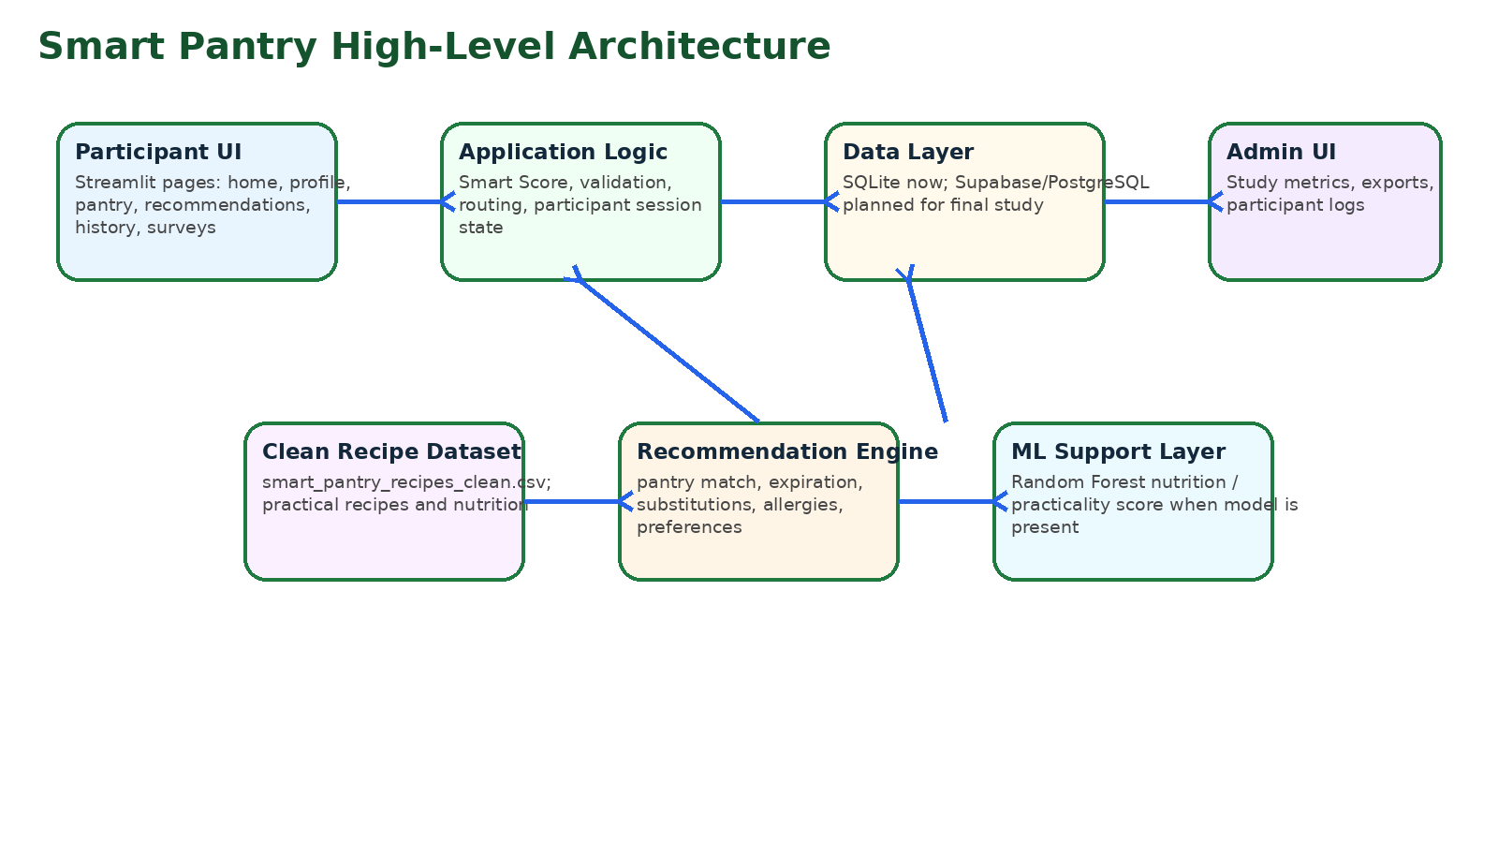
Figure 1. High-level architecture diagram for Smart Pantry.
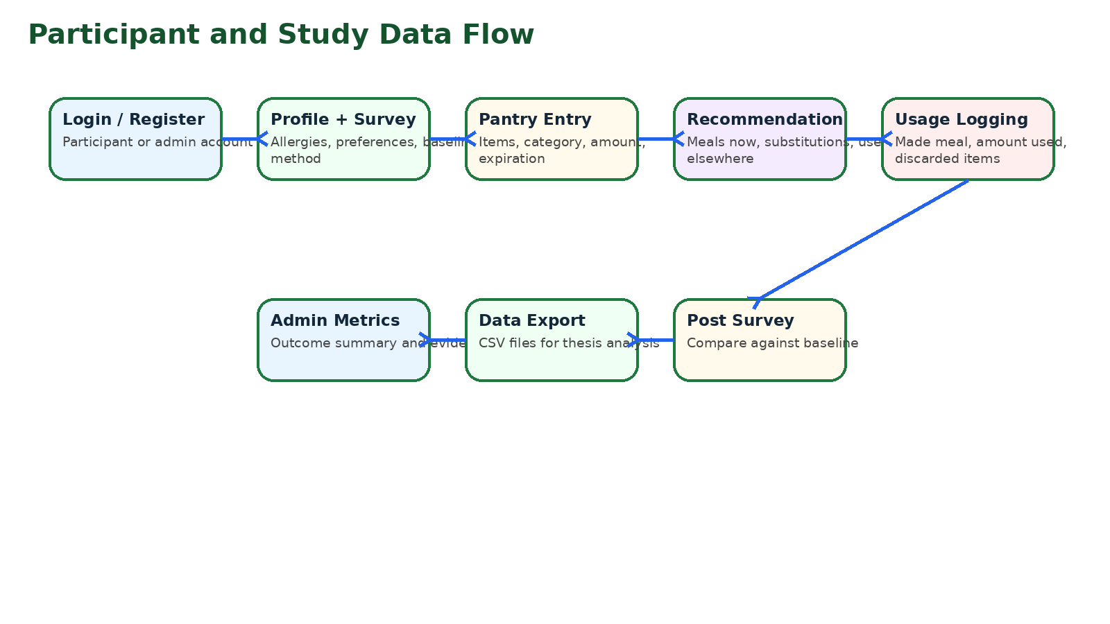
Figure 2. Participant and study data flow.
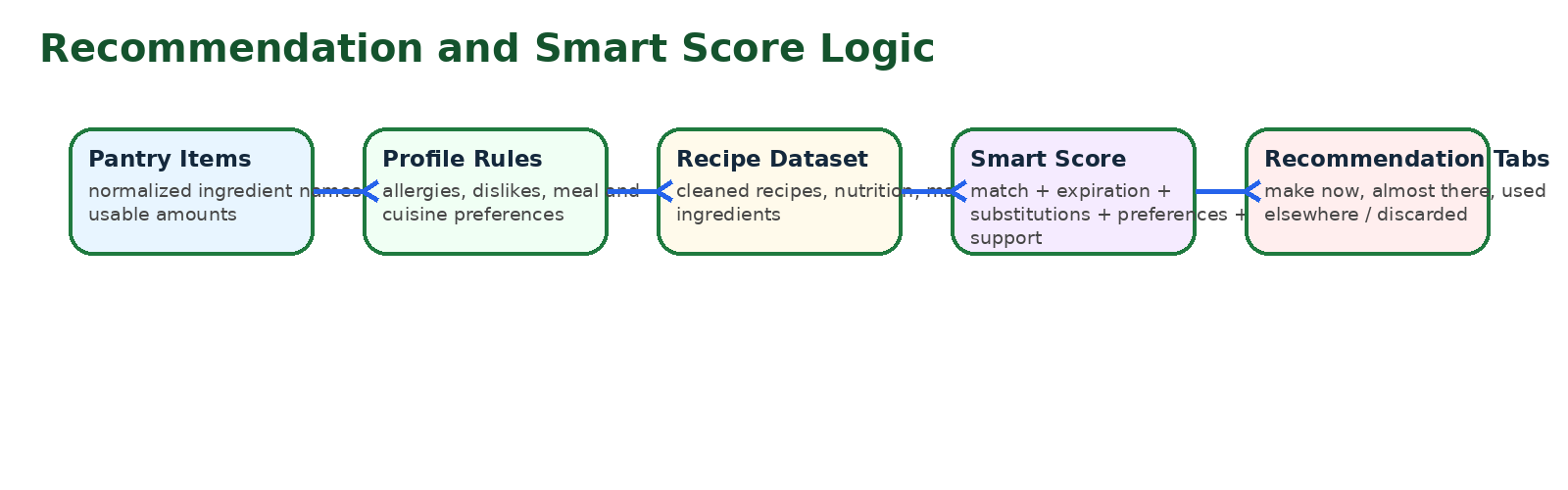
Figure 3. Recommendation and Smart Score flow.
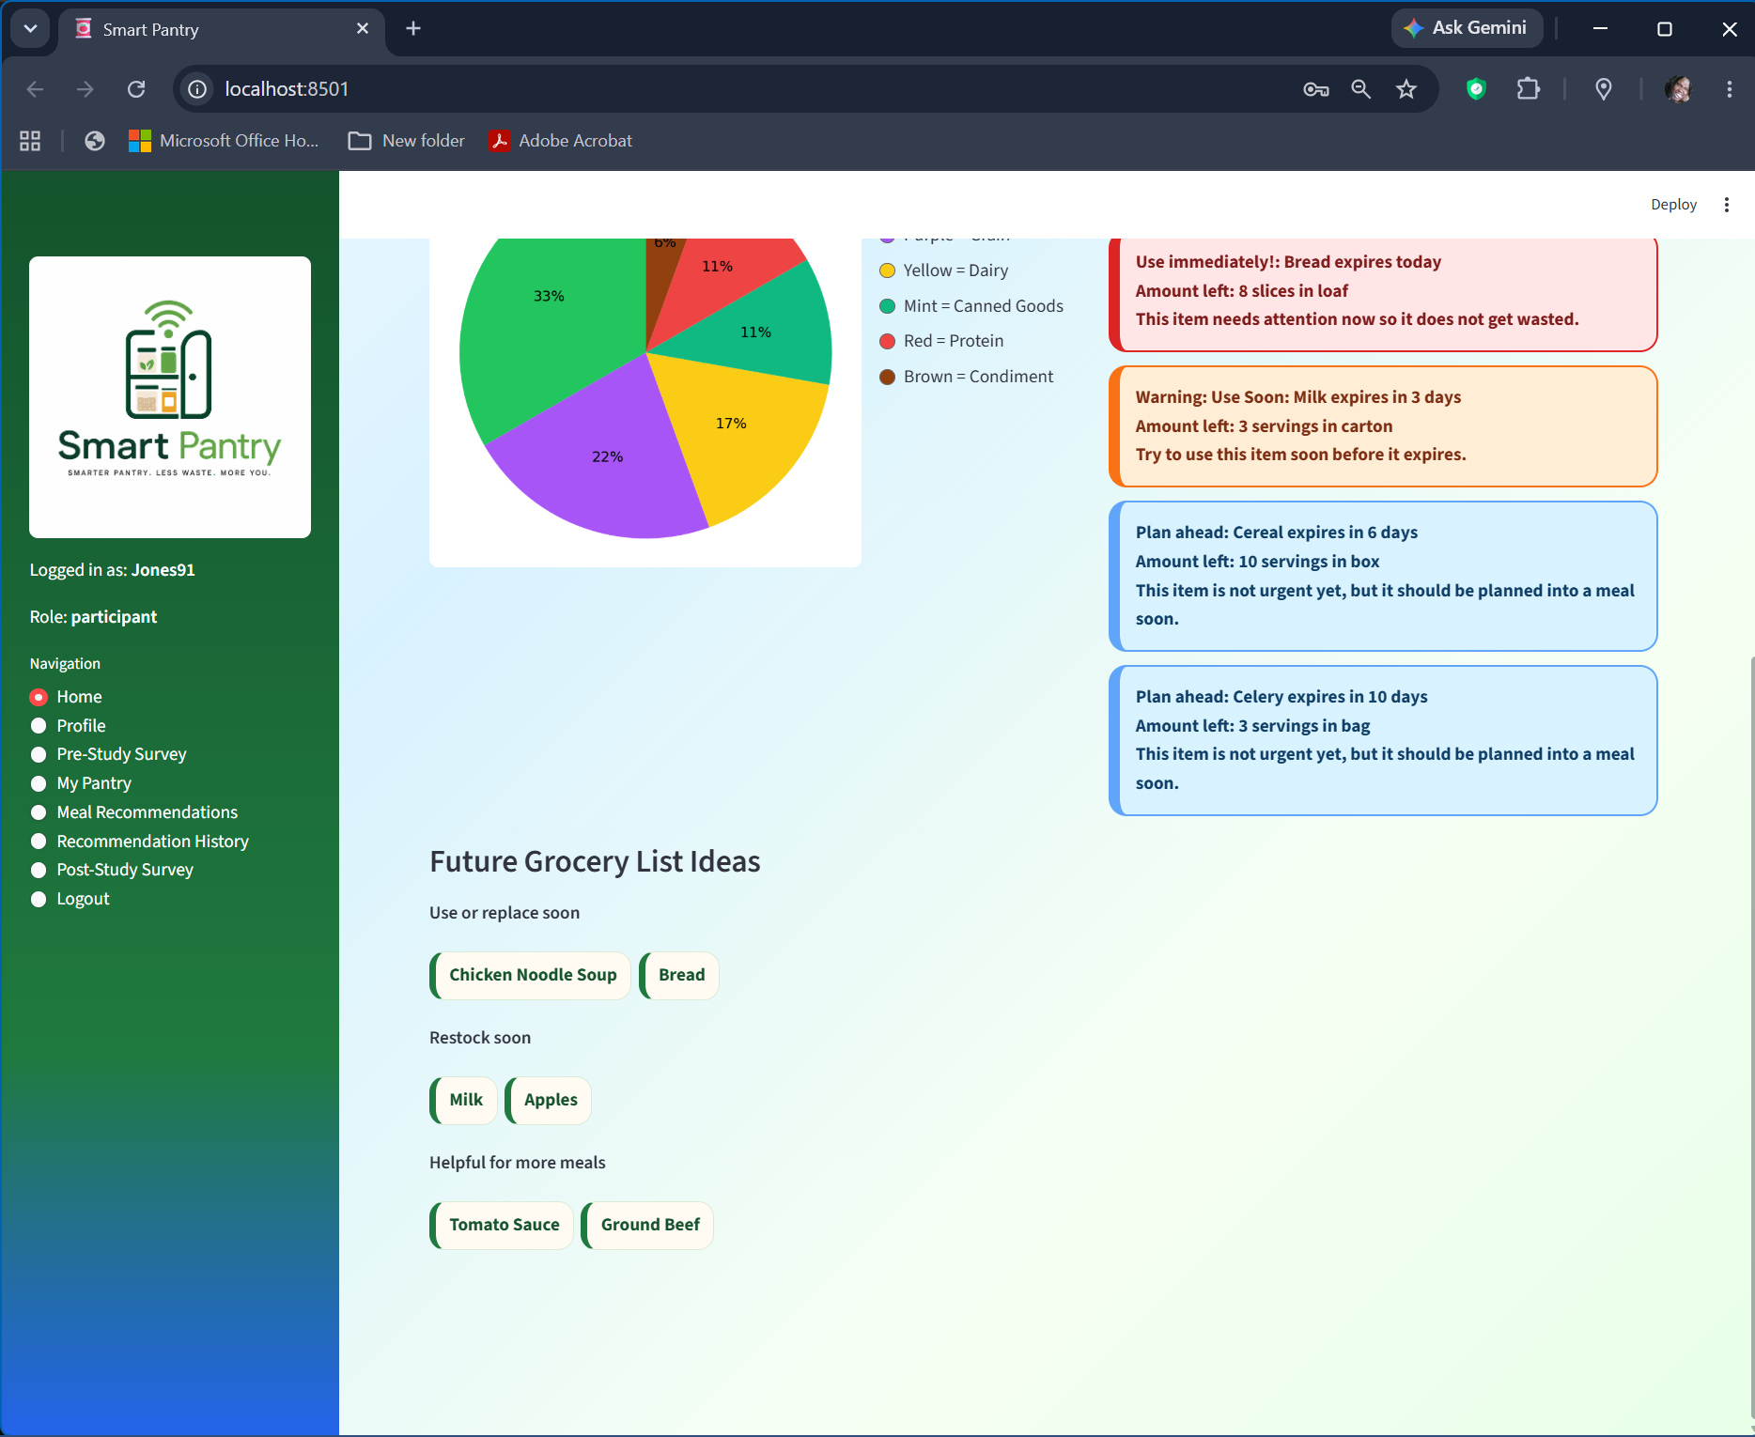
Figure 4. Current Smart Pantry interface screenshot showing the sidebar layout and participant dashboard styling.

5. Production Documentation

5.1 Feature List
Number | Feature | Category | Priority | Difficulty
F1 | Participant login and account creation | UI/System | High | Medium
F2 | Admin role and dashboard access | System | High | Medium
F3 | User-specific data separation by user_id | System | High | Hard
F4 | Profile preferences: allergies, dislikes, meal types, cuisines | UI/System | High | Medium
F5 | Pre-study survey with baseline and competitor questions | UI/Research | High | Medium
F6 | Post-study survey with comparison questions | UI/Research | High | Medium
F7 | Editable pantry table | UI/System | High | Hard
F8 | Pantry item add form with dataset-assisted dropdowns | UI/System | High | Medium
F9 | Category color key and pantry pie chart | UI/Analytics | Medium | Medium
F10 | Expiration alert system | System/UI | High | Medium
F11 | Future grocery list ideas | UI/System | Medium | Medium
F12 | Manual grocery list additions | UI | Medium | Easy
F13 | Cleaned recipe dataset integration | System | High | Hard
F14 | Recipe name cleaning and practical recipe filtering | System | High | Hard
F15 | Seasoning/staple ignore list | System | High | Medium
F16 | Pantry-to-recipe matching | System | High | Hard
F17 | Substitution matching | System | High | Medium
F18 | Allergy and disliked ingredient checking | System | High | Medium
F19 | Smart Score ranking | System | High | Hard
F20 | Random Forest ML support model | AI/ML | Medium | Hard
F21 | Meals You Can Make Now tab | UI/System | High | Medium
F22 | Possible Substitutions / Almost There tab | UI/System | High | Medium
F23 | Used Ingredients Elsewhere / Discarded tab | UI/System | High | Medium
F24 | Actual amount used deduction | System | High | Hard
F25 | Recommendation feedback collection | UI/Research | High | Medium
F26 | Recommendation history colored cards | UI | Medium | Medium
F27 | Admin Study Metrics | Analytics | High | Hard
F28 | Outcome Summary | Analytics | High | Medium
F29 | Usage and Recommendation Evidence | Analytics | High | Medium
F30 | CSV export support | Tool | Medium | Medium
F31 | SQLite local database | System | High | Medium
F32 | Supabase/PostgreSQL migration plan | System | Medium | Hard
F33 | Streamlit deployment plan | Tool | Medium | Medium
F34 | Cold-start setup documentation | Tool | High | Easy
F35 | V&V test plan | Documentation | High | Medium
F36 | Participant pilot workflow | Research | High | Medium
F37 | Dataset dropdown expansion | System/UI | Medium | Medium
F38 | Performance optimization / lazy loading | System | High | Hard
F39 | Admin-only detailed study data | System/Research | High | Medium
F40 | Future OCR/barcode grocery input plan | Future System | Low | Hard

5.2 Master Task List
Task | Description | Feature(s) | Dependencies
T1 | Set up project folder, virtual environment, and GitHub workflow | F34 | None
T2 | Implement login, registration, and role-based navigation | F1,F2 | T1
T3 | Create SQLite schema and database functions | F31 | T1
T4 | Add user_id separation across pantry, surveys, logs, and history | F3 | T2,T3
T5 | Build profile page for allergies, dislikes, meal/cuisine preferences | F4 | T2,T3
T6 | Build pre-study survey with baseline and app comparison questions | F5 | T3
T7 | Build post-study survey with comparison and usefulness questions | F6 | T3
T8 | Develop pantry add form and editable table | F7,F8 | T3,T4
T9 | Implement category colors and pantry pie chart | F9 | T8
T10 | Implement expiration alert logic | F10 | T8
T11 | Build future grocery list logic and manual additions | F11,F12 | T8,T10
T12 | Create recipe cleaning script and cleaned dataset | F13,F14,F15 | T1
T13 | Load cleaned dataset with caching and lazy loading | F13,F38 | T12
T14 | Develop ingredient normalization and pantry matching | F16 | T8,T13
T15 | Develop substitution logic | F17 | T14
T16 | Connect allergy/preference checks to recommendations | F18 | T5,T14
T17 | Create Smart Score calculation | F19 | T14,T15,T16
T18 | Train and connect Random Forest model | F20 | T12,T13
T19 | Build recommendation tabs and recipe cards | F21,F22,F23 | T17
T20 | Implement actual amount used deduction | F24 | T8,T19
T21 | Save recommendation feedback and usage logs | F25,F39 | T3,T19,T20
T22 | Create participant recommendation history cards | F26 | T21
T23 | Build admin raw data tables and exports | F30,F39 | T3,T21
T24 | Build Admin Study Metrics and Outcome Summary | F27,F28,F29 | T6,T7,T21,T23
T25 | Test multiple participant accounts and admin access | F3,F39 | T2-T24
T26 | Prepare Supabase schema and migration plan | F32 | T3,T25
T27 | Prepare Streamlit deployment checklist | F33 | T1,T25
T28 | Run pilot test with 3-5 users | F36 | T25
T29 | Fix pilot issues and update V&V results | F35,F36 | T28
T30 | Prepare final study launch checklist | F36 | T29

6. Development Roadmap
The roadmap is padded by about 10% to account for debugging, participant testing issues, dataset problems, and advisor feedback. Supabase is planned but intentionally not started until the local version is stable.
Milestone | Timeline | Tasks / Deliverables
Milestone 1 - Local Stability and Survey Readiness | Week 1 | Lock v28 working version, back up code, test participant/admin flow, confirm pre/post surveys, confirm user data separation, and verify cleaned dataset loads quickly. Buffer: 0.5 day.
Milestone 2 - Admin Metrics and V&V | Week 2 | Test Study Metrics, Outcome Summary, Usage and Recommendation Evidence, CSV exports, and V&V workflows. Fix survey mapping and formulas if any metric is unclear. Buffer: 1 day.
Milestone 3 - Pilot Test | Week 3 | Run pilot with 3-5 users using local or controlled access. Collect bug reports, confusion points, recommendation issues, and survey feedback. Buffer: 1 day.
Milestone 4 - Supabase Preparation | Week 4 | Design Supabase tables, map SQLite fields to PostgreSQL fields, draft RLS rules, and test a small migration. Do not move production data until local V&V passes. Buffer: 1 day.
Milestone 5 - Streamlit Deployment | Week 5 | Deploy with Streamlit, set secrets, connect Supabase, verify participant login, pantry persistence, recommendations, and admin metrics online. Buffer: 1-2 days.
Milestone 6 - Full Study Preparation | Week 6 | Finalize recruitment materials, participant instructions, consent/participation notes if required by course, and a clean demo script. Launch full participant study after pilot issues are fixed. Buffer: 1 day.

7. Verification and Validation (V&V)
Verification is developer-facing: it checks whether the feature functions according to the design. Validation is user-facing: it checks whether the feature actually helps the participant or researcher. The success criteria below avoid vague terms like “done” and can be tested during milestone screencasts and pilot testing.
Feature | Verification (developer-facing) | Validation (user/research-facing)
F1 Login / Register | A new participant account can be created and then used to log in without errors. Invalid passwords are rejected. | A participant can reach the home page without seeing admin credentials or technical setup text.
F2 Admin Dashboard | An admin account routes to Admin Dashboard and can access participant data tables. | The researcher can locate study records without using the database manually.
F3 User Data Separation | Two test users have different pantry, survey, and history records in the database by user_id. | User1 cannot see User2 pantry, surveys, or history. Admin can see both.
F4 Profile Preferences | Allergies, dislikes, meal types, and cuisine types save and reload from the profile table. | A participant can enter onion, mushrooms, or cuisine preferences and see recommendations adjust.
F5/F6 Surveys | Pre and post survey answers save with survey_type and response JSON/fields. | Participants understand the questions and can complete each survey without extra help.
F7 Editable Pantry Table | Edits to quantity, unit, category, and expiration date update the database row. | A participant can fix a mistaken date without deleting and re-entering the item.
F10 Expiration Alerts | Items with 0-1 days, 2-4 days, and 5-10 days produce the correct alert category. | Users can quickly tell which items need attention first.
F11 Grocery List Ideas | Items expiring within 5 days, low quantity staples, and helpful ingredients appear as item names only. | Users see a simple list that feels useful rather than cluttered.
F13 Clean Dataset | The app loads smart_pantry_recipes_clean.csv and does not load the large raw CSV during normal use. | Meal Recommendations loads fast enough for testing.
F16 Pantry Matching | A pantry containing bread, eggs, and cheese returns relevant recipes and ignores seasonings. | Recommendations feel connected to the pantry items entered.
F17 Substitutions | If a recipe calls for chicken and the pantry has shrimp, a substitution can be shown when configured. | The participant sees realistic alternatives instead of an empty recommendation page.
F18 Allergy Checks | Recipes containing allergy/disliked terms are flagged or ranked appropriately. | Participants feel the app respects health and preference information.
F19 Smart Score | Score changes when pantry match, expiration, substitution, preference, and ML support factors change. | Participants can understand why a meal is recommended.
F20 ML Support | If recommendation_model.pkl exists, get_ml_health_score returns a numeric support value; if missing, the app continues with explainable scoring. | The researcher can explain ML as a support layer without app failure.
F24 Quantity Deduction | Using 8 slices from 12 slices updates the pantry quantity to 4 slices. | Participants trust the pantry table after making a meal.
F25 Feedback | Feedback field accepts text and enforces the 250-word limit. | Participants can explain what they made or changed without writing too much.
F26 History Cards | Actions render with the expected color category: made meal, substitution, used elsewhere, discarded, saved, or feedback. | Participants can review activity without seeing raw research details.
F27 Study Metrics | Admin metrics calculate survey completion, improvements, acceptance rate, and utilization rate from stored data. | The researcher can use the dashboard to defend the project outcomes.
F30 CSV Export | Export buttons create downloadable CSVs from the admin data tables. | The researcher can move study data into a spreadsheet for analysis.
F32 Supabase Plan | Supabase tables and RLS approach are documented before migration begins. | The team can delay Supabase without blocking local testing.

8. Risk Areas and Backup Plans
Risk / Conflict | Solution / Backup Plan
Large dataset slows app | Use smart_pantry_recipes_clean.csv, lazy load recipes, limit recipe processing, and keep raw CSV out of deployment.
Recommendations feel strange | Clean recipe names, remove weird/unrealistic recipes, rank everyday meals higher, and test with sample pantry lists.
Machine learning is not strong enough | Keep Random Forest as support layer; Smart Score remains the primary explainable fallback.
Manual entry discourages users | Use common/dataset ingredient dropdowns, editable pantry table, and future grocery upload/OCR as future improvements.
Participant data mixes together | Use user_id filtering on every participant-facing database query; test with multiple accounts.
Supabase takes longer than expected | Continue local SQLite testing until the app is stable; migrate only after V&V and pilot testing.
Survey data does not answer hypothesis | Map every survey question to pantry awareness, recommendation usefulness, ingredient utilization, or baseline comparison.
Admin dashboard only shows raw logs | Include Study Metrics, Outcome Summary, acceptance rate, utilization rate, and pre/post changes.
Participants ignore feedback steps | Keep wording friendly and short; use simple buttons, dropdowns, and color-coded history.
Deployment issue before study | Maintain a stable local backup and a deployment checklist; test with 3-5 pilot users before full study.

9. References
[1] U.S. Department of Agriculture, "Food Loss and Waste," USDA. [Online]. Available: https://www.usda.gov/about-food/food-safety/food-loss-and-waste. [Accessed: May 1, 2026].
[2] U.S. Environmental Protection Agency, "Food Recovery Hierarchy," EPA. [Online]. Available: https://www.epa.gov/sustainable-management-food/food-recovery-hierarchy. [Accessed: May 1, 2026].
[3] Streamlit, "st.cache_data," Streamlit Documentation. [Online]. Available: https://docs.streamlit.io/develop/api-reference/caching-and-state/st.cache_data. [Accessed: May 24, 2026].
[4] Supabase, "Row Level Security," Supabase Documentation. [Online]. Available: https://supabase.com/docs/guides/database/postgres/row-level-security. [Accessed: May 24, 2026].
[5] SQLite, "SQLite Documentation." [Online]. Available: https://sqlite.org/docs.html. [Accessed: May 1, 2026].
[6] pandas, "pandas Documentation." [Online]. Available: https://pandas.pydata.org/docs/. [Accessed: May 1, 2026].
[7] scikit-learn Developers, "RandomForestRegressor," scikit-learn Documentation. [Online]. Available: https://scikit-learn.org/stable/modules/generated/sklearn.ensemble.RandomForestRegressor.html. [Accessed: May 1, 2026].
[8] SuperCook, "Recipe Search by Ingredients." [Online]. Available: https://www.supercook.com/. [Accessed: May 1, 2026].
[9] Samsung Food, "Samsung Food." [Online]. Available: https://food.samsung.com/. [Accessed: May 1, 2026].
[10] Python Software Foundation, "sqlite3 - DB-API 2.0 interface for SQLite databases," Python Documentation. [Online]. Available: https://docs.python.org/3/library/sqlite3.html. [Accessed: May 1, 2026].
[11] Streamlit, "Caching overview," Streamlit Documentation. [Online]. Available: https://docs.streamlit.io/develop/concepts/architecture/caching. [Accessed: May 1, 2026].

