1: Passengers Who Traveled on Routes 1 to 25

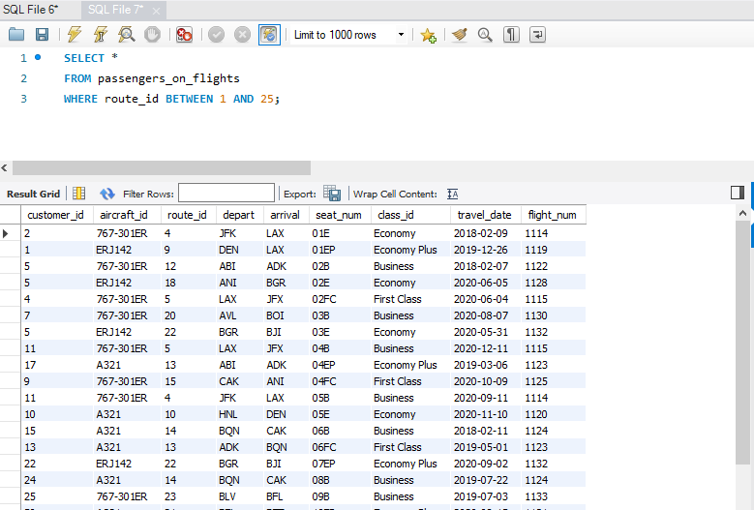

2. Business class passenger count + revenue

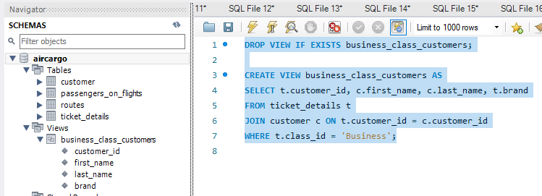

3 Display full name from customer

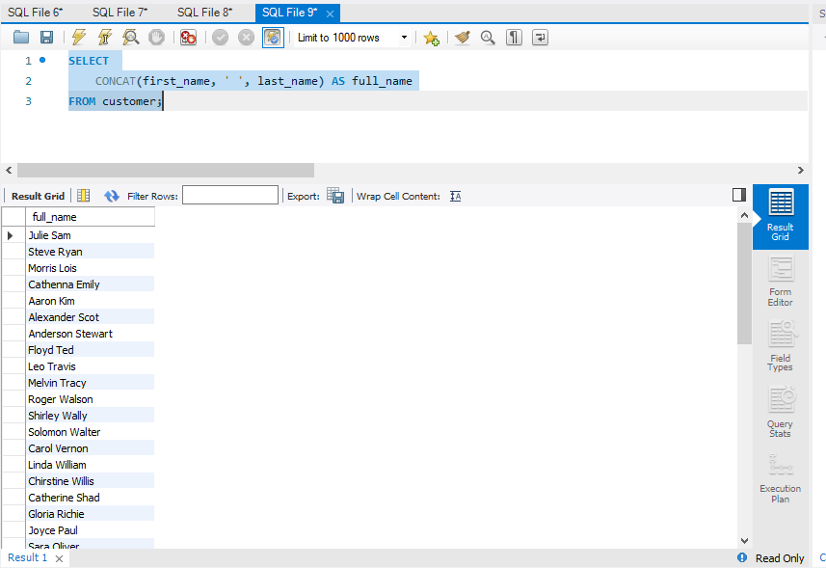

4 Customers who registered and booked tickets

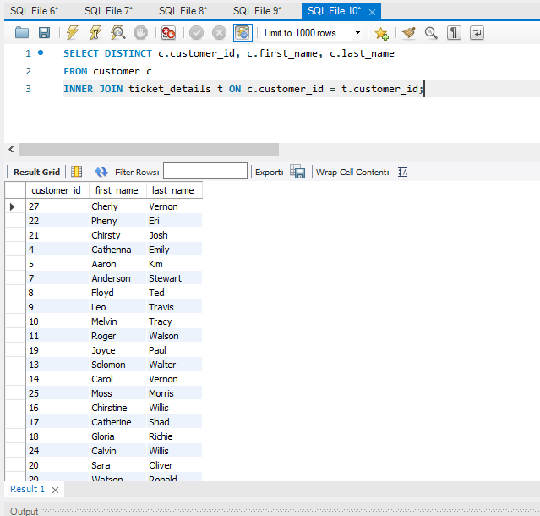

5 Customer name by brand ‘Emirates’

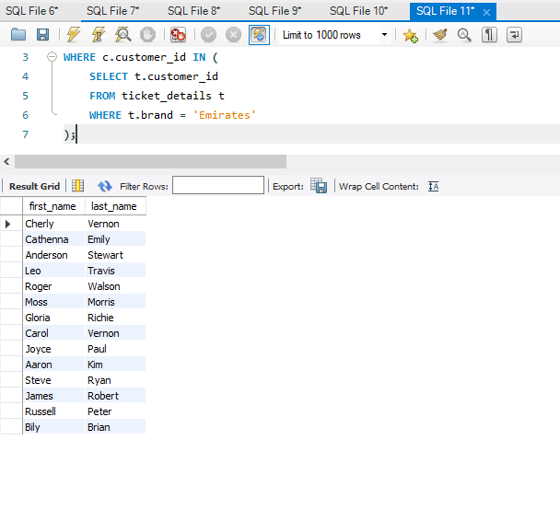

6 Customers who traveled by Economy Plus (subquery)

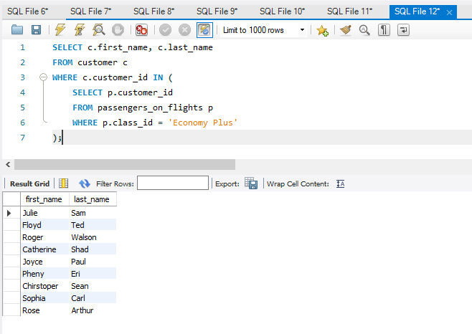

7 Check if revenue > 10000 using IF clause

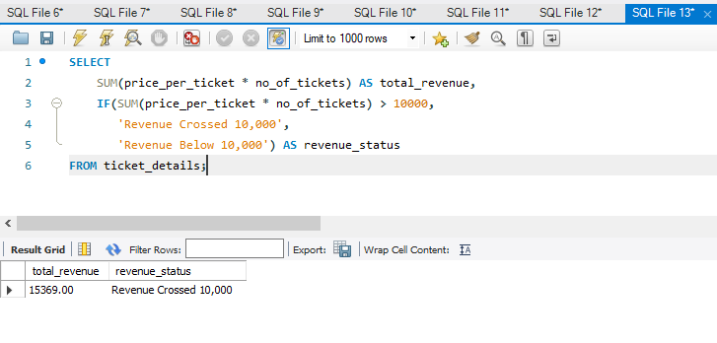

8 Create & grant access to new user

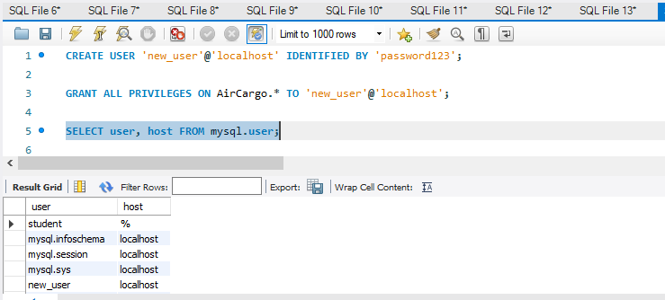

9 Max ticket price per class (window function)

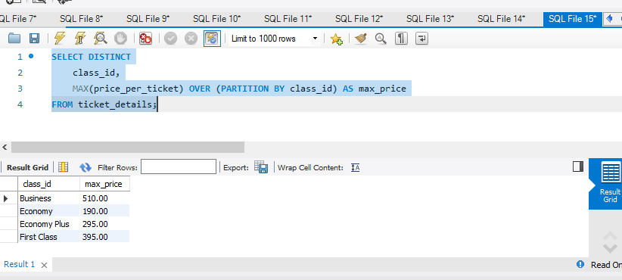

10 Improve performance for route 4 (index)

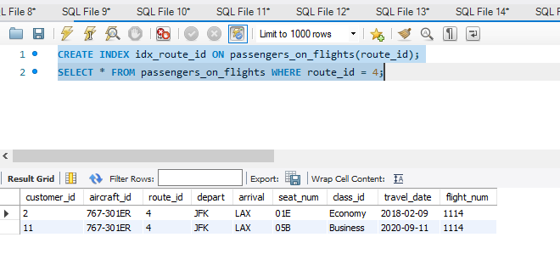

11 View execution plan for route 4

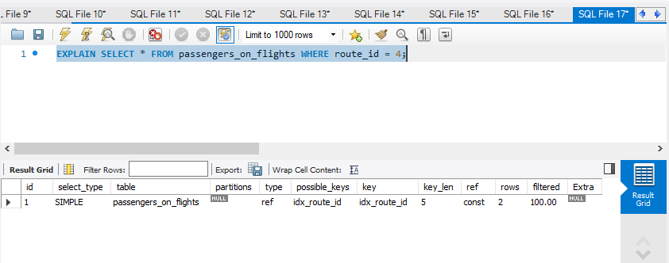

12 Total ticket price per customer/aircraft (ROLLUP)

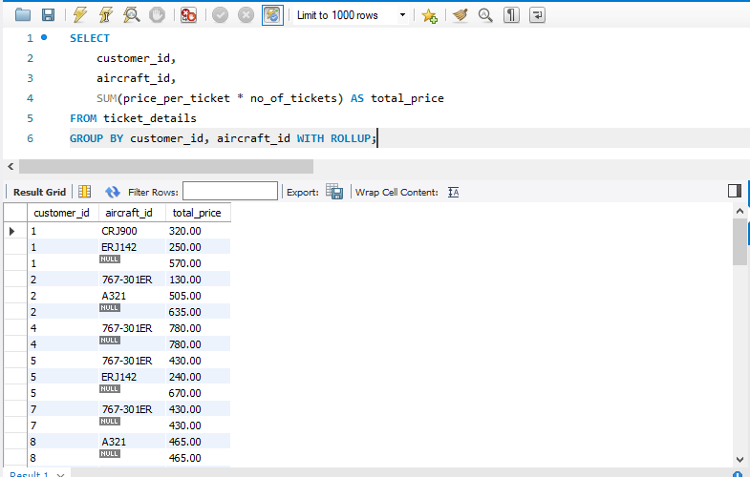

13 Create a view for business class customers



14 Stored procedure for routes > 2000 miles

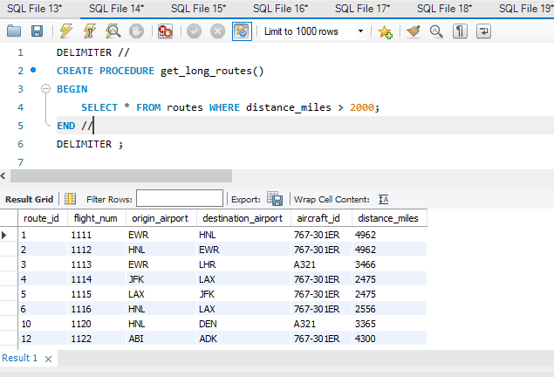

15 Total tickets and price paid by each customer

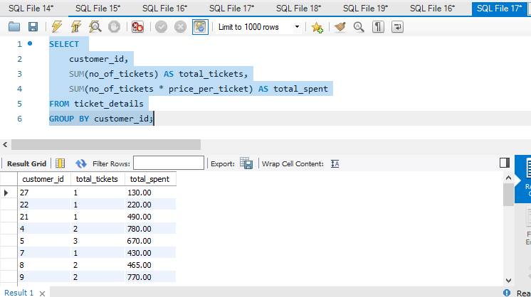

16 Average passengers per route

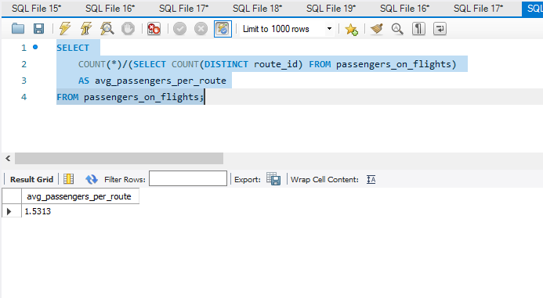

17 Create tables

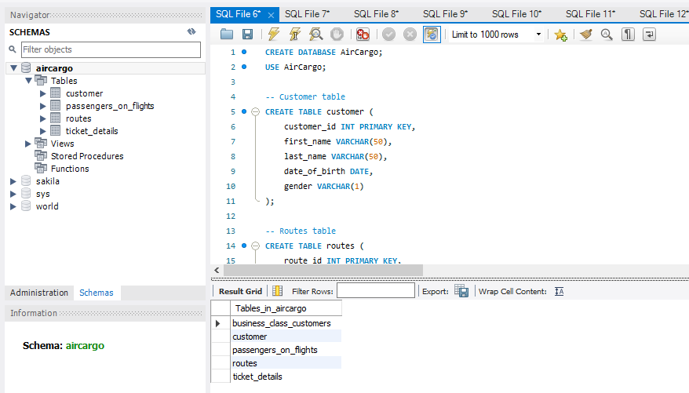

18 ER Diagram

