Blood Network

Florin Gabriel Barbuceanu

Patricia Carla Petrut

CTI-en 4th year, UPT

Introduction

Blood Network is a mobile application for Android 6 that is meant to help the people in critical need of blood. Once installed, the user can view the centers for blood donation sorted by priority or by proximity, also he has an up to date history of his donations and a countdown until he can donate again.

We choose this project because we wanted an app to help the people and maybe make them more eager to donate. If you have 2 hours to loose and you get informed by the app that there is a donation center nearby, why not donate?

Design and Implementation

The application is implemented using AndroidStudio, for API 23.

To sign up, the user has to provide his email, create a password, name, address, blood type and weight in kilograms.

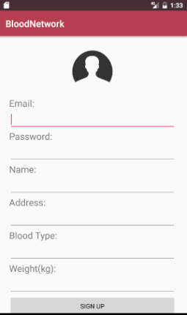

Once he has an account, he can always sign in with his email and password and he will only see information related to his blood type.

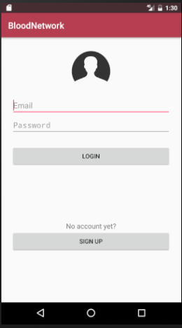

In the application, the user can see a menu where he can choose between the nearest centers, critical need centers or his donations’ history. At all times, the user is informed of how many days are remaining until he can donate again (based on the amount of donated blood and his weight).