DOCUMENTATION

ASSIGNMENT 2

STUDENT NAME: DANCI PATRICIA-IOANA
GROUP: 30424

CONTENTS

1. Assignment Objective 3
2. Problem Analysis, Modeling, Scenarios, Use Cases 3
3. Design 3
4. Implementation 3
5. Results 3
6. Conclusions 3
7. Bibliography 3

Assignment Objective
The Queues Management Application is designed to efficiently assign clients to queues in order to minimize their waiting time. It simulates a series of clients arriving for service, entering queues, waiting, being served, and finally leaving the queues. The application tracks the total time spent by each client in the queues and computes the average waiting time.

In order to achieve such functionality, the following must be addressed:

- Analyze and identify requirements
- Design the application itself
- Implement the simulator
- Test the application

Problem Analysis, Modeling, Scenarios, Use Cases

Functional requirements:

- The application should allow simulation setup by the insertion of number of clients, number of queues, simulation interval, arrival timing interval and service timing interval
- The application should allow choice of strategy
- The application should allow simulation starting
- The application should display the simulation of the queues in real-time

Non-functional requirements:

- The application should be intuitive and easy to use by the user

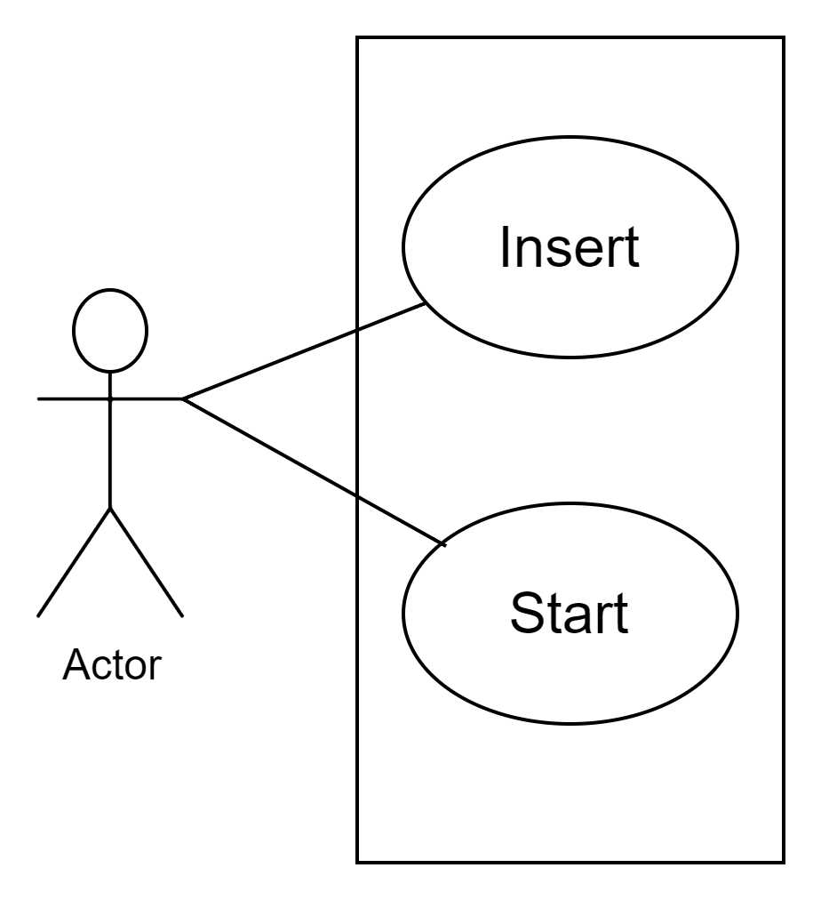
Furthermore, based on these functional requirements, I will provide a use case diagram where the actor is being represented by the user, who interacts with the queue management application. The use cases in this diagram are given by the setup of the simulation (insert of: clients, queues, simulation interval, min arrival time, max arrival time, min service time, max service time, as well as choice between QUEUE/TIME strategy) and the start functionality (START button that starts the real-time simulation

- Use Case: Insert
- Primary Actor: user
- Main Success Scenario:

- The user is able to insert the values for no of clients, no of queues, simulation interval, min arrival time, max arrival time, min service time, max service time, as well as choose an option for strategy
- The user clicks “start”
- The application validates the data by checking if the no of queues and clients is greater than 0, as well as if the time intervals are correctly denoted

- Alternative Sequence:

- The user insert values that are invalid
- A pop-up window appears with the corresponding message based on which parameter is incorrect
- The user does not choose a strategy
- A pop-up window appears telling the user to choose a strategy

- Use Case: Start
- Primary Actor: user
- Main Success Scenario:

- The inserted values are correct and therefore the application starts, displaying the real-time simulation of the queues’ content

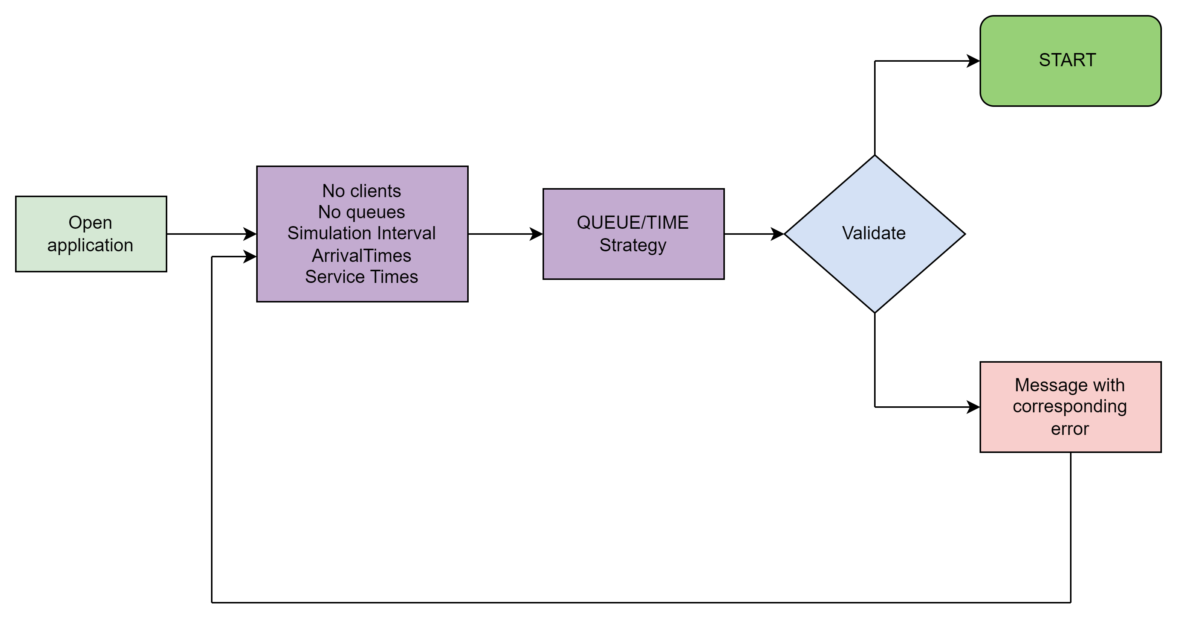

Design

The class design of the Queue Management Applcation compresses 3 main components denoted as packages: The GUI package handles the graphical user interface, including user input and output. It contains the UI class, which creates the main window and manages user interactions. The BusinessLogic package contains the core logic of the simulation. The classes manage the simulation process, client generation, queue management, and strategy selection. The Model package defines the data model of the application. The classes here encapsulate data and behavior related to clients and queues, ensuring a separation of concerns between data representation and application logic. Together, these packages provide a structured and modular design for the simulation application.

Conceptual Architecture:

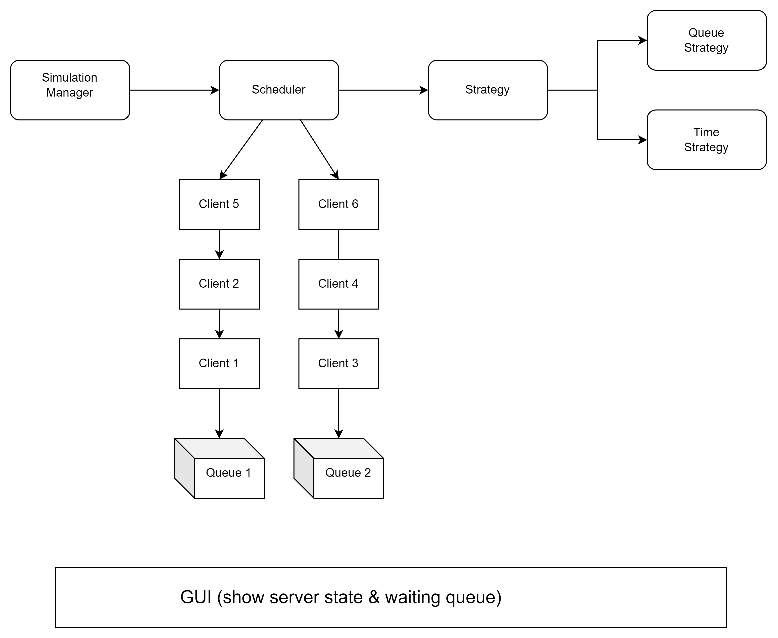

Division into sub-systems/packages:

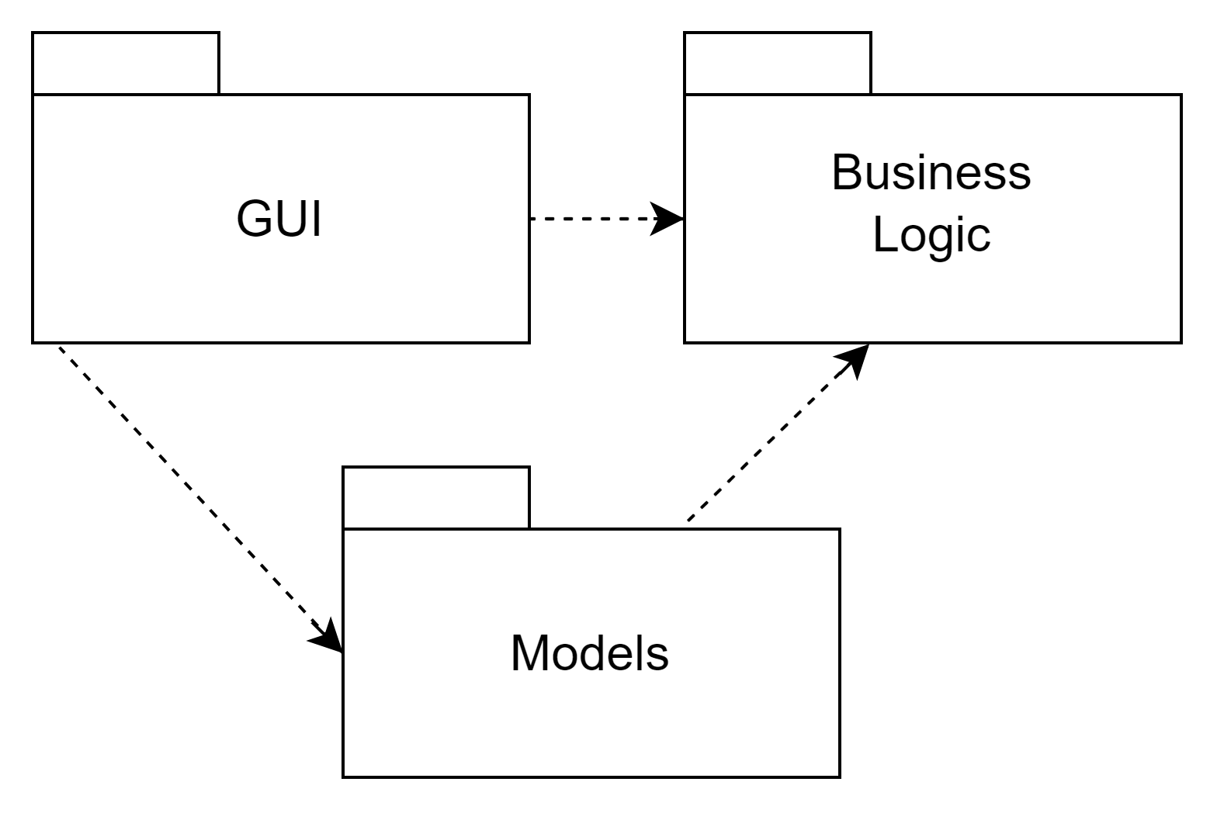

The GUI package contains class UI that embodies the essence of user interaction. This class defines the interface elements, such as buttons, text fields and text labels, each positioned to enhance the user experience. Moreover, this package seamlessly integrates Action Listeners, dynamically responding to users’ selections of mathematical operations.

The BusinessLogic package contains classes responsible for the core logic of the simulation. The SimulationManager class orchestrates the simulation process, including client generation, queue management, and strategy selection. TimeStrategy and QueueStrategy are implementations of the Strategy interface, providing different strategies for adding clients to queues based on waiting times or queue lengths. The Scheduler class manages the queues and dispatches clients according to the selected strategy. These classes work together to simulate the behavior of a queue management system.

The Model package encapsulates the fundamental data structures used in the simulation. The Client class represents individual clients with attributes such as ID, arrival time, and service time. The Queue class models the queues where clients wait for service, tracking the clients in the queue and calculating service and waiting periods. These classes form the backbone of the simulation by providing the necessary entities and structures to simulate client interactions within the system.

Data Structure Identification:

- ArrayList: Used in SimulationManager and Scheduler classes to store the list of waiting clients and queues, respectively. It provides dynamic resizing and efficient random access.

- BlockingQueue (LinkedBlockingQueue): Utilized in the Queue class to manage the clients waiting in the queue. It ensures thread-safety for concurrent access by multiple threads.

- AtomicInteger: Employed in the Queue class to maintain the service and waiting periods. Atomic integers provide atomic operations to ensure thread safety in concurrent environments.

UML Class Diagram:

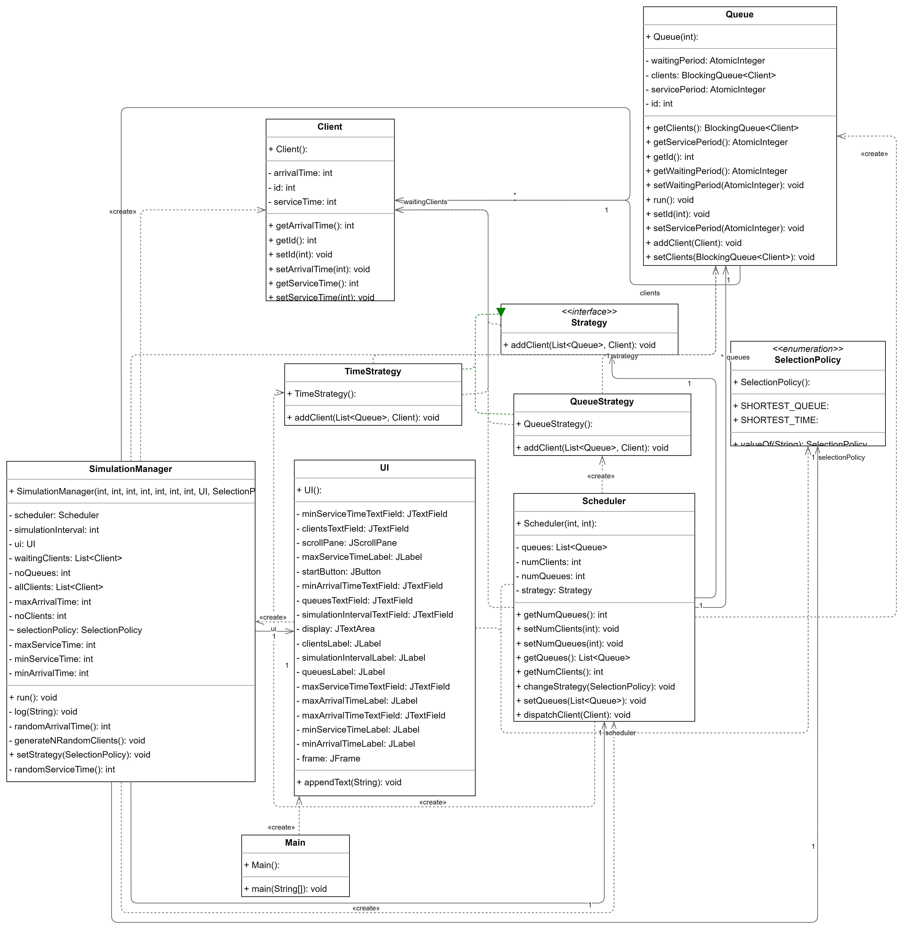

Implementation

- Model Package: Client and Queue

The Client Class defines the characteristics of a client in the system, including arrival time and service time. It provides methods to get and set these attributes. Structure fields include client ID, arrival time, and service time. Key methods are getId(), getArrivalTime(), and getServiceTime() for accessing client attributes.
The Queue Class represents a queue in the system where clients wait for service. It manages the clients in a thread-safe manner and simulates client service times. This class implements the Runnable interface, as its instances are executed by a thread. Structure fields include a BlockingQueue to hold clients and AtomicInteger for service and waiting periods.

- Run() method simulates the client service process within the queue. It continuously checks for clients in the queue and reduces their service time by one unit in each iteration, simulating the passage of time. If a client's service time reaches zero, indicating completion of service, the client is removed from the queue

@Override
public void run() {
while (true) {
if (!clients.isEmpty()) {
Client client = clients.peek();
try {
Thread.sleep(1000);
client.setServiceTime(client.getServiceTime() - 1);
//waitingPeriod.getAndAdd(-1);
if (client.getServiceTime() == 0) {
clients.remove(client);
}
} catch (InterruptedException e) {
e.printStackTrace();
}
}
}
}

- addClient() method adds a new client to the queue while updating the service and waiting period accordingly; the service period is computed by adding the service time of each client that enters the queue, whereas the waiting period represents how long s client has to wait in order to get in front of the queue; in order to achieve such functionality, we iterate through each client that is already in the queue and add their service time

public void addClient(Client newClient) {
for(Client client : clients) {
waitingPeriod.getAndAdd(client.getServiceTime());
}
clients.add(newClient);
servicePeriod.getAndAdd(newClient.getServiceTime());
//waitingPeriod.getAndAdd(servicePeriod.get() - newClient.getServiceTime());
}

- Business Logic Package: SimulationManager, Scheduler, Strategy, TimeStrategy, QueueStrategy

The SimulationManager Class orchestrates the simulation process. It generates random clients, dispatches them to queues based on a selected strategy, and logs simulation details. This class also implements the Runnable interface, as its instances are executed by a thread. Structure fields include parameters for simulation setup and lists to store clients and queues.

- Run() method iterates over the simulation time interval, handling the arrival of clients, dispatching them to queues and updating the simulation state; additionally, it logs the status of waiting clients and queues at each step; this method also calculates metrics such as peak hour (given by the time when the queues are the most busy), and average waiting/serving time, in order to get insights into the simulation’s performance

@Override
public void run() {
log("-----------------");
log("Simulation started.");
int peakHour = 0;
int maxClients = 0;
for (int currentTime = 0; currentTime <= simulationInterval; currentTime++) {
List<Client> arrivedClients = new ArrayList<>();
for (int i = 0; i < waitingClients.size(); i++) {
Client client = waitingClients.get(i);
if (client.getArrivalTime() == currentTime) {
arrivedClients.add(client);
waitingClients.remove(i);
i--;
}
}
for (Client client : arrivedClients) {
scheduler.dispatchClient(client);
}
int totalClients = 0;
for (Queue queue : scheduler.getQueues()) {
totalClients += queue.getClients().size();
}
if (totalClients > maxClients) {
// I have considered the peak hour as in the time when the number of clients in the queues is maximum
maxClients = totalClients;
peakHour = currentTime;
}
boolean allQueuesEmpty = true; // Here, we check to see if there is at least one queue with clients at it
for (Queue queue : scheduler.getQueues()) {
if (!queue.getClients().isEmpty()) {
allQueuesEmpty = false;
break;
}
}
if (waitingClients.isEmpty() && allQueuesEmpty) {
break; // We exit the loop if no more waiting clients and all queues are empty
}
StringBuilder stringBuilder = new StringBuilder("Time " + currentTime);
stringBuilder.append('\n');
stringBuilder.append("Waiting clients: ");
for (Client client : waitingClients) {
stringBuilder.append("(").append(client.getId()).append(", ").append(client.getArrivalTime()).append(", ").append(client.getServiceTime()).append(") ");
}
stringBuilder.append('\n');
for (Queue queue : scheduler.getQueues()) {
stringBuilder.append("Queue").append(queue.getId()).append(": ");
if (queue.getClients().isEmpty()) {
stringBuilder.append("closed");
} else {
for (Client client : queue.getClients()) {
stringBuilder.append("(").append(client.getId()).append(", ").append(client.getArrivalTime()).append(", ").append(client.getServiceTime()).append(") ");
}
}
stringBuilder.append('\n');
}
stringBuilder.append('\n');
log(stringBuilder.toString());
try {
Thread.sleep(1000);
} catch (InterruptedException e) {
e.printStackTrace();
}
}
log("Simulation ended.");
double totalServiceTime = 0.0;
for (Queue queue : scheduler.getQueues()) {
totalServiceTime += queue.getServicePeriod().intValue();
}
double averageServiceTime = totalServiceTime / noClients;
log("Average serving time: " + averageServiceTime);
double totalWaitingTime = 0.0;
for(Queue queue : scheduler.getQueues()) {
totalWaitingTime += queue.getWaitingPeriod().intValue();
}
double averageWaitingTime = totalWaitingTime / noClients;
if(averageWaitingTime < 0) {
averageWaitingTime = 0.0;
}
log("Average waiting time: " + averageWaitingTime);
log("Peak hour: " + peakHour);
}

- generateNRandomClients() method creates a specified number of clients with random arrival and service time, initializing the client object with unique IDs; the clients are added to the waiting clients list, since the assignment requirements states that all clients are generated at the start of the simulation

private void generateNRandomClients() {
for (int i = 0; i < noClients; i++) {
int arrivalTime = randomArrivalTime();
int serviceTime = randomServiceTime();
Client client = new Client();
client.setId(i);
client.setArrivalTime(arrivalTime);
client.setServiceTime(serviceTime);
waitingClients.add(client);
allClients.add(client); //here, we store all clients to calculate the average waiting time
}
}

- log() method is responsible for appending messages to both the UI display and an external file for record-keeping

private void log(String message) {
ui.appendText(message);
try {
FileWriter writer = new FileWriter("simulation_output_tests.txt", true);
writer.write(message + "\n");
writer.close();
} catch (IOException e) {
e.printStackTrace();
}
}

The Scheduler Class manages multiple queues and dispatches clients to them based on a selected strategy. Structure fields include lists of queues and parameters for the number of queues and clients, as well as an instance of Interface Strategy

- dispatchClient(Client client) method manages the allocation of clients to queues, ensuring efficient distribution of workload; this method plays a pivotal role in maintaining the balance and performance of the system by optimizing resource utilization and minimizing waiting times

public void dispatchClient(Client client) {
strategy.addClient(queues, client);
}

The Strategy Interface serves as a blueprint for strategy classes to follow, ensuring that they provide a consistent method signature for adding clients to queues

public void addClient(List<Queue> queues, Client client);

The TimeStrategy Class implements a strategy to dispatch clients to the queue with the shortest waiting time; it first stores the first queue in a variable and then it iterates through the rest of the queues in order to find the one with the shortest ServicePeriod, meaning the queue at whose front the client will arrive the fastest

- addClient() method determines the queue with the shortest total service time and assigns a new client to it

@Override
public void addClient(List<Queue> queues, Client client) {
Queue shortestQueue = queues.get(0);
double shortestWaitingTime = shortestQueue.getServicePeriod().intValue();
for (Queue queue : queues) {
if (queue.getServicePeriod().intValue() < shortestWaitingTime) {
shortestQueue = queue;
shortestWaitingTime = queue.getServicePeriod().intValue();
}
}
shortestQueue.addClient(client);
}
The QueueStrategy Class implements a strategy to dispatch clients to the shortest queue; It does not take into account the amount of time a client will have to wait in that specific queue, but the length of the queue itself

@Override
public void addClient(List<Queue> queues, Client client) {
Queue leastBusyQueue = queues.get(0);
int leastBusySize = leastBusyQueue.getClients().size();
for (Queue queue : queues) {
if (queue.getClients().size() < leastBusySize) {
leastBusyQueue = queue;
leastBusySize = queue.getClients().size();
}
}
leastBusyQueue.addClient(client);
}

- GUI Package: UI

The UI Class manages the user interface of the Queue Management Application. It provides a graphical interface for users to input parameters and visualize the simulation process. The structure fields include various Swing components such as labels, text fields, buttons, and text areas. Overall, this class ensures the retrieval of data inserted by the user, as well as validation of that data based on conditions such as number of clients/queues > 0 and max arrival/service time > min arrival/service time; in case these conditions are not met, a message is displayed stating the error; additionally, this class provides the user with two buttons appended to a label “Strategy”, so that the user can choose which simulation strategy they wish to implement: QUEUE or TIME; if neither button is pressed, the simulation does not start and a message is displayed.

- appendText() method adds text to the display area, allowing dynamic updates of simulation information; it ensures that new messages are displayed at the bottom of the text area, maintaining readability and providing real-time feedback to the user

public void appendText(String text) {
display.append(text + "\n");
display.setCaretPosition(display.getDocument().getLength());
}

- The queueButton ActionListener sets the simulation strategy to "Shortest Queue" when the "QUEUE" button is clicked. It updates the simulation strategy to prioritize the shortest queue for client dispatching.

queueButton.addActionListener(new ActionListener() {
@Override
public void actionPerformed(ActionEvent e) {
SimulationManager.setStrategy(SelectionPolicy.SHORTEST_QUEUE);
}
});

- The timeButton ActionListener sets the simulation strategy to "Shortest Time" when the "TIME" button is clicked. It updates the simulation strategy to prioritize the shortest service time for client dispatching.

timeButton.addActionListener(new ActionListener() {
@Override
public void actionPerformed(ActionEvent e) {
SimulationManager.setStrategy(SelectionPolicy.SHORTEST_TIME);
}
});

- The startButton ActionListener initiates the simulation process when the "Start" button is clicked. It reads the input values from the text fields (number of clients, queues, etc.), performs input validation to ensure correctness, and starts the simulation with the specified parameters. If any input is invalid (e.g., non-positive values, invalid time ranges), it displays an error message using a JOptionPane.

startButton.addActionListener(new ActionListener() {
@Override
public void actionPerformed(ActionEvent e) {
int clients = Integer.parseInt(clientsTextField.getText());
int queues = Integer.parseInt(queuesTextField.getText());
int simulationInterval = Integer.parseInt(simulationIntervalTextField.getText());
int minArrivalTime = Integer.parseInt(minArrivalTimeTextField.getText());
int maxArrivalTime = Integer.parseInt(maxArrivalTimeTextField.getText());
int minServiceTime = Integer.parseInt(minServiceTimeTextField.getText());
int maxServiceTime = Integer.parseInt(maxServiceTimeTextField.getText());
// Check for invalid inputs
if (clients <= 0 || queues <= 0) {
JOptionPane.showMessageDialog(frame, "Number of clients and queues must be greater than 0", "Invalid Inputs", JOptionPane.ERROR_MESSAGE);
return;
}
if (maxArrivalTime <= minArrivalTime) {
JOptionPane.showMessageDialog(frame, "Max arrival time must be greater than min arrival time", "Invalid Inputs", JOptionPane.ERROR_MESSAGE);
return;
}
if (maxServiceTime <= minServiceTime) {
JOptionPane.showMessageDialog(frame, "Max service time must be greater than min service time", "Invalid Inputs", JOptionPane.ERROR_MESSAGE);
return;
}
// Check if a strategy is selected
if (SimulationManager.selectionPolicy == null) {
JOptionPane.showMessageDialog(frame, "Choose a strategy", "Invalid Inputs", JOptionPane.ERROR_MESSAGE);
return;
}
SimulationManager simulationManager = new SimulationManager(queues, clients, simulationInterval, minArrivalTime, maxArrivalTime, minServiceTime, maxServiceTime, UI.this, SimulationManager.selectionPolicy);
Thread thread = new Thread(simulationManager);
thread.start();
}
});

Results
The tests for this application have been run over the following sets of input data:

Test1:
No. of clients: 4
No. of queues: 2
Simulation Interval: 60
Arrival Time Interval: [2,30]
Service Time Interval: [2,4]

Test2:
No. of clients: 50
No. of queues: 5
Simulation Interval: 60
Arrival Time Interval: [2,40]
Service Time Interval: [1,7]

Test3:
No. of clients: 1000
No. of queues: 20
Simulation Interval: 200
Arrival Time Interval: [10,100]
Service Time Interval: [3,9]

The Results can be viewed inside the simulation_output.txt file

Conclusions

In conclusion, in this assignment I have gained a deeper understanding of developing a simulation application in a multi-thread environment using Object-Oriented Porgramming in Java. I've learned about structuring code into packages for better organization, implementing graphical user interfaces with Swing, and utilizing multi-threading for concurrent processing. Additionally, I've explored concepts such as strategy patterns for dynamic behavior and input validation for ensuring data integrity.

As for future developments, I could enhance the application by implementing more sophisticated scheduling algorithms and improve error handling. Furthermore, I could explore integrating the application with database systems for data storage.

Some useful future developments could be:

- Restricting the number of clients allowed per queue and opening a new queue when the ones that are currently open reach their limit
- Open queues only when necessary, instead of retrieving a number of queues as parameter
- Design a more efficient algorithm for cases when more then one client arrives at the same time by taking into account all their service times and dispatching them to the most suitable queue instead of dispatching clients simply by the order or their arrival -> this could also be done by sorting the clients based on their service time

Bibliography

https://docs.oracle.com/javase/tutorial/essential/concurrency/runthread.html
https://docs.oracle.com/javase/tutorial/essential/concurrency/sleep.html
https://dsrl.eu/courses/pt/materials/PT_2024_A2_S2.pdf
https://docs.oracle.com/javase/8/docs/api/java/util/concurrent/BlockingQueue.html
https://docs.oracle.com/en/java/javase/17/docs/api/java.base/java/util/concurrent/atomic/AtomicInteger.html
https://www.geeksforgeeks.org/linkedblockingqueue-peek-method-in-java/
https://docs.oracle.com/javase%2F7%2Fdocs%2Fapi%2F%2F/java/lang/Runnable.html
https://stackoverflow.com/questions/541487/implements-runnable-vs-extends-thread-in-java
https://docs.oracle.com/javase%2Ftutorial%2Fuiswing%2F%2F/components/textarea.html
https://www.w3schools.com/java/java_files_create.asp
https://app.diagrams.net/

