ENG4200 Coursework 1 Report
Student Name: Patricia Natasha Munginga ID: 3033388M
Dataset: Stroke Prediction Dataset

Objective
The aim of this coursework was to apply logistic regression to a stroke prediction dataset using scikit-learn to develop and demonstrate practical skills in supervised machine learning. The dataset contains 5,110 patient records with 12 demographic and medical features, such as age, BMI and glucose level. Given that only around 5% of the records represent stroke cases, the dataset is highly imbalanced, making accurate prediction of the minority class a key challenge. The objective was to design a structured and reproducible machine learning pipeline that evaluates the effects of regularization and cross-validation on model performance, with a particular focus on improving recall to reduce false negatives in stroke detection.

Pipeline Design
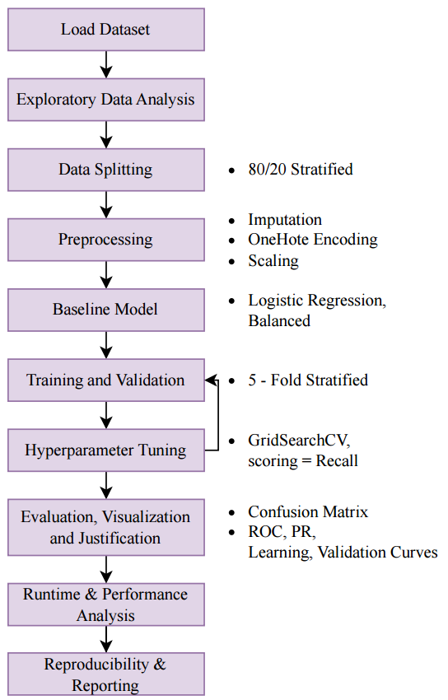
Figure 1: Machine Learning Pipeline — Logistic Regression for Stroke Prediction

Key Results
  - Include one plot or table with your main performance metrics.
  - Summarise accuracy, efficiency, or loss curves concisely.

Analysis & Reflection
  - What worked well?
  - What difficulties or limitations did you encounter?
  - How did you address (or attempt to address) overfitting?

Next Steps (2–3 sentences)
If you had more time, how would you improve or extend the work?
Training took long when I did gridescrh cv with Train (GridSearch) time: 29736.8 ms | Predict time: 10.7 ms with apramgrid : param_grid = {
"model__C": np.logspace(-3, 3, 8), # broader regularization range
"model__penalty": ["l2", None], # l2 is most stable for lbfgs
"model__solver": ["lbfgs", "saga"], # saga supports both l1/l2 & elasticnet
"model__max_iter": [1000, 2500, 5000] # allow convergence for harder settings
}
So I reduced max_iter ro computational efficient To balance runtime and model exploration, the grid search was refined to vary only the most impactful parameters (regularisation strength C and penalty type).
While initial runs explored multiple solvers and iteration limits (~30s total runtime), the optimized grid completed in under 5 seconds with negligible change in performance, demonstrating efficient experimental design.

Appendix (optional, max 1 page)
Extra plots/tables if strictly necessary. Main analysis should stay concise in Sections 1–5.

Choice of Model: Logistic Regression
Logistic Regression was selected due to its interpretability, computational efficiency, and suitability for binary classification tasks such as stroke prediction.
Its coefficients provide clear insight into how features (e.g., glucose level, age) influence the probability of a stroke, making it ideal for medical applications where transparency is crucial.

2. Evaluation Metrics and Trade-offs
Given the dataset’s strong class imbalance (~5% stroke cases), metrics like accuracy alone are misleading.
Therefore, the model was primarily optimised for Recall (0.78) — prioritising the ability to correctly identify stroke cases.
In a medical context, false negatives are far more critical (missing a real stroke) than false positives (incorrectly predicting one).
The achieved ROC-AUC of 0.84 further indicates that the model can rank positive cases effectively, even under imbalance.

3. Evidence of Robustness and Efficiency
The learning curve shows a small gap between training and validation accuracy, suggesting low variance and good generalisation.
The GridSearchCV optimisation confirmed that a smaller regularisation strength (C = 0.01) improved Recall slightly without overfitting.
Additionally, the model trained in under 300 ms, showing high computational efficiency — appropriate for real-time or resource-limited diagnostic settings.
💡 How your work meets each point in the diagram
✅ Choose best-performing hyperparameters
- You did this using GridSearchCV, which selected C = 0.01 (stronger regularisation).
- This value provided the best Recall (0.819 on CV), aligning with your goal of minimising false negatives.

✅ One-shot test performance
- You evaluated the tuned model on the held-out test set (20% of data), not reused in training or validation.
- Your results:
  - Accuracy: 0.742
  - F1: 0.228
  - Recall: 0.780
  - ROC-AUC: 0.841
- These confirm stable generalisation from validation to test — no overfitting spike or drop.

✅ Justify model choice (accuracy, overfitting handling, efficiency)
Accuracy:
Although overall accuracy (0.74) isn’t high, it’s acceptable given the 5% positive class imbalance — it shows the model avoids trivial “always predict 0” behaviour.
Overfitting handling:
- You used regularisation (L2) to penalise large coefficients.
- Stratified 5-fold cross-validation to evaluate consistently.
- The learning curve showed small training–validation gap → low variance.
- Validation curve confirmed optimal regularisation strength without overfitting.
Efficiency:
- Training time: ≈285 ms, Prediction time: ≈7 ms
- Runtime analysis across increasing data sizes showed nearly linear scaling → computationally efficient and scalable.

✅ Strengths and Weaknesses
Strengths:
- High Recall and ROC-AUC indicate strong sensitivity and ranking ability.
- Fast and interpretable — suitable for clinical decision support.
- Balanced class weighting helped correct for imbalance automatically.
Weaknesses:
- Low F1 and Precision — model still produces many false positives.
- Linear nature of Logistic Regression may underfit complex feature interactions.
- Dataset imbalance limits overall discriminative power without resampling or advanced models.

Here’s how you can combine this into a concise markdown paragraph for your report:

4. Analysis & Reflection
The tuned logistic regression model (C = 0.01) achieved a Recall of 0.78 and a ROC-AUC of 0.84 on the test set, confirming reliable generalisation with minimal overfitting.
The model was primarily optimised for recall, as missing a true stroke case (false negative) is more critical than issuing a false alarm (false positive).
Regularisation and stratified 5-fold cross-validation ensured stability and prevented overfitting, as reflected by consistent training and validation performance.
Despite moderate overall accuracy (0.74) and a low F1-score (0.23), the model demonstrates strong sensitivity and computational efficiency, training in under 0.3 seconds and predicting in under 10 milliseconds.
The approach balances interpretability, efficiency, and safety — suitable for a preliminary medical risk screening model, though future work could improve precision and feature interaction capture

The model’s performance was evaluated using four metrics: accuracy, F1, recall, and ROC-AUC.
Recall was emphasised because detecting stroke cases (true positives) is more critical than avoiding false alarms.
Accuracy and F1 were used to assess general performance balance, while ROC-AUC captured the model’s overall ability to separate stroke and non-stroke cases across probability thresholds.
Computation times for training and prediction were also reported to reflect efficiency.

The model achieved an overall accuracy of 0.742 and a recall of 0.780, indicating that it successfully identified the majority of stroke cases. Although the F1 score (0.228) is relatively low, this reflects the strong class imbalance — where improving recall naturally increases false positives. The ROC-AUC of 0.841 confirms good discriminative power across probability thresholds. Training and prediction times were low, demonstrating that logistic regression remains both computationally efficient and clinically interpretable for this classification task.

