My Horse

My horse Askanya has teached me very much since she came to me.

I’ve been horse riding since I was 3 years old and ever since I love these gentle, empathic, majestic, powerful and wild creatures.

When I decided to buy Askanya in winter 2020 it was love on first pinning her ears down on me. In horse language that pretty much means ‘get lost, one more step and you’ll find out what those hooves are for’. Sounds weird, is weird. Every other horse we looked at was super friendly and already knew some basic things like how to put a halter on.

Askanya did not. She did not like humans and made that very clear to anyone who wanted to touch her. But somehow, she did not get out of my head, and she had cast a spell on me with her stubbornness and strong will.

She has not made it easy for me to gain her trust and we still have a verry long way to go but on the way we already have mastered, she teached me patience, a loooot more patience, to pay attention to even the smallest details, to always make a plan in advance but also be able to adjust and change it to whatever the circumstances may bring and to be prepared for anything. And of course, patience.

Later we found out that Askanya didn’t only seem to be a little different than most horses, she actually has a literal crack in her head. A trainer who’s helped I sought saw that her head isn’t symmetric and when we X-rayed it, it became clear that there had been a huge fracture through her entire left side of her skull.

It is unsure ho much that affects her behaviour, but she definitely is special compared with other horses and she is quite a challenge, but I am looking forward to tackle this challenge with her together and to see how we both can grow on it.

My name is Patricia Schultze, I am a Game Engineer, studying at the MD.H in Berlin.   
I love programming and I am currently in the 4th semester.   
I like tuna with corn, I love cats and dogs and pretty much any other animal as well (including leeches).   
One unique skill I have is I would say, that the more stress there is, the calmer I becom which my crazy horse teached me.   
Because the sentence "Only one of you gets to freak out at a time and it's never your turn" is very true.

We worked in a group of six. We had 4 artists, two 2D artists, one 3D artist and our art lead, who pretty much did anything else that was needed as well as the sound. The other two of us were programmer.   
I also was the producer of the team and programming wise I did the entire UI and anything that came with it. I designed most of it, programmed the inventory, dialogue system, the settings, the hints and trigger boxes and the saving system of the game.

In the very end then I pretty much worked within every script as well to fix the bugs and to polish the game - I worked with the character movement, the interactable system, camera movement, the spawning, traps and puzzles.

Of course, I learned quite a lot about the programs we worked with – unity, codecks, miro, perforce and certainly about C# and programming.   
But the thing I think I learned the most about is being a producer and to lead a working group.

I learned that you can not really depend on, that others will manage their time themselves and should have talked about that with everyone way earlier in detail.   
I also learned that discussing everything with everyone is not the right way. Of course, everyone’s ideas are amazing, and everyone should see a part of their own vision within their game but if you are in a big group, it takes a lot of time when you only decide on something, when everyone is happy with something.   
Also, I realized, that if you do not ask people on some matters when you simply need a decision soon, that mostly no one minds and is actually happy that they don’t have to care.  
I learned, that it’s best to rather present an idea which then can be adjusted together in the group, than to present open questions.

As I was working on the UI I learned more how to use the UI toolkit of Unity and did the inventory and the dialogue system as bigger systems.

[[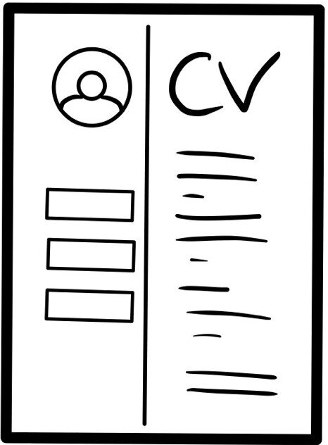](http://127.0.0.1:5500/images/iconCV.jpg)](http://127.0.0.1:5500/images/iconCV.jpg)

[Download CV](http://127.0.0.1:5500/images/iconCV.jpg)

I love making games, because there are just so many different aspects to it, that are each so interesting and awesome to me.

When I was looking for what I want to study and what I wanna be doing in my live there were just so many different things I all wanted to do, best all at the same time.

I wanted to do something with technology, calculating building and programming things, I wanted to learn more about biology and medicine, how the body and the muscles and mechanics of movement work. I also wanted to be creative, when I was younger I always wanted to become an author, creating worlds, stories, characters and their lives, dreams and growth.

I looked at many different courses and it still was a hard decision to make for me but I decided for Game Design, because I nearly see all of my different interests concerted within this one studies.

There is the technical side, working with the engine, different systems and programming, there is so much creativity in the world building, character creation, thinking of mechanics, doing level and game design. Then of course there also is the art side, drawing, modeling and animating for which you also need to know biomechanics and right proportions.

Why Game Desgin?

Why Programming?

I have chosen the programming branch of our course and I love it to solve the problems and make the mechanics work and seeing the game by them coming to life.

Still I would love to do everything else as well, the designing and planning, well everything, but I think it’s better to get really good at one thing rather than starting many things shallow.

In my free time I go dancing, mostly salsa, but also other standard / Latin dances.

I also go horse riding or rather currently doing groundwork with my horse Askanya since her head was broken and it is very hard for her to relax. So that it is someday safe to go riding on trails in the woods, we have to do quite more training and work continuously on that she can rely on me in any situation.

From her I had to learn and enormous amount of patience and sensitivity and even though she often had brought me to my limits and quite some despair she also is such a great teacher to me and I wouldn’t change her one bit even if I could.

Otherwise I love listening to music, watching series and sometimes organizing game nights at my place.