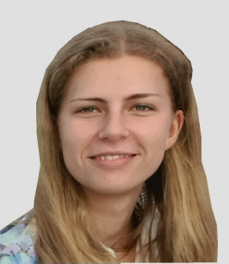
PATRICIA SCHULTZE
  - https://patriciaschultze.de | patricia.schultze@gmx.de
Berlin | (+49) 0176 31285050 | 19.06.2002
Game Design – focus on programming and producing

EDUCATION
 | OCTOBER 2022  – APRIL 2026 |  | Game Design Studies, mdh Berlin  Pursuing the Bachelor of Science with a degree in Game Design as a Programmer
 | SEPTEMBER 2024  – March 2025 |  | Internship, Trotzkind GmbH Berlin  Programming for the Game “Selina: Mind at Large”
 | OCTOBER 2021  – JULY 2022 |  | Orientation Studies “MINT-Grün”, TU Berlin  One year at the TU with the possibility to join any lecture and class
 | SEPTEMBER 2012  – JULY 2021 |  | Gymnasium Steglitz, Berlin  Graduation: Abitur, 1,6; Main Subjects: English, Biology
 | SEPTEMBER 2018  – JULY 2019 |  | Chilliwack Secondary, Canada  School year abroad, I attended following classes:  Creative Writing, Animation, Drama, Spanish, Japanese, Ceramics, Horse Riding
 | Projects

Mansion of Time Purrfect Catch Verdyn
2.5D point-and-click puzzle Fishing Adventure Dungeon Crawler Co-op 3D jump and run game
Unity - Programming Lead Unity - Producer, Programmer Unreal - Producer, Programmer
 | SKILLS |  |  | WORK EXPERIENCE
- C, C++, C#, HTML, CSS/USS, JavaScript, Unreal Blueprints  - English (fluent), German (native), Spanish (basics), Latin (Latinum), Ancient Greek (Graecum)  - Teamwork, Empathy, Patience, Learning fast |  |  |  | - Receptionist and support at our family’s Bed and breakfast  - Tutor (Math, Latin, Greek, German, English, History, Biology, English)  - Festivals mini jobs  - Carer in holiday camps
HOBBIES
Horse riding • Dancing • Walks with my dog • Reading Books • Games • Traveling

