CYBERSECURITY INTERNSHIP
API Security Risk Analysis Report
JSONPlaceholder public demo API
API tested | https://jsonplaceholder.typicode.com
Assessment type | Read-only API security risk analysis (no exploitation)
Tools | Postman with a post-response test script
Prepared by | Patricia Wanjiru Wachira
Date | 20 October 2026

1. Executive Summary
This report presents a read-only security risk analysis of JSONPlaceholder (https://jsonplaceholder.typicode.com), a free public API built for testing and prototyping. Eleven requests were sent with Postman, covering read, create, update and delete operations on posts and users, a check of how the API returns user data and filters by user, and tests with a fabricated token, a wrongly typed value and a non-existent resource. Each response was reviewed for authentication, access control, data exposure, input validation and security headers.
The main result is that the API requires no authentication for any operation tested. Anyone can read, create, change and delete records, view a full user profile, and request any user's posts. A made-up Authorization token is accepted just the same. JSONPlaceholder is a sandbox, so this is expected by design, and its guide states that write requests are faked and nothing is saved. The findings below are therefore rated as they would be if the same behavior existed in a production SaaS API holding real customer data.
Severity | Findings | Issues
High | 5 | Unauthenticated create, update and delete; excessive exposure of user data; fabricated token ignored
Medium | 3 | Unauthenticated read; no object-level access control; weak input validation
Low | 2 | Missing HSTS header; very high rate limit

Key message for business readers: if this were a production API, an anonymous attacker could read customer details, add or alter records, and delete users, with no login and no record of who did it. Adding authentication and per-request authorization checks is the first and most important fix.

2. Scope, Authorization and Ethics
Item | Detail
API tested | JSONPlaceholder, https://jsonplaceholder.typicode.com, a public API built for testing and learning
In scope | A small number of single requests (GET, POST, PUT, DELETE) and inspection of status codes, headers and response bodies
Out of scope | Flooding or load testing, exploitation or bypass attempts, and any private or production API
Authorization | The API is public and intended for testing
Conduct | Every request was sent once, with harmless values only and no real credentials (one request used a fabricated token)
Data impact | JSONPlaceholder fakes write requests, so no data was changed. The first created post returned id 101, the next number after its 100 sample posts

3. Methodology and Tools
Tools: Postman for building requests and reading responses, with a post-response script that checks whether credentials were sent, whether access was granted, and whether key security headers are present.
Method:
- Reviewed the JSONPlaceholder guide to list resources and supported methods.
- Sent each request with no Authorization header or API key, apart from one test that used a fabricated token. The request Headers tab confirmed that only auto-generated headers were sent (Figure 7).
- Recorded the status code, headers and body of each response and took a screenshot.
- Compared each observation with what a secure API should do.
- Rated severity and mapped each finding to the OWASP API Security Top 10 (2023).
A first update attempt (PUT /comments?postId=1) returned 404 Not Found because PUT needs a single resource and not a filtered collection. It was excluded from the findings and repeated correctly as request 5.
Severity rating:
Level | Meaning
High | Easy to abuse, and it exposes sensitive data or lets an attacker modify or destroy data
Medium | Needs some conditions to abuse, or exposes limited data
Low | A hardening or best-practice gap with little direct impact
Each rating weighs how sensitive the data or action is and how easy it is to abuse without credentials or special skill.

4. Requests Tested
# | Method | Endpoint | Auth sent | Status | Result
1 | GET | /posts/1 | No | 200 OK | Data returned without credentials
2 | POST | /posts | No | 201 Created | Record creation accepted (first run)
3 | PUT | /comments?postId=1 | No | 404 Not Found | Inconclusive: invalid target for PUT. Repeated as request 5
4 | DELETE | /users/1 | No | 200 OK | Deletion accepted without credentials
5 | PUT | /posts/1 | No | 200 OK | Update accepted; submitted body echoed back
6 | GET | /users/1 | No | 200 OK | Full user profile returned, including contact and location details
7 | GET | /posts?userId=2 | No | 200 OK | Another user's posts returned with no ownership check
8 | POST | /posts (userId 555) | No | 201 Created | Post accepted for a user that does not exist; id 101 assigned
9 | Not recorded | Request with a fabricated Authorization header | Fake token | Normal response | Token ignored; response the same as without it
10 | POST | /posts (userId "HELLO") | No | Created | Wrongly typed value accepted; post still created
11 | GET | Non-existent post | No | 404 Not Found | Generic 404 with no internal details

5. Summary of Findings
ID | Finding | Endpoint | Severity | OWASP category
API-01 | Unauthenticated read access | GET /posts/1 | Medium | API2:2023 Broken Authentication
API-02 | Unauthenticated record creation | POST /posts | High | API2:2023; API5:2023
API-03 | Unauthenticated record update | PUT /posts/1 | High | API2:2023; API5:2023
API-04 | Unauthenticated record deletion | DELETE /users/1 | High | API2:2023; API5:2023
API-05 | Excessive exposure of user data | GET /users/1 | High | API3:2023 Broken Object Property Level Authorization
API-06 | No object-level access control | GET /posts?userId=2 | Medium | API1:2023 Broken Object Level Authorization
API-07 | Weak input validation | POST /posts | Medium | Improper Input Validation (CWE-20)
API-08 | Missing HSTS header | Responses checked | Low | API8:2023 Security Misconfiguration
API-09 | Fabricated authorization token ignored | Any request with a made-up token | High | API2:2023 Broken Authentication
API-10 | Very high rate limit | Rate-limit header | Low | API4:2023 Unrestricted Resource Consumption

6. Detailed Findings

API-01: Unauthenticated read access
Endpoint | GET /posts/1
Severity | Medium
OWASP category | API2:2023 Broken Authentication
Description | The endpoint returns data with no Authorization header or API key.
Evidence | 200 OK, 1.08 KB in 94 ms, no credentials sent (Figure 1).
Business impact | Anyone can read data without identifying themselves, so access cannot be attributed, limited or revoked, and bulk collection of data is easy. Rated Medium here because the content is generic; it would be High for customer data.
Remediation | Require token-based authentication (OAuth 2.0 or JWT) on every endpoint that is not intentionally public, with least-privilege scopes.

API-02: Unauthenticated record creation
Endpoint | POST /posts
Severity | High
OWASP category | API2:2023 Broken Authentication; API5:2023 Broken Function Level Authorization
Description | The API accepted create requests with no credentials and returned 201 Created.
Evidence | 201 Created on two separate POST requests. The request Headers tab shows no Authorization header (Figures 2 and 7).
Business impact | Anyone could insert records. In production this enables spam, polluted data, fake records and extra storage and processing cost, and it lets attackers feed bad data into systems that trust stored records.
Remediation | Require authentication on all write methods, check that the caller is allowed to create that resource, and validate and rate-limit write requests.

API-03: Unauthenticated record update
Endpoint | PUT /posts/1
Severity | High
OWASP category | API2:2023 Broken Authentication; API5:2023 Broken Function Level Authorization
Description | The API accepted an update to an existing post with no credentials and returned 200 OK with the submitted body.
Evidence | 200 OK, 792 ms, request body {"id": 1, "title": "updated", "body": "updated", "userId": 1} echoed back (Figure 3).
Business impact | Attackers could alter existing records, tampering with content or user data and destroying trust in the accuracy of the system.
Remediation | Require authentication, enforce ownership or role checks before any update, and log who changed what and when.

API-04: Unauthenticated record deletion
Endpoint | DELETE /users/1
Severity | High
OWASP category | API2:2023 Broken Authentication; API5:2023 Broken Function Level Authorization
Description | The API accepted a delete request for a user record with no credentials and returned 200 OK.
Evidence | 200 OK, 1.36 s, no credentials sent (Figure 4).
Business impact | In production, any anonymous caller could remove user data, causing data loss, service disruption, and possible legal and reputational damage.
Remediation | Restrict deletes to authenticated users with explicit permission, enforce record ownership, log every delete, and alert on unusual or bulk deletions.

API-05: Excessive exposure of user data
Endpoint | GET /users/1
Severity | High
OWASP category | API3:2023 Broken Object Property Level Authorization (excessive data exposure)
Description | An unauthenticated request returns the full user object: name, username, email, a complete address (street, suite, city, zipcode and geo coordinates), phone, website and company details.
Evidence | 200 OK, 1.21 KB in 1.79 s, all fields visible in the response body (Figure 5). The demo data is fictional; it is rated as real personal data.
Business impact | Anonymous exposure of personal and contact data enables phishing, identity fraud and stalking, and can breach data protection law such as Kenya's Data Protection Act, 2019 or the GDPR, leading to fines and loss of customer trust.
Remediation | Return only the fields each client needs (response shaping), require authentication, restrict sensitive fields by role, and review every endpoint for data minimization.

API-06: No object-level access control
Endpoint | GET /posts?userId=2
Severity | Medium
OWASP category | API1:2023 Broken Object Level Authorization
Description | Changing the userId value returns another user's posts. No identity is checked, so the API cannot confirm that the caller may see that data.
Evidence | 200 OK, 146 ms, 1.87 KB, posts with userId 2 and ids 11, 12 and 13 (Figure 6).
Business impact | Any caller can step through predictable numeric ids and collect other customers' records. Rated Medium for public-style posts; it would be High for private data.
Remediation | Enforce object-level authorization on the server for every request, take the user identity from the token and not from client-supplied ids, and consider non-sequential identifiers (UUIDs) as defense in depth.

API-07: Weak input validation
Endpoint | POST /posts with userId 555
Severity | Medium
OWASP category | Improper Input Validation (CWE-20)
Description | The API accepted a new post for userId 555, a user that does not exist in the dataset, and also accepted userId sent as the text "HELLO" instead of a number. Both posts were created with no validation error.
Evidence | 201 Created, 522 ms. The response echoed the submitted values and assigned id 101 (Figure 2). The request with userId set to "HELLO" also created the post.
Business impact | Invalid or orphaned records can corrupt data and break application logic, and weak validation often points to wider gaps that attackers exploit.
Remediation | Validate every request on the server (data types, ranges, required fields), check that referenced users exist and that the caller may act for them, and return 400 or 422 for invalid input.

API-08: Missing HTTP Strict Transport Security (HSTS)
Endpoint | Responses checked by the test script
Severity | Low
OWASP category | API8:2023 Security Misconfiguration
Description | The Strict-Transport-Security response header is not set.
Evidence | The Postman header check for strict-transport-security failed (Figure 1) and the same result pattern appeared on the other requests where the script ran.
Business impact | A client may be tricked into connecting over plain HTTP, exposing traffic to interception on hostile networks such as public Wi-Fi.
Remediation | Add Strict-Transport-Security: max-age=31536000; includeSubDomains to all responses and serve HTTPS only.

API-09: Fabricated authorization token ignored
Endpoint | Requests sent with a made-up Authorization header
Severity | High
OWASP category | API2:2023 Broken Authentication
Description | When a random Authorization value is added to a request, the API ignores it and responds exactly as it does with no header. Tokens are never validated.
Evidence | The response with the fabricated token was the same as the response without it (observed in Postman).
Business impact | Developers may believe requests are protected when they are not, and any attacker can send any value as a token and be treated as legitimate. In production this would be a complete authentication bypass.
Remediation | Validate the token (signature, expiry, issuer and audience) on every request, reject missing or invalid tokens with 401 Unauthorized, and test that fabricated tokens are refused.

API-10: Very high rate limit
Endpoint | Response rate-limit header
Severity | Low
OWASP category | API4:2023 Unrestricted Resource Consumption
Description | The API returns a rate-limit header with the value 3600000. If this is the per-window request allowance, it is too high to restrict any single client, so rate limiting gives little practical protection.
Evidence | Response Headers tab: rate-limit header value 3600000. Enforcement was not tested because load testing is out of scope, so this is rated Low.
Business impact | Without effective limits, one client can scrape the whole dataset, overload the service or run up hosting costs. With no authentication, abuse cannot be throttled per user.
Remediation | Set realistic per-client limits (per API key or IP address), return 429 Too Many Requests with a Retry-After header when exceeded, and monitor for unusual traffic.

7. Positive Observations
A balanced assessment also records what is working:
- X-Content-Type-Options was present on the responses checked.
- A request for a non-existent post returned a generic 404 Not Found with no stack trace or internal details, which is good error-handling practice.
- No Access-Control-Allow-Origin header was returned on the request tested, so no wildcard cross-origin access was observed.
- All requests were served over HTTPS.

8. Remediation Roadmap
Priority | Action | Addresses
Quick win | Add the HSTS header and enforce HTTPS only | API-08
Quick win | Trim user responses to the fields each client needs | API-05
Short term | Require authentication on every non-public endpoint, especially POST, PUT, PATCH and DELETE | API-01 to API-04
Short term | Validate every Authorization token and reject invalid ones with 401 | API-09
Short term | Add server-side input validation, including data types and checks that referenced objects exist | API-07
Medium term | Add role-based access control and per-object ownership checks | API-02 to API-06
Medium term | Set realistic per-client rate limits, return 429 with Retry-After, and monitor for abuse | API-10
Long term | Add audit logging, monitoring and alerts for write and delete operations, and test the API for security regularly | API-02 to API-04

9. Limitations and Further Testing
This was a small, read-only sample of single requests against a sandbox, so the findings are observations and not a complete audit. The following were not covered and are recommended for any follow-up:
- Token handling: only one fabricated token was tested. Expired, tampered and valid tokens were not tested because the API has no real authentication.
- Rate limiting: only the header value was observed. Enforcement was not tested because load testing is out of scope.
- CORS: observed on a request sent without an Origin header. Behavior when an Origin is sent was not tested.
- Error handling: a non-existent post was tested. Malformed JSON and other error conditions were not.
- Input validation: a wrong data type and a non-existent reference were tested. Special characters and oversized values were not.
- HSTS and other header checks were made by script. A capture of the response Headers tab is recommended as additional evidence.

10. Conclusion
JSONPlaceholder behaves as a public sandbox should: open, forgiving and free of real data. Measured against production standards, however, every operation tested works without authentication, a made-up token is ignored, user records expose far more personal data than a client needs, objects can be requested by any caller, input is not checked for type or against existing records, the rate limit is too high to matter, and a basic transport security header is missing. The same design in a real SaaS API would be high risk.
The priority is clear: put authentication and authorization in front of every endpoint, then reduce the data returned, validate input, and add monitoring. These changes address all ten findings in this report.

References
- OWASP API Security Top 10 (2023): https://github.com/OWASP/API-Security
- API Security Checklist: https://github.com/shieldfy/API-Security-Checklist
- JSONPlaceholder guide: https://jsonplaceholder.typicode.com/guide/
- Data Protection Act, 2019 (Kenya)

Appendix A: Evidence Screenshots
All screenshots are Postman captures of requests sent without credentials.
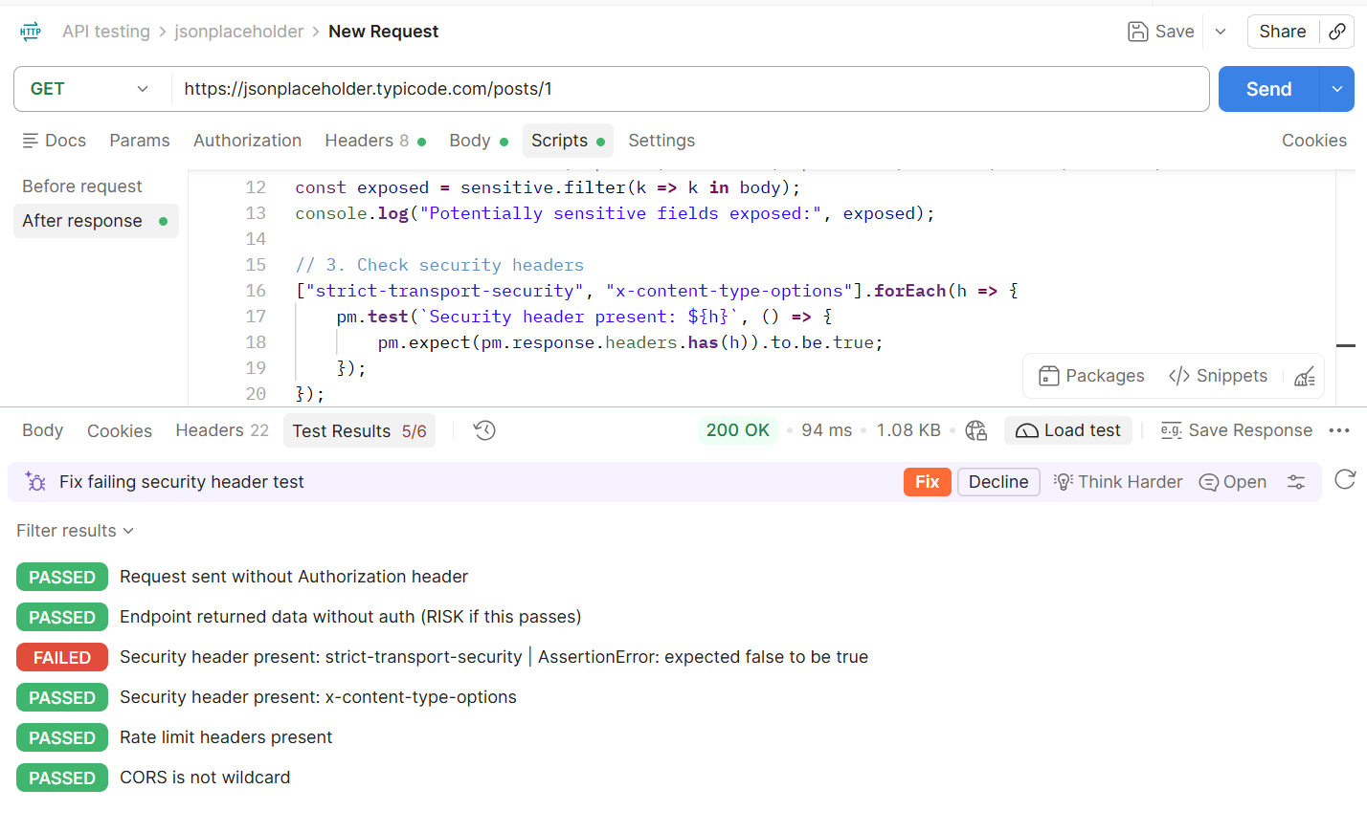
Figure 1: GET /posts/1: 200 OK with no credentials; the strict-transport-security header check fails (API-01, API-08)
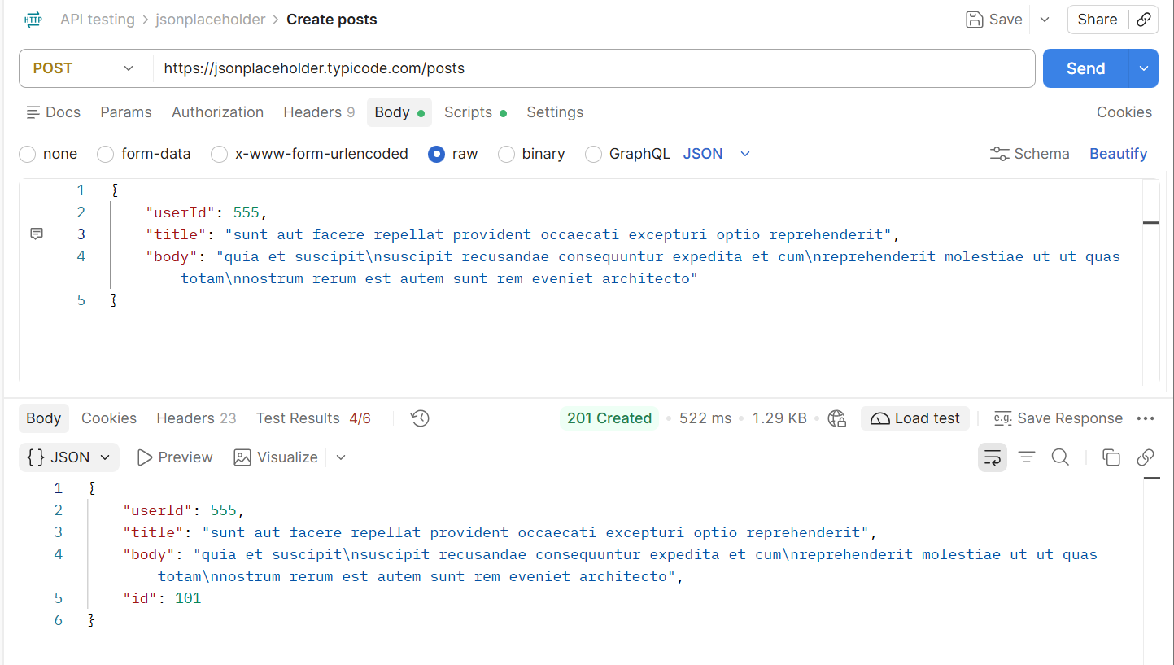
Figure 2: POST /posts with userId 555: 201 Created and id 101 assigned (API-02, API-07)
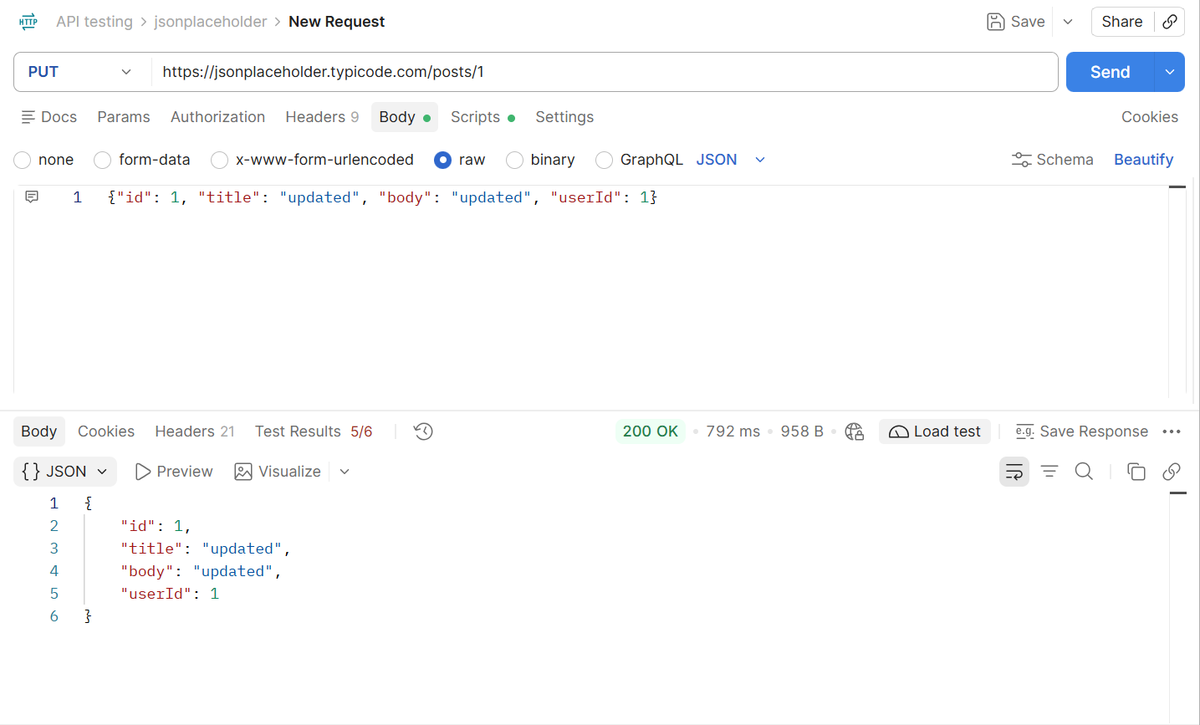
Figure 3: PUT /posts/1: 200 OK, submitted body echoed back (API-03)
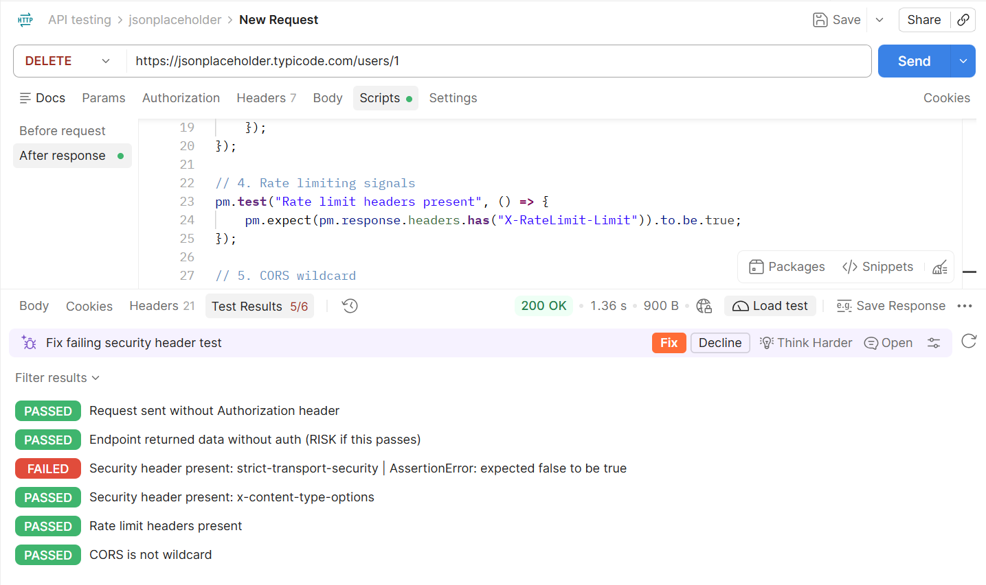
Figure 4: DELETE /users/1: 200 OK with no credentials (API-04)
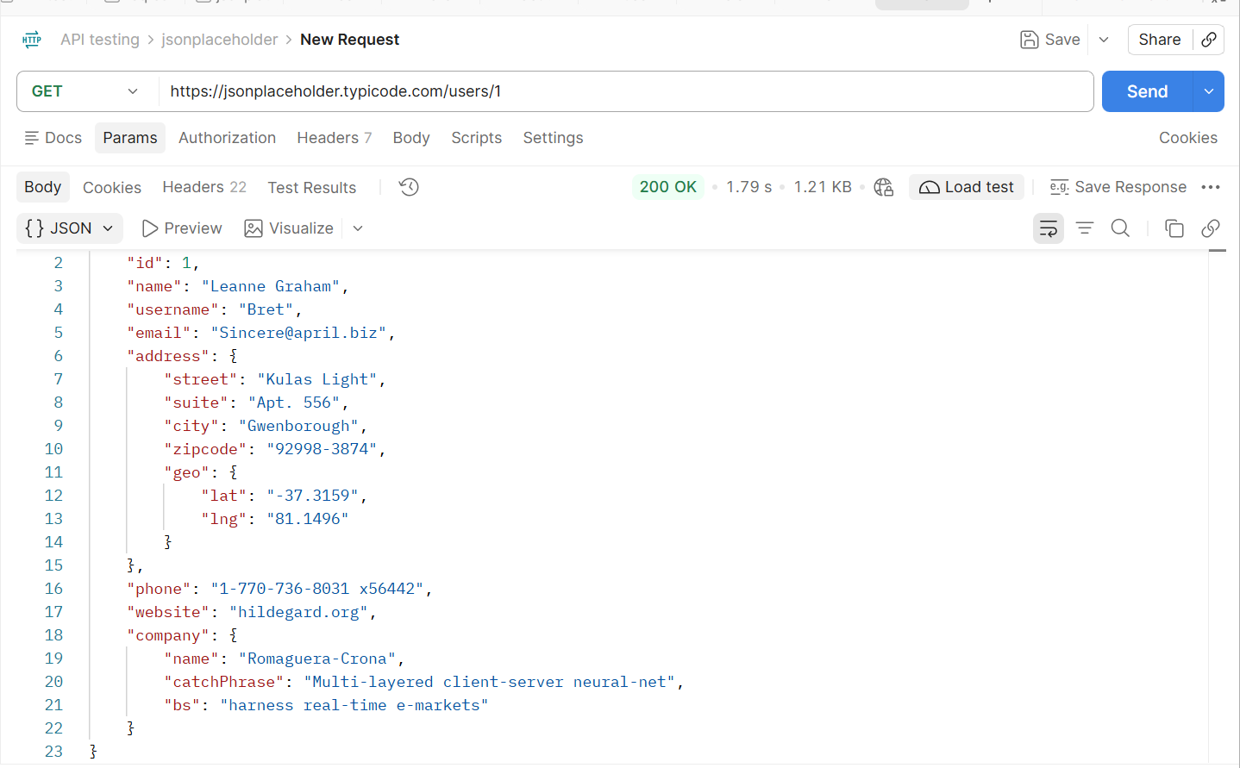
Figure 5: GET /users/1: full user profile including email, phone, address and coordinates (API-05)
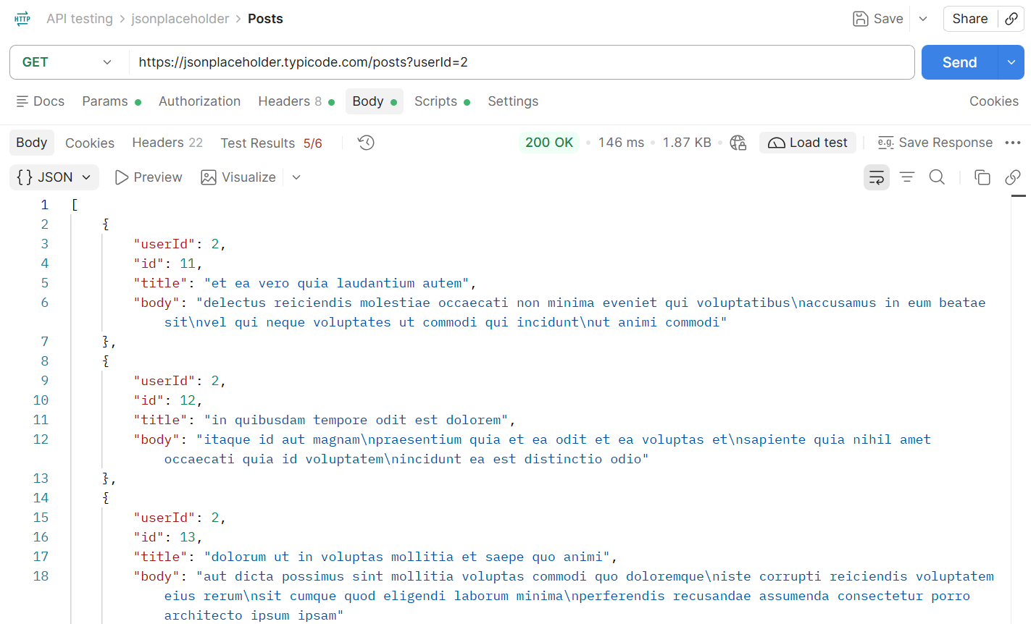
Figure 6: GET /posts?userId=2: another user's posts returned (API-06)
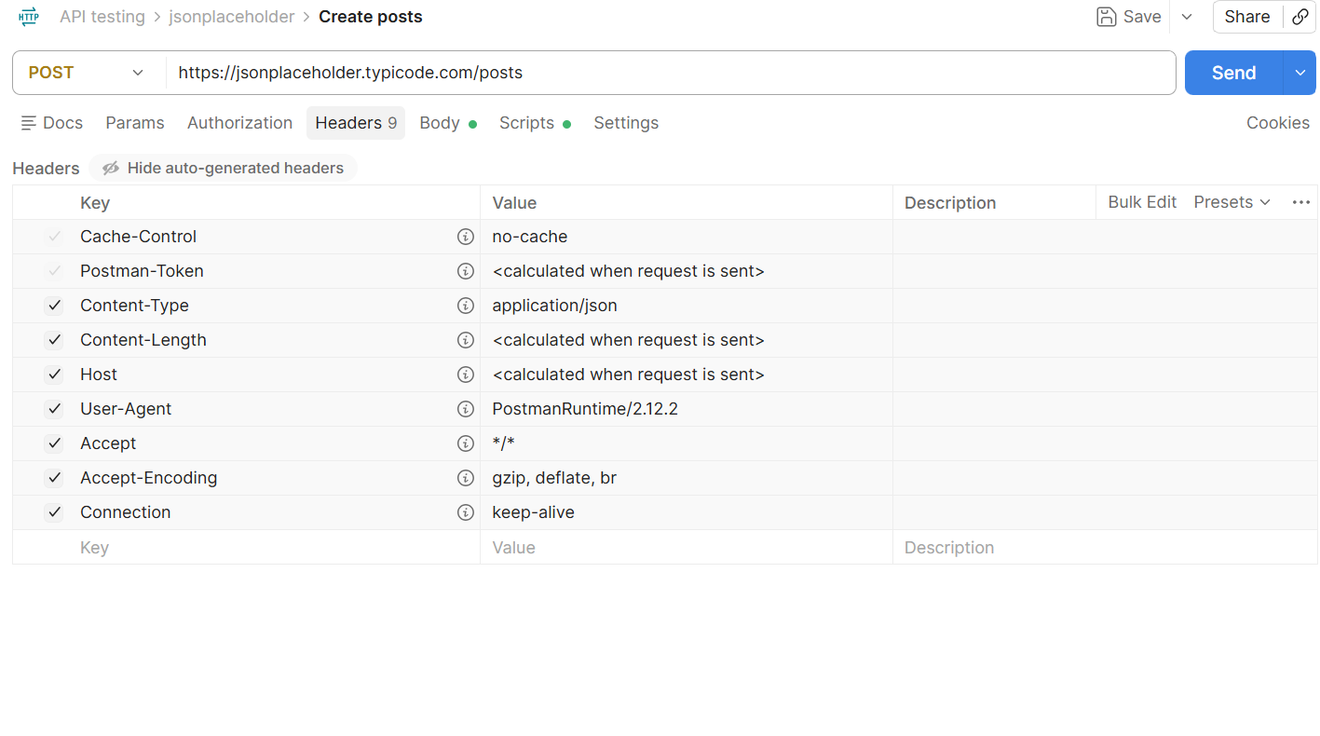
Figure 7: Request headers for POST /posts: no Authorization header sent (supports API-02)

