Close

Neural Networks: Representation

5 questions

1.

Which of the following statements are true? Check all that apply.



Any logical function over binary-valued (0 or 1) inputs *x*1 and *x*2 can be (approximately) represented using some neural network.



The activation values of the hidden units in a neural network, with the sigmoid activation function applied at every layer, are always in the range (0, 1).



A two layer (one input layer, one output layer; no hidden layer) neural network can represent the XOR function.



Suppose you have a multi-class classification problem with three classes, trained with a 3 layer network. Let *a*(3)1=(*h*Θ(*x*))1 be the activation of the first output unit, and similarly *a*(3)2=(*h*Θ(*x*))2 and *a*(3)3=(*h*Θ(*x*))3. Then for any input *x*, it must be the case that *a*(3)1+*a*(3)2+*a*(3)3=1.

2.

Consider the following neural network which takes two binary-valued inputs *x*1,*x*2∈{0,1} and outputs *h*Θ(*x*). Which of the following logical functions does it (approximately) compute?

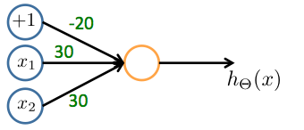



OR



AND



NAND (meaning "NOT AND")



XOR (exclusive OR)

3.

Consider the neural network given below. Which of the following equations correctly computes the activation *a*(3)1? Note: *g*(*z*) is the sigmoid activation function.

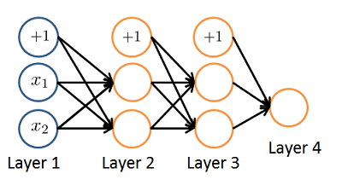



*a*(3)1=*g*(Θ(2)1,0*a*(2)0+Θ(2)1,1*a*(2)1+Θ(2)1,2*a*(2)2)



*a*(3)1=*g*(Θ(1)1,0*a*(1)0+Θ(1)1,1*a*(1)1+Θ(1)1,2*a*(1)2)



*a*(3)1=*g*(Θ(1)1,0*a*(2)0+Θ(1)1,1*a*(2)1+Θ(1)1,2*a*(2)2)



The activation *a*(3)1 is not present in this network.

4.

You have the following neural network:

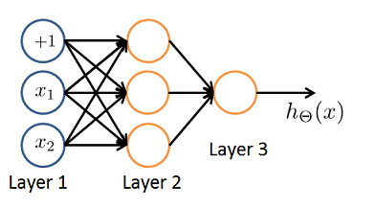

You'd like to compute the activations of the hidden layer *a*(2)∈R3. One way to do so is the following Octave code:

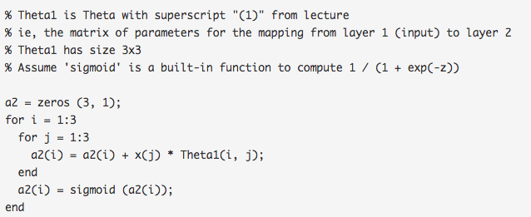

You want to have a vectorized implementation of this (i.e., one that does not use for loops). Which of the following implementations correctly compute *a*(2)? Check all that apply.



z = Theta1 \* x; a2 = sigmoid (z);



a2 = sigmoid (x \* Theta1);



a2 = sigmoid (Theta2 \* x);



z = sigmoid(x); a2 = sigmoid (Theta1 \* z);



a2 = sigmoid (Theta1 \* x);

5.

You are using the neural network pictured below and have learned the parameters Θ(1)=[112.10.61.3−1.2] (used to compute *a*(2)) and Θ(2)=[14.53.1] (used to compute *a*(3)} as a function of *a*(2)). Suppose you swap the parameters for the first hidden layer between its two units so Θ(1)=[110.62.1−1.21.3] and also swap the output layer so Θ(2)=[13.14.5]. How will this change the value of the output *h*Θ(*x*)?

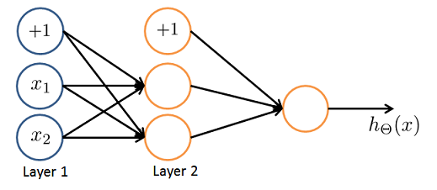



It will stay the same.



It will increase.



It will decrease



Insufficient information to tell: it may increase or decrease.

3 questions unanswered

Submit Quiz