Close

Advice for Applying Machine Learning

5 questions

1  
point

1.

You train a learning algorithm, and find that it has unacceptably high error on the test set. You plot the learning curve, and obtain the figure below. Is the algorithm suffering from high bias, high variance, or neither?

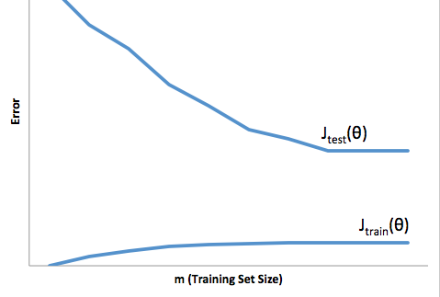



High bias



Neither



High variance

1  
point

2.

Suppose you have implemented regularized logistic regression

to classify what object is in an image (i.e., to do object

recognition). However, when you test your hypothesis on a new

set of images, you find that it makes unacceptably large

errors with its predictions on the new images. However, your

hypothesis performs **well** (has low error) on the

training set. Which of the following are promising steps to

take? Check all that apply.



Try decreasing the regularization parameter *λ*.



Try evaluating the hypothesis on a cross validation set rather than the test set.



Try increasing the regularization parameter *λ*.



Try using a smaller set of features.

1  
point

3.

Suppose you have implemented regularized logistic regression

to predict what items customers will purchase on a web

shopping site. However, when you test your hypothesis on a new

set of customers, you find that it makes unacceptably large

errors in its predictions. Furthermore, the hypothesis

performs **poorly** on the training set. Which of the

following might be promising steps to take? Check all that

apply.



Try evaluating the hypothesis on a cross validation set rather than the test set.



Try decreasing the regularization parameter *λ*.



Try adding polynomial features.



Use fewer training examples.

1  
point

4.

Which of the following statements are true? Check all that apply.



Suppose you are training a regularized linear regression model. The recommended way to choose what value of regularization parameter *λ* to use is to choose the value of *λ* which gives the lowest **test set** error.



The performance of a learning algorithm on the training set will typically be better than its performance on the test set.



Suppose you are training a regularized linear regression model. The recommended way to choose what value of regularization parameter *λ* to use is to choose the value of *λ* which gives the lowest **cross validation** error.



Suppose you are training a regularized linear regression model.The recommended way to choose what value of regularization parameter *λ* to use is to choose the value of *λ* which gives the lowest **training set** error.

1  
point

5.

Which of the following statements are true? Check all that apply.



If the training and test errors are about the same, adding more features will **not** help improve the results.



A model with more parameters is more prone to overfitting and typically has higher variance.



If a learning algorithm is suffering from high bias, only adding more training examples may **not** improve the test error significantly.



If a learning algorithm is suffering from high variance, adding more training examples is likely to improve the test error.

1 question unanswered

Submit Quiz