Close

Anomaly Detection

5 questions

1  
point

1.

For which of the following problems would anomaly detection be a suitable algorithm?



From a large set of primary care patient records, identify individuals who might have unusual health conditions.



Given an image of a face, determine whether or not it is the face of a particular famous individual.



Given data from credit card transactions, classify each transaction according to type of purchase (for example: food, transportation, clothing).



Given a dataset of credit card transactions, identify unusual transactions to flag them as possibly fraudulent.

1  
point

2.

Suppose you have trained an anomaly detection system for fraud detection, and your system that flags anomalies when *p*(*x*) is less than *ε*, and you find on the cross-validation set that it is missing many fradulent transactions (i.e., failing to flag them as anomalies). What should you do?



Increase *ε*



Decrease *ε*

1  
point

3.

Suppose you are developing an anomaly detection system to catch manufacturing defects in airplane engines. You model uses

*p*(*x*)=∏*nj*=1*p*(*xj*;*μj*,*σ*2*j*).

You have two features *x*1 = vibration intensity, and *x*2 = heat generated. Both *x*1 and *x*2take on values between 0 and 1 (and are strictly greater than 0), and for most "normal" engines you expect that *x*1≈*x*2. One of the suspected anomalies is that a flawed engine may vibrate very intensely even without generating much heat (large *x*1, small *x*2), even though the particular values of *x*1 and *x*2 may not fall outside their typical ranges of values. What additional feature *x*3 should you create to capture these types of anomalies:



*x*3=*x*1×*x*2



*x*3=*x*21×*x*2



*x*3=*x*1+*x*2



*x*3=*x*1/*x*2

1  
point

4.

Which of the following are true? Check all that apply.



When choosing features for an anomaly detection system, it is a good idea to look for features that take on unusually large or small values for (mainly the) anomalous examples.



If you do not have any labeled data (or if all your data has label *y*=0), then is is still possible to learn *p*(*x*), but it may be harder to evaluate the system or choose a good value of *ϵ*.



If you have a large labeled training set with many positive examples and many negative examples, the anomaly detection algorithm will likely perform just as well as a supervised learning algorithm such as an SVM.



If you are developing an anomaly detection system, there is no way to make use of labeled data to improve your system.

1  
point

5.

You have a 1-D dataset {*x*(1),…,*x*(*m*)} and you want to detect outliers in the dataset. You first plot the dataset and it looks like this:

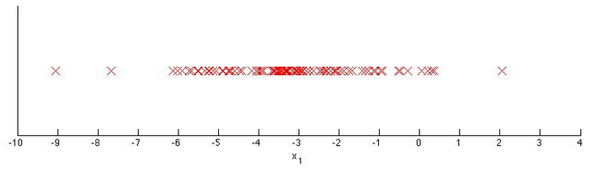

Suppose you fit the gaussian distribution parameters *μ*1 and *σ*21 to this dataset. Which of the following values for *μ*1 and *σ*21 might you get?



*μ*1=−3,*σ*21=4



*μ*1=−6,*σ*21=4



*μ*1=−3,*σ*21=2



*μ*1=−6,*σ*21=2

3 questions unanswered

Submit Quiz