**LABORATORY WORK NO. 7**

Network Layer – IPv6

1. Objectives

At the end of the lab, students will be able: to explain the characteristics of the IPv6 protocol, to describe the dynamic IPv6 configuration, to explain the routing process, and to implement basic IPv6 network configurations.

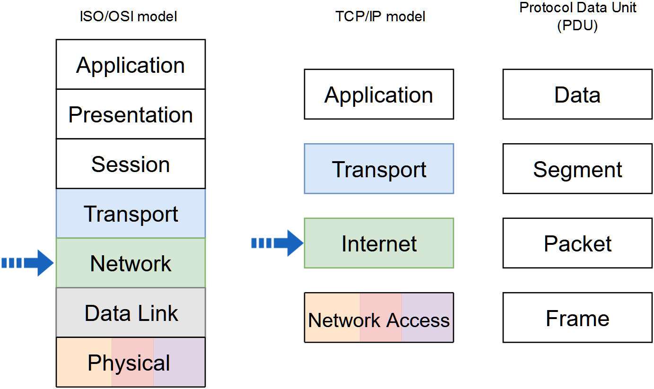

2. Theoretical considerations

**2.1 IPv6**

IPv6 was developed by the Internet Engineering Task Force (IETF) to overcome the limitations of IPv4.

The main limitation of IPv4 is the exhaustion of addresses because the address request is larger than the address space provided by the 32 bits of the address. The solution for the IPv4 address depletion is private addressing and NAT. This solution in turn creates several drawbacks such as lack of end-to-end connectivity and increased network complexity.

IPv6 provides the following improvements:

* Increased address space based on 128 bit address;
* Improved packet handling due to the simplified header with fewer fields;
* Eliminates the need for NAT by eliminating the need for private addresses.

The packet header is presented below:

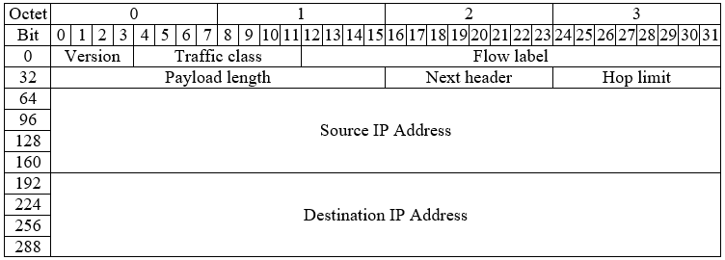

* Version - version field, equal to 6;
* Traffic class - equivalent to DiffServ – DS field;
* Payload length – indicates the length of the payload of the IPv6 packet;
* Next header – defines the next level protocol;
* Hop limit – replaces the Time to live field in IPv4;
* Source address – the IPv4 address of the sender of the packet;
* Destination address – the IPv4 address of the receiver of the packet;

IPv6 packet may contain extension headers, placed between IPv6 header and the payload, providing optional network layer information. Routers do not fragment IPv6 packets.

IPv6 addresses are 128 bits in length. The preferred format for writing an IPv6 address is x:x:x:x:x:x:x:x, with each “x” consisting of four hexadecimal values, 4 bits being represented by a hexadecimal digit. Hextet is an unofficial term, it refers to a segment of 16 bits (4 values in hexadecimal). Example of an IPv6 addresses in the preferred format:

|  |  |
| --- | --- |
| Type | Format |
| Preferred | 2001:0b20:0000:00d7:0000:0000:0000:0012 |

There are two rules to reduce or compress IPv6 representation. The first rule is to omit the zeros that are at the beginning of each hextet - leading 0s (zeros).

|  |  |
| --- | --- |
| Type | Format |
| Preferred | 2001:0b20:0000:00d7:0000:0000:0000:0012 |
| No leading 0s | 2001:b20:0:d7:0:0:0:12 |

The second rule is to omit the segments (hextets) that contain all the bits 0 and replace them with "double colon" (::). This replacement can be done only once

|  |  |
| --- | --- |
| Type | Format |
| Preferred | 2001:0b20:0000:00d7:0000:0000:0000:0012 |
| No leading 0s | 2001:b20:0:d7:0:0:0:12 |
| Compressed | 2001:b20:0:d7::12 |
| or |  |
| Compressed | 2001:b20::d7:0:0:0:12 |

Types of IPv6 addresses:

* Unicast
  + Uniquely identifies an interface
  + The source address must be unicast
* Multicast
  + It is used to send a single IPv6 packet to multiple destinations
  + IPv6 does not have a broadcast address, but there is a multicast address that provides the same result
  + Well-Known Multicast Addresses
    - ff02 :: 1: All IPv6 devices
    - ff02 :: 2: All IPv6 routers
    - ff02 :: 5: All OSPFv3 routers
    - ff02 :: a: All EIGRP (IPv6) routers
* Anycast
  + Any unicast address that can be assigned to multiple devices
  + A packet sent to anycast address is routed to the nearest device with that address

IPv6 prefix length indicates the network portion of an IPv6 address. It is represented in slash notation and can range from 0 to 128. The recommended IPv6 prefix length for LANs is /64. Example of an IPv6 address and prefix length: 2001:b20:0:d7::12/64

|  |  |
| --- | --- |
| Prefix (64 bits) | Interface ID (64 bits) |
| 2001:0b20:0000:00d7 | 0000:0000:0000:0012 |

Types of unicast addresses:

* Global Unicast Address (GUA)
  + Globally unique
  + Routable on the Internet
  + Similar to a public IPv4 address
* Link-local Address (LLA)
  + Required for every IPv6-enabled device
  + Created even if the device has not been assigned a global unicast address
  + For communication with other devices from the same local link
  + Allow devices to communicate only on the same link
  + Unique only in the local link
  + Not routable on the Internet
  + They are in the range FE80::/10
  + The router's link-local address is usually used as the default gateway
* Unique Local Address (ULA)
  + Local addressing within a site or between a limited number of sites

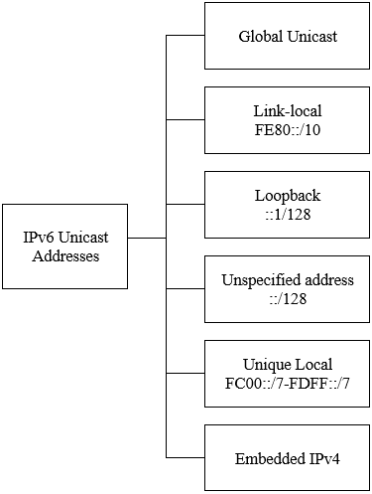

Structure of the Global Unicast Addresses (GUA)

* Global routing prefix
  + Network
  + Portion of the address assigned by the provider
  + Typical /48
* Subnet ID
  + For subnetting in an organization
  + Usually, 16 bits
* Interface ID
  + The equivalent of the host portion of an IPv4 address
  + Usually, 64 bits

Example of an IPv6 global unicast address: 2001:b20:0:d7::12/64

|  |  |  |
| --- | --- | --- |
| Global Routing Prefix | Subnet ID | Interface ID |
| 2001:0b20:0000 | 00d7 | 0000:0000:0000:0012 |

**2.2 Host configuration**

Methods:

* Static
  + Manual configuration of the IPv6 address
* Dynamic
  + Stateless Address Autoconfiguration (SLAAC)
  + Stateful DHCPv6

A device obtains the IPv6 addressing information dynamically, through Internet Control Message Protocol version 6 (ICMPv6) messages. IPv6 routers periodically send out ICMPv6 Router Advertisement (RA) messages to all IPv6-enabled devices on the network. An RA message will also be sent in response to a host sending an ICMPv6 Router Solicitation (RS) message, which is a request for an RA message.

The ICMPv6 RA message is a suggestion to devices on how to obtain IPv6 addressing information. The ICMPv6 RA message includes the following:

* Network prefix and prefix length
* Default gateway address
* DNS addresses and domain name

There are three methods for RA messages:

* Method 1: SLAAC - prefix, prefix length, and default gateway address
* Method 2: SLAAC with a stateless DHCPv6 server – partial information, the rest of the information, such as DNS addresses, needs to be obtained from a stateless DHCPv6 server
* Method 3: Stateful DHCPv6 (no SLAAC) - default gateway address, the rest of the information, needs to be obtained from a stateful DHCPv6 server

The decision of how a client will obtain IPv6 addressing information depends on the settings within the RA message. An ICMPv6 RA message includes three flags to identify the dynamic options available to a host, as follows:

* A flag - Address Autoconfiguration flag. Use Stateless Address Autoconfiguration (SLAAC) to create an IPv6 GUA.
* O flag - Other Configuration flag. Other information is available from a stateless DHCPv6 server.
* M flag - Managed Address Configuration flag. Use a stateful DHCPv6 server to obtain an IPv6 GUA.
* Method 1 - SLAAC

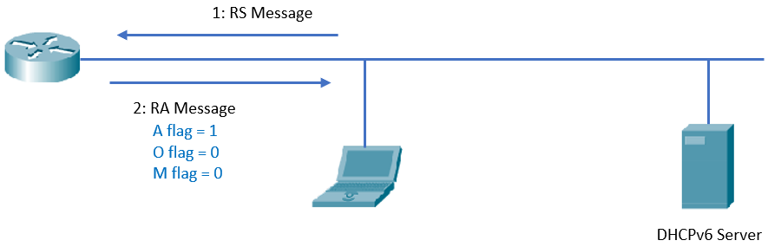

* Method 2 - SLAAC with a stateless DHCPv6 server

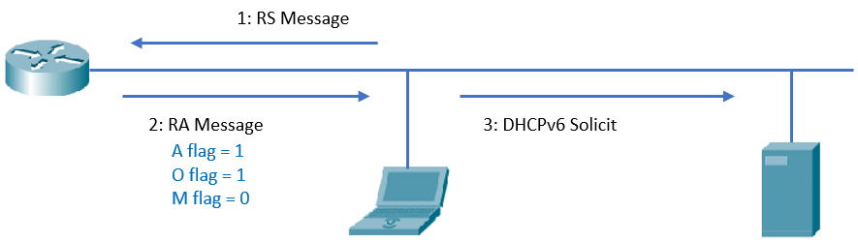

* Method 3 - Stateful DHCPv6 (no SLAAC)

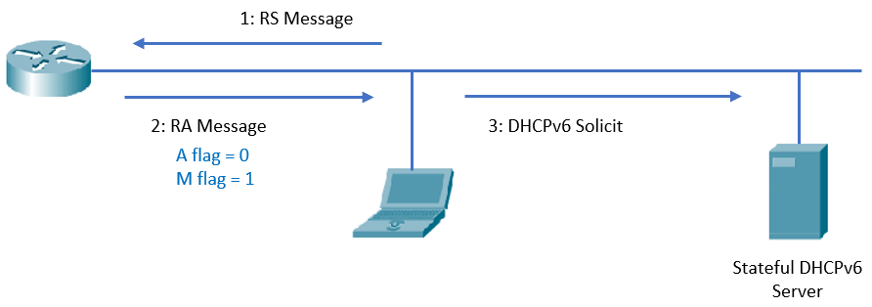

3. Lab activity

3.1 Discuss the theoretical aspects.

3.2 Consider the network topology below:

**Step 1:** Before configuring the network devices, discuss the IPv6 address assignment in the table below:

|  |  |  |
| --- | --- | --- |
| **Device** | **Interface** | **IPv6 Address** |
| Laptop 1 | Fa0 | DHCPv6 |
| Laptop 2 | Fa0 | DHCPv6 |
| R1 | Gig0/0 | 2001:1:1:1::1/64  fe80::1 link-local |
| R1 | Gig0/1 | 2001:1:1:2::1/64 |
| R2 | Gig0/1 | 2001:1:1:2::2/64  fe80::2 link-local |
| R2 | Gig0/0 | 2001:1:1:3::1/64 |

Note*: pay attention to the interface names of the router you are using, some routers may only have FastEthernet interfaces.

**Step 2:** Assign hostnames, enable IPv6 routing and assign static IPv6 addresses to router interfaces.

Example:

*R1>enable*

*R1#configure terminal*

*Enter configuration commands, one per line. End with CNTL/Z.*

*Router(config)#hostname R1*

*R1(config)#ipv6 unicast-routing*

*R1(config)# interface gigabitEthernet 0/0*

*R1(config-if)#ipv6 address fe80::1 link-local*

*R1(config-if)#ipv6 address 2001:1:1:1::1/64*

*R1(config-if)#no shutdown*

Use the following command to display the IPv6 addresses configured on the router:

*R1#show ipv6 interface brief*

**Step 3:** Configure a static route on each router pointed to the IPv6 address of Gig0/1 on the other router. For R1 router specify the LLA address for the next hop and for the R2 router specify the GUA address the next hop. Discuss the differences!

*R1(config)#ipv6 route 2001:1:1:3::/64 GigabitEthernet0/1 FE80::2*

*R2(config)# ipv6 route 2001:1:1:1::/64 2001:1:1:2::1*

Use the following command to display the IPv6 routing table:

*Router#show ipv6 route*

**Step 4:** Verify SLAAC Address Assignment.

**Step 5:** Test the connectivity between end devices from opposite networks.

a. ping <target IP>

b. tracert <target IP>

**Step 6:** Replace the configured static routes with default routes and test the connectivity between end devices from opposite networks. In IPv6, the default route is ::/0.

*R1(config)#no ipv6 route 2001:1:1:3::/64 GigabitEthernet0/1 FE80::2*

*R2(config)#no ipv6 route 2001:1:1:1::/64 2001:1:1:2::1*

*R1(config)#ipv6 route ::/0 ______________________________________*

*R2(config)#ipv6 route ::/0 ______________________________________*

**Step 7:** Configure R1 to provide stateless DHCPv6 for Laptop 1.

*R1(config)#ipv6 dhcp pool R1_NET1*

*R1(config-dhcpv6)#dns-server 2001:1:1:1::F*

*R1(config-dhcpv6)#domain-name NET1.com*

*R1(config-dhcpv6)#exit*

*R1(config)#interface gigabitEthernet 0/0*

*R1(config-if)#ipv6 nd other-config-flag*

*R1(config-if)#ipv6 dhcp server R1_NET1*

**Step 8:** Verify stateless DHCPv6 Address Assignment.

**Step 9:** Configure R2 to provide stateful DHCPv6 for Laptop 2.

*R2(config)#ipv6 dhcp pool R2_NET3*

*R2(config-dhcpv6)#* *address prefix 2001:1:1:3::/64*

*R2(config-dhcpv6)#dns-server 2001:1:1:3::A*

*R2(config-dhcpv6)#domain-name NET3.com*

*R2(config-dhcpv6)#exit*

*R2(config)#interface gigabitEthernet 0/0*

*R2(config-if)#ipv6 nd managed-config-flag*

*R2(config-if)#ipv6 dhcp server R2_NET3*

**Step 10:** Verify stateful DHCPv6 Address Assignment

**Step 11:** Test the connectivity between end devices from opposite networks.

a. ping <target IP>

b. tracert <target IP>

**Notes**