LABORATORY WORK NO. 3a
OPTICAL FIBERS AND COMPONENTS

1. Objectives

The objective of this work is gaining knowledge on optical fibers and components, link performance analysis and the optical power budget calculus.

2. Theoretical considerations

2.1 Optical fibers and components
The current laboratory work continues the focus on the Physical layer of the ISO/OSI stack by providing knowledge on optical fibers and components. Furthermore, on part 3b, the main network devices and elements of structured cabling are presented.
Once the drop in the price of optical fibers, and appropriate communications equipment, this has become the environment of choice for new high-speed connections (exterior and interior).
To transmit data, optical fibers send light signals along glass or plastic cores (of the order tens of microns (μ), which constitutes a wavelength guide for light, obtained from a combination of silicon dioxide and other elements).
An optical fiber strand is the basic element of an optical fiber cable (a cable contains several strands). A strand has three layers: core, cladding and coating. A fiber optic cable consists of several components: fiber strand(s), buffer, protective materials, outer jacket.
The core is wrapped by material made of silicon dioxide having a refractive index lower than the core called cladding. In order to protect the cladding, this is wrapped in a plastic material. This is called buffer and is wrapped in a material, usually Kevlar, which confers resistance of fiber at the time of installation. Optical fiber buffers are of two categories: tight (a protective covering is applied over the coating of each fiber strand) or loose-tube (several strands inside a tube filled with a protective gel). For outdoor, long-distance installation, loose-tube fiber is preferred. The last wrapper is the jacket which protects the fiber against abrasive materials, solvents and other factors. The color enclosure in the case of multimode optical fiber is usually orange and in the case of single-mode optical fiber is usually yellow. Each fiber optics cable is composed of two fibers wrapped separately, a fiber being used for transmission and another for the reception, ensuring in this way a full-duplex connection. A cable of optical fiber may contain from two up to hundred separate fiber strands (usually in LANs, up to 24). Figure 2.1 presents the layer of an optical fiber and an optical fiber transversal section.
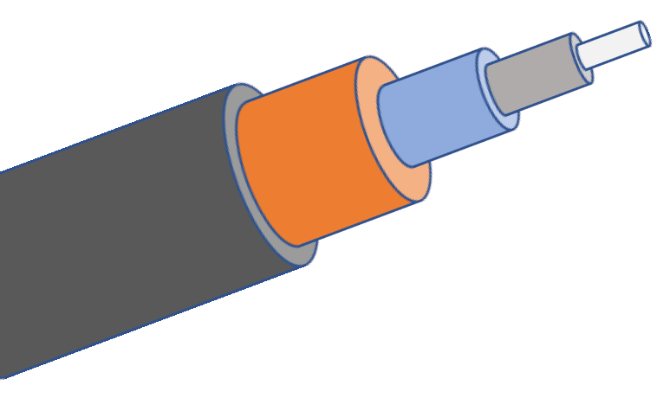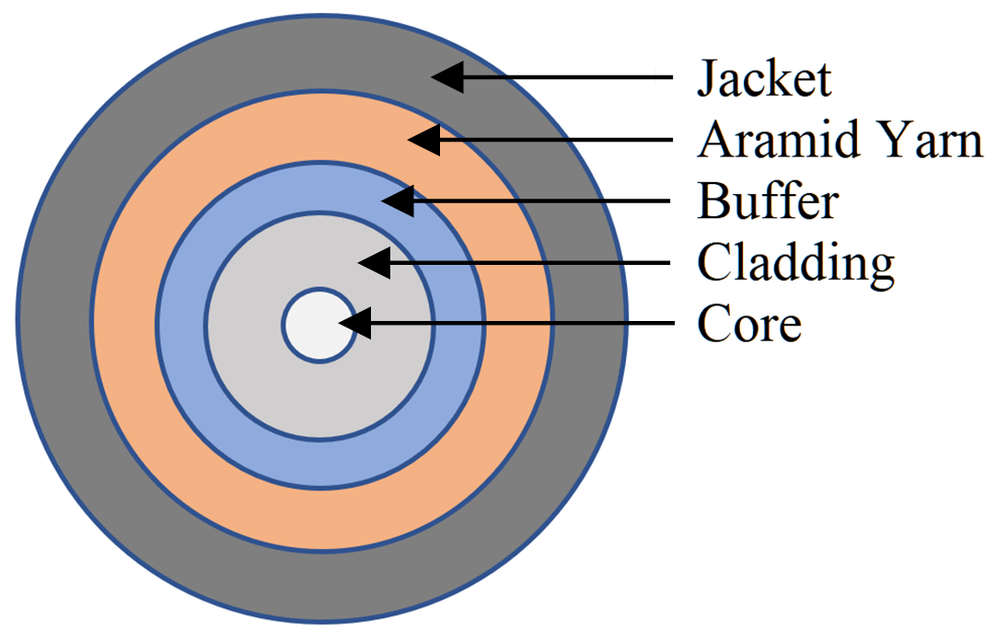
Figure 2.1 a. Optical fiber layers b. Optical fiber transversal section

For the signal to be reflected without loss, the following two conditions need to be met:
- Optical-fiber must have a refractive index higher than the material surrounding it;
- The angle of incidence of light signal must be greater than the critical angle of fiber and of the material surrounding it. The angle of incidence of light signal can be controlled by using the next two factors:
  - Numerical aperture of the fiber is the range of angles of the light signal for which the reflection is complete;
  - The modes are the ways that the signal light can follow.
Unlike copper-based transmission media, optical fiber is not susceptible to, and it does not generate electromagnetic or crosstalk interference.
Two main optical fibers are commonly used in LANs and WANs: single-mode and multimode. Single-mode optical fiber is used for long distance links and for vertical cabling in buildings (building’s backbone). Multimode optical fiber is commonly used in horizontal and vertical cabling. Multimode fiber has a larger core diameter compared to single-mode. Thus, multimode does not require the same precision as single-mode, resulting in less expensive connectors, transmitters etc.
For the single-mode fiber the core diameter is small enough as to permit only one mode (one way) light signal, being sent in a straight line through the middle of the core. Single-mode optical fiber cables use cores with diameter between 8μ and 10μ. The most used single-mode optical fibers have 9μ diameter and cladding with a diameter of 125μ. They are usually referred as 9/125μ optical fibers. Light source used is the infrared laser. It is recommended caution when using lasers as source of light since it may affect the eyes. Single-mode fibers may transmit data at distances over 100km. The loss on km of single-mode optical fiber is specified by the manufacturer. In the case of single-mode fiber, the refractive index of glass stays constant. This type of glass is called step index glass.

The core of multimode fiber has a sufficiently large diameter as to permit several modes (several ways) for light signal. Standard multimode optical fiber cables have a core diameter of 62, 5μ or 50μ and cladding with a diameter of 125μ. They are usually referred as optical fibers of 62.5/125μ or 50/125μ. Usually, the light sources used with multimode fibers are Infrared Light Emitting Diode (LED) or Vertical Cavity Surface Emitting Lasers (VCSEL). LED-s are cheaper and require less safety measures than lasers. The disadvantage of LED is that may not transmit light signals at distances as large as lasers. Multimode fibers of 62.5/125 may transmit data at distances of up to 2000m. The loss of multimode optical fiber is specified by the manufacturer. In the case of multimode fiber, the refractive index of glass may be constant (multimode step index glass) or may also decreases from the center to the exterior (variable or graded-index glass and allows various illuminating modes to reach the receiver at the same time).

In optical fiber, beside propagation, the light is subjected to two main phenomena: attenuation and dispersion. Attenuation or absorption is essentially due to the presence of hydroxyl ions -OH and of the various metal ions. Light may also be spread by micro crystals, lower than the wavelength, which form at the cooling of the glass. Attenuation limits the length of optical fiber to be used. The dispersion or impulse width widening is mainly due in multimode fibers to the different length of the modes. The chromatic dispersion appears due to the variation of the refraction index function of the light colour or wavelength. The dispersion limits the use of optical fiber in the frequency or in bandwidth. The two limitations multiplied characterize most accurate an optical fiber. 20MHz-km values are obtained for fiber with step index, 1GHz-km for the variable index and 1000GHz-km for the single-mode in which there is no modal dispersion.

Optical fiber transmitters convert electrical signals in equivalent luminous pulses. There are two types of light source used by transmitters for optical-fiber:
- The LED which produces infra-red light having a wavelength of 850nm or 1310nm. They are used with multimode fibers. Coupling to optical fiber can be improved by using a spherical lens;
- LASER semiconductor diode containing which produces infra-red light having a wavelength of 1310nm or 1550nm. They are used with multimode or single-mode fibers.

There are two types of basic design for LEDs: with surface emission and with edge emission. At surface emission led, the emission of light is perpendicular to the plane of junction through a thin transparent layer. They emit in a geometric radial spectrum. At edge emission led the light is emitted in a plane parallel to the junction at semiconductor edge. The materials used are often compounds III V as GaAs or Al×GA_{1-X}As for wavelengths of 0.8-0.9 μm and Ga×In_{1-X}P_{Y}As_{1-y} for wavelengths of 1.3-1.6 μm. Emission spectrum of a LED is between 25 to 40 μm for small wavelengths and 50-100 μm for larger wavelengths.

LASER semiconductor diodes, laser diodes (LD), are obtained by introducing a led into an optical resonant cavity. The effect of laser only appears at the existence of a direct current high enough to achieve an inversion of the population of the electrons and holes from the two energy strips of conduction and valence. The current value from which this effect appears is called limit current. Under this current the device acts as an ordinary led. Since the light emitted by a laser is much more coherent than issued by a LED, the efficiency of the optical fiber coupling is higher. Optical power also captured by laser is greater than that emitted by the LED.

An analysis compared between the two types of transmitters is clearly in favour of LD because the possibility to use higher frequencies, narrower spectrum and in favour of the LED due to price and power stability in relation to temperature.

The life expectancy of both devices is equal and is of the order of 10 million hours.

The fiber optics receivers convert luminous pulses into equivalent electrical signals. Semiconductor devices normally used for optical fiber are classified in two types: simple and with internal gain. The first may be called PIN photodiode by type of doping (p intrinsic and n) and the second category is called APD (Avalanche Photo- Diodes). These devices are sensible at 850, 1310 and 1550nm wavelengths, wavelengths used by transmitters for optical fiber. As semiconductor materials are used Si for wavelengths of 800-900 nm and Ge or InGaAsP for 1300 and 1500 nm. Si has optimum sensitivity only within a reduced frequencies range but Ge has an appreciable darkness current and is more sensitive to noise. For this reason last possibility is the best but requires a more sophisticated manufacturing technology and therefore has a higher price.
In order to connect multiple fibers or for achieving a longer fiber, splices (junctions) may be used. Splices are of two types: mechanical and fusion. Attenuations introduced are lower than 0.5dB (ANSI/TIA-568-C.3 specifies that mechanical or fusions splices shall not exceed a maximum optical insertion loss of 0.3dB). At mechanical splices the two ends of the fiber, carefully cut, cleaned and polished are caught in a rigid mechanical holder that they fix to each other in an fixed ensemble. Fusion splices shall be carried out by heating close to the melting point. At this moment the two fibers are pressed against one another and cooled. These operations shall be preceded by cutting operations and finishing their ends and prior alignment of the two ends which will be connected. Fusion splices also remake draw/bursting resistance of the fiber at approximate 90% of the original value. To protect the splices, splice enclosures are used.
Connectors in the optical fiber allow the connection to ports. The common used connectors are SC (Subscriber Connector) - snap on type, ST (Straight Tip) - twist on type, FC (Ferrule Connector) - screw on type, LC (Lucent Connector) - snap on type and MTP/MPO - push/pull type, for multimode optical fibers and for single-mode optical fibers. Attenuation introduced by an optical connector, even of superior quality is greater than that introduced by a splice, having values of approximately 1 dB. Connectors are high precision mechanical equipment and usually one end of the fiber is in the connector and one is free. In this case attaching a connector shall be reduced to the execution of a splice. Such a solution is usually more advantageous than mounting a connector directly to the end of the fiber because prefabricated connectors ensure the accuracy of mounting much higher. If the optical fiber is ended into an optical fiber terminator for redistribution this end connector is also called pig-tail and is prefabricated type. A special category of connectors is optical cords for distribution or connection. These are special optical fibers with connectors at both ends allowing small fiber curvature radii of approximately 2,5-5 cm. Their color is yellow for single-mode fiber and orange for multimode fiber

Repeaters are optical amplifiers receiving light signals attenuated as a result of the distance traveled through optical fiber, remake the form, power and time parameters of these signals and send them away.

Patch panels for optical fiber are similar with copper cable patch panels, increasing flexibility of the optical networks. For connecting different equipment, an optical fiber patch cord is used (also known as a zip cord - two flexible optical fibers with connectors at each end).

Additionally, several other active or passive devices are used with optical fibers (e.q.: optical couplers - combines or splits optical signals; optical attenuators - reduce the power level of an optical signal; optical isolators; fiber-optic switches; optical multiplexers, etc.).

The ISO/IEC 11801-1 specifies the requirements for coaxial, twisted-pair copper and optical fiber. The ISO/IEC 11801 (Europe) and ANSI/TIA-568-C (USA and Canada) standards define 7 classes of optical fibers (single-mode and multimode) as shown in table 2.1, together with several important parameters (optical fiber requirements, the cable transmission performance and the physical cable requirements):

Table 2.1 Optical fiber characteristics

 |  | Multimode |  |  |  |  | Single-mode
Type |  | OM1  62,5/125 μm | OM2  50/125 μm | OM3  50/125 μm | OM4  50/125 μm | OM5  50/125 μm | OS1  9/125 μm | OS2  9/125 μm
Wavelength |  | 850, 1300nm | 850, 1300nm | 850, 1300nm | 850, 1300nm | 850, 1300nm | 1300nm, 1550nm  (1383nm) | 1300nm, 1550nm
Max. attenuation (db/km) |  | 2.6 /  2.4 | 3.56 / 2.3 | 2.6 /  1.9 | 2.9 /  1.5 | 2.9 /  1.5 | 1 | 0.4
Light source |  | LED (Light-Emitting Diode) /  VCSEL (Vertical Cavity Surface-Emitting Lasers Light Source) |  |  |  |  | LASER (Light Amplification by Stimulated Emission of Radiation)
Distance/ data rate | 1 Gbps | 275m | 550m | - | - | - | 5-120km
Distance/ data rate | 10Gbps | 33m | 82m | 300m | 400m | 400m | 10-80km
Distance/ data rate | 40-100 Gbps | - | - | 100m | 150m | 150m | 2-80km
Color |  | orange/ slate | orange | aqua | violet/ aqua | green/ lime | yellow | yellow
Incorrect installation of optical fiber has as result the increase in attenuation for the optical signal. The scope or exaggerated than optical fiber may cause cracks in the heart to disperse the signal light. Exaggerated stretching or bending of the optical fiber may cause small cracks of the core which will scatter the light signal. Exaggerated bending of the optical fiber may have as a result the drop in incident angle of the light signal under critical angle of total reflection. For the connector installation the heads must be cut off and finished. After installation, the heads of the optical fibbers, the fiber connectors and ports must be kept clean so that no attenuation will be introduced. Before use of optical fiber cables, their attenuation must be tested. At the design of an optical-fiber links, loss of power signal that can be tolerated must be calculated. This is called the budget of loss of optical link. Loss of power is measured in decibels (dB).

For optical fiber link testing there are several methods: continuity testing, visual fault locator, measurement of optical power output, OTDR and BER test error rate.

Continuity testers are used to test the continuity in an optical fiber. A visual fault locator (VFL) tool allows a technician to identify breaks, macrobends (refers to the minimum bending radius) or poor fusion splices.

The measurement of optical power output determines the loss of power through the optical link by measuring the output power at a known input power. The unit of measurement for optical power is the miliwatt (mW) but for practical reasons shall be used other unit of measure which measure the gain (G) or loss (L) in a system, namely decibel (DB).

The procedure OTDR Optical Time Domain Reflectometer is the procedure by which the attenuation characteristics of an optical fiber and its length may be visualized. This procedure is the only through which can be detected positions such breaks in optical fibre. OTDR displays a graphic having as X axis the fibre length and as Y axis the attenuation. From this graphic, the fiber attenuation and the splices and connectors quality can be deduced. Also can be determined the braking position in the cable if externally the cable is not affected.

The BER test (Bit Error Rate) is the final test for a data link through optical fiber. This test or criterion shows at how many bits transmitted through the fibre an error due fibre will be produced. The BER test must meet the requirements imposed by the producers of the DTE equipment that are coupled to the optical fibre. For computer networks they ask to be less than 1 bit of error at 10⁹/10¹² bits transmitted or BER < 10⁻⁹/10⁻¹². For the testing is required a generator of random bit sequence and an interface to optical fibre if a loop is tested or two if a single fibre is tested. In order to have significant results, the test must be carried out over a period long enough so as to provide a sufficient number of bits. The test period of one day or two are common if it is working at a large bit rate in the use of optical fibre link and small BER. A counter may automatically count the number of errors detected.

Calculation of optical power budget shall be made according to the following table.

Table 2.2 Optical power budget

Crt. | Optical loss or power | DB
1. | The km loss in Optical Fibre db/km X _____km fibre | _____dB
2. | The loss in Splices ___dB/splice X _____splices | _____dB
3. | The loss in Connectors __dB/connector X ___ connectors | _____dB
4. | Losses on other components | _____dB
5. | Margin of error | _____dB
6. | Total loss on the Link (1+2+3+4+5) | _____dB
7. | The power of average emission of the transmitter | _____dB
8. | Average power received by the receiver (7-6) | _____dB
9. | The dynamic of the receiver _____dB at _____dB
10. | Receiver sensitivity at a rate of errors given by BER | _____dB
11. | Available Remaining Power (8-10) | _____dB
Remarks

For item 3. the transmitter connection losses to the optical will not be taken into account, these being already included. The amount calculated in item 8. must be within the range of item 9. for the receiver to operate correctly. The amount calculated in item 11 must be positive in order to have a functional optical data link.

The error margin is due to take into account the average values for all link components. The dispersion of these values around the mean value is known and may take a margin of error large enough to cover deviations from an average with a probability of 99.9% or more. As the number of items is greater and as it is desirable a larger cover probability than a larger error margin will be taken.

Optical emission power of the transmitter is a catalogue data and includes the loss of connection at one end of the optical fiber in the case in which the connection is made in accordance with recommendations. The power is greater at the LASER diodes and smaller at the LED. In the case of LASER usage for relatively short distances an attenuator is necessary so that the receiver will not be destroyed.

Receiver dynamics represents the power range which a receiver can transform in electrical signal without loss of information.

It is also needed a minimum optical power necessary for fulfilling the tolerated error rate condition which for computer networks is situated at the value of 1 bit erroneous at one billion bits transmitted.

Calculus example of the optical power budget

Optical fiber diameter: Core 62.5μm/Cladding 125μm.
Numerical aperture of the fiber NA: 0.275.
The wavelength of the optical equipment: 1310μm.

Table 2.3 Calculus example

Crt. | Optical loss or power | DB
1. | The km loss in Optical Fiber 1,8db/km X 3,5km fiber | 6,3dB
2. | The loss in Splices 0,5dB/splice X 2 splices | 1,0dB
3. | The loss in Connectors 1,0dB/connector X 2 connectors | 2,0dB
4. | Losses on other components | 0,0dB
5. | Margin of error | 2,0dB
6. | Total loss on the Link (1+2+3+4+5) | 11,3dB
7. | The power of average emission of the transmitter | -10,0dB
8. | Average power received by the receiver (7-6) | -21,3dB
9. | The dynamic of the receiver _____dB at _____dB
10. | Receiver sensitivity at a rate of errors given by BER | -26,0dB
11. | Available Remaining Power (8-10) | +4,7dB

The power at the receiver is in the dynamic of the receiver, which makes possible its function, and the remaining available power is positive, ensuring a viable connection.

There should be taken into account the fact that during the life of the link, aging phenomena may occur, leading to increase the power loss, as well as the fact that optical fiber may be broken accidentally and needs to be spliced.

A calculation made to the limit endangers the length of service of a link through optical fiber.

3. Lab activity
3.1 The characteristics of various types of optical fibers, components and aspects related to the cabling of computer networks using this transmission environment should be discussed.
3.2 Explore the fiber optic infrastructure deployed in the oceans available at https://www.submarinecablemap.com/
3.3 A 9/125μ single-mode optical fiber having the length of 2,5km and the loss equal to 0,5dB/km, which connects two DTE equipments is considered. The attenuation introduced by splices and connectors is equal to 0,5 and 1dB respectively. The error margin taken into consideration is 3dB. The power of average emission of the transmitter is -15dB, the receiver sensitivity at a rate of errors given by BER 10⁻⁹ is -25dB and dynamic of the receiver is in the range -10 ÷ -30dB. Calculate the optical power budget.

Notes

