People

Head of Laboratory

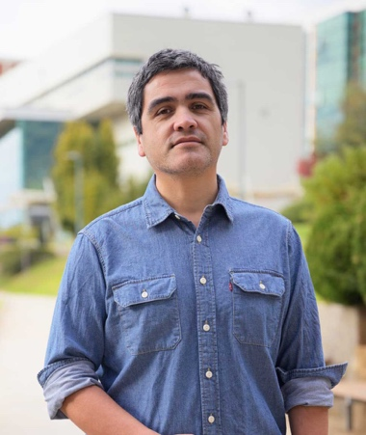
Paulo Salinas, DVM, MSc, PhD
Principal Investigator
Pontifical Catholic University of Valparaíso (PUCV)

Postgraduate Alumni
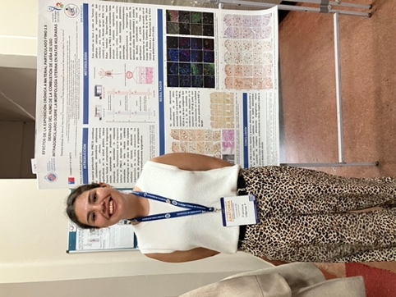 | 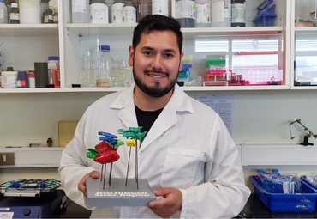
Francisca Villarroel, MSc | Samuel Núñez-Cook, MSc

Undergraduate Students
(Current and former students)
Class of 2025
Francisca San Martín · Javier Rivera · Danae Tapia · Francisca Leiva · Ruth Camargo · Joaquín Olivos · Resef Contreras (UST) · Willy Espinoza · Mónica Conforti
Class of 2024
Matías Vergara · Armando Norambuena · Paula Cerda
Class of 2023
Jovely Silva · Constanza Quizás · Noelia Arroyo · Valentina Zamorano · Giovanni Aguilar · Guiseppe Balsarini · Tamara Lazcano
Class of 2022
Leslie Belmar (UCT) · Mariana Manzor

Collaborators
- Carlos Sandoval MSc — Veterinary Histopathology Center, Chile
- Álvaro González PhD — Department of Mechanical Engineering, PUCV
- Fernando Vidal — IUCN / Fauna Andina, Chile
- María Angélica Miglino PhD — University of Marília (UNIMAR), Brazil
- Erwin Paz PhD — University of Western Australia, Australia

