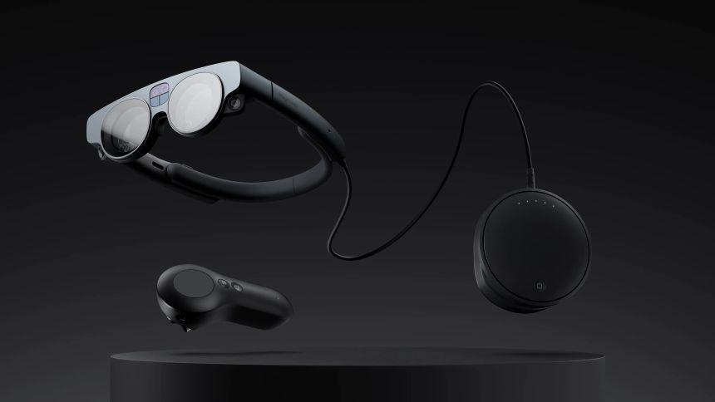

**MAGIC LEAP DISSECTION**

1. **ABOUT:**

Magic Leap, Inc. is an American technology company founded in 2010, with its headquarters proudly located in South Florida. The company's mission revolves around amplifying human potential through its advanced Augmented Reality (AR) platform. This platform empowers individuals to intuitively perceive and interact with digital content seamlessly integrated into the physical world.

At its core, Magic Leap offers a leading AR/VR platform that superimposes 3D computer-generated imagery onto real-world objects, creating immersive experiences. Central to their vision is the development of a light-field chip using silicon photonics, exemplifying their commitment to cutting-edge technology.

With substantial investments from prominent entities like Google and Alibaba Group, Magic Leap's value has soared, reaching an estimated $4.5 billion by Forbes in December 2016. In 2018, AT&T became an exclusive partner, facilitating broader access to Magic Leap's innovative AR solutions. The Magic Leap One, a head-mounted AR display, became available to consumers in the United States through AT&T.

Magic Leap's journey is marked by innovation. In May 2020, the company secured an additional $350 million in funding, coinciding with the announcement of CEO Rony Abovitz's departure. His successor, former Microsoft executive Peggy Johnson, took the helm, ushering in a new era for the company.

One of Magic Leap's standout features is its developer ecosystem, notably the "Magic Leap World" app store. Here, developers could distribute and monetize their AR applications and experiences, subject to platform guidelines and approval. This ecosystem, along with Magic Leap's spatial computing capabilities, versatility across domains, and unique interaction paradigms, positions it as a leading AR/VR platform.

In summary, Magic Leap stands at the forefront of AR/VR technology, offering a robust platform for creating immersive experiences. Its ongoing evolution and commitment to pushing the boundaries of augmented reality make it an intriguing subject for exploration and analysis in the ever-evolving landscape of human-computer interaction.

1. **FEATURES OF MAGIC LEAP 2 DEVICE:**

| What is… | Magic Leap 2 is an augmented reality device that maintains its users' view of their environment while integrating digital content within it. Purpose-built for enterprise use, its open platform and industry-leading technology and features are designed to run transformative enterprise solutions. |
| --- | --- |
| Immersive ness and visual experience | Highly immersive. A real-time view of the physical world is maintained through transparent optics. Digital content is integrated into the user's view where and when it is needed. |
| Detrimental effects: Motion sickness ("cyber sickness") and/or feeling of disembodiment | Unlikely |
| User adaptability | Users adapt immediately with little training. |
| Collaboration | Fully collaborative remote or co-located experience across Magic Leap 2 devices and platforms |
| Real-world interactivity | High |
| Spatial mapping | Yes. Persistent spatial mapping. |
| Target industries and use cases | Enterprise. Currently deployed in manufacturing, healthcare, public sector/government, architecture, engineering, & construction (AEC), and retail for a variety of use cases |
| Working environment | Indoor and outdoor adjacent |
| Ergonomics and mobility | Lightweight headset (260g) suitable for extended daily use. Ergonomically designed to minimize discomfort, fatigue, and eye strain. Highly mobile. |
| Development and platform support | Unrestricted open platform |
| Available devices | Magic Leap 2 |

1. **PRODUCT OR PLATFORM??**

Magic Leap can be considered both a platform and a product, depending on how you look at it.

* Magic Leap as a Platform:
  + AR Development Platform: Magic Leap provides developers with a platform for creating augmented reality (AR) experiences. Developers can use Magic Leap's tools, APIs, and resources to build AR applications and content that can run on Magic Leap devices. In this sense, Magic Leap serves as a platform for AR development.
  + Spatial Computing Platform: Magic Leap is known for its spatial computing capabilities, which allow digital content to interact with the physical world. This aspect of Magic Leap positions it as a platform for creating spatially aware AR experiences.
* Magic Leap as a Product:
  + Magic Leap One: The Magic Leap One is a specific product offered by Magic Leap. It's an AR headset incorporating the technology and platform for AR experiences. It includes hardware components (such as the headset itself, controller, and sensors) and software components that enable users to experience AR content. As a product, the Magic Leap One is a physical device that consumers or developers can purchase and use.

Magic Leap 2 continues the legacy of its predecessor, Magic Leap One, as an advanced AR headset. However, it goes far beyond a singular device, embodying an ecosystem that empowers developers to craft rich, spatially aware AR/VR experiences. This platform-centric approach is evidenced by the comprehensive developer resources and tools provided by Magic Leap.

The Magic Leap Creator Portal, a hub for developers, offers a range of documentation, tutorials, and guidelines for building immersive content. Developers can harness the Magic Leap SDK, a robust set of APIs, to create spatial computing applications that interact seamlessly with the real world.

Additionally, Magic Leap's commitment to fostering a community of creators is exemplified by the Magic Leap Developer Forum, a vibrant space for collaboration and knowledge sharing. Here, developers can engage with peers, seek assistance, and stay updated on the latest platform developments.

Magic Leap's ecosystem extends to spatial computing, enabling developers to place digital content in the physical world, enhancing its utility across domains. This spatial awareness, coupled with unique interaction paradigms, positions Magic Leap 2 as a platform tailored for the creation of spatially immersive AR/VR experiences.

Magic Leap 2 is unequivocally more than a standalone product; it's a dynamic AR/VR platform that empowers developers to shape the future of immersive technology. Its comprehensive suite of resources and spatial computing capabilities underscore its position as a leading platform for AR/VR innovation.

1. **MAGIC LEAP 2 AS A PLATFORM:**
2. **Hardware Components:**

Magic Leap's hardware components are designed to enable a natural and immersive AR experience:

1. **Lightwear (AR Goggles):** The centerpiece of Magic Leap's hardware is the Lightwear, which is a pair of AR goggles or glasses. These goggles are equipped with several key components:
2. **Optics:** Magic Leap uses waveguide optics to project digital content into the user's field of view. The optics are designed to make virtual objects appear as if they exist in the physical world.
3. **Sensors:** The Lightwear is packed with various sensors, including cameras, gyroscopes, accelerometers, and magnetometers. These sensors enable the device to understand the user's surroundings, track their movements, and detect gestures.
4. **Spatial Audio:** Integrated speakers provide spatial audio, allowing sounds from virtual objects to appear as if they originate from their virtual locations.
5. **Processor and GPU:** Magic Leap's Lightpack, a small computing unit, contains the processor and GPU responsible for running applications and rendering 3D graphics.
6. **Control Devices:** Magic Leap offers a range of control devices, including handheld controllers and hand tracking. These allow users to interact with virtual objects in their environment.
7. **Software Components:**

Magic Leap's software components are essential for creating, managing, and interacting with AR content:

* 1. **Lumin OS:** Magic Leap's operating system is called Lumin OS. It's designed to handle the unique requirements of AR, such as spatial computing and gesture recognition. The OS manages the hardware components, handles user interactions, and runs AR applications.
  2. **Spatial Computing:** Magic Leap's core technology is spatial computing. The device scans and maps the physical environment using sensors and computer vision. It understands the geometry of the space, detects surfaces, and creates spatial anchors that allow virtual objects to stay in place as users move around.
  3. **Development Tools:** Magic Leap provides developers with a range of development tools, including:
  + **Unity and Unreal Engine Integration:** Developers can create AR experiences using popular game engines like Unity and Unreal Engine. Magic Leap offers integrations and plugins for these engines.
  + **Magic Leap SDK:** The Magic Leap SDK includes APIs and tools for creating spatially aware AR applications. Developers can access APIs for hand tracking, gesture recognition, spatial mapping, and more.
  1. **Content Management:** Magic Leap offers tools for content creators to design, build, and deploy AR experiences. Developers can create 3D models, animations, and interactive content.

1. **How Magic Leap Works:**
2. **Spatial Mapping:** Magic Leap's sensors and cameras continuously scan the user's physical environment to create a detailed spatial map. This map includes information about surfaces, objects, and spatial features.
3. **Spatial Anchors:** Virtual objects are anchored to specific locations in the real world using spatial anchors. This anchoring ensures that virtual objects stay in place and interact realistically with the physical environment.
4. **Interaction:** Users can interact with AR content using gestures, hand tracking, or handheld controllers. The system recognizes these interactions and responds accordingly.
5. **Rendering:** The Lightpack processes the data from sensors and runs AR applications. It renders 3D graphics and combines them with the real-world view, providing an immersive experience through the Lightwear goggles.
6. **Spatial Audio:** The spatial audio system simulates sound sources in 3D space, allowing users to hear virtual objects as if they exist in their environment.
7. **Developer Ecosystem:** Developers create AR applications using Magic Leap's development tools and APIs. These apps can then be distributed through the Magic Leap World app store.
8. **REAL-WORLD PROBLEMS & MAGIC LEAP’S SOLUTIONS:**

**1. Remote Collaboration and Communication:**

* In an increasingly globalized and digital world, the need for effective remote collaboration and communication has never been more critical. Traditional video conferencing tools, while functional, often fall short in replicating the nuances of in-person interactions. Magic Leap's AR technology offers a transformative solution. By leveraging spatial computing, Magic Leap creates immersive virtual environments where users feel like they're sharing the same physical space, even when they are miles apart. This technology provides a deeper level of engagement, allowing colleagues, clients, and friends to interact more naturally and effectively.
* Imagine a virtual boardroom where avatars of team members are seated around a table. You can see their body language, gestures, and expressions, making meetings more human and intuitive. Moreover, you can manipulate 3D models and data as if they were physical objects, enhancing collaboration in fields such as architecture, design, and engineering. Whether for business meetings, creative brainstorming sessions, or simply connecting with loved ones, Magic Leap's approach to remote collaboration has the potential to bridge the gap between physical and digital interaction.

**2. Medical Training and Visualization:**

* Medical education and training have long relied on textbooks, 2D images, and lectures to convey complex anatomical structures and surgical procedures. However, these methods often struggle to provide a comprehensive understanding of the intricacies of the human body. Magic Leap's AR technology offers a game-changing solution for medical professionals and students. By overlaying 3D medical models onto the physical world, Magic Leap enables users to explore the human anatomy in an immersive and interactive manner.
* Imagine medical students donning Magic Leap headsets and viewing a lifelike 3D model of the human heart suspended in mid-air. They can walk around it, manipulate it, and see how it functions in a way that was never possible with traditional teaching methods. Surgeons can plan and practice complex procedures in a risk-free virtual environment before stepping into the operating room. Patients can also benefit as doctors use AR to explain diagnoses and treatment options in a more visual and accessible way. Magic Leap's AR technology has the potential to revolutionize medical education, surgical planning, and patient communication.

**3. Retail and E-Commerce:**

* Online shopping has become a ubiquitous part of modern life, yet it comes with certain limitations, especially when it comes to visualizing products before making a purchase. Magic Leap addresses this challenge by introducing augmented reality into the retail and e-commerce landscape. With a Magic Leap headset, shoppers can bring products into their own physical environment virtually. For instance, if you're considering buying a new piece of furniture, you can use Magic Leap to place a 3D virtual representation of that furniture in your living room. This allows you to see how it fits with your existing decor and whether it meets your expectations in terms of size and style.
* Additionally, Magic Leap's technology can enhance the shopping experience in physical stores. Retailers can deploy AR solutions that provide customers with interactive product information, such as reviews, specifications, and price comparisons, all by simply looking at an item with the headset. This level of immersion and interactivity can significantly impact purchasing decisions and improve the overall shopping experience. For e-commerce platforms, integrating Magic Leap's AR capabilities can reduce return rates by giving customers a more accurate understanding of the products they are buying. In essence, Magic Leap's solution can bridge the gap between online and offline retail, providing consumers with a richer and more informed shopping experience.

**4. Training and Simulation:**

* High-risk jobs, such as firefighting, military service, and aviation, require rigorous and realistic training. However, conducting such training in real-world scenarios can be prohibitively expensive and, in some cases, dangerous. Magic Leap's AR technology offers a groundbreaking solution in the form of immersive training simulations. Trainees can wear Magic Leap headsets to enter virtual environments that replicate real-world scenarios with an unprecedented level of detail.
* For example, firefighters can practice extinguishing virtual fires in realistic settings, pilots can undergo flight training in a virtual cockpit, and soldiers can participate in combat simulations. These experiences provide valuable training without the risks associated with actual high-stakes situations. Moreover, the interactive nature of Magic Leap's AR allows trainers to monitor and provide real-time feedback to trainees, enhancing the learning process. This approach not only saves costs but also improves safety and prepares individuals for high-pressure professions.

**5. Education and Remote Learning:**

* The COVID-19 pandemic dramatically accelerated the shift towards remote learning, highlighting the challenges of engaging students in virtual classrooms. Magic Leap's AR technology presents a compelling solution to enhance education and remote learning. By creating immersive and interactive educational content, Magic Leap helps students overcome the limitations of traditional online courses.
* Imagine a history lesson where students can walk through ancient ruins, a science class where they can manipulate and observe virtual molecules, or a language lesson where they converse with lifelike virtual avatars to practice speaking. Magic Leap's spatial computing capabilities bring subjects to life, making learning engaging and memorable. Moreover, remote learners can participate in virtual classrooms, feeling as though they are sitting side by side with their peers and instructors.
* Magic Leap's AR technology has the potential to make education more accessible and effective, catering to diverse learning styles and subjects. It opens up new possibilities for educators and students alike, offering a glimpse into the future of immersive learning experiences.

Magic Leap's augmented reality technology represents a groundbreaking approach to solving real-world problems across various domains. From enhancing remote collaboration and medical education to revolutionizing retail and training simulations, Magic Leap's AR platform offers immersive solutions that bring digital content into the physical world. This transformative technology has the potential to reshape industries and provide innovative solutions to some of today's most pressing challenges.

1. **Features of Magic Leap:**
2. **User Profiles:**

* User profiles allow individuals to create and customize their digital identity within the Magic Leap 2 platform. Users can provide personal information, select avatars, and set preferences.
* User profiles offer a personalized experience by tailoring content, interactions, and recommendations based on user data. They facilitate social interactions, enabling users to connect with others and build a sense of identity within the AR/VR space.

1. **Spatial Anchors:**

* Spatial anchors enable users to place persistent markers or tags in their physical environment. These markers can be used to attach digital content, making it appear consistently in the same physical location.
* Spatial anchors enhance productivity and organization by allowing users to associate AR content with specific real-world locations. For example, users can pin virtual notes on their office desks or place navigation cues in their homes.

1. **User Authentication and Permissions:**

* User authentication ensures secure access to the Magic Leap 2 platform, requiring users to log in with their credentials. Permissions control data access and usage.
* These features are vital for data privacy and security. User authentication prevents unauthorized access, while permissions enable users to control who can view, edit, or interact with their AR content.

1. **Content Discovery and Recommendation:**

* Magic Leap 2 utilizes algorithms to analyze user behavior, preferences, and interactions to suggest relevant AR content and experiences.
* Content discovery and recommendation enhance user engagement by delivering content tailored to individual interests. This feature keeps users engaged and encourages exploration within the platform.

1. **Interactive Gestures and Controllers:**

* Magic Leap 2 supports intuitive gestures and controllers that allow users to interact with AR objects and navigate virtual environments.
* Interactive gestures and controllers are fundamental for user immersion. They provide a natural and intuitive way to engage with the AR/VR environment, making it more accessible and enjoyable.

1. **Collaboration Tools:**

* Collaboration tools enable users to work together in real-time, even in remote settings. This includes features like screen sharing, co-editing, and communication tools.
* In today's interconnected world, collaboration tools are essential for remote teamwork and communication. They enable users to collaborate effectively within the AR/VR environment, enhancing productivity and communication.

1. **Content Creation and Editing Tools:**

* Magic Leap 2 offers tools for users to create, edit, and share their AR content and experiences. This can include 3D modeling, animation, and content-authoring tools.
* Empowering users to be content creators fosters creativity and diversity within the platform. It encourages user-generated content, expanding the AR ecosystem and providing a wide range of experiences.

1. **Accessibility Features:**

* Accessibility features cater to users with disabilities. These can include voice commands, text-to-speech, customizable interfaces, and more.
* Ensuring accessibility is essential for inclusivity. These features make the platform usable by individuals with different abilities, enhancing the user base and promoting diversity.

1. **Community and Social Integration:**

* Social integration features allow users to connect with others, form communities, and share AR experiences. This includes friend lists, chat functions, and social sharing.
* Social integration fosters a sense of belonging and community within the platform. It encourages social engagement, interaction, and user-generated content, making the platform more dynamic and appealing.

1. **User Support and Feedback:**

* User support includes in-app help, FAQs, and access to customer support channels. Feedback mechanisms allow users to provide input and report issues.
* Providing user support ensures a positive user experience by addressing user queries and issues promptly. Feedback channels enable users to contribute to platform improvement, making it more user-friendly and adaptable to their needs.

Incorporating these user-centered features into the Magic Leap 2 AR/VR platform design prioritizes user experience, personalization, security, and inclusivity. It fosters a thriving user community and ensures that the platform caters to a diverse audience with varying needs and preferences. Ultimately, a user-centric approach enhances user satisfaction and the platform's overall success.

1. **SCHEMA DESIGN:**

**Understanding Schema Design:**

A database schema defines how data is organized within a relational database; this is inclusive of logical constraints such as table names, fields, data types, and the relationships between these entities. Schemas commonly use visual representations to communicate the architecture of the database, becoming the foundation for an organization’s data management discipline. This process of database schema design is also known as data modeling.

A database schema is considered the “blueprint” of a database which describes how the data may relate to other tables or other data models. However, the schema does not actually contain data.

Logical database schemas are less abstract, compared to conceptual schemas. They clearly define schema objects with information, such as table names, field names, entity relationships, and integrity constraints. (i.e. any rules that govern the database. However, they do not typically include any technical requirements.)

**Some key benefits of database schemas include:**

**Access and security:** Database schema design helps organize data into separate entities, making it easier to share a single schema within another database. Administrators can also control access through database permissions, adding another layer of security for more proprietary data.

**Organization and communication:** Documentation of database schemas allows for more organization and better communication among internal stakeholders. Since it provides a common source of truth, it enables users to understand the logical constraints and methods of aggregation across tables.

**Integrity:** This organization and communication also helps to ensure data validity. For example, it can help administrators manage normalization processes to avoid data duplication. It can also assist in monitoring compliance with the constraints in the schema's database design, enabling adherence to ACID properties (atomicity, consistency, isolation, durability).

Below is a high-level schema design that incorporates the mentioned features:

* **User Entity:**
  + Attributes:
    - * UserID (Primary Key)
      * Username
      * Email
      * Password (Hashed and Salted)
      * Avatar URL
      * Location
      * Biography
      * Preferences (Stored as JSON or separate table)
  + Relationships:
    - * One-to-Many with Content (User creates and interacts with content)
      * Many-to-Many with Friends (Users can have multiple friends)
      * One-to-Many with Permissions (User's access to shared content)
      * One-to-Many with Interaction History (Record of user interactions)
* **SpatialAnchor Entity:**
  + Attributes:
    - * AnchorID (Primary Key)
      * UserID (Foreign Key to User)
      * Location (3D coordinates)
      * Description
      * Timestamp
  + Relationships:
    - * One-to-one with AR Content (AR content associated with an anchor)
* **Permissions Entity:**
  + Attributes:
    - * PermissionID (Primary Key)
      * ContentID (Foreign Key to AR Content)
      * UserID (Foreign Key to User)
      * AccessLevel (e.g., Read, Write)
  + Relationships:
    - * Many-to-Many with User (User's permissions for shared content)
* **Ar_Content Entity:**
  + Attributes:
    - * ContentID (Primary Key)
      * Title
      * Description
      * Type (e.g., 3D model, video, game)
      * Tags/Categories (Stored as JSON or separate table)
      * Author/Creator (Foreign Key to User)
      * Creation Date
  + Relationships:
    - * One-to-Many with SpatialAnchor (AR content associated with spatial anchors)
      * Many-to-Many with User (Users can like and interact with content)
      * One-to-Many with Author of Content(AR_content)
* **Interaction Entity:**
  + Attributes:
    - * InteractionID (Primary Key)
      * UserID (Foreign Key to User)
      * ARContentID (Foreign Key to AR Content)
      * Timestamp
      * GestureType (e.g., tap, swipe)
      * InteractionDetails (e.g., gesture coordinates)
  + Relationships:
    - * Many-to-One with User (User's interactions)
      * Many-to-One with AR Content (Content interactions)
* **CollaborationSession Entity:**
  + Attributes:
    - * SessionID (Primary Key)
      * Participants (List of UserIDs)
      * Start Time
      * End Time
  + Relationships:
    - * Many-to-Many with User (Users participating in a session)
* **ContentCreation Entity:**
  + Attributes:
    - * CreationID (Primary Key)
      * UserID (Foreign Key to User)
      * ARContentID (Foreign Key to AR Content)
      * CreationDate
      * Editing Tools (e.g., 3D modeling software used)
  + Relationships:
    - * Many-to-One with User (User's content creations)
* **AccessibilitySettings Entity:**
  + Attributes:
    - * SettingsID (Primary Key)
      * UserID (Foreign Key to User)
      * VoiceCommandsEnabled
      * TextToSpeechEnabled
      * CustomizableInterfaces (Stored as JSON)
  + Relationships:
    - * One-to-One with User (User's accessibility settings)
* **Friendship Entity:**
  + Attributes:
    - * FriendshipID (Primary Key)
      * UserID1 (Foreign Key to User)
      * UserID2 (Foreign Key to User)
      * FriendshipStatus (e.g., pending, accepted)
  + Relationships:
    - * Many-to-Many with User (User's friends)
* **SupportTicket Entity:**
  + Attributes:
    - * TicketID (Primary Key)
      * UserID (Foreign Key to User)
      * Category (e.g., technical issue, feedback)
      * Description
      * Status (e.g., open, closed)
      * Timestamp
  + Relationships:
    - * Many-to-One with User (User's support tickets)

This schema design incorporates the mentioned user-centered features into various tables and relationships. It supports user profiles, spatial anchors, permissions, content discovery, interactive gestures, collaboration, content creation, accessibility, social integration, and user support. This structure enables the Magic Leap 2 AR/VR platform to provide a rich, user-centric experience while maintaining data integrity and security.

1. **ER DIAGRAM:**

An Entity Relationship (ER) Diagram is a type of flowchart that illustrates how “entities” such as people, objects or concepts relate to each other within a system. ER Diagrams are most often used to design or debug relational databases in the fields of software engineering, business information systems, education and research. Also known as ERDs or ER Models, they use a defined set of symbols such as rectangles, diamonds, ovals and connecting lines to depict the interconnectedness of entities, relationships and their attributes.

ER diagrams are related to data structure diagrams (DSDs), which focus on the relationships of elements within entities instead of relationships between entities themselves. ER diagrams also are often used in conjunction with data flow diagrams (DFDs), which map out the flow of information for processes or systems.

ER Diagrams are composed of entities, relationships and attributes. They also depict cardinality, which defines relationships in terms of numbers. Here’s a glossary:

**Entity:** A definable thing—such as a person, object, concept or event—that can have data stored about it. Think of entities as nouns. Examples: a customer, student, car or product. Typically shown as a rectangle.

**Entity type:** A group of definable things, such as students or athletes, whereas the entity would be the specific student or athlete. Other examples: are customers, cars or products.

### **Relationship:** How entities act upon each other or are associated with each other. Think of relationships as verbs. For example, the named student might register for a course. The two entities would be the student and the course, and the relationship depicted is the act of enrolling, connecting the two entities in that way.

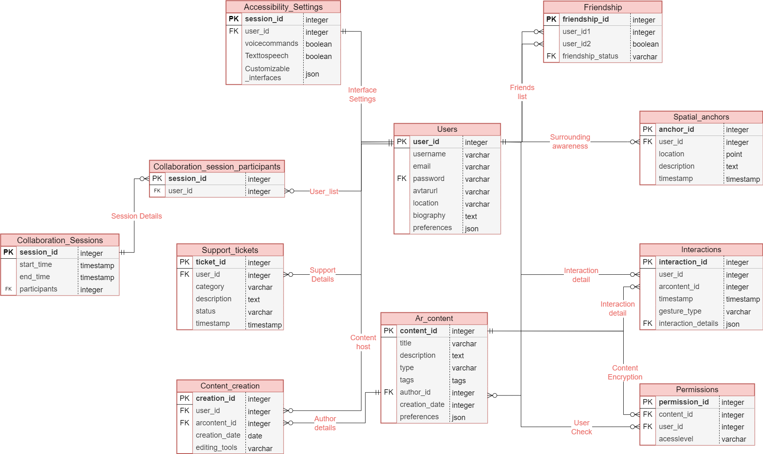

1. **CONCLUSION:**

In this comprehensive exploration, we have ventured into the intricate schema and Entity-Relationship diagram design for the Magic Leap 2 AR/VR platform. Magic Leap 2, representing a groundbreaking evolution in augmented and virtual reality technology, embodies the fusion of the digital and physical realms.

Its schema, a meticulously crafted structure encompassing entities like users, spatial anchors, content, and permissions, serves as the bedrock for a platform that prioritizes the user experience at every turn.

By delving into this schema, we unearth a profound understanding of how Magic Leap 2 adeptly navigates the intricacies of user interactions, content creation, collaboration, and accessibility. It showcases the platform's unwavering commitment to placing users at the forefront, ensuring their security, personalization, and inclusivity. This schema isn't merely a technical blueprint; it's a testament to Magic Leap 2's potential to reshape diverse industries, from education and healthcare to entertainment and innovation.

Magic Leap 2's schema is the canvas upon which users can craft immersive experiences, educators can inspire, and creators can innovate. It solidifies Magic Leap 2's standing as a pioneering AR/VR platform, poised to redefine the landscape of human-computer interaction. In essence, it's the foundation upon which the future of augmented and virtual reality will be built, ushering in a new era of transformative experiences.

1. **REFERENCES:**

[1] Introduction to Schema & Details <https://www.ibm.com/topics/database-schema>

[2] Creating ER Diagram using PostgreSQL <https://www.enterprisedb.com/blog/create-erd-pgadmin-4>

[3] The official Magic Leap website provides an overview of the technology, hardware, and software components. <https://www.magicleap.com/>

[4] This portal offers access to developer documentation, SDKs, and resources for creating AR experiences on the platform. <https://developer.magicleap.com/>

[5] In-depth documentation and guides for creators and developers interested in building AR content for Magic Leap. <https://creator.magicleap.com/>

[6] The community forums can be a valuable resource for asking questions, sharing knowledge, and seeking help from other developers. <https://forum.magicleap.com/>

[7] Magic Leap's spatial computing documentation provides insights into designing AR experiences that interact with the physical world. <https://developer.magicleap.com/learn/guides/spatial-computing-concepts>