PENETRATION TESTING REPORT
FOOTPRINTING & NETWORK SCANNING PHASES
W2-PM1-5-FINAL | CYBERSECURITY | NETWORKWALKS

Pentester Name  (Cybersecurity Professional) | Patrick Alabi
Program/Batch | B083-Networkwalks
Date | 15 September 2026
Modules completed | W2-PM1 (Multiple Kali Tools)  W2-PM2 (GHDB)  W2-PM3 (Maltego)  W2-PM4 (theHarvester)  W2-PM5 (Zenmap Scanning)
Client/Target | 1. Networkwalks (secured written permission already)  2. Microsoft.com (accessing publicly available information)  3. My own local LAN Network
Permission secured from client? | Yes
Phases covered | Phase 1: Reconnaissance & Footprinting  Phase 2: Scanning & Network Discovery

1. Liability Disclaimer
I have performed these activities only on the systems & devices where I had secured written permission or the devices/systems that I own myself. All these materials are for education and research purpose only. Do not use anything from here to break the law. The instructor, the authors and Networkwalks are not responsible for what you do with this knowledge. Every action you take is your own responsibility. Misuse can lead to criminal charges, heavy fines, loss of your job and a permanent record. In most countries unauthorised access is a crime even when nothing is damaged.

2. Introduction
This final Week 2 report consolidates the five completed project modules: multiple Kali Linux footprinting tools (W2-PM1), Google Hacking Database reconnaissance (W2-PM2), Maltego footprinting (W2-PM3), theHarvester reconnaissance against microsoft.com (W2-PM4), and Zenmap network discovery on my local LAN (W2-PM5).
The activities demonstrate a progression from passive information gathering to network discovery. Work against networkwalks.com was performed with the required permission, Microsoft.com information was gathered from public sources as specified by the practical, and Zenmap scanning was performed against my own local network. Screenshots have been added in the evidence section of this report.

3. Tools Used
The table below lists each tool used in this report and its purpose.
Tool | Purpose
Kali Linux & Windows | Operating systems used for reconnaissance activities
WHOIS | Find domain registration details (owner, dates, name servers).
whatweb | Fingerprint web technologies (server, CMS, plugins, IP).
nslookup | Resolve the domain name to its IP address using DNS.
curl -I | Read the HTTP response headers of the website.
wafw00f | Detect whether a Web Application Firewall protects the site.
dnsrecon | Enumerate all DNS records (NS, MX, SPF, TXT, SRV).
Zenmap (Nmap GUI) | Scan the local subnet to find live hosts, IPs and MAC addresses.
Windows CMD | Local IP and MAC address identification
GHDB (Google Hacking Database) | Use Google dorks to identify publicly indexed exposed devices and files.
Maltego | Map relationships around a domain and run email-related transforms.
theHarvester | Gather publicly available email addresses, sub-domains and hosts from multiple sources.

4. Activities Performed

4.1 Footprinting & Reconnaissance
I completed W2-PM1 by performing passive reconnaissance of networkwalks.com with six Kali Linux tools. WHOIS returned domain registration and name-server information; WhatWeb identified the web stack; Nslookup resolved the domain; Curl inspected HTTP response headers; Wafw00f identified the WAF; and DNSRecon enumerated DNS infrastructure.
WHOIS identified GoDaddy as the registrar, a 2019 creation date, a 2027 expiry date, and HostGator name servers. The registrant information was privacy-protected. WhatWeb identified Apache, Bootstrap 7.1, jQuery 3.7.1, WordPress 7.1 and WordPress Download Manager 3.3.58, with the site resolving to 192.232.216.135.
Curl returned HTTP/2 200 response headers and exposed the WordPress REST API reference /wp-json/. Wafw00f identified ModSecurity (SpiderLabs), while DNSRecon returned SOA, NS, MX, A, TXT and SRV records and reported unsigned DNSSEC.

4.2 Footprinting & Reconnaissance with GHDB
W2-PM2 used the Google Hacking Database (GHDB) and Google search operators to identify publicly indexed exposures. The practical required two searches: ten live exposed security-camera interfaces and ten listings containing downloadable mathematics PDF material.
For Task 1, the completed worksheet recorded ten exposed camera endpoints and their associated Google dorks, with no usernames or passwords recorded. Because these were live third-party camera interfaces, the final report intentionally records the finding and methodology without reproducing the live access links.
For Task 2, ten publicly indexed mathematics PDF directory listings were recorded. The exercise demonstrated how search-engine indexing can expose directory structures and documents without directly interacting with a target system.

4.3 Footprinting with Maltego
W2-PM3 involved downloading and installing Maltego on Windows, completing the initial configuration and creating the free Maltego account. A Domain entity was then created for networkwalks.com and email-related transforms were run to identify email addresses associated with the organization.
Evidence below confirmed that email-related entities were harvested from the domain. The result provides useful reconnaissance context because exposed organizational email addresses can contribute to later social-engineering and phishing risk assessments.

4.4 Footprinting & Reconnaissance with theHarvester
For W2-PM4, I used theHarvester 4.8.2 against microsoft.com. Task 1 used the command "theHarvester -d microsoft.com -l 1000 -b baidu". The run returned 0 emails address and 7 hosts, with no IPs or people reported.
Task 2 used "theHarvester -d microsoft.com -l 50 -b all". The run returned 7 email addresses, no IPs and no people, and reported 1,312 hosts. Several data sources could not be used because API keys were missing or source connections failed; the run also reported an API-endpoint wordlist error. These limitations were documented rather than treated as findings.
The results demonstrate the scale of information that can be assembled from public sources. TheHarvester documentation also notes that results can change as external information sources change, so the output represents the state observed during this task.

4.5 Network Scanning with Zenmap
W2-PM5, I used Zenmap, the Nmap graphical interface, to perform a Ping Scan of the local 10.0.0.0/24 subnet. The completed scan reported four live hosts.
The observed live hosts were 10.0.0.1, 10.0.0.2, 10.0.0.9 and 10.0.0.10. The scan output recorded the MAC addresses 52:54:00:12:35:00 (QEMU virtual NIC), 08:00:27:A7:5B:C5 (Oracle VirtualBox virtual NIC), 08:00:27:FF:36:16 (Oracle VirtualBox virtual NIC), and 08-00-27-E7-F1-2D for the local machine. The scan covered 256 IP addresses and completed with four hosts up.
The Zenmap Topology view was also used as required by the task, with the legend enabled and the topology saved as a PDF.

5. Risk Analysis / Impact
Based on the combined results from W2-PM1 through W2-PM5, the following are potential security risks and observations. They represent information exposure and discovery findings, not confirmed vulnerabilities.
# | Risk / Finding | Evidence / Observation | Potential Impact | Risk Level
1 | Web technology information exposed | WhatWeb identified WordPress and WP Download Manager | Attackers may use exposed technology/version information to identify software requiring further security review | ● Medium
2 | Server IP address identifiable | Nslookup resolved the domain to 192.232.216.135 | Provides information about the network location of the web service | ● Low
3 | HTTP technical information exposed | Curl returned HTTP response headers and exposed /wp-json/ | May assist technology fingerprinting and further enumeration | ● Low
4 | WAF technology identifiable | Wafw00f identified ModSecurity (SpiderLabs) | Reveals information about the web application’s security architecture | ● Low
5 | DNS infrastructure information exposed | DNSRecon identified DNS, mail and service-related records | DNS information can help build a broader infrastructure profile | ● Medium
6 | Multiple live hosts visible on local network | Zenmap identified four live hosts on 10.0.0.0/24 | Unknown devices may increase the network attack surface | ● Medium
7 | Publicly indexed camera interfaces | GHDB identified 10 exposed camera endpoints | Potential privacy, access-control and security risk | ● High
8 | Public directory/file exposure | GHDB identified 10 mathematics PDF directory listings | May reveal directory structure or files | ● Low
9 | Organizational email addresses exposed | Maltego returned email entities for networkwalks.com | May support phishing and social engineering | ● Medium
10 | Large public sub-domain/host footprint | theHarvester returned 1,312 hosts | Large public host footprint requires asset review | ● Medium

Risk level key: ● Critical ● Medium ● Low
The risks above are observations from the footprinting and scanning exercises, not confirmed vulnerabilities.
The practical exercises primarily involved information gathering and host discovery. No exploitation or vulnerability validation was performed as part of these two modules.
Therefore, the presence of information such as a software version, IP address or DNS record does not by itself mean that the system is vulnerable. Further authorized security testing would be required to confirm any actual vulnerability.

6. Recommendations
Based on the observations from these activities, I recommend the following security improvements:
- Review publicly exposed technology information
Organizations should regularly review what information about their web technologies, CMS and plugins is publicly visible.
- Keep software updated
CMS platforms, plugins and other web technologies should be regularly updated and reviewed against current security advisories.
- Review HTTP headers
HTTP response headers should be reviewed to determine whether unnecessary technical information is being exposed.
- Review DNS records regularly
DNS records should be checked periodically to ensure that only required information and services are publicly exposed.
- Properly configure and monitor the WAF
Keep the WAF (ModSecurity) enabled and tuned, since it already blocks naive attacks.
- Perform regular internal network discovery
Organizations should periodically scan their own networks to identify active devices.
- Investigate unknown devices
Any unexpected device discovered during network scanning should be investigated and verified.
- Maintain network documentation
Network topology and device information should be documented and updated regularly.
- Perform security testing with authorization
Reconnaissance and scanning should only be performed against systems and networks where appropriate authorization has been provided.
- Review Google-indexed exposure
Organizations should periodically search their own domains for exposed devices, directories and documents and remove or restrict information that should not be public.
- Secure externally accessible surveillance devices
Camera interfaces should require strong authentication, appropriate network restrictions and secure configuration rather than being directly exposed to the public internet.
- Minimize public email exposure
Public-facing contact addresses should be separated from sensitive operational accounts and protected with appropriate anti-phishing controls.
- Maintain an accurate sub-domain inventory
Large externally visible host lists should be reviewed so that unused, forgotten or unnecessary sub-domains can be removed or restricted.
Review Google-indexed exposure
Organizations should periodically search their own domains for exposed devices, directories and documents and remove or restrict information that should not be public.
Secure externally accessible surveillance devices
Camera interfaces should require strong authentication, appropriate network restrictions and secure configuration rather than being directly exposed to the public internet.
Minimize public email exposure
Public-facing contact addresses should be separated from sensitive operational accounts and protected with appropriate anti-phishing controls.
Maintain an accurate sub-domain inventory
Large externally visible host lists should be reviewed so that unused, forgotten or unnecessary sub-domains can be removed or restricted.

7. Conclusion
During Week 2 of my Cybersecurity & Ethical Hacking internship, I completed five practical modules covering passive footprinting, Google-based reconnaissance, relationship mapping, public-source harvesting and local network discovery.
Across the modules, I used WHOIS, WhatWeb, Nslookup, Curl, Wafw00f, DNSRecon, GHDB, Maltego, theHarvester and Zenmap. These tools demonstrated how publicly available information can reveal domain registration details, technologies, DNS infrastructure, indexed exposures, organizational email information, public hosts and active local devices.
TheHarvester showed how results can vary by source and how missing API keys or source failures can affect collection. Zenmap then provided a practical view of local network discovery by identifying four live hosts and their MAC addresses on the scanned subnet.
The combined exercises showed that reconnaissance is a major part of cybersecurity assessment. Before exploitation is considered, a security professional can build an understanding of the visible attack surface and identify information that defenders may need to reduce or monitor.
I also learned that technical findings must be documented with their evidence, limitations and potential impact. Public exposure does not automatically mean a confirmed vulnerability; further authorized validation is required before assigning a confirmed vulnerability status.
Finally, all reconnaissance and scanning activities must remain within an authorized scope. The Networkwalks practicals were completed for educational purposes, with Networkwalks used under the stated permission, Microsoft.com information gathered from public sources as specified by the task, and Zenmap used on my own local network.

8. Evidences Collected
Figure 1 – W2-PM1: WHOIS and WhatWeb output.
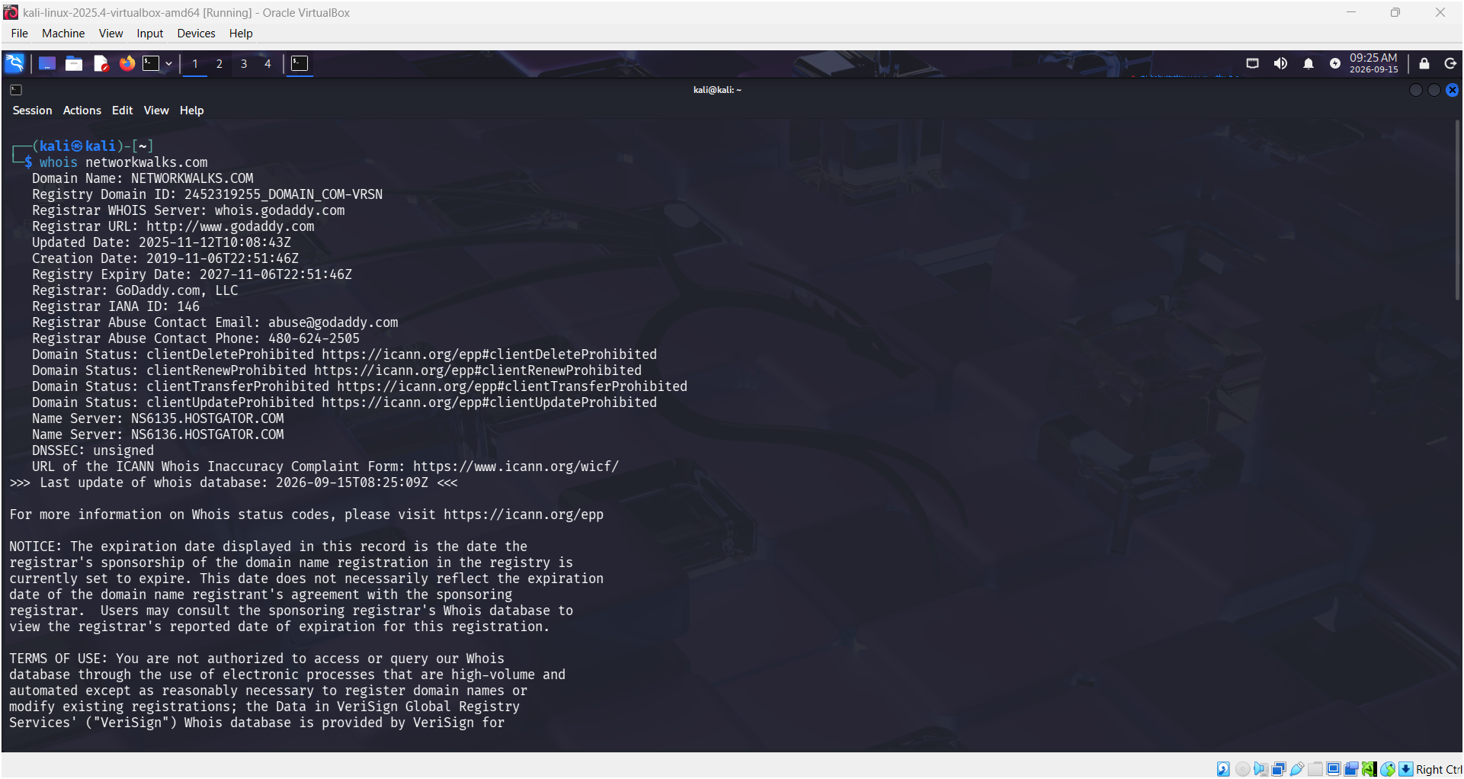
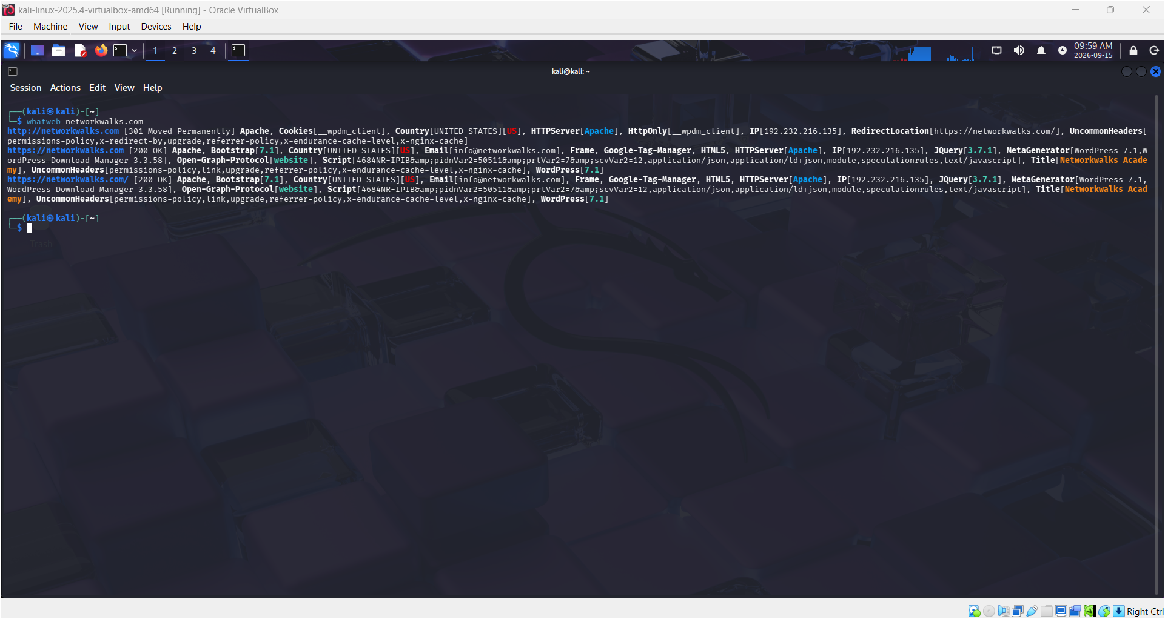
Figure 2 – W2-PM1: Nslookup, Curl and Wafw00f output.
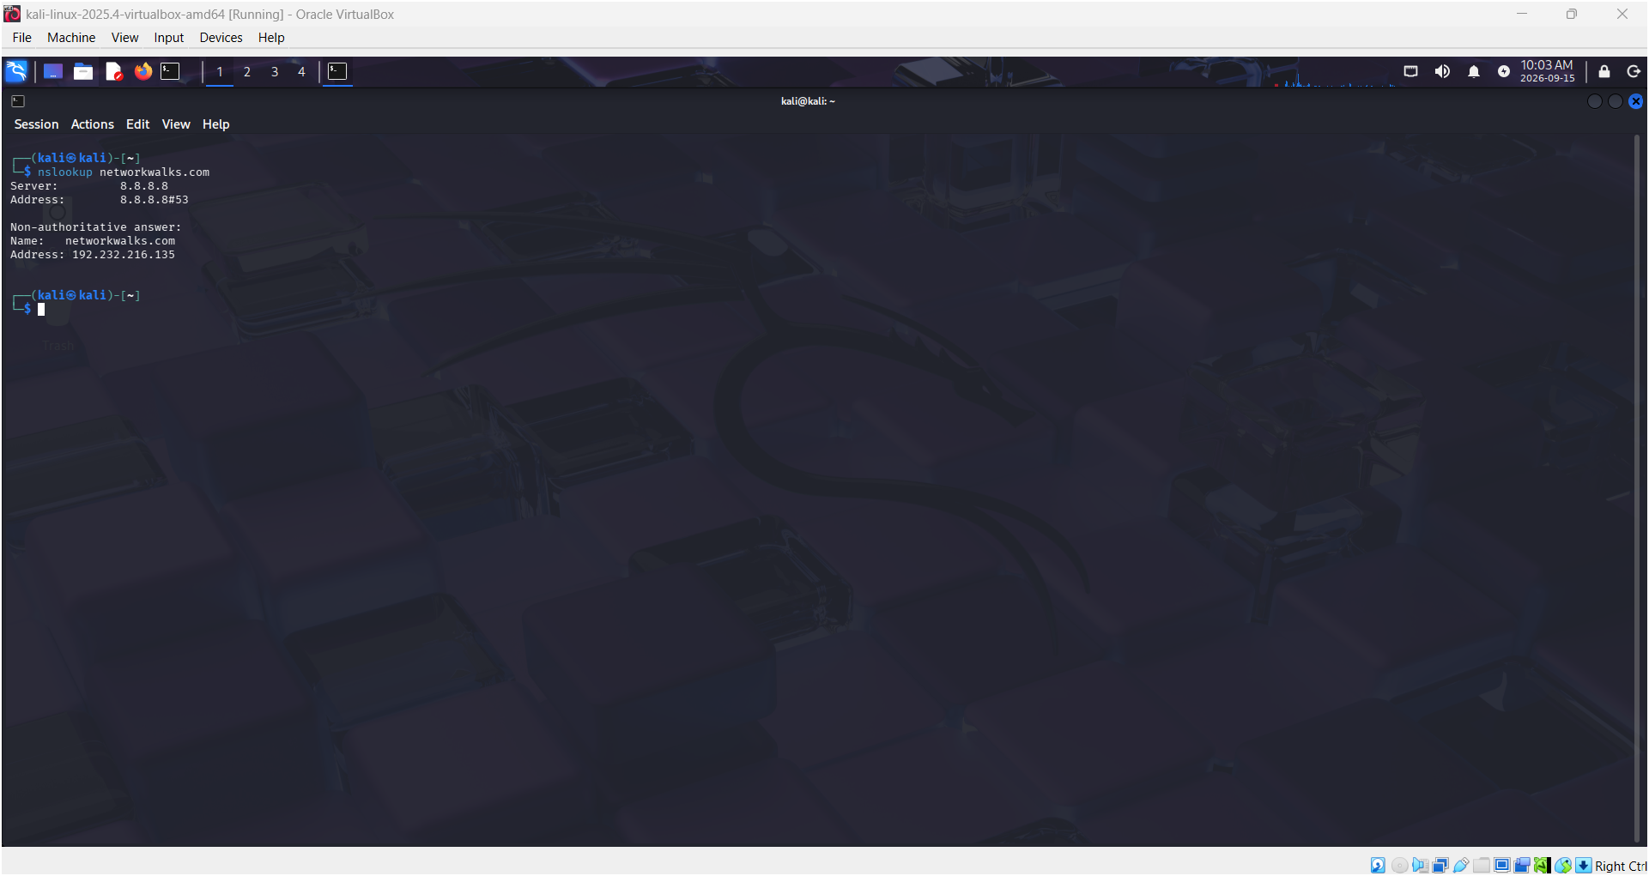
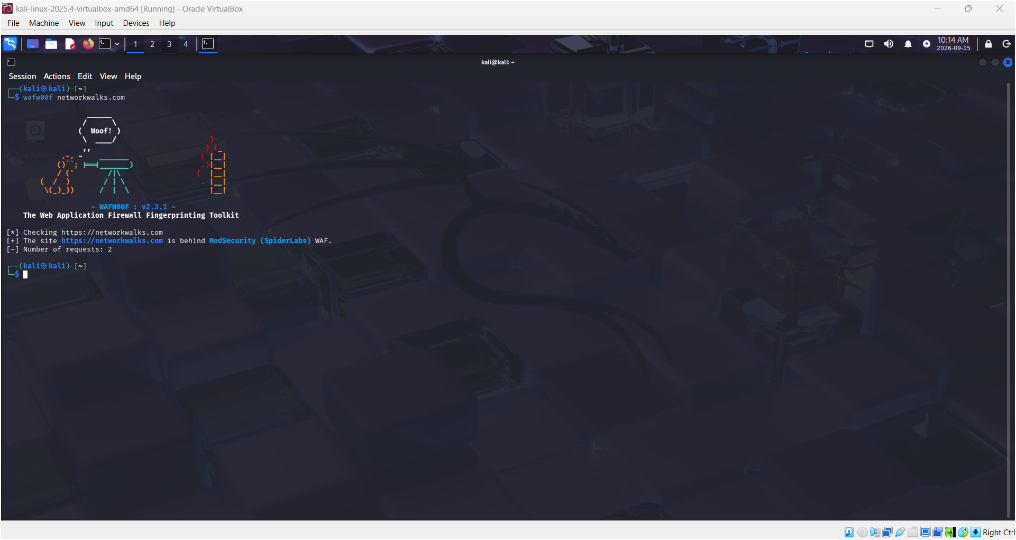
Figure 3 – W2-PM1: DNSRecon output.
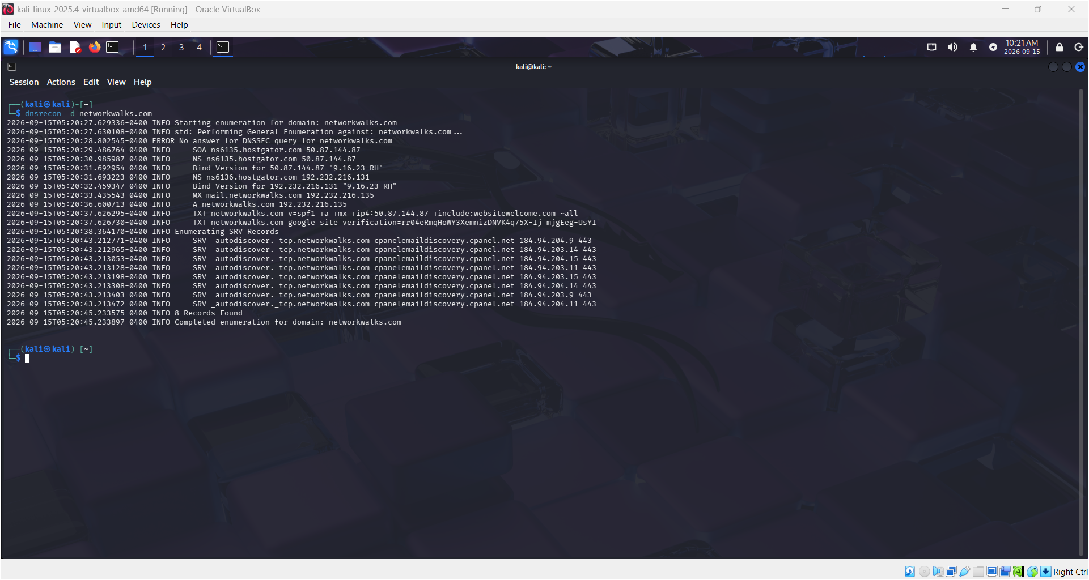

Figure 4 – W2-PM2: GHDB search and completed findings evidence.

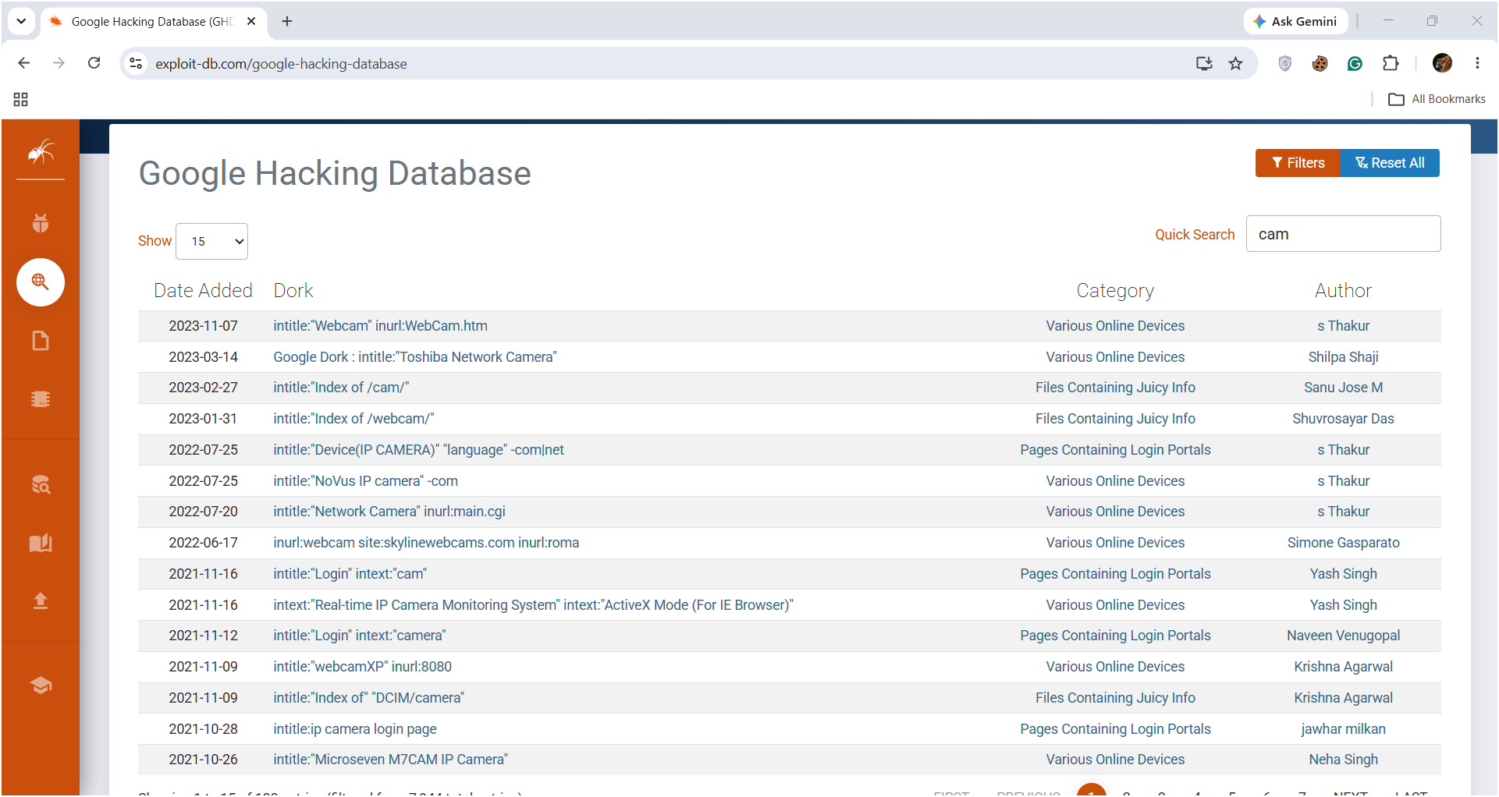

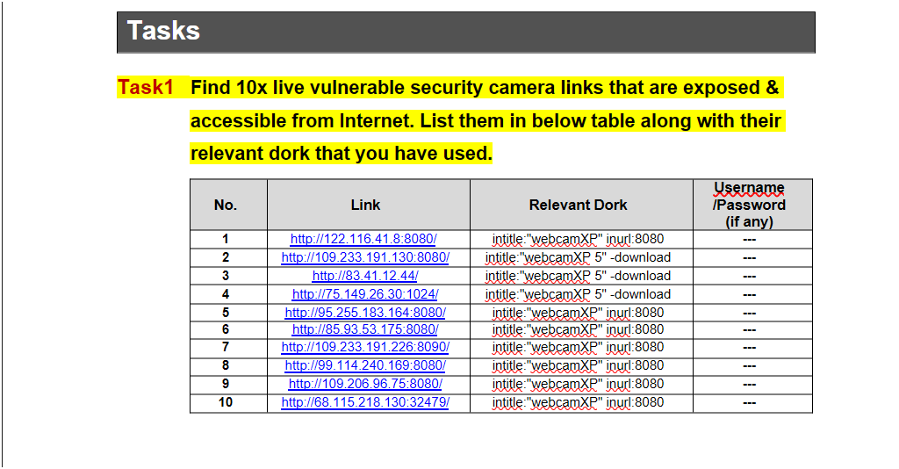
Figure 5 – W2-PM3: Maltego domain entity and email transform results.

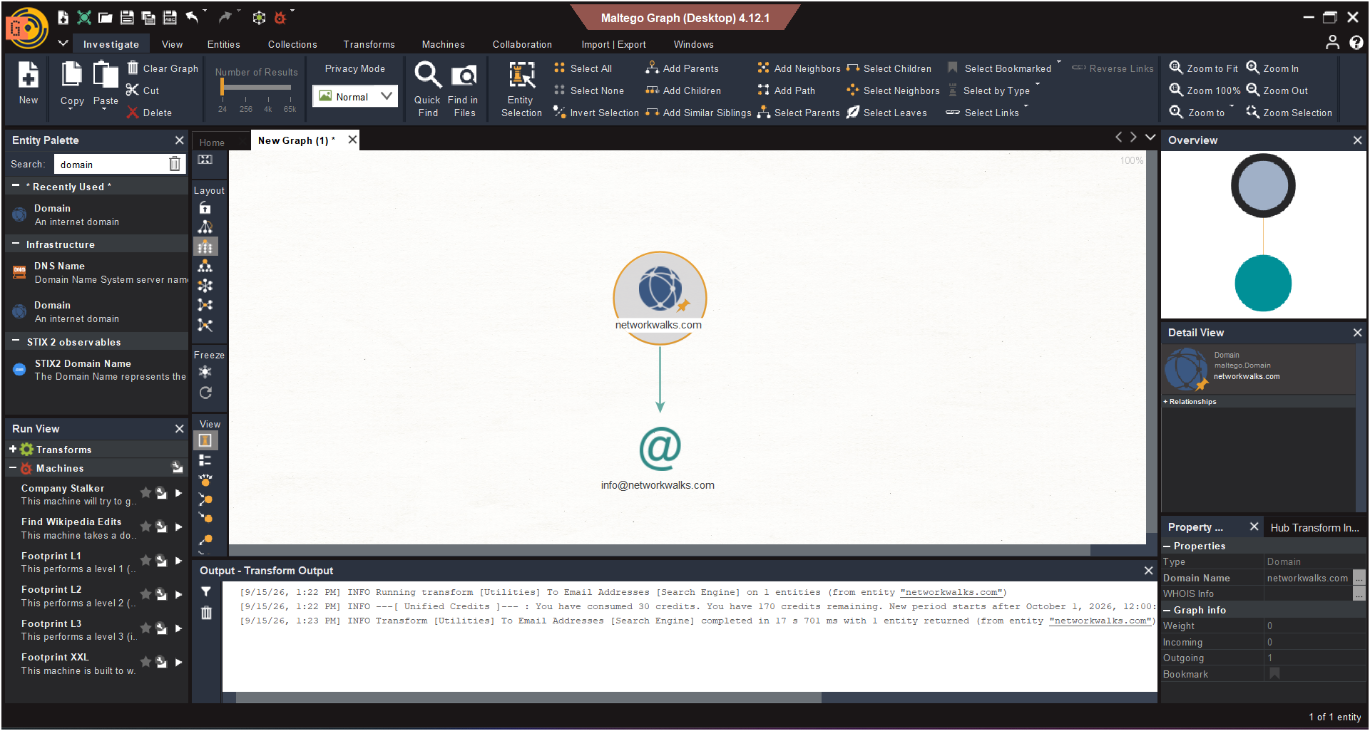
Figure 6 – W2-PM4: theHarvester Baidu results.
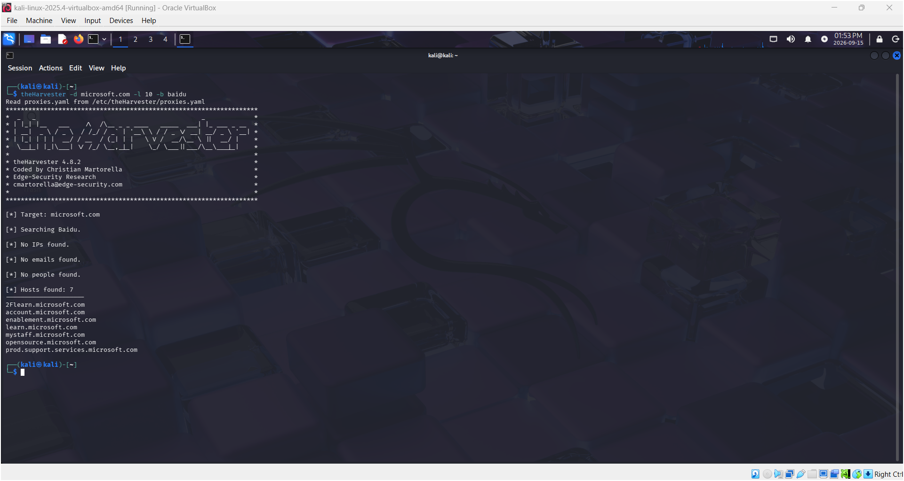
Figure 7 – W2-PM4: theHarvester all-source results and limitations.

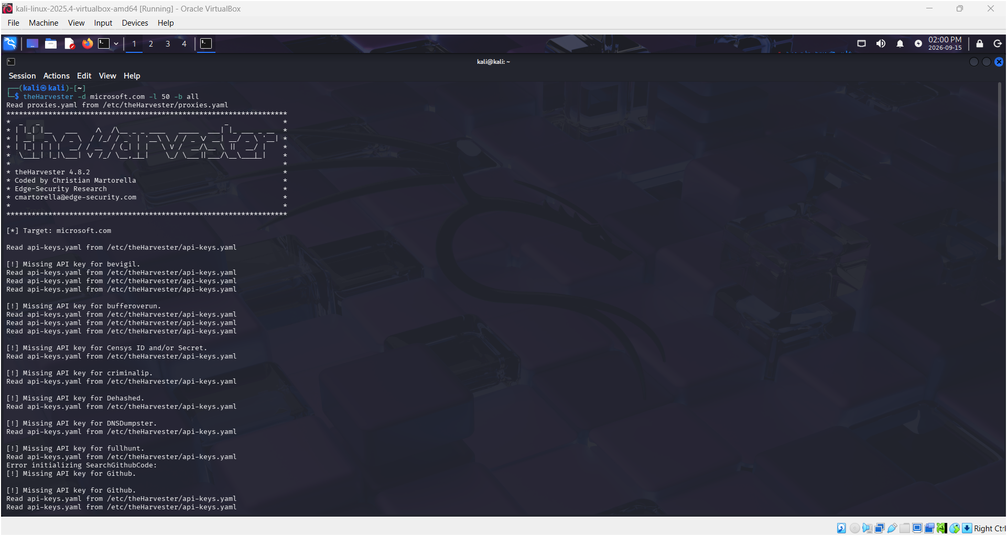

Figure 8 – W2-PM5: Zenmap Ping Scan results showing the four live hosts.
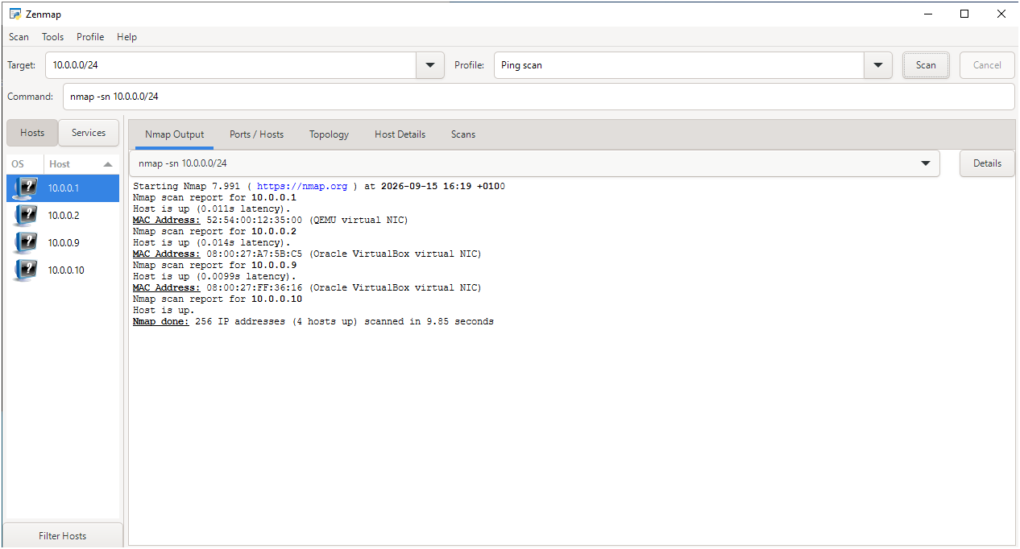
Figure 9 – W2-PM5: Zenmap Topology view and saved PDF evidence.

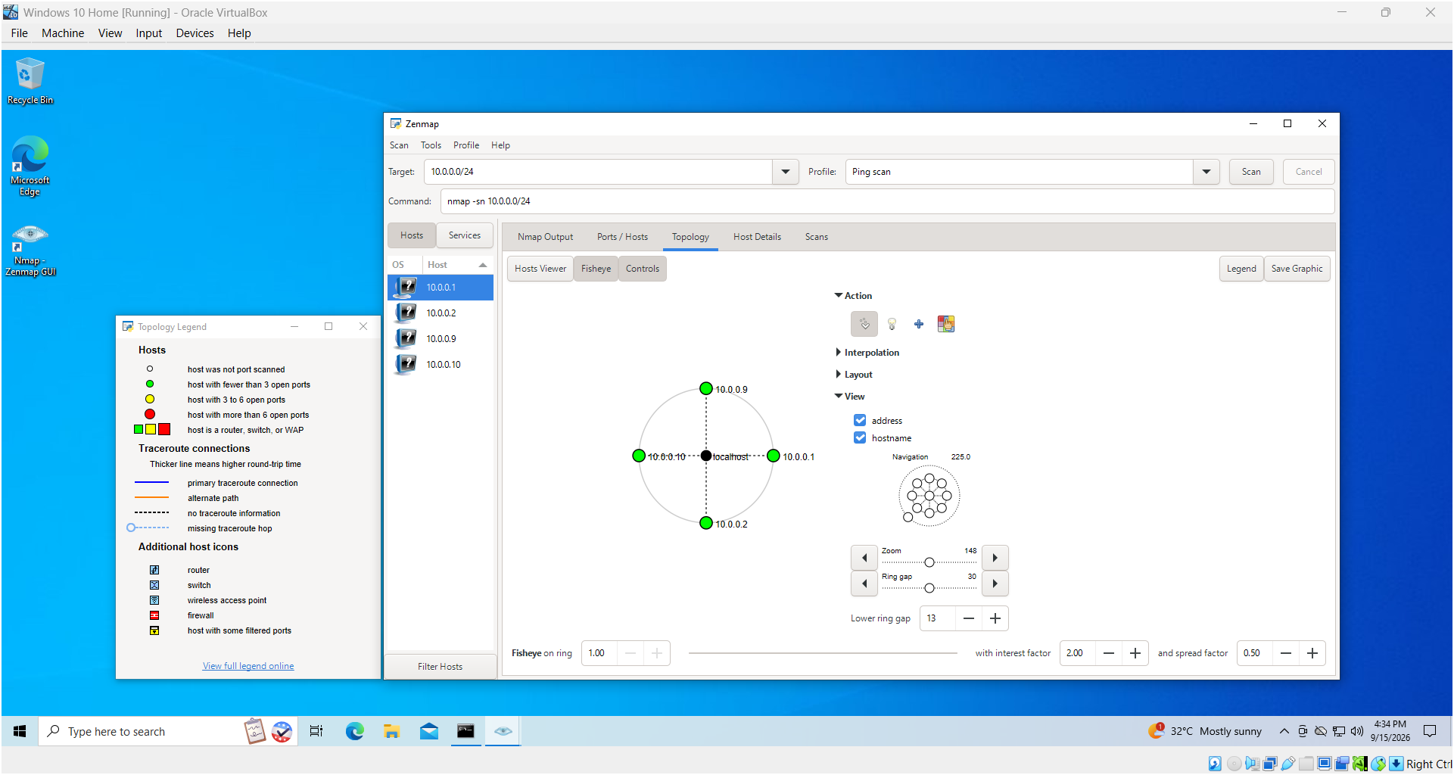

-End-

👤 Author
Patrick Alabi
Cybersecurity Professional B083

📌 Project Information
Program Name: Cybersecurity Internship program at Networkwalks | Week: 02 | Report: W2-PM1-5-FINAL

