1. Write a recursive function to count the instances of a letter in a string. Use recursion rather than split and filter
2. Create Tree Node for the tree(refer picture below)

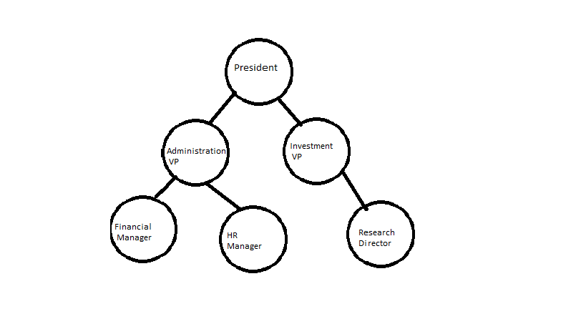

1. . Write a program to count number of nodes in the trees(excluding root node)
2. Write a program to add property , parent with value 'true' to the nodes that have children( not to the leaf nodes).
3. Write a program to return list all leaf nodes( that have no children).
4. Create an array of objects with count of children and name of the node as properties