This report is a living document on the progress of developing a 1-site model for water, parameterized to reproduce the experimentally observed melting temperature of ice Ih.

Abascal and Vega have recently observed that the melting points of common 3-site and 4-site models correlates strongly with their dipolar and quadrupolar interactions. Based on the suggestion of Carnie and Patey, as well as Rick, they have described the quadrupole moment in the plane of the hydrogens and parallel to the hydrogens as a parameter QT. They have shown that the water models, which most accurately reproduce the melting point of ice Ih, have a ratio of the dipole moment to QT of approximately unity.

Based on this observation, we have begun work on a 1-site model with intentions of setting the dipole moment and structuring the quadrupole tensor in such a way that will give us a ratio of unity. As a starting point, we have collapsed the TIP4P/Ice 4-site water model onto a 1-site model (TIP1P/Ice). The parameters for both models can be seen in Table 1, and corresponding dipole and quadrupole moments in Table 2.

|  |  |  |  |  |  |  |  |
| --- | --- | --- | --- | --- | --- | --- | --- |
| Table 1. | | | | | | | |
|  | Sigma (Å) | Epsilon (kcal/mol) | OH bond length (Å) | OM bond length (Å) | qH (e) | qM(e) | HOH angle (degrees) |
| TIP4P/Ice | 3.1668 | 0.2108509 | 0.9572 | 0.1577 | +0.5897 | -1.1794 | 104.52 |
| TIP1P/Ice | 3.1668 | 0.2108509 | - | - | - | - | - |

|  |  |  |  |  |  |
| --- | --- | --- | --- | --- | --- |
| Table 2. | | | | | |
|  | Dipole moment  (D) | Qxx (DÅ) | Qyy (DÅ) | Qzz (DÅ) | QT (DÅ) |
| TIP4P/Ice | 2.4255966 | 0.0 | 1.62291807 | 0.74278997 | 2.434 |
| TIP1P/Ice | 2.4255966 | 0.0 | 1.62291807 | 0.74278997 | 2.434 |

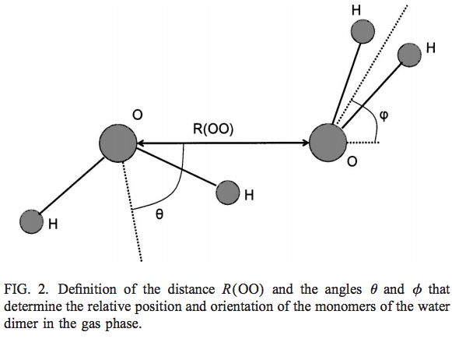

Macintosh HD:Users:plouden:Desktop:TIP1P_Ice:Test1_plot.epsIn Test 1, the Lennard-Jones parameter sigma was varied while holding the other parameters of the TIP1P/Ice model constant. We see that an optimal ROO distance of approximately 2.9 Å is obtained when sigma is set to about 3.25 Å. However, this results in theta and phi angles of 36o and 31o, which are both far from the values obtained from ab initio calculations.

Macintosh HD:Users:plouden:Desktop:TIP1P_Ice:Test2_plot.eps

In Test 2, the Lennard-Jones parameter epsilon was varied while holding the other parameters of the TIP1P/Ice model constant. We see that an optimal ROO distance of approximately 2.9 Å is obtained when epsilon is set to about 0.275 kcal/mol. However, this results in theta and phi angles of 38o and 33o, which are both far from the values obtained from ab initio calculations.

Macintosh HD:Users:plouden:Desktop:TIP1P_Ice:Test2_5_plot.eps

In Test 3, the Qzz component of the Quadrupole tensor was varied while holding the other parameters of the TIP1P/Ice model constant. We see that an optimal ROO distance of approximately 2.9 Å is not achieved over the range investigated. The angles theta and phi seem to cross over one another, where the ab initio calculated value for each is achieved at drastically different values of Qzz.

Macintosh HD:Users:plouden:Desktop:TIP1P_Ice:Test6_plot.eps

In Test 4, damping alpha was varied while holding the other parameters of the TIP1P/Ice model constant. We see that an optimal ROO distance of approximately 2.9 Å is not achieved over the range investigated. The angles theta and phi also never reach the ab initio calculated values of 56 and 58 degrees, respectively.