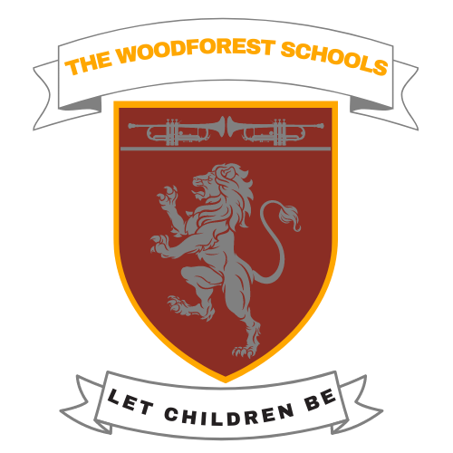

**THE WOODFOREST SCHOOLS NANYUKI**

*Let Children Be*

P.O BOX 2029-10400

Off Mt. Kenya Rd, Nanyuki.

Tel: 0796 333555.

e-mail: [*info@thewoodforestschools.com*](mailto:info@thewoodforestschools.com)

**WEEKLY MEALS MENU**

|  |  |  |  |
| --- | --- | --- | --- |
| **DAY** | **10 O’CLOCK** | **LUNCH** | **3 O’CLOCK** |
| **Monday** | Porridge | Rice, green grams and oranges/ripe banana  (Seasonal fruit) | Milk |
| **Tuesday** | Tea & bread | Stewed spaghetti and watermelon | Milk |
| **Wednesday** | Porridge | Ugali, minced meat, vegetables and ripe banana /orange  (Seasonal fruit) | Milk |
| **Thursday** | Tea & bread | Pilau, minced meat, cabbage and watermelon | Milk |
| **Friday** | Porridge | Chips, boiled egg, salad and ripe banana | Yoghurt |