**Jellyfish Can't Swim in the Night** 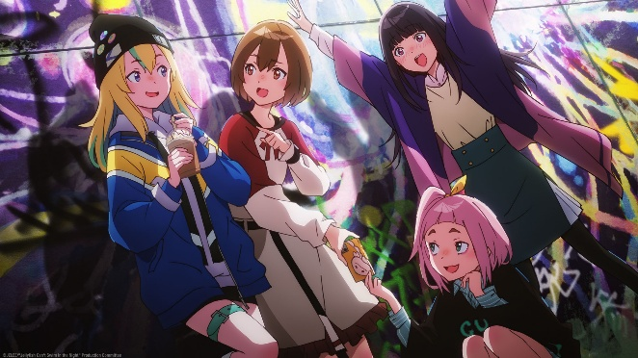

(Japanese: 夜のクラゲは泳げない, Hepburn: Yoru no Kurage wa Oyogenai), abbreviated as YoruKura (ヨルクラ), is an original anime television series produced by Doga Kobo for its 50th anniversary. Set in Shibuya, this series follows four Japanese girls, one of them is a illustrator, an idol, a music composer and a VTuber that forms a band named JELEE, to make into a global phenomenon, freeing themselves of their acrimonious past.

The series was directed by Ryōhei Takeshita and aired from April to June 2024. A manga adaptation illustrated by Niko Fujii was serialized on Kodansha's Magazine Pocket manga website from April to December 2024.[1] The series is licensed in North America and Australia by Sentai Filmworks and is streaming through its Hidive platform.

Plot

Four girls, Mahiru Kouzuki, an illustrator who stops drawing, Kano Yamanouchi, a former idol who wants to prove herself with singing, Nox Ryūgasaki, the self-proclaimed "strongest" VTuber, and Kimura-chan, a mysterious composer who wants to support her favorite person, together form an anonymous artist group, JELEE.

Characters

JELEE

Mahiru Kōzuki (光月 まひる, Kōzuki Mahiru) / Yoru Umitsuki (海月 ヨル, Umitsuki Yoru)[2]

Voiced by: Miku Itō[1] (Japanese); Luci Christian[3] (English)

A 16-year-old high school student who loves drawing but stopped out of the fear of being ridiculed. She returns to drawing after meeting Kano, and serves as JELEE's illustrator.

Kano Yamanouchi (山ノ内 花音, Yamanouchi Kano) / Nonoka Tachibana (橘 ののか, Tachibana Nonoka)[2]

Voiced by: Rie Takahashi[1] (Japanese); Juliet Simmons[3] (English)

A 17-year-old former member of Sunflower Dolls who worked as its center but was forced to retire after a scandal. She has been working as a cover singer, and serves as JELEE's vocalist and lyricist.

Kiui Watase (渡瀬 キウイ, Watase Kiui) / Nox Ryūgasaki (竜ヶ崎 ノクス, Ryūgasaki Nokusu)[2]

Voiced by: Miyu Tomita[1] (Japanese); Molly Searcy[3] (English)

A VTuber and childhood friend of Mahiru who lives as a shut-in after realizing she cannot fit in with her prep school. She lends her talents to JELEE as its video editor and mixer. She publicly expresses her gender fluidity in the eleventh episode, criticizing those who want her to behave in a "normal" manner, unashamed for embracing what she likes.[4]

Mei Kim Anouk Takanashi (高梨・キム・アヌーク・めい, Takanashi Kimu Anūku Mei) / Kimura-chan (木村ちゃん)

Voiced by: Miyuri Shimabukuro[1] (Japanese); Natalie Rial[3] (English)

A 17-year-old high school student who takes up professional piano lessons and is a super fan of Kano as she helped her go through her social anxieties. She serves as JELEE's composer.

Entertainment industry

Shizue Baba (馬場 静江, Baba Shizue) / Miiko (みー子, Mīko)

Voiced by: Sumire Uesaka[5]

An underground idol singer who has been working for 14 years and is a single mother to Ariel.

Mero Setō (瀬藤 メロ, Setō Mero)

Voiced by: Miho Okasaki[5] (Japanese); Karlii Hoch[3] (English)

The new center of Sunflower Dolls after Kano's retirement.

Momoko Yanagi (柳 桃子, Yanagi Momoko)

Voiced by: Yukina Shuto[5]

A member of Sunflower Dolls.

Akari Suzumura (鈴村 あかり, Suzumura Akari)

Voiced by: Sally Amaki[5]

A member of Sunflower Dolls.

Yukine Hayakawa (早川 雪音, Hayakawa Yukine)

Voiced by: Yūko Kaida[6] (Japanese); Patricia Duran[3] (English)

The producer for Sunflower Dolls, who is also Kano and Mion's estranged mother.

Other characters

Kaho Kōzuki (光月 佳歩, Kōzuki Kaho)

Voiced by: Ayu Matsuura[6]

Mahiru's younger sister.

Mion Hayakawa (早川 美音, Hayakawa Mion)

Voiced by: Chika Anzai[6]

Kano's older sister.

Ariel Baba (馬場 亜璃恵瑠, Baba Arieru)

Voiced by: Nao Tōyama[6]

Shizue's daughter who passionately supports her mother's activities.

Koharu (小春)

Voiced by: Asami Seto[6] (Japanese); Emi Lo[7] (English)

A woman who Kano and Kiui met at a motorcycle riding school and has gone through multiple plastic surgeries.

Ship Manager Honami (保奈美店長, Honami-tenchō)

Voiced by: Hekiru Shiina[6]

The manager of the bar Mahiru and Kano work part-time in.