# WDD 230 - W12 Activity: Term Website Planning Document Peer Review

Author: Patrick Armani

### ✍ Site Name

bountifulfoods.com

✍ Site Purpose

Manage the sale of organic products over the internet, offering fresh and healthy food options, made to order (fruit drinks and fruit bags).

### ✍ Target Audience and Scenarios

The site is voted for two audiences: the local population and to tourists visiting the coastal areas.

### ✍ Site Map

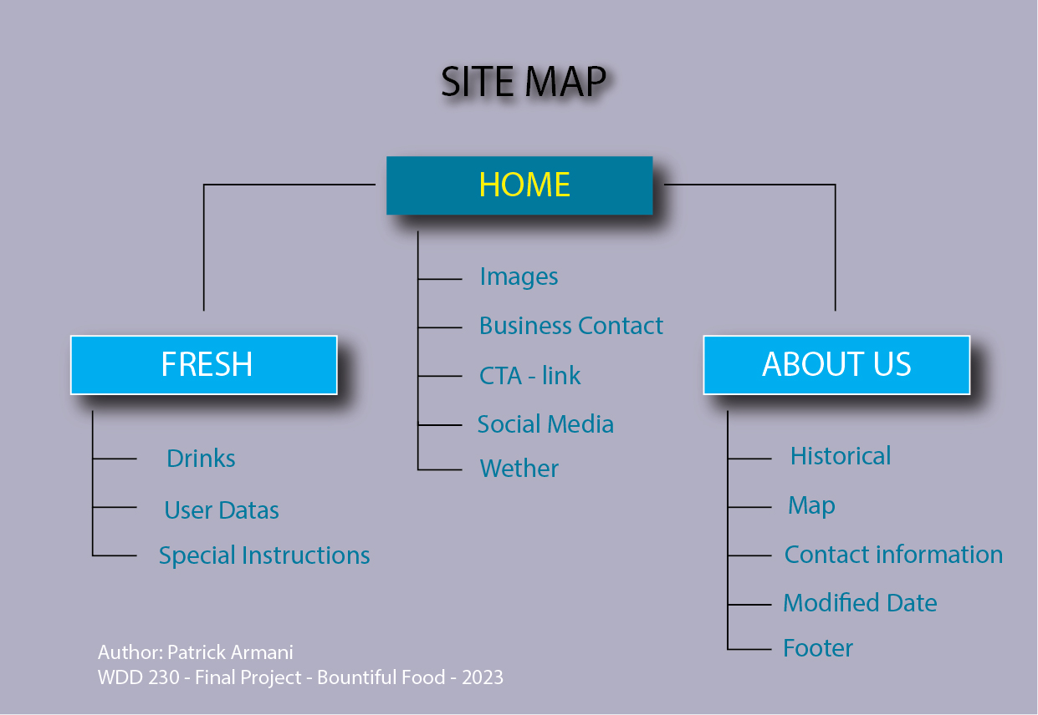

### ✍ Color Scheme

### Palete url: <https://coolors.co/036016-99c24d-b084cc-665687-f7edf0>

### ✍ Typography

|  |  |  |  |  |
| --- | --- | --- | --- | --- |
| Site header | DM sans | 40px | #036016 | SAMPLE |
| Primary Navigation | DM sans | 30px | #99C24D | SAMPLE |
| Footer Navigation | DM sans | 20px | #B084CC | SAMPLE |
| Heading 1(h1) | DM sans | 32px | #036016 | Sample |
| Heading 2(h2) | DM sans | 24px | #036016 | Sample |
| Heading 3(h3) | DM sans | 19px | #036016 | Sample |
| Heading 4(h4) | DM sans | 15px | #036016 | Sample |
| Heading 5(h5) | DM sans | 13px | #036016 | Sample |
| Heading 6(h6) | DM sans | 11px | #036016 | Sample |
| Paragraph Text(p) | DM sans | 16px | #000000 | Sample |

**The primary text font is DM sans**

### ✊ Wireframe Sketches

### Home page(large)

### Logo

### White box with logo and 3 tags

### Pictures of vegetables

### Boxes representing days of the week and locations of services

### Box with text about Bountiful Foods

### Location link

### Link of social media

### Text on the end: Contact information’s

**Fresh page(large)**

8 – Background / 9 – Juice Picture

10 – Name / 11 – Email / 13 – Select Fruits / 14 – Field of Instructions /

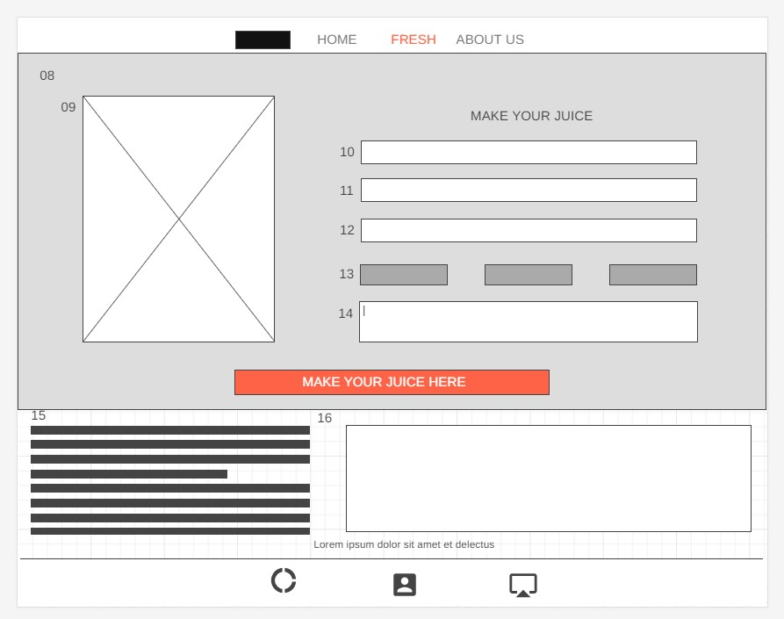15 – Summary of order / 16 – Nutrition Facts

**About us page (large)**

17 – Text about Bountiful Foods

18 – Company photo.

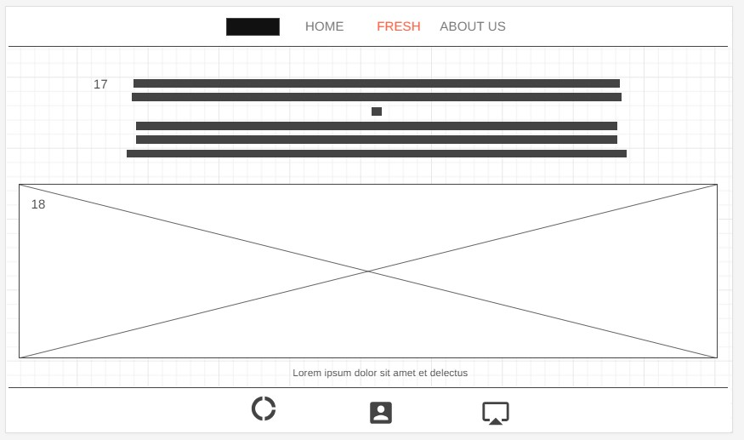

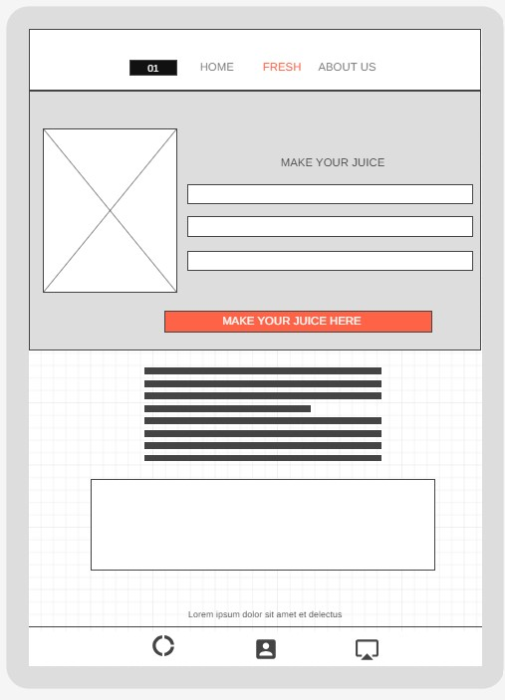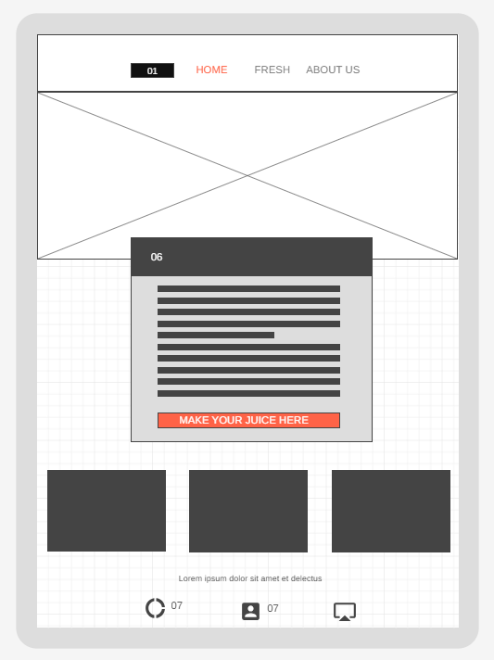Home Page (medium) Fresh page(medium)

About us page(medium)

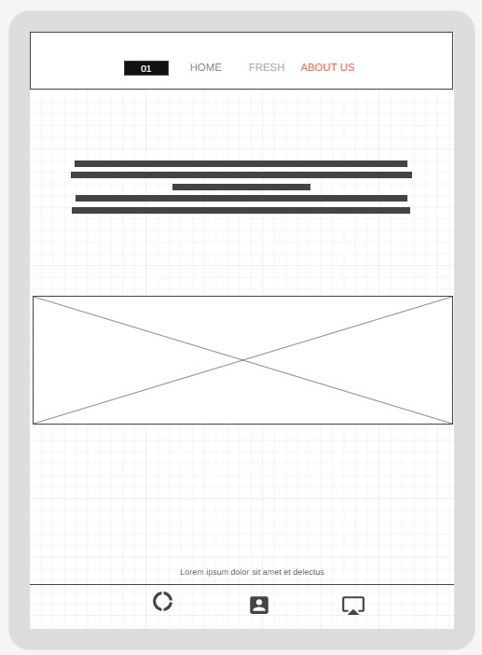

Small Pages:

