

Practices for Secure Software Report

Table of Contents
Document Revision History 3
Client 3
Developer 3
1. Algorithm Cipher 3
2. Certificate Generation 4
3. Deploy Cipher 4
4. Secure Communications 5
5. Secondary Testing 6
6. Functional Testing 7
7. Summary 8
8. Industry Standard Best Practices 9
References 9

Document Revision History

Version | Date | Author | Comments
1.0 | October 18, 2026 | Patrick Byrne | Project Two submission

Client



Developer
Patrick Byrne

Algorithm Cipher

For Artemis Financial's file verification step, I recommend SHA-256 for the checksum. It's on Oracle's list of standard MessageDigest algorithm names and it's built into Java, so there's nothing extra to install (Oracle, 2017). For the connection itself, HTTPS uses TLS with the 2048-bit RSA certificate I made with keytool, and TLS encrypts the actual data with a symmetric cipher like AES.

SHA-256 is a hash function, not regular encryption. It takes any amount of data and turns it into a fixed 256-bit value, which shows up as 64 hex characters. It only goes one way, so you can't get the data back from the checksum. Change even one letter and the checksum comes out completely different, which is exactly what you want for catching a file that got changed. 256 bits is also big enough that nobody has found two inputs with the same SHA-256 hash, which is called a collision. Older hashes like MD5 and SHA-1 didn't hold up. In 2017 Google and CWI made two different PDF files with the same SHA-1 hash (Stevens et al., 2017).

Random numbers matter on the encryption side. Keys have to be impossible to guess, so Java uses SecureRandom instead of the regular Random class (Manico & Detlefsen, 2015). Symmetric encryption like AES uses one shared key for both locking and unlocking, and it's fast, so it handles the bulk data. Asymmetric encryption like RSA uses a public and private key pair and is slower. TLS uses it at the start of a connection so the server can prove who it is, then both sides switch to a shared symmetric key. That's why my certificate is RSA but the traffic itself ends up encrypted with AES.

Encryption has changed a lot over time. DES was the US standard in the 1970s, but its 56-bit key could be brute forced by the late 1990s, and AES replaced it in 2001. Hashes went the same way. MD5 and SHA-1 used to be everywhere and then got broken. Today the SHA-2 family, which includes SHA-256, is the standard, and Java also supports the newer SHA-3 family as a backup (Oracle, 2017).

Certificate Generation
I generated a self-signed certificate with the Java keytool, running it in the Terminal view inside Eclipse. It uses a 2048-bit RSA key, the alias selfsigned, and is valid for 360 days. For the name I entered localhost, since that's the address of the server (SSL Shopper, 2010). Then I exported the certificate to server.cer and printed it. The Owner and Issuer are the same, which is what makes it self-signed.

Generating the keystore with keytool in the Eclipse Terminal view:
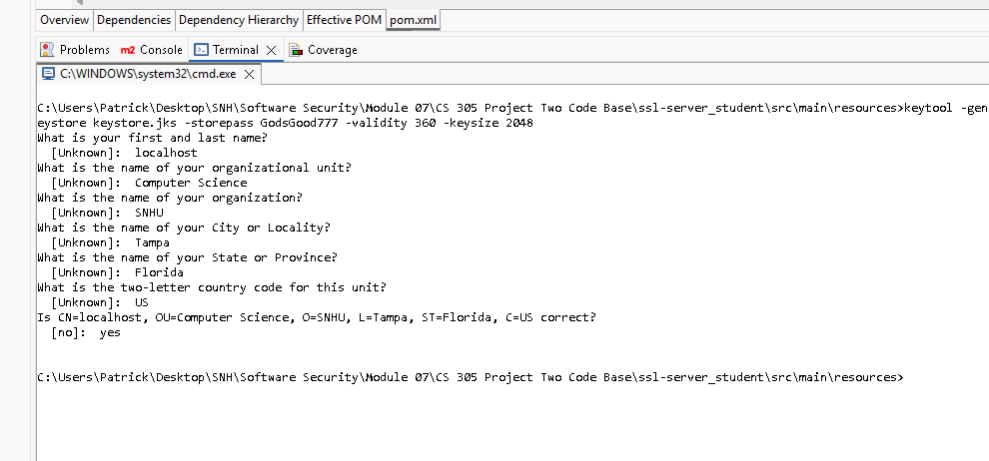

Printout of the exported server.cer file:
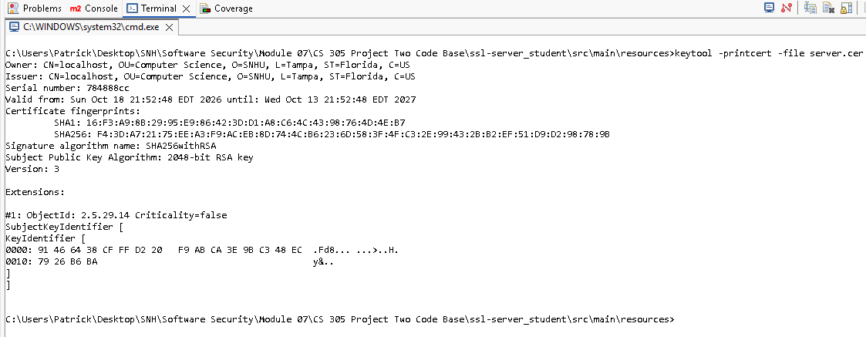

Deploy Cipher
I refactored SslServerApplication.java to add a /hash route, which was the FIXME in the code base. It hashes the string "Hello Patrick Byrne Check Sum!" with SHA-256 using Java's MessageDigest class, converts the bytes to hex, and returns the data, the algorithm name, and the checksum to the browser.

Checksum verification at https://localhost:8443/hash:
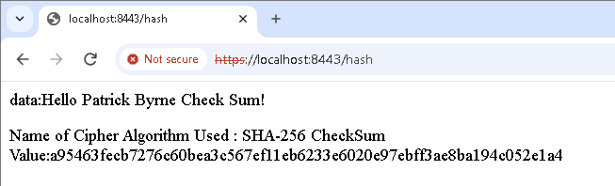

Secure Communications
In application.properties I replaced the ???? placeholders with the key alias (selfsigned), the keystore password, the keystore location (classpath:keystore.jks), and the keystore type, and left the port at 8443. The type is PKCS12, not JKS, because newer versions of keytool make PKCS12 keystores even when the file name ends in .jks. I confirmed it with keytool -list.

When I ran the app, Tomcat started on port 8443 (https) and the page loaded at https://localhost:8443/hash. Chrome still says "Not secure," but that's only because the certificate is self-signed and not from a trusted certificate authority. The connection is still encrypted. The certificate viewer shows the browser is using my localhost certificate, and its SHA-256 fingerprint matches the one from server.cer.

Certificate viewer for the HTTPS page, showing the localhost certificate:
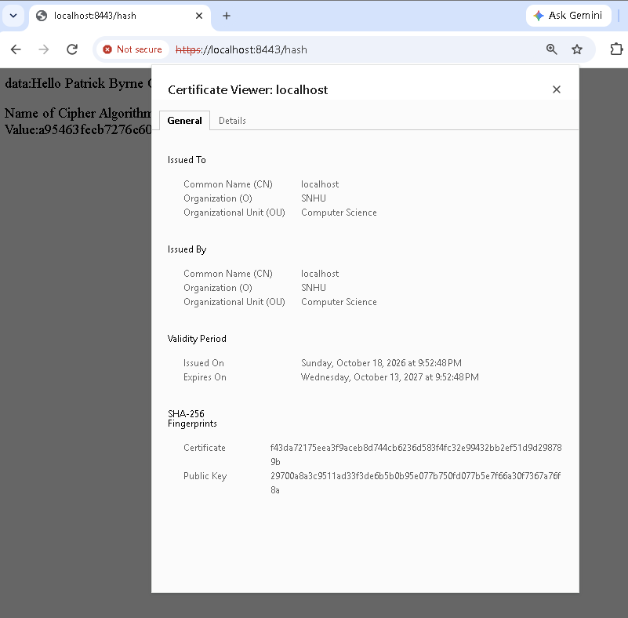

Secondary Testing
The dependency-check plugin in pom.xml was version 5.3.0, which can't download vulnerability data from NVD anymore, so I updated it to 13.0.0 and added my NVD API key. I ran it once before changing any code to get a baseline, then again after all the refactoring.

Both scans came out exactly the same: 49 dependencies (28 unique), 14 vulnerable, and 254 vulnerabilities. Nothing new showed up, which makes sense because my code only uses Java's built-in MessageDigest and didn't add any libraries. The 254 all come from the old Spring Boot 2.2.4 libraries that were already in the code base, like Tomcat 9.0.30 and Spring Framework 5.2.3. The real fix for those is upgrading Spring Boot, which should be the next step for Artemis.

Refactored code running without errors:
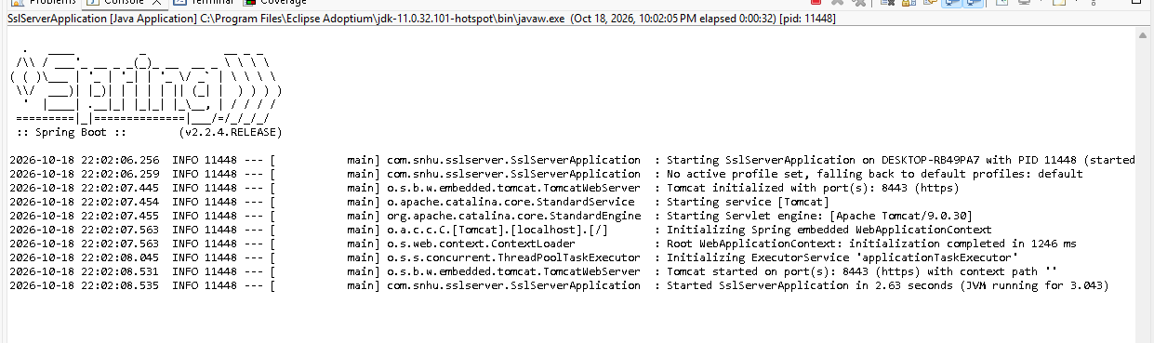

Maven install with the dependency check finishing with BUILD SUCCESS:
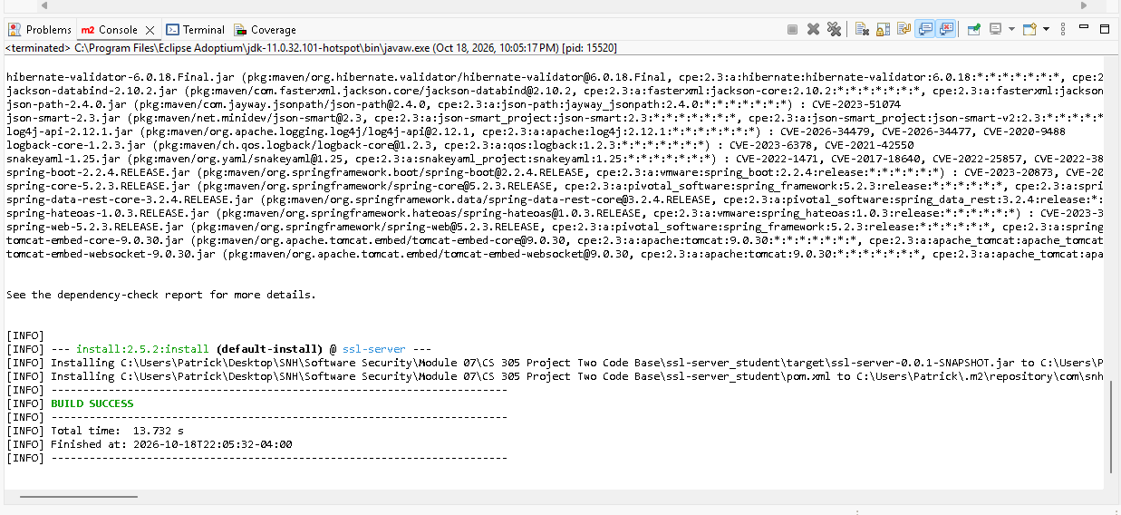

Dependency-check report summary after refactoring:
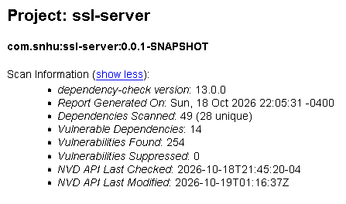

Functional Testing
I went through the refactored code by hand looking for syntax, logic, and security problems.

Syntax: Eclipse shows 0 errors. The 2 warnings are about the project asking for Java 1.8 while JDK 11 is installed, not about the code.

Logic: The data string is converted to bytes as UTF-8, so the checksum comes out the same on any computer. The bytesToHex method adds a leading 0 to bytes under 16, so every checksum is the full 64 characters. Without that, some bytes would only show one digit and the checksum would be wrong.

Security: The route only hashes a fixed string, so there's no user input that could be used for injection or cross-site scripting. One issue I found is that the keystore password sits in application.properties in plain text. That's fine for a class project, but in production it should come from an environment variable, like I did with the NVD API key. The self-signed certificate is also only for development. A real site would need a certificate from a CA.

Refactored code in Eclipse, running without errors (0 errors in Problems):
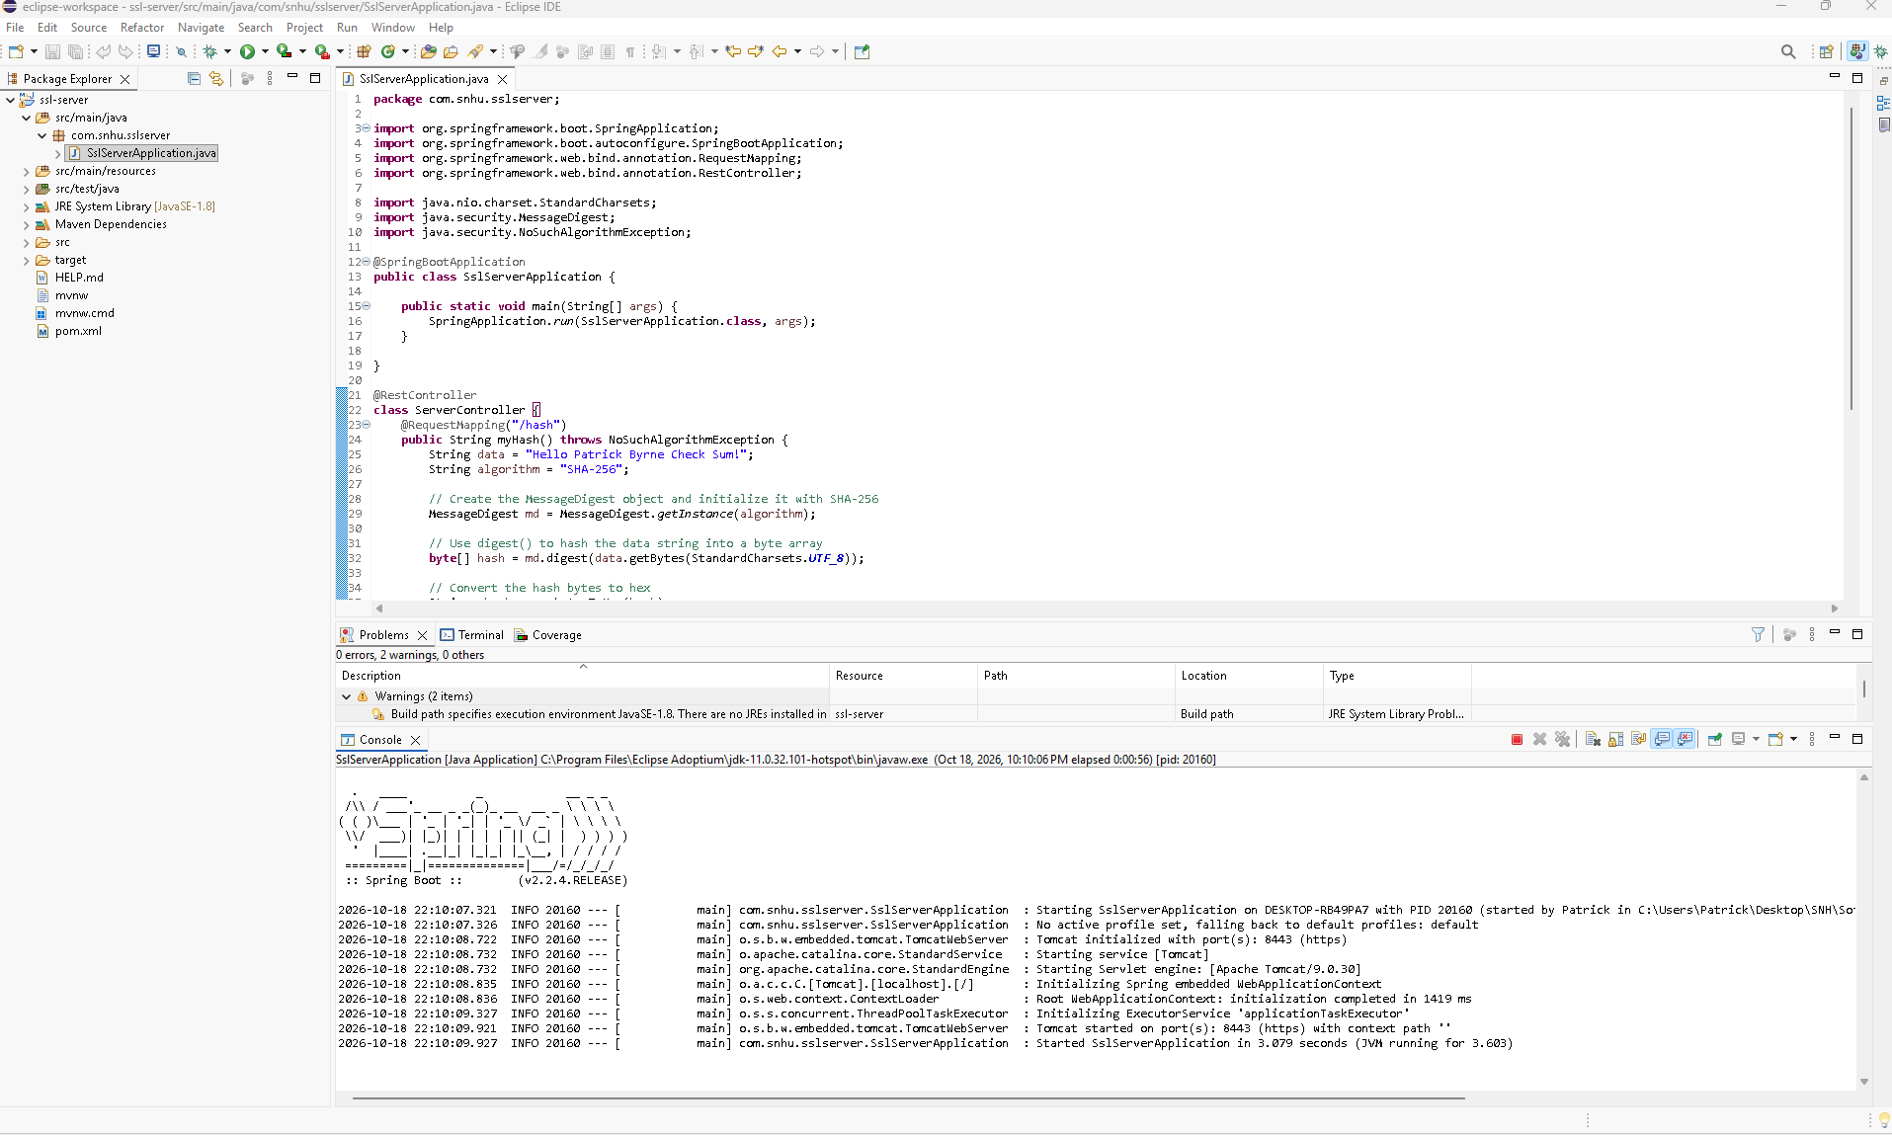

Summary

I added security to Artemis Financial's application in layers. First, the server now runs over HTTPS on port 8443 using my keystore, so data between the browser and server is encrypted. Second, the new /hash route creates a SHA-256 checksum so data can be verified. Third, I ran the dependency check before and after the changes to make sure I didn't add any new vulnerabilities. Last, I reviewed the code by hand.

Looking at the vulnerability assessment process flow diagram, the areas I addressed were Cryptography (the SHA-256 checksum and TLS encryption), Client/Server (the browser and server now talk over HTTPS), and APIs (the /hash REST endpoint is only reachable over HTTPS). The diagram also says static testing helps decide which code reviews are needed. My dependency check pointed straight at the old libraries as the biggest risk left, and I reviewed the controller code I added myself.

Industry Standard Best Practices

I stuck with standard tools instead of making my own. The checksum uses Java's built-in MessageDigest with SHA-256 instead of homemade code or an outdated hash like MD5 or SHA-1. Data in transit is protected with TLS, which is the standard way to secure network traffic (Manico & Detlefsen, 2015). I kept the existing code the way it was and only added what the project needed, so I didn't break the security it already had, and I used the OWASP dependency check to confirm nothing new got introduced.

This matters for Artemis because it's a financial company holding clients' personal and financial information. Laws like the Gramm-Leach-Bliley Act require financial companies to protect that data, and a breach can mean fines, lost money, and lost customer trust, which is really hard to win back (Manico & Detlefsen, 2015). Catching problems while the code is being written is a lot cheaper than cleaning up after an attack.

References

Manico, J., & Detlefsen, A. (2015). Iron-clad Java: Building secure web applications. McGraw-Hill Education.

Oracle. (2017). Java security standard algorithm names. https://docs.oracle.com/javase/9/docs/specs/security/standard-names.html

SSL Shopper. (2010, October 30). How to create a self signed certificate using Java keytool. https://www.sslshopper.com/article-how-to-create-a-self-signed-certificate-using-java-keytool.html

Stevens, M., Bursztein, E., Karpman, P., Albertini, A., Markov, Y., Petit Bianco, A., & Baisse, C. (2017, February 23). Announcing the first SHA1 collision. Google Security Blog. https://security.googleblog.com/2017/02/announcing-first-sha1-collision.html

