Module 05 Course Project – Adding Forms

Patrick A Brunner

Rasmussen College

1. Home Page with Navigation

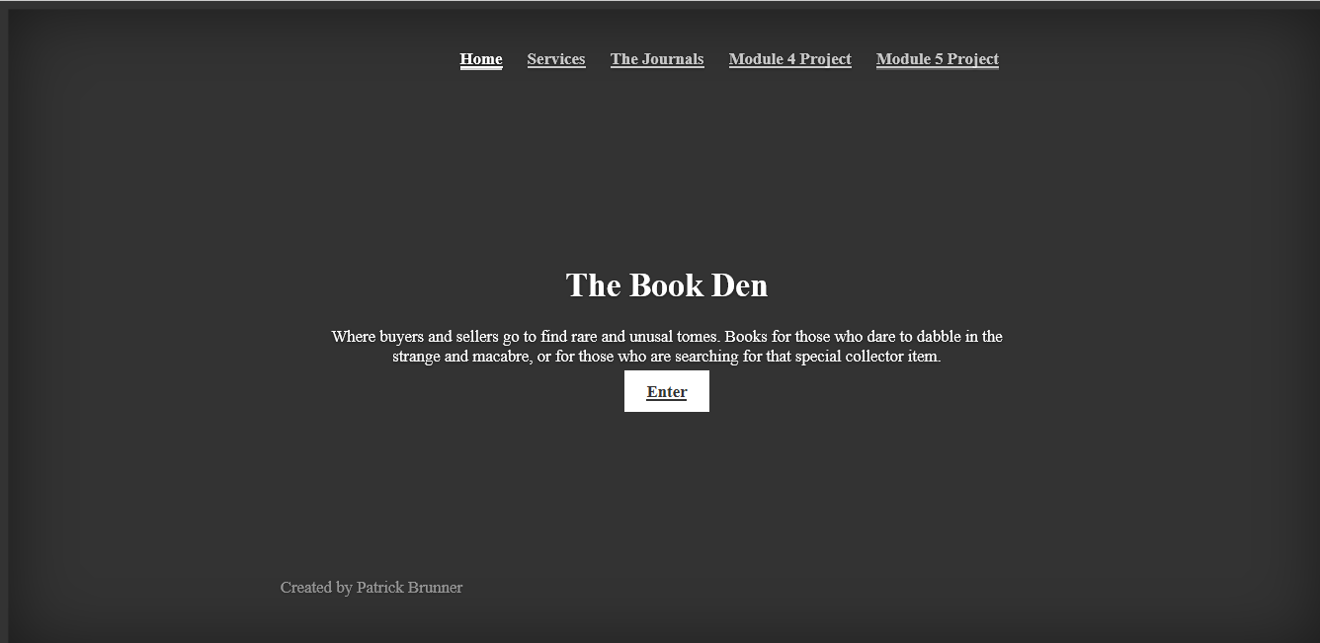

1. Project Page

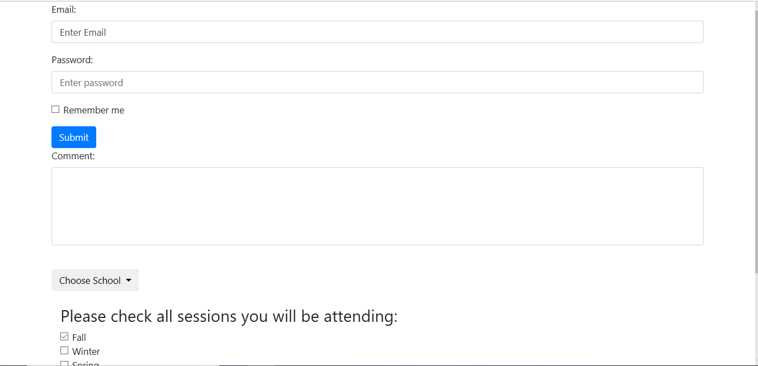

1. Page previews

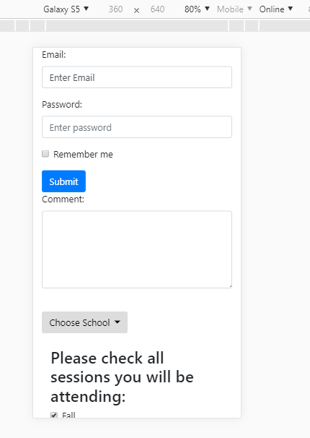

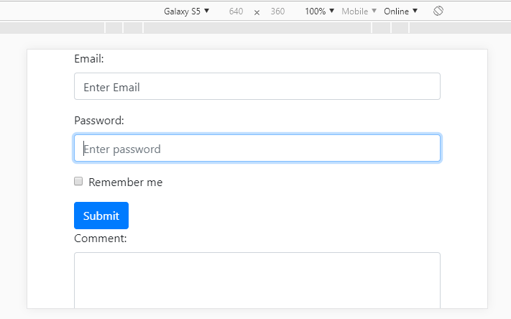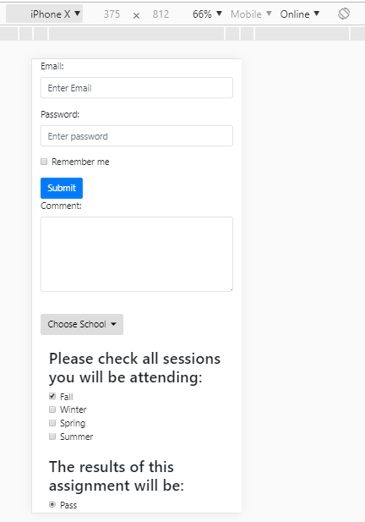

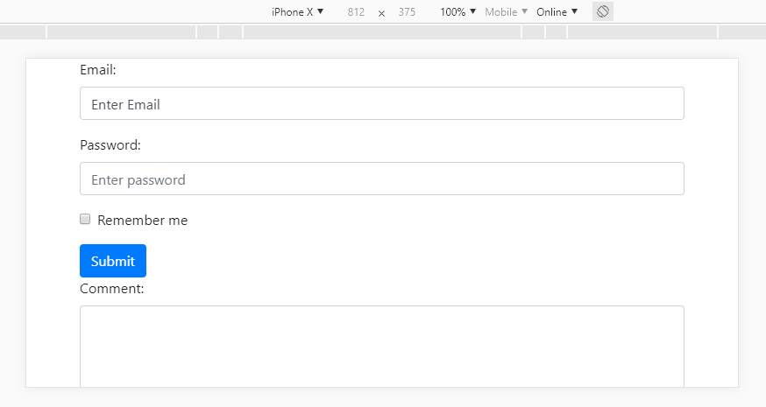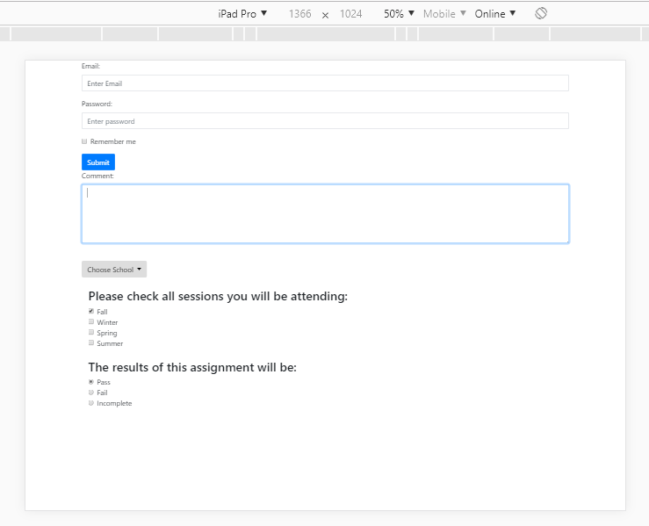

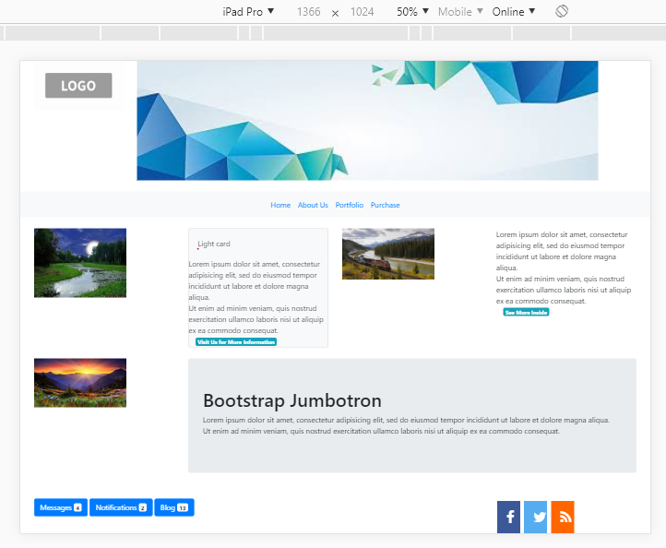

1. Home Site URL - <http://sotd.us/patrickbrunner/CIS4655C/CIS4655-fall2018/module03/Project/Home.html>
2. Project Site URL - <http://sotd.us/patrickbrunner/CIS4655C/CIS4655-fall2018/module04/project/PBrunnerMod4Project.html>
3. GitHub URL - https://github.com/PatrickBrunner/CIS4655-fall2018/tree/master/module04