Patrick Hoey
Advanced Digital Systems
EECE.5500
Final Project Report

CPE CPU – A RISC-V Soft Core

System Overview
The CPE CPU is a soft core CPU implementing the RISC-V RV32I instruction set. The RV32I ISA is a fully open source instruction set that is considered the baseline for all RISC-V implementations, and compilation for this ISA is fully supported by GNU’s gcc and the associated linking and assembly tools.
It was designed completely hierarchically with a high focus on readability, and it's main purpose was for me to develop a better understanding of Computer Architecture. The processor is a single cycle design and it does not implement any sort of pipe-lining. The memory interface for both the instruction and data memory is a simple 32-bit interface with some control lines to select the read and write method (byte, half word, full word). The micro architecture was implemented based on the design within Patterson and Hennessy’s Computer Architecture and Design with some modifications to support the full RV32I ISA.
The RV32I ISA is fully specified within this document: RISC-V Specification
This site offers valuable examples of using the ISA alongside the instruction format for each instruction: Examples and Instruction Explanations

CPE CPU Micro Architecture
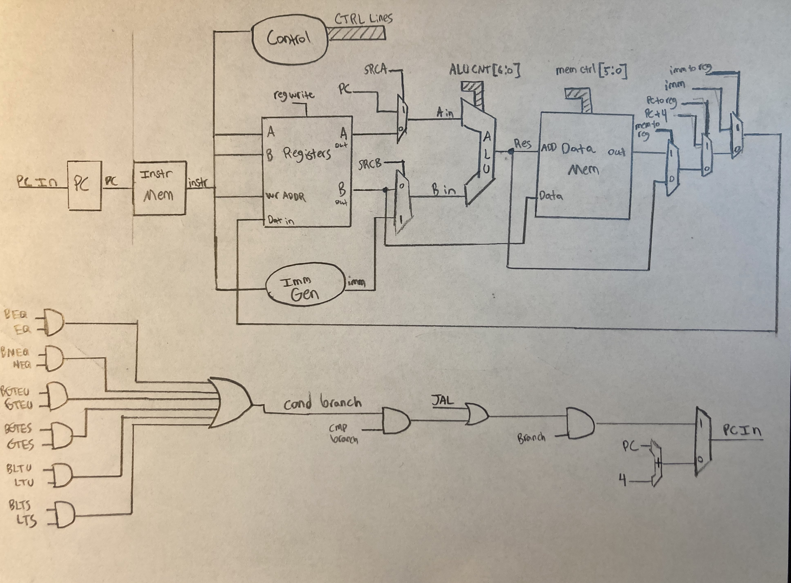

CPE CPU
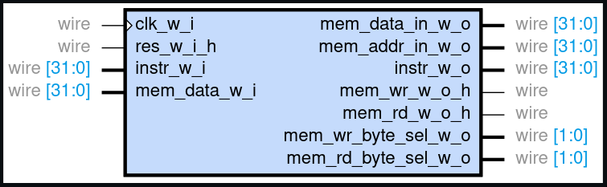
cpe_cpu.v

The focus here was by no means to be efficient. This is a single cycle processor, it's far from efficient. The goal was simplicity. The interface wires are relatively straight forward. The reset is asynchronous high. The outputs are responsible for selecting the proper instruction from the memory, for determining whether a read or write should occur to the data memory, and determine what the method of the read or write should be as well (Byte, Half Word, Word). The only other signal that may need clarification is instr_w_o, which is the program counters output (IE: what memory address to read from the instruction memory).

Sub Module – ALU
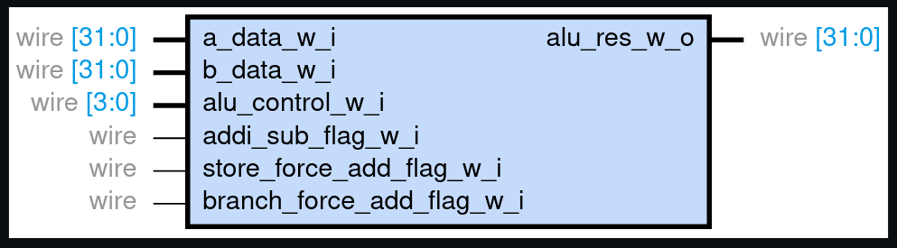
alu.v

The ALU is capable of performing all of the basic arithmetic operations on the systems. The A input can come from either register output 1, or from the program counter, and the B input can either come from register output 2 or the immediate generator.
addi_sub_flag_w_i forces an add even when were adding an immediate (ADDI allowed negative control bits on the standard ALU control bits). store_force_add_flag_w_i forces the ALU to add so that it can calculate the proper memory address. Again due to competing control lines. branch_force_add_flag_w_i forces the ALU to, you guessed it, add again. I need to calculate the memory and these all have different control signals that contradict one another based upon the different instruction types.

Sub Module – Compare Generator
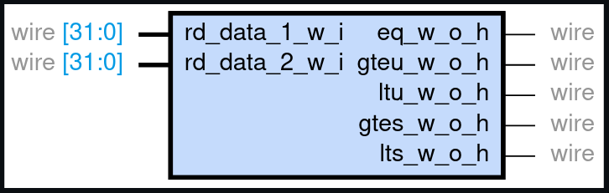
cmp_gen.v

This module simply compares the outputs of register out 1 and register out 2 and gives you some comparison flags based upon them. These flags control branch instructions later.

Sub Module – Conditional Branch Control
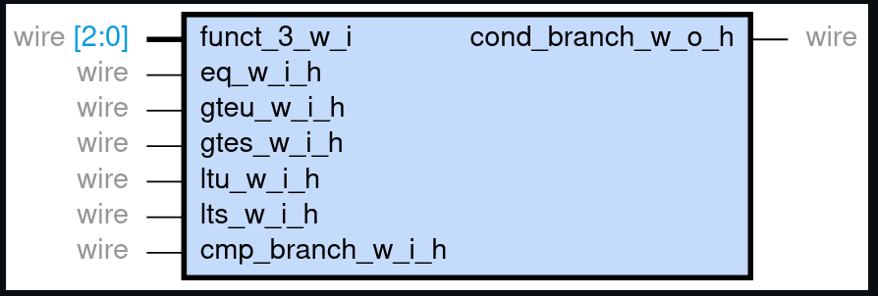
cond_branch_control.v

This module determines based upon the instruction in and the compare flags from cmp_gen whether or not a branch should be taken. This alongside the control registers that MUX of the PC input determine the branch result.

Sub Module – Control

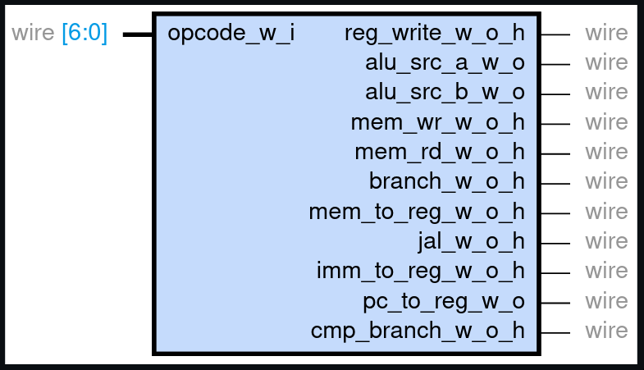
control.v

This module takes in the op code and sets the relative control signals to the expected values. Alongside the conditional branch control this determines what path the signals take throughout the chip. It controls things like the mux lines, the memory control signals, and the memory word selects (for Byte, Half Word, and Word reads and writes). It also enables or disables the branch at the top level based on the opcode.

Sub Module – Immediate Generator
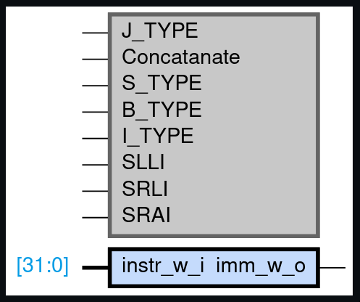
imm_gen.v

This module takes the instruction input and based upon the opp code and function values it will generate the appropriate immediate. Note the gray block is simply the parameter used as internal defines.

Sub Module – Program Counter
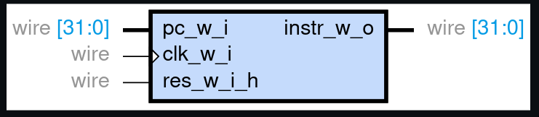
pc.v

The program counter simply counts based upon the selected input. This will just be PC + 4 if you're not branching, and if you are branching the result will be dependent upon the instruction.

Sub Module – Register Page
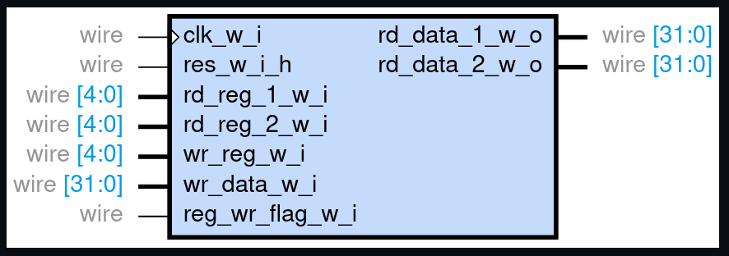
registers.v

The register page updates the registers based upon the write value and write address every clock cycle. It will output the selected outputs 1 and 2 as soon as the internal combinatorial logic allows as well. The register page contains 32, 32-bit registers. Register 0 will always be zero, even if written to.

Testing
Test development was done on Linux using Icarus Verilog alongside Make. GTKWave was used for the waveform viewer. Sub modules are self checking, but at the top level I model the memory and check results by hand. The instruction list can be seen within the ISA Breakdown spreadsheet within the notes folder.

Testing - Required Packages
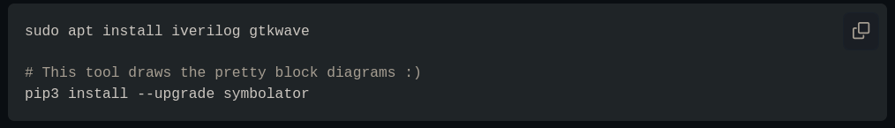
Testing - Running Tests
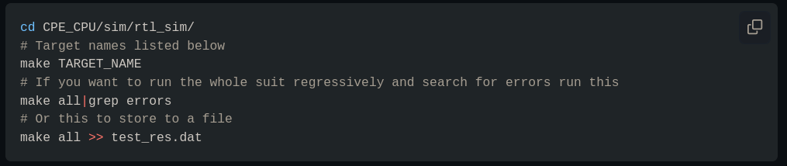

Testing - Test Targets
- all – runs all tests repressively
- cpe_cpu – runs the top level module and must be checked by hand
- alu
- cmp_gen
- control
- imm_gen
- pc
- registers
- cond_branch_control

It should be noted that all of the above targets can be appended with _wave to view the .vcd output of the test benches with the exception of the target all.

Testing - Sub Module Test Results
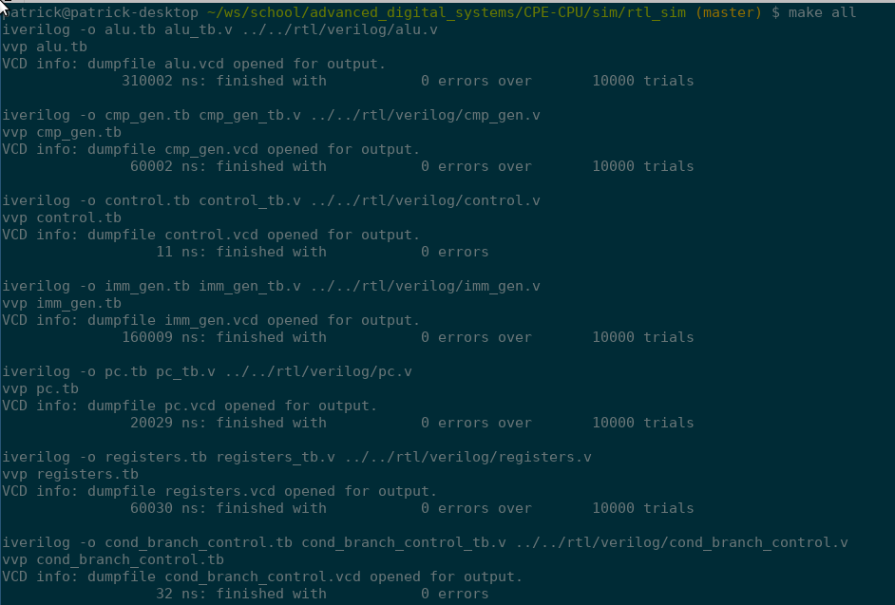
All sub modules pass without error.

CPE CPU Test Vectors and Expected Results

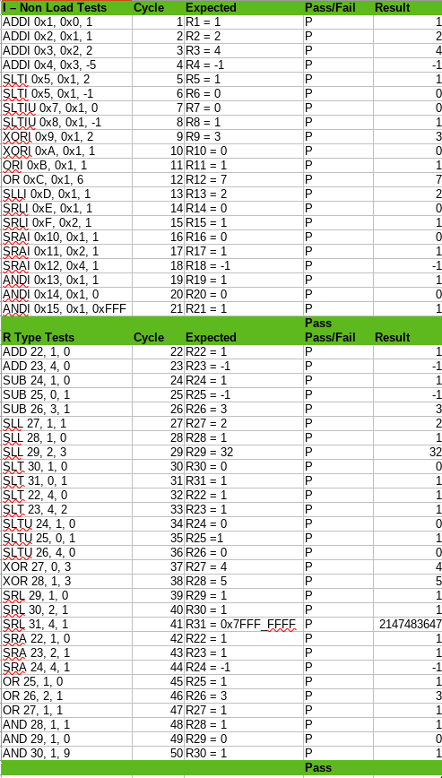

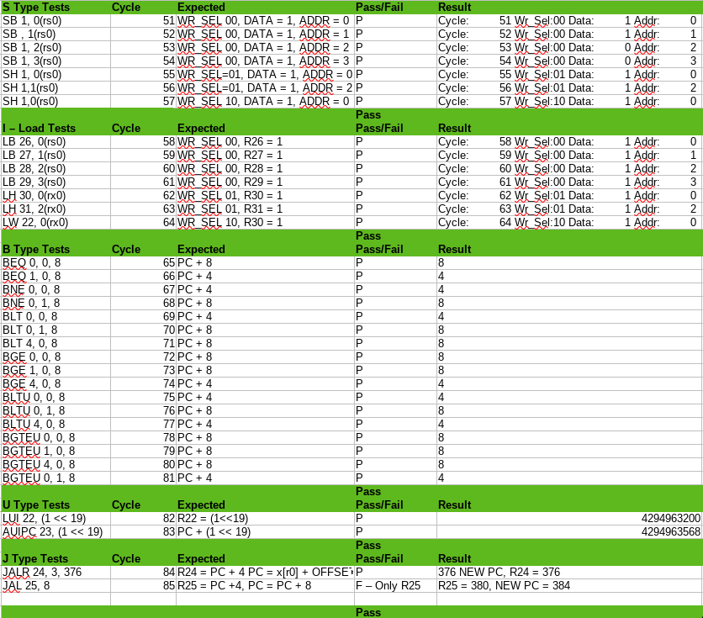

Testing - CPE CPU Results

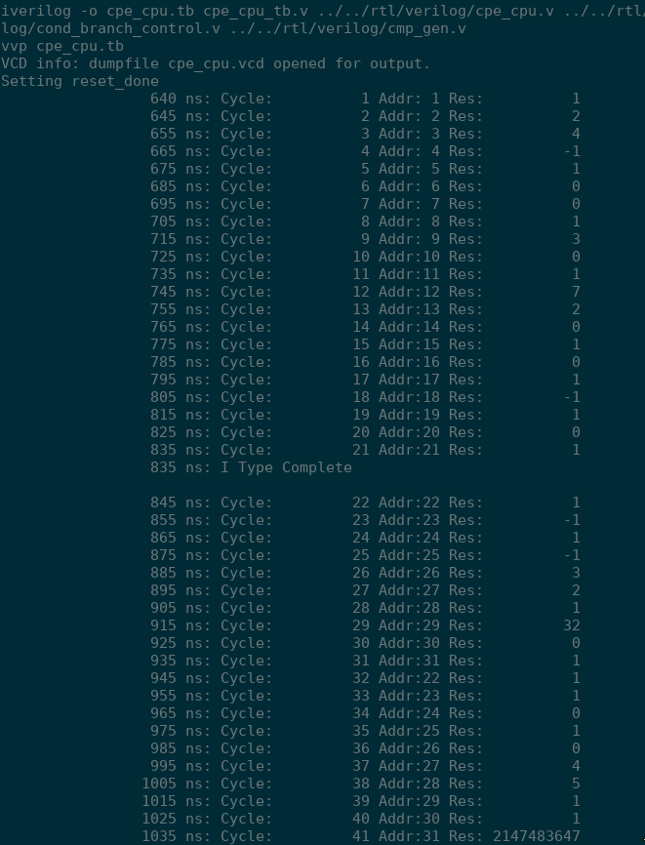

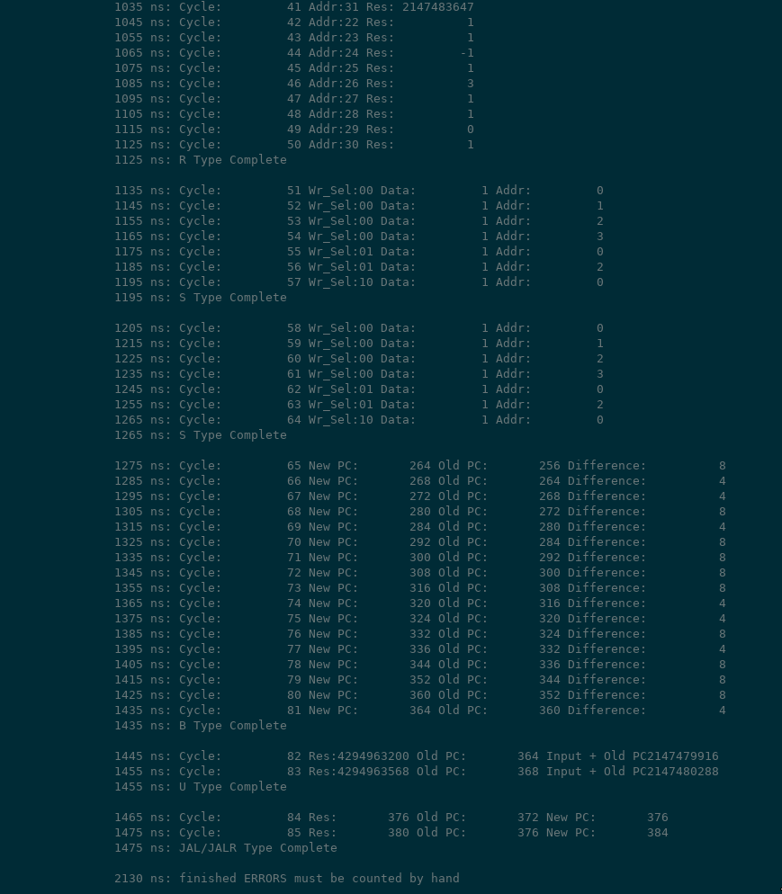

Testing - Conclusions
As you can see, all of the test results were combined into the test vector data sheet and compared against the expected results. After a lot of bug fixing, all tests are passing and the ISA is fully functional. The only exceptions to this are the ECALL, EBREAK, and FENCE instructions. These instructions are used to organize memory accesses between different processor cores, and for the GNU debugger to take execution of the processor over live. Neither of these features was relevant to me within this design. This design can be compiled for with GCC assuming the memory architecture you design has an appropriate linker script.

