Patrick Hoey
EECE.5500

CPE CPU – A Soft-Core RISC-V Processor

Introduction:
The CPE CPU is a soft-core processor designed designed to implement the RV32I instruction set. The processor implements the relevant hardware pertaining to the programming model within the RV32I specification.

Requirements:
- The CPE CPU shall be compatible with the RV32I specification with the exception of FENCE, ECALL, and EBREAK.
- I/O Connections
  - Inputs
    - The CPE CPU shall have a single clock input.
    - The CPE CPU shall have an active high asynchronous reset input that will place the module in a initialized state wherein execution will begin at instruction 0.
    - The CPE CPU shall have a data input bus that is 32 bits wide.
  - Outputs
    - The CPE CPU shall have an address output bus that is 32 bits wide.
    - The CPE CPU shall have a data output bus that is 32 bits wide.
    - The CPE CPU shall have an active high data read enable output line.
    - The CPE CPU shall have an active high data write enable output line.
    - The CPE CPU shall have a instruction address output bus that is 32 bits wide.
  - Registers
    - The CPE CPU shall have 32 general purpose registers that are 32 bits wide. These are set to 0 upon reset.
    - The CPE CPU shall have a 32 bit program counter register that is set to 0 upon reset.

System Overview:
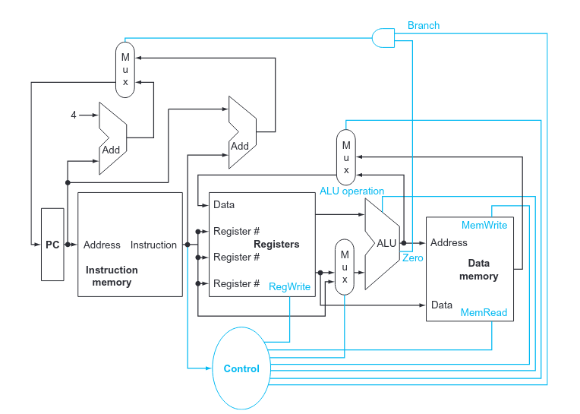

Overview of module is shown in figure above and modifications will be made to it. Figure taken from Computer Organization and Design (Patterson and Hennessy). Note that the instruction memory and data memory blocks are outside the scope of this module.

References:
Computer Organization and Design (RISC-V Edition), Patterson and Hennessy. http://home.ustc.edu.cn/~louwenqi/reference_books_tools/Computer%20Organization%20and%20Design%20RISC-V%20edition.pdf

RISK-V ISA Specification Version 2.2, RISC-V Foundation.
https://riscv.org/wp-content/uploads/2017/05/riscv-spec-v2.2.pdf

CMOD-A7 35T Development Board, Digilent.
https://digilent.com/shop/cmod-a7-breadboardable-artix-7-fpga-module/

