**MAXIMIZING FLAMING GORGE DAM RELEASES TO LAKE POWELL**

by Patrick Campana

12/13/2020

CEE 6410

Dr. David Rosenburg

# INTRODUCTION

The Colorado River Basin (CRB) is a heavily modified and regulated watershed. Growing water demands due to population increases, combined with extended drought conditions are straining the water supply provided by the Colorado River Basin Storage Project’s reservoirs and unregulated hydrologic inputs (Wang et al. 2020). Therefore, in an attempt to find solutions to this growing problem, new CRB management strategies and their respective benefits should be evaluated. Currently, Flaming Gorge Dam is not operated in coordination with Lake Powell. Coordinated operation of Flaming Gorge Dam with Glen Canyon Dam may increase the overall amount of water stored in Lake Powell and offer Glen Canyon Dam managers increased flexibility and capability in regard to meeting water supply demands and environmental flow targets in the Lower Colorado River Basin (LCRB).

Consequentially, the objective of this study is to design a simplified, yet representative model of the operation of Flaming Gorge Reservoir which maximizes flow releases to Lake Powell, thereby increasing the water available to Glen Canyon Dam managers. Ideally, model results will offer insight into the tradeoffs of satisfying six Flaming Gorge Dam management objectives to varying degrees while maximizing release flows to Lake Powell. In total this study will exam seven different objectives. These objectives are:

1. Satisfy hydropower demand
2. Maintain enough storage capacity to successfully route floods
3. Maintain enough storage to meet water supply demands
4. Satisfy baseflow requirements
5. Maximize the number of years environmental spring flow releases are met for Humpback Chub larvae flood plain access in Reach 2
6. Maximize the number of years environmental summer base flows are met for Colorado Pikeminnows in Reach 2.
7. Maximize the flow sent to Lake Powell from Flaming Gorge

This report first reviews prior modeling efforts of the Colorado River Basin and Flaming Gorge Dam. Next, a system description of Flaming Gorge Dam and the Green River in regard to the two different United States Bureau of Reclamation (USBR) environmental release objectives is provided. Subsequentially, the representation of Flaming Gorge operations and the Green River watershed used in this study’s model are described. Finally, this study’s model formulation is presented and the failure of the model to obtain feasible solutions is discussed. The overarching purpose of this report was to offer insight into the potential trade-offs between management objectives as well as any other relevant findings from model results. However, given that the model produced infeasible solutions for all but two of the model scenarios, the two feasible model solutions produced and possible reasons for the model’s infeasible solutions are discussed instead.

# LITERATURE REVIEW

This section reviews prior modeling efforts of Flaming Gorge Dam and describes the complex Flaming Gorge Dam environmental flow releases in the three reaches of the Green River downstream from Flaming Gorge Dam. Additionally, a description of each of the three reaches is provided.

## Prior Modeling Efforts of Flaming Gorge Dam

Modeling the Colorado River Basin (CRB) requires balancing the primary management objectives of flood control, providing water for consumptive use, recreation, ecosystems, and hydropower (Fulp and Harkins, 2001). Water rights, regulations, and management policies, collectively known as the Law of the River, limited natural hydrologic inputs, reservoir storage capacities and minimum elevations, hydropower demands, and environmental flow targets collectively form a complex, interconnected system of resources and operating constraints in the CRB (Wheeler, Rosenberg, and Schmidt, 2019). This section will describe aspects of the most notable CRB model, the Colorado River System Simulation (CRSS), as applicable to this project’s objectives.

Colorado River System Simulation. The CRSS has existed in various forms for approximately 40 years. Its present form is a conglomerate of previously independent models as well as improvements to the original integration of independent CRB models. The CRSS is compiled using the software RiverwareTM. The current model includes 12 reservoir nodes, 29 headwater tributary and within-basin stream-flow gauges, 520 water user objects, and 145 operating rules which represent the Law of the River (Wheeler, Rosenberg, and Schmidt, 2019). Although the model is quite complex in certain aspects, it coarsely defines many locations and their associated hydrologic budgets and other applicable attributes. This is because the CRSS was primarily developed to model the impact of modifications to the operations of major hydraulic structures within the CRB.

The CRSS also operates on a monthly timestep making it difficult to model the impacts of events which occur at finer time scales. An example of such an event is the daily fluctuations in dam releases for environmental flows below reservoirs (Wheeler, Rosenberg, and Schmidt, 2019). Consequentially, the CRSS is best applied to modeling basin wide issues and responses (Wheeler, Rosenberg, and Schmidt, 2019). For finer physical and temporal scales, the current configuration of the CRSS is inappropriate for finding optimal solutions to water supply and environmental tradeoffs (Wheeler, Rosenberg, and Schmidt, 2019). The CRSS represents Flaming Gorge as a reservoir node and has logical operators which represents its reservoir operations directly whenever possible. However, some policies are not defined precisely and, therefore, are represented by interpretations. In addition, because the CRSS operates on a monthly time step the Flaming Gorge environmental releases are estimated and converted to average monthly flows outside of core operations of the model. The estimated average monthly environmental flows are then integrated into the basin-wide model network (Wheeler, Rosenberg, and Schmidt, 2019).

This study’s model will also use a monthly time step but will differ from the CRSS by exclusively focusing on modeling the trade-offs in the seven management objectives discussed in the introduction of this report. By comparing this study’s model results with CRSS results, UCRB management policies which improve current UCRB operations or alter CRSS modeling logic may be identified. Before presenting the representation of Flaming Gorge Operations and the Green River watershed used in this study’s model, it is important to review current Flaming Gorge’s environmental release operations due to the significant modeling challenges these operations present.

## Flaming Gorge Dam Environmental Flow Releases

The USBR *2006 Record of Decision* (ROD) currently governs the overall operation strategy of Flaming Gorge Reservoir Operation (USBR 2006). The 2006 ROD adopted two environment flow release recommendations from *Flow and Temperature Recommendations for Endangered Fishes in the Green River Downstream of Flaming Gorge Dam*s (UCREFRP 2000). These environmental flow releases are the Larval Trigger Release Plan (LTRP) and the Colorado Pikeminnow Summer Baseflow Experiment (CPMSBE).

Larval Trigger Release Plan. The LTRP environmental flow release is designed to replicate pre dam peak spring flooding events which allowed larvae of the endangered fish species the Humpback Chub to access marshes adjacent to the main channel of the Green River. Accessing these marshes is key for larval Humpback Chubs survival. The LTRP flow is initiated by the first appearance of larval humpback chub at select monitoring locations. Larvae first appear in late May or early June with an average first day of appearance of May 28th (UCREFRP 2000).

Colorado Pikeminnow Summer Baseflow Experiment. The CPMSBE is designed to increase recruitment of the endangerd Colorado Pikeminnow. However, it is controversial if the CPMSBE actually benefits the Colorado Pikeminnow (Bestgen 2006). Regardless, this study assumes the CPMSBE is the best environmental release strategy available to Flaming Gorge Dam management. The CPMSBE begins when Colorado Pikeminnow are detected spawning. Colorado Pikeminnow typically begin spawning between June 20th and July 24th with an average first day of appearance of July 4th.

## Green River Reaches

The Green River downstream of Flaming Gorge Dam is subdivided into three different reaches (Figure 1). The LTRP and CPMSBE environmental flow releases for each reach are defined explicitly in Appendix A (UCREFRP 2000). LTRP and the CPMSBE environmental flow targets are defined for each reach such that it is infeasible to minimally satisfy them for each reach of the Green River simultaneously (USBR 2006). However, when baseflow or environmental flow releases in Reach 2 are met the baseflow or environmental flow releases in Reach 1 and 3 are typically met (USGS, 2005). Therefore, this study will focus exclusively on environmental releases flows in Reach 2. In their *Flaming Gorge Operation Plan – May 2020 through April 2021* operations plan the USBR provided LTRP and CPMSBE flow targets for Reach 2 as well as estimated Flaming Gorge Release volumes to satisfy Reach 2 environmental releases (USBR 2020). This study’s model formulation represents environmental release flows based on these flow targets and estimated releases as much as possible.

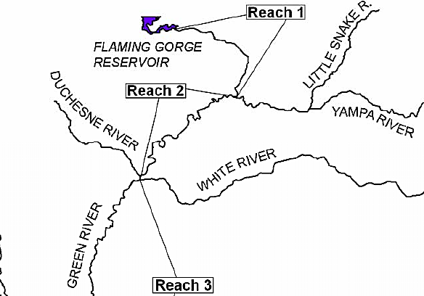

Figure 1. The Three Reaches of the Green River Down Stream of Flaming Gorge Dam (UCREFRP 2000)

Reach 1. Reach 1 is defined as starting immediately downstream of Flaming Gorge Dam and ending at the confluence of the Green River with the Yampa River. The Green River in Reach 1 is essentially directly controlled by releases from Flaming Gorge dam. Therefore, satisfying environmental release flows in Reach 1 by adjusting Flaming Gorge dam releases is easily accomplished (USBR 2005).

Reach 2. Reach 2 is defined as starting immediately downstream of the confluence of the Green River with the Yampa River and ending at the confluence of the Green River with the White River. In the spring, flow in this reach is only partially controlled by releases from Flaming Gorge Dam due to the significant contributions from Yampa River during spring runoff (USBR 2005). Therefore, depending on spring runoff flows in the Yampa River the exact timing and flow rates from Flaming Gorge Dam required to satisfy LTRP flows are difficult to quantify or predict. In addition, for any given year, when Reach 2 flow contributions from the Yampa River are below a certain threshold Flaming Gorge Dam releases for LTRP are reduced or suspended (USBR 2005). During summer, fall, and winter, flows in Reach 2 are largely controlled by releases from Flaming Gorge Dam. Therefore, the CPMSBE flows are largely satisfied by Flaming Gorge Dam releases (USBR 2005).

Reach 3. Reach 3 is defined as starting immediately downstream of the confluence of the Green River with the White River and ends at the confluence of the Green River with the Colorado River. The effect Flaming Gorge Dam releases have on Reach 3 are less significant due to flow contributions from the San Rafael, Price, Duchesne, White, and Yampa rivers (USBR 2005).

**MODEL FORMULATION**

This section presents this study’s model formulation. First, the representation of Flaming Gorge Dam operations and the Green River watershed the model formulation is based on is described. Then the formal model formulation is presented.

## Representation of Flaming Gorge Operations and Green River Watershed

The operation of Flaming Gorge Dam is controlled by a complex set of operational policies which are designed to allow rapid fluctuations in Flaming Gorge Dam releases to meet sudden changes in hydropower demands, changes in inflows to Flaming Gorge Dam, and changes in flows in the Green River downstream of the reservoir (USBR 2005). Flaming Gorge Dam release flows are sometimes adjusted over timescales less than an hour in length. In addition, inflows upstream and flows downstream of the dam from unregulated water sources vary continuously. The representation of Flaming Gorge operations and the Green River watershed’s hydrologic inputs described in this section were used to formulate this study’s model and produce input data for the model.

Total Monthly Flow Volumes. It is outside the scope of this study to fully resolve the time varying nature of Flaming Gorge Dam’s hydropower demands and hydrologic inputs. In addition, the model produced by this study is intended to be operated over a 5-year period. Therefore, to reduce data processing and model complexity a monthly timestep was selected. Consequentially, average daily hydropower demands, average daily hydrologic inputs, environmental releases, and continuous baseflow requirements were converted into total monthly demands and flow volumes.

Hydropower. Historical data of average daily hydropower release flow rates from October 2015 to October 2020 was obtained (USBR 2020). Next total monthly release volumes were calculated from these flow rates. The minimum hydropower release rate for each month over this 5-year period was used to generate a 12-month minimum hydropower demand series for the model (Figure 2). Minimum hydropower demands were selected because they provided a way to incorporate hydropower demands into the model while reducing the likely hood the model would become infeasible due to failing to meet hydropower demand constraints. A minimum hydropower generation elevation of 5,909 ft was also defined as halfway between the rated hydropower elevation and the minimum hydropower reservoir elevation.

Figure 2. Monthly Hydropower Release Volumes from Flaming Gorge

Hydrologic Inputs and the Larval Trigger Release Plan. To simplify the statistical and uncertainty analysis of hydrologic inputs to the Green and Yampa rivers, as well as estimate LTRP release volumes from Flaming Gorge Dam, USGS average daily flow rate data from 2013, 2014, and 2017 was used to represent dry, average, and wet hydrologic scenarios (Figures 3-5, Appendix A). Hydrologic inputs to Flaming Gorge Dam were obtained by summing the flow rate data from USGS gages 09224700, 09217000, and 09229500 which measure flow in the Blacks Fork near Little America, WY, the Green River near Green River, WY, and Henrys Fork near Manila, UT, respectively. Yampa River flow rates were obtained from USGS gage 09260050 near Deerlodge Park, CO. LTRP releases were assumed to occur only in June. The total June monthly release volume satisfying the LTRP environmental flows for each hydrologic scenario was estimated by subtracting Yampa River total monthly flow volumes from Green River total monthly flow volumes in Reach 2 obtained from USGS gage 09261000 near Jensen, UT.

Figure 3. Dry Hydrologic Scenario (USGS, 2020)

Figure 4. Average Hydrologic Scenario (USGS, 2020)

Figure 5. Wet Hydrologic Scenario (USGS, 2020)

Colorado Pikeminnow Summer Base Flow Experiment. CPMSBE releases were assumed to start at the beginning of July and end the last day of September. The Flaming Gorge Dam flow volumes used to achieve CPMSBE in Reach 2 were determined from the *Flaming Gorge Operational Plan 2020 May to April 2021* approximate Flaming Gorge flow releases for satisfying Colorado Pikeminnow environmental releases (2020). CPMSBE flows are reduced in drier years to conserve water in Flaming Gorge Dam. For dry scenarios this corresponded to a flow rate of 1600 cfs. For average and wet scenarios this corresponded to a flow rate of 2000 cfs.

Baseflows. The total monthly base flow volume for each hydrologic scenario was also estimated from *Flaming Gorge Operational Plan 2020 May to April 2021* (2020).The CPMSBE environmental flow release monthly flow volume requirements were small enough they were used as baseflow requirements for the months of July, August, and September. The base flow requirements for Flaming Gorge in each hydrologic scenario, including total environmental release flow volumes for both the LTRP and CPMSBE, are presented in Appendix B. The June LTRP environmental release flows are listed in the baseflow requirement tables but are not considered as baseflow requirements in the following model formulation. Hydropower demands are used as the June monthly baseflow constraint in years when LTRP flows are neglected.

## Formal Model Formulation

The following model formulation represents Flaming Gorge Dam with Glen Canyon Dam. The actual increase in Glen Canyon Dam’s storage is not determined. It is assumed by maximizing Flaming Gorge Dam releases to Glen Canyon Dam, Flaming Gorge Dam is being operated to optimally benefit Glen Canyon Dam. This model does not consider the detrimental effects lower Flaming Gorge Reservoir elevations will cause, such as increased Cyanobacteria blooms as predicted in the 2005 Flaming Gorge FEIS (USBR 2005). In addition, this model ignores all consumptive irrigation and evaporation in Reach 1, Reach 2, and from Flaming Gorge Reservoir. Finally, rather than use reservoir elevations in the model formulation, the minimum reservoir elevation, hydropower elevation, and maximum reservoir elevation values were all converted into volumes prior to their use in the model using the following equation determined by applying a curve fit to storage-elevation data (Equation 1) (Rosenberg 2020).

Where is the Flaming Gorge Reservoirs Storge in Acre-ft, and is Flaming Gorge Reservoir elevation in ft.

## Model Dimensions

The dimensions of the model are time (months or years) and space (location). All storage and flow volumes will be in units of acre-ft. Time will be units of months and years.

## Decision Variables

There are three decision variables in this model. These are the total monthly flow volumes released , the reservoir storage in each month , and the binary environmental flow variables for the LTRP .

## Objective Functions

This model addresses seven objectives:

1. Satisfy hydropower demands
2. Maintain enough storage capacity to successfully route floods
3. Maintain enough storage to meet water supply demands
4. Satisfy baseflow requirements
5. Maximize the number of years environmental spring flow releases are met for Humpback Chub larvae flood plain access in Reach 2
6. Maximize the number of years environmental summer base flows are met for Colorado Pikeminnows in Reach 2.
7. Maximize the flow sent to Lake Powell from Flaming Gorge

Objectives 1-4 convert naturally to constraints and are defined in the constraints section of this model formulation. Objectives 5-7 are represented by the flowing equations (Equations 2-4):

Where is the number of years LTRP flows are achieved and is a binary variable that takes on a value of 1 when LTRP flows are achieved and 0 when they are not.

Where is the number of years CPMSBE flows are achieved and is a binary variable that takes on a value of 1 when CPMSBE flows are achieved and 0 when they are not.

Where is the total volume of flow in acre-ft released over the entire 5-year period the model evaluates.

This model will be solved using a mixed integer linear solver incapable of optimizing more that one objective function at a time. Therefore, two of the three objective functions need to be converted to constraints. Equations 3 and 4 were selected to be transformed into constraints. As previously stated CPMSBE flows were used as baseflow constraints in the months of June, July, and August. Therefore, CPMSBE are always met in any feasible solution of this model. Equation 4 was converted into a separate constraint (Equations 5).

Where is the total flow volume over the 5 year study period released from Flaming Gorge Dam.

## Constraints

This model has the following constraints:

1. **Hydropower Demand.** Flaming Gorge Dam releases must be greater than or equal to the required hydropower releases for all months (Equation 6).

Where is the total monthly hydropower release volume.

1. **Flood Routing.** Flaming Gorge Reservoir must always have enough storage capacity to safely route floods with a 1 to 10% exceedance range (Equation 7).

Where is the maximum safe reservoir storage volume of 3,086,976 acre-ft which corresponds to an elevation of 6,023 ft.

1. **Water Supply and Hydropower.** Flaming Gorge Reservoir must always have enough storage capacity to meet downstream water supply demands. This constraint was also combined with the minimum hydropower storage constraint with the minimum hydropower constraint assumed to be binding (Equation 8).

Where is set as the minimum hydropower generation volume of 545,757.5 acre-ft which corresponds an elevation of 5,909 ft.

1. **Baseflow and CPMSBE.** Flaming Gorge Dam releases must always satisfy required baseflow and CPMSBE releases (Equation 9).

Where is the total monthly baseflow volume in each month.

1. **Release Capacity.** Flaming Gorge Dam releases must not exceed the capacity of the turbine and bypasses tunnels. Assumes a 30-day month. Operation of Flaming Gorges spillway is not considered in this model.

Where is Flaming Gorge Dam’s maximum monthly release capacity of 511735.5 ac-ft per month.

1. **LTRP Release Flow Binary Decision.** This constraint requires the model to either release LTRP flows or to be bound by the binding constraint of baseflow or hydropower in the month of June.

Where corresponds to and is the LTRP total June flow volume for a given hydrologic scenario.

1. **Flaming Gorge Conservation of Mass.** This is the conservation of mass constraint for Flaming Gorge. An initial storage will have to be selected.

(12)

Where is the total monthly inflow to Flaming Gorge Dam.

# MODEL RESULTS

Unfortunately, the model produced infeasible solutions for essentially all but two scenarios. These scenarios differed by the value of parameter . is the total flow volume over the 5 year study period released from Flaming Gorge Dam. for the first scenario, *Scenario 1,* was set as zero. *Scenario 1* was used to evaluate the results of the model without having to meet the constraint in Equation 5. In this regard *Scenario 1* is representative of current Flaming Gorge operations. However, even though the wet hydrologic scenario was used for all 5 years in *Scenario 1,* results showed storage in Flaming Gorge Reservoir continually decreased each year (Figure 6). This indicates that even without the constraint of Equation 5, hydropower, baseflow, the LTRP release volumes were cumulatively to high (Figure 7).

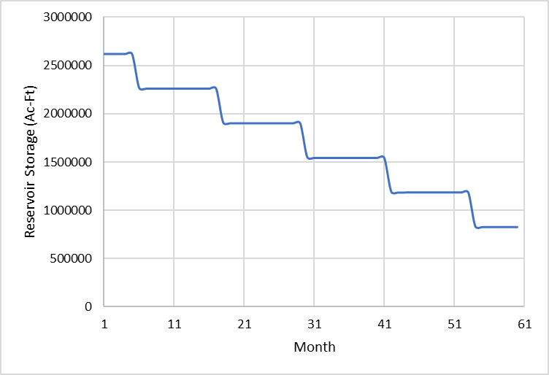

Figure 6. Scenario 1 Flaming Gorge Reservoir Storage

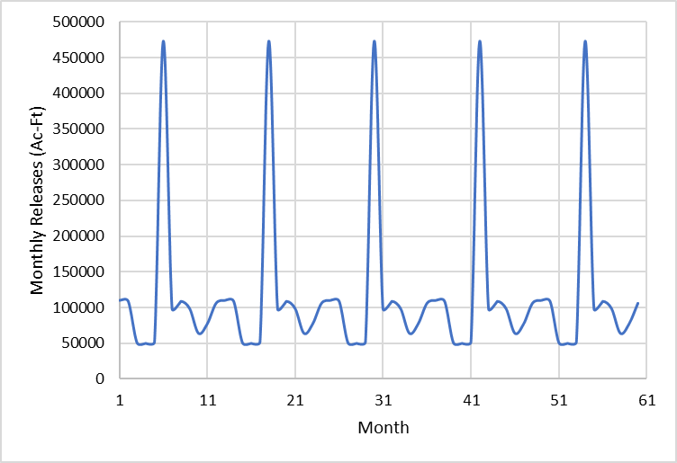

Figure 7. Scenario 1 Flaming Gorge Dam Releases.

There are many major modeling obstacles remaining at this point. Primarily they are related to implementing the model formulation into GAMS or and Excel sheet, and obtaining a feasible solution. I am also worried that by using total monthly flow volumes based on average hydropower releases, or anticipated release volumes for the Colorado Pikeminnow I am overestimating the total monthly release volumes by a huge margin. I may have to go back and reduce these flow volumes which raises the concern that if I do so, I am still representing the actual system. Lastly if ever manage to get my model working, I still need to interpret model results and based upon them come up with recommendations or insight into the operations of Flaming Gorge Dam.

# REFERENCES

Bestgen, K. R., Beyers, D. W., Rice, J. A., & Haines, G. B. (2006). Factors Affecting Recruitment of Young Colorado Pikeminnow: Synthesis of Predation Experiments, Field Studies, and Individual-Based Modeling. *Transactions of the American Fisheries Society,* *135*(6), 1722-1742. doi:10.1577/t05-171.1

Campana, P (2020). *Maximizing Flaming Gorge Releases to Lake Powell*. https://github.com/PatrickCampana/CEE6410_SemesterProject

De Cicco, L.A., Hirsch, R.M., Lorenz, D., Watkins, W.D., (2018). dataRetrieval: R packages for discovering and retrieving water data available from Federal hydrologic web services, doi:10.5066/P9X4L3GE

Fulp, T., Harkings, J. (2001). Policy Analysis Using RiverWare: Colorado River Interim Surplus Guidelines. Proceedings of the ASCE World Water & Environmental Resource Congress, Orlando, FL, 2001. Retrieved from: <https://www.colorado.edu/cadswes/policy-analysis-using-riverware-colorado-river-interim-surplus-guidelines>

Rosenberg. D. (2020). Engineering Economics Juboish Problem Flaming Gorge Data

Upper Colorado River Endangered Fish Recovery Program (UCREFRP) (2000). Flow and Temperature Recommendations for Endangered Fishes in the Green River Downstream of Flaming Gorge Dam. Retrieved from: <https://www.coloradoriverrecovery.org/documents-publications/technical-reports/isf/flaminggorgeflowrecs.pdf>

U. S. Bureau of Reclamation. (2005). Operation of Flaming Gorge Dam Final Environmental Impact Statement. Retrieved from: <https://www.usbr.gov/uc/envdocs/eis/fgFEIS/index.html>

U. S. Bureau of Reclamation. (2006) Record of Decision Operation of Flaming Gorge Dam Final Environmental Impact Statement. Retrieved from: <https://www.usbr.gov/uc/envdocs/rod/fgFEIS/final-ROD-15feb06.pdf>

U. S. Bureau of Reclamation. (2020) Flaming Gorge Operation Plan – May 2020 through April 2021 Retrieved from: <https://www.usbr.gov/uc/DocLibrary/Plans/FlamingGorge/20200430-FlamingGorgeOperationPlan-May2020-April2021-508-PO.pdf>

U. S. Bureau of Reclamation. (2020) Upper Colorado Region Water Operations: Historic Data. Retrieved from: <https://www.usbr.gov/rsvrWater/HistoricalApp.html>

U.S. Geological Survey (2020). USGS 09224700 BLACKS FORK NEAR LITTLE AMERICA, WY. National Water Information System data available on the World Wide Web (USGS Water Data for the Nation), accessed [November 27, 2020], at <https://waterdata.usgs.gov/wy/nwis/uv?09224700>

U.S. Geological Survey (2020). USGS 09217000 GREEN RIVER NEAR GREEN RIVER, WY. National Water Information System data available on the World Wide Web (USGS Water Data for the Nation), accessed [November 27, 2020], at <https://waterdata.usgs.gov/wy/nwis/uv?09217000>

U.S. Geological Survey (2020). USGS 09261000 GREEN RIVER NEAR JENSEN, UT. National Water Information System data available on the World Wide Web (USGS Water Data for the Nation), accessed [November 27, 2020], at <https://waterdata.usgs.gov/usa/nwis/uv?site_no=09261000>

U.S. Geological Survey (2020). USGS 09229500 HENRYS FORK NEAR MANILA, UT. National Water Information System data available on the World Wide Web (USGS Water Data for the Nation), accessed [November 27, 2020], at URL <https://waterdata.usgs.gov/wy/nwis/uv?09229500>

U.S. Geological Survey (2020). USGS 09260050 YAMPA RIVER AT DEERLODGE PARK, CO. National Water Information System data available on the World Wide Web (USGS Water Data for the Nation), accessed [November 27, 2020], at URL <https://waterdata.usgs.gov/usa/nwis/uv?site_no=09260050>

Wang, J., Rosenberg, D. E., Wheeler, K. G., and Schmidt, John C (2019). Managing the Colorado River for an Uncertain Future. Center for Colorado River Studies. Retrieved from: <https://qcnr.usu.edu/coloradoriver/files/CCRS_White_Paper_3.pdf>

Wheeler, K. G., Schmidt, John C, and Rosenberg, D. E. (2019). Water Resource Modeling of the Colorado River: Present and Future Strategies. Center for Colorado River Studies. Retrieved from: <https://qcnr.usu.edu/coloradoriver/files/CCRS_White_Paper_2.pdf>

# APPENDIX A ENVIROMENTAL RELEASES FOR EACH REACH OF THE GREEN RIVER

Table 1A. Recommeded Magnitudes and Duration of Maximum Spring Peak (LTRP) and Summer-to-Winter (CPMSBE) Releases (USBR 2005)

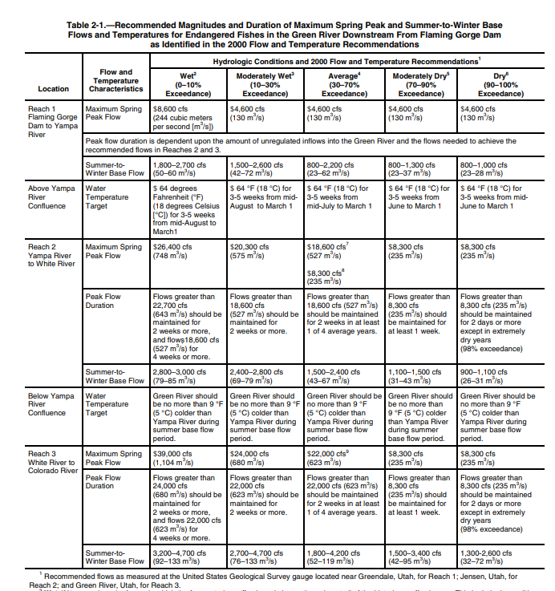

# APPENDIX B HYDROGRAPHS OF THE GREEN AND YAMPA RIVER

This appendix contains plots of average daily hydrographs from USGS steam gages and tabulate total monthly flow volumes for each gage and year. The USGS gages used are Green River near Green River, WY (#09217000), Yampa River at Deer Lodge, CO (#09260050), and Green River near Jensen, UT (#09261000). Gage #09217000 is located upstream of Flaming Gorge Dam and gage #09261000 is located downstream of the confluence of the Green River and the Yampa River.

## Green River near Green River, WY (#09217000)

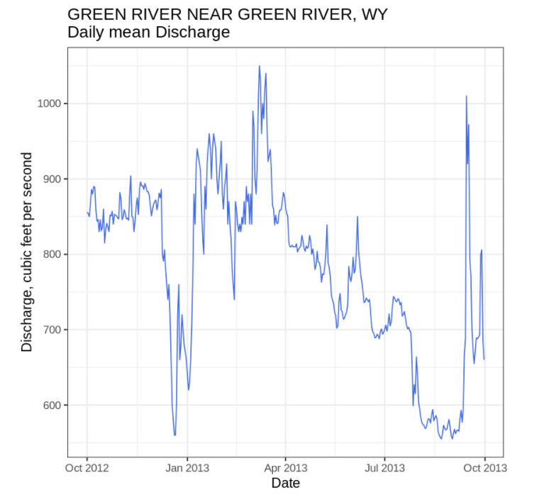

Figure B1. Gage #09217000 2013 Water Year

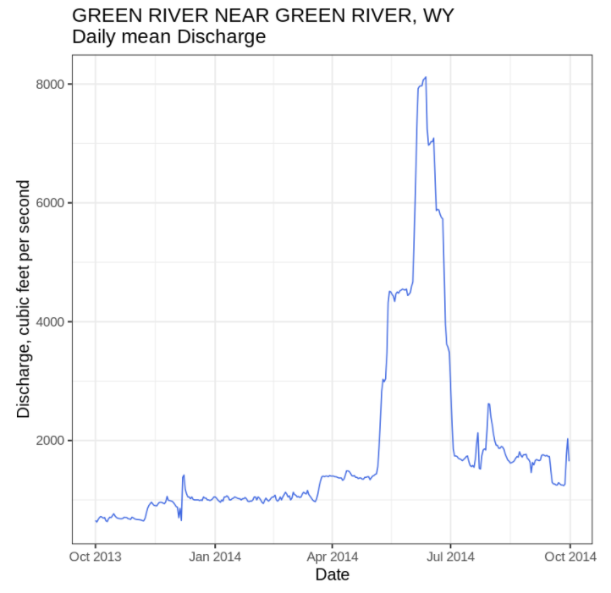

Figure B2. Gage #09217000 2014 Water Year

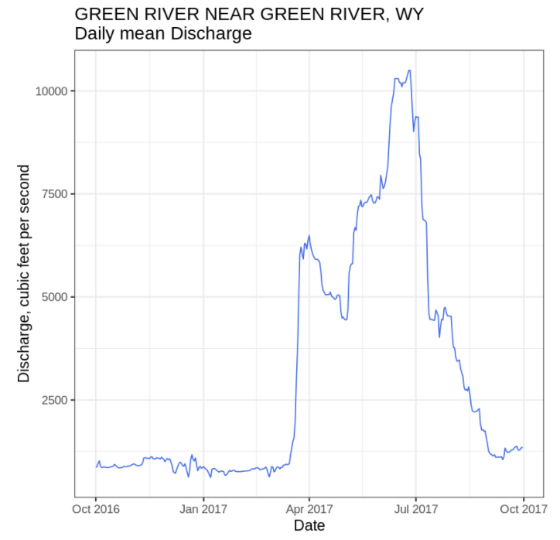

Figure B3. Gage #09217000 2017 Water Year

## Yampa River at Deer Lodge, CO (#09260050)

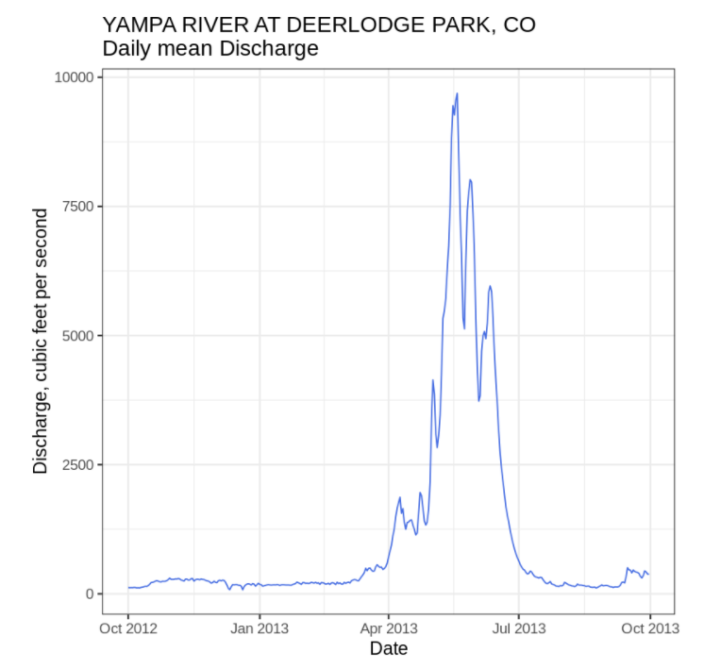

Figure B4. Gage #09260050 2013 Water Year

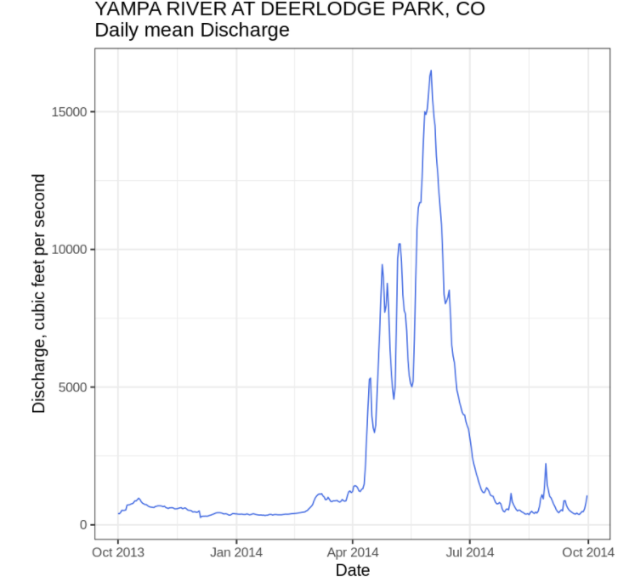

Figure B5. Gage #09260050 2014 Water Year

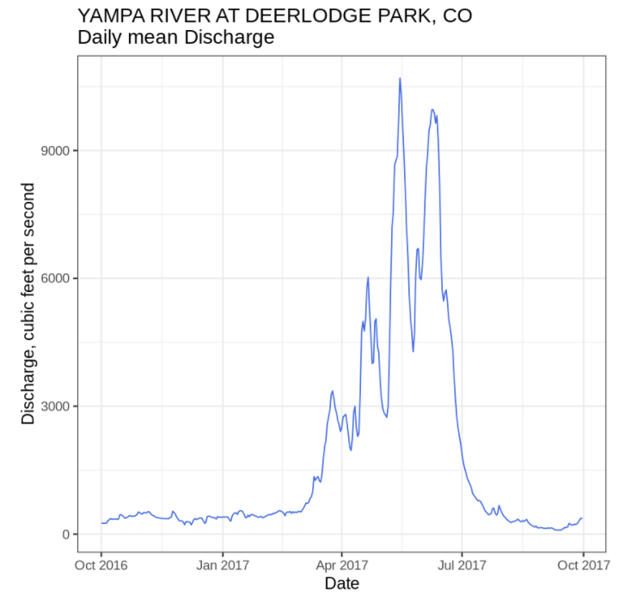

Figure B6. Gage #09260050 2017 Water Year

## Green River near Jensen, UT (#09261000)

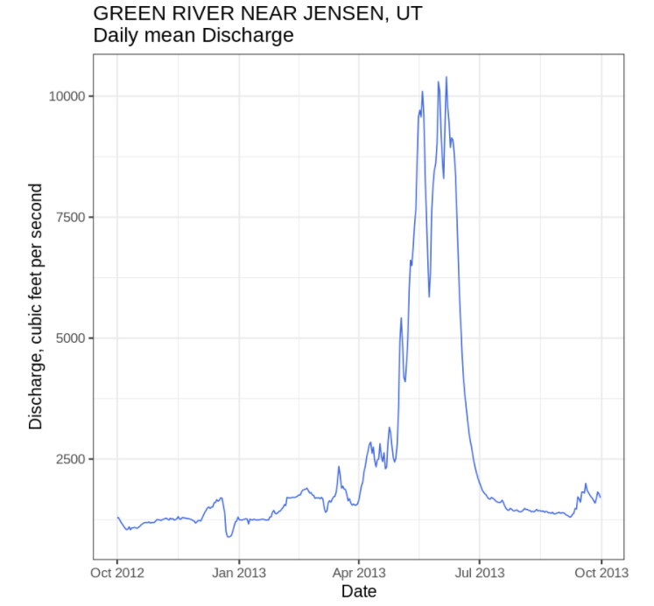

Figure B7. Gage #09261000 2013 Water Year

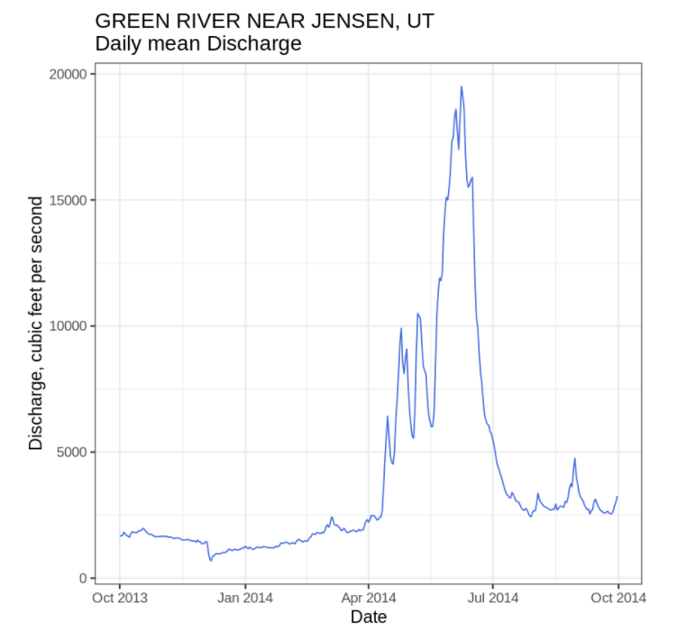

Figure B8. Gage #09261000 2014 Water Year

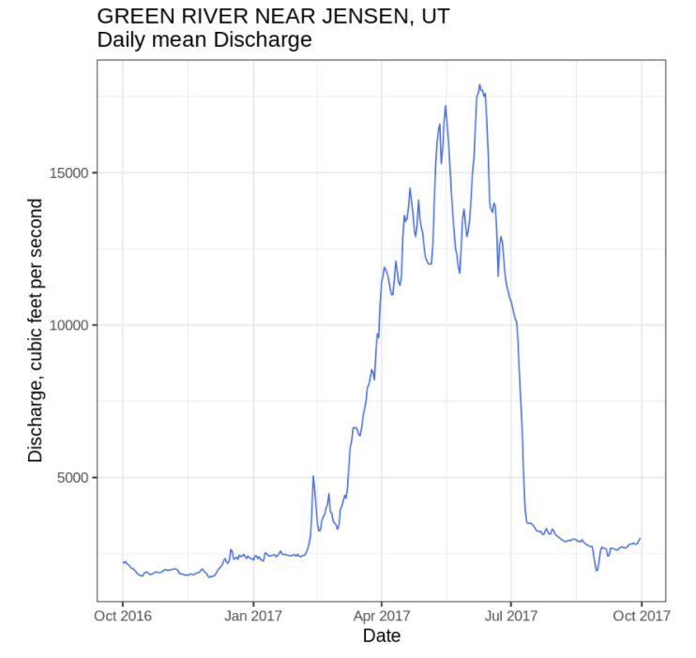

Figure B9. Gage #09261000 2017 Water Year

## Tabulated Total Monthly Flow Volume Water Year Data.



Figure B10. Water Year Total Monthly Flow Volume Tabulated Data

# Appendix C BASE FLOW AND ENVIROMENTAL RELEASE DEMANDS

The following tables contain the Flaming Gorge Dam total monthly flow demands for each hydrologic scenario. These tables included the June LTRP environmental flow release. Note for years were June environmental release flows are not met hydropower demands are used as the monthly binding outflow constraint.

Table C1. Wet Year



Table C2. Average Year



Table C3. Dry Year

