# PROBLEM OVERVIEW

The Colorado River Basin (CRB) is a heavily modified and regulated watershed. Growing water demands due to population increases, combined with extended drought conditions are straining the water supply provided by the Colorado River Basin Storage Project’s reservoirs and unregulated hydrologic inputs (Wang et al. 2020). Therefore, in an attempt to find solutions to this growing problem, new CRB management strategies and their respective benefits should be evaluated. Currently, Flaming Gorge Dam is not operated in coordination with Lake Powell. Coordinated operation of Flaming Gorge Dam with Glen Canyon Dam may increase the overall amount of water stored in Lake Powell and offer Glen Canyon Dam managers increased flexibility and capability in regard to meeting water supply demands and environmental flow targets in the Lower Colorado River Basin (LCRB).

Consequentially, the objective of this study is to design a simplified, yet representative model of the Upper Colorado River Basin (UCRB) in regard to the coordinated operation of Flaming Gorge Reservoir with Glen Canyon Dam. Ideally, model results will offer insight in regard to Flaming Gorge Dam operations which result in maximized releases to Lake Powell while simultaneously satisfying Flaming Gorge Dam management objectives such as environmental flow releases.

Therefore, this study’s model will attempt to address four Flaming Gorge Dam management objectives. The four objectives are:

1. Maximizing the flow sent to Lake Powell from Flaming Gorge
2. Maintaining storage in Flaming Gorge
3. Maximizing the number of years environmental spring flow releases are met for Humpback Chubs in Reach 2
4. Maximizing the number of years environmental summer flows are met for Colorado Pike Minnows in Reach 2.

This report first reviews prior modeling efforts of the Colorado River Basin. Next a system description of Flaming Gorge Dam and the Green River in regard to current USBR water management objectives is provided. Finally, the model formulated in this study is presented and model results are discussed. The overarching purpose of the discussion is to offer insight into the potential trade offs between management objectives and any other relevant findings from model results.

# LITERATURE REVIEW

Modeling the Colorado River Basin (CRB) requires balancing the primary management objectives of flood control, providing water for consumptive use, recreation, ecosystems, and hydropower (Fulp and Harkins, 2001). Water rights, regulations, and management policies, collectively known as the Law of the River, limited natural hydrologic inputs, reservoir storage capacities and minimum elevations, hydropower demands, and environmental flow targets collectively form a complex, interconnected system of resources and operating constraints in the CRB (Wheeler, Rosenberg, and Schmidt, 2019). This literature review will describe aspects of the most notable CRB model, the Colorado River System Simulation (CRSS), as applicable to this project’s objectives, as well as select background information.

The CRSS has existed in various forms for approximately 40 years. Its present form is a conglomerate of previously independent models as well as improvements to the original integration of independent CRB models. The CSSR is compiled using the software RiverwareTM. The current model includes 12 reservoir nodes, 29 headwater tributary and within-basin stream-flow gauges, 520 water user objects, and 145 operating rules which represent the Law of the River (Wheeler, Rosenberg, and Schmidt, 2019). Although the model is quite complex in certain aspects, it coarsely defines many locations and their associated hydrologic budgets and other applicable attributes. This is because the CSSR was primarily developed to model the impact of modifications to the operations of major hydraulic structures within the CRB (Wheeler, Rosenberg, and Schmidt, 2019).

Consequentially, the CSSR is best applied to modeling basin wide issues and responses (Wheeler, Rosenberg, and Schmidt, 2019). For finer physical and temporal scales, the current configuration of the CRSS is inappropriate for finding optimal solutions to water supply and environmental tradeoffs (Wheeler, Rosenberg, and Schmidt, 2019). Therefore, the contribution of this project to the existing body of CRB models is to provide a model with improved spatial resolution, relative to the CSSR, which maximizes environmental flow releases from Flaming Gorge Dam Flaming Gorge while simultaneously prioritizing maximizing releases to Lake Powell. By comparing this study’s model results with CSSR results, UCRB management policies which improve current UCRB operations may be identified.

Records of Flaming Gorge Dam operations can be accessed at the *Upper Colorado Region Water Operations: Historical Data* webpage (USBR 2020). The USBR *2006 Decision of Record* (DOR) currently governs the overall operation strategy of Flaming Gorge Reservoir Operation (USBR 2006). The 2006 DOR adopted environment flow target recommendations from *Flow and Temperature Recommendations for Endangered Fishes in the Green River Downstream of Flaming Gorge Dam*s for three different reaches (Figure 1) (Upper Colorado River Endangered Fish Recovery Program 2000).

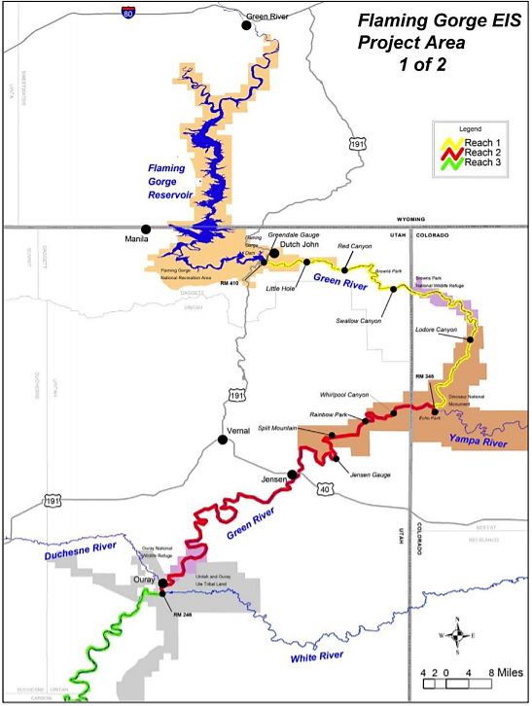

Figure 1. The Three Reaches of The Green River (USBR 2005)

**SYSTEM DESCRIPTION AND SIMPLICFICATION**

The operation of Flaming Gorge Dam is controlled by a complex set of operational policies which are designed to allow rapid fluctuations in Flaming Gorge Dam releases to meet sudden changes in hydropower demands, changes in inflows to Flaming Gorge Dam, and changes in flows downstream of the reservoir in reaches impacted by flows from unregulated tributaries. Flaming Gorge Dam release flows are sometimes adjusted over timescales less than an hour in length. In addition, inflows upstream and flows downstream of the dam from unregulated water sources vary continuously.

It is outside the scope of this study to fully resolve the time varying nature of these hydropower demands and hydrologic inputs. In addition, the model produced by this study is intended to be operated over a 5-year period. Therefore, to reduce data processing and model complexity a monthly timestep was selected. Consequentially, average daily hydropower demands and hydrologic inputs were individually aggregated into total monthly demands and flow volumes. In addition, operational and environmental releases rates were transformed into simplified monthly flow volume constraints. Finally, to simplify statistical and uncertainty analysis of hydrologic inputs to the Green and Yampa rivers, USGS flow rate data from 2013, 2014, and 2017 were used to represent dry, average, and wet hydrologic scenarios. This study’s model will use various combinations of these scenarios, switching between them on a yearly scale.

In regard to hydropower, average daily hydropower release flow rates from October 2015 to October 2020 were obtained (USBR 2020). Next total monthly release volumes were calculated from these flow rates. The minimum hydropower release rate for each month over this 5-year period was used to generate a 12-month minimum hydropower demand series for the model (Figure 2). Minimum hydropower demands were selected because they provided a way to incorporate hydropower demands into the model while reducing the likely hood the model would become infeasible due to failing to meet hydropower demand constraints.

Figure 2. Monthly Hydropower Release Volumes from Flaming Gorge

In regard to operational and environmental flow demands, it is infeasible to always satisfy the 2006 ROD baseflow and environmental flow release volumes for each reach of the Green River simultaneously due to the inability of Flaming Gorge Dam to provide enough water to satisfy the demands by itself. This is because demands are met in part by contributions from unregulated hydrologic inputs such as the Yampa (Reach 2) and White river (Reach 3) (USBR, 2006). However, when the base flow requirements of Reach 1 are met the base flow requirements of Reach 2 and 3 are usually met. In addition, when the environmental flow releases in Reach 2 are met the environmental flow releases in Reach 1 and 3 are typically met (USGS, 2005). Therefore, this study’s model will optimize Flaming Gorge operations based on satisfying Reach 1 baseflow requirements and Reach 2 environmental flow requirements that have been converted into Flaming Gorge Dam monthly release volumes. This required further simplification of hydrologic inputs from the Yampa river and environmental flows in Reach 2.

Two major environmental flow releases occur each year. The first is the Larval Trigger Release Plan (LTRP) and the second is the Colorado Pike Minnow Summer Baseflow Experiment (CPMSBE). For LTRP flows, depending on spring runoff volumes upstream of Flaming Gorge Dam and in the Yampa watershed, Reach 2 flow rates of approximately 14,000 cfs are targeted for 7 to 14 days. In addition, peak flow rates of 18,000 cfs are targeted. In order to limit temperature fluctuations due to reservoir releases, Flaming Gorge release rates are ramped up to and down from their flow contributions to the environmental flows in Reach 2 (USBR, 2006).

The exact timing and monthly release volumes from Flaming Gorge Dam to satisfy its required contribution to the LTRP flows is difficult to quantify or predict. Regarding timing, LTRP are initiated by the first appearance of larval humpback chub at select monitoring locations. Larvae first appear in late May or early June with an average first day of appearance of May 28th (UCR Endangered Fish Recovery Program, 2000). Therefore, larval appearance was assumed to occur entirely in the month of June and LTRP flow volumes were incorporated into June total monthly flow volumes. Regarding flow rate, flow contributions in Reach 2 from the Yampa river vary continuously and are often radically different from year to year. In addition, the amount of water available for release in Flaming Gorge Dam depends on uncertain hydrologic inputs.

Therefore, hydrologic scenarios consisting of total monthly flows calculated from USGS stream gauge data from 2013, 2014, and 2017 water years were created (Figures 3-5; Appendix A). The 2013, 2014, and 2017 water years represent dry, average, and wet hydrologic scenarios. These categories were determined by visually inspecting annual hydrographs of the Green and Yampa River’s from 2010 to 2020. Then for each hydrologic scenario the total monthly flow volume of Reach 2 in June was determined. Finally, Flaming Gorge total monthly flow volumes in June were estimated by subtracting the June total monthly flow rate of the Yampa River from the Green River measured downstream of the confluence of the Yampa River and Green River.

Figure 3. Dry Hydrologic Scenario (USGS, 2020)

Figure 4. Average Hydrologic Scenario (USGS, 2020)

Figure 5. Wet Hydrologic Scenario (USGS, 2020)

Regarding the CPMSBE, Colorado Pike Minnow first appear in Reach 2 in late June to early July with an average first day of appearance of July 4th (USBR 2020). Therefore, Flaming Gorge Dam CPMSBE releases were assumed to start at the beginning of July. CPMSBE flows are sustained from their initiation until the last day of September. The typical Flaming Gorge Dam flow volumes used to achieve CPMSBE in Reach 2 were determined from the *Flaming Gorge Operational Plan 2020 May to April 2021’s* approximate Flaming Gorge flow releases for satisfying Colorado Pike Minnow environmental releases. CPMSBE flows are reduced in drier years to conserve water in Flaming Gorge Dam. For dry scenarios this corresponded to a flow rate of 1600 cfs, for average and wet scenarios this correspond to a flow rate of 2000. The exact monthly flow volume requirement for Flaming Gorge in each hydrologic scenario are presented in Appendix B.

# MODEL FORMULATION

The following model formulation accounts for the desired elements of a simplified model of the coordinated operation of Flaming Gorge Dam with Glen Canyon Dam. The four management objectives are simplified into one maximization objective function and three constraints. The actual increase in Glen Canyon Dam’s storage is not determined. It is assumed by maximizing Flaming Gorge Dam releases to Glen Canyon Dam, Flaming Gorge Dam is being operated to optimally benefit Glen Canyon Dam.

A monthly time scale was selected for this project based on the abundance of readily available monthly data. This time scale introduces added uncertainty in model result. This model does not consider the detrimental effects lower Flaming Gorge Reservoir elevations will cause, such as increased Cyanobacteria blooms as predicted in the 2005 Flaming Gorge FEIS (USBR 2005). In addition, this model ignores all consumptive uses in Reach 1 and evaporation from Flaming Gorge Reservoir.

## Model Dimensions

The dimensions of the model are time (months or years) and space (location). All storage and flow volumes will be in units of acre-ft. Time will be units of months and years.

## Objective Functions

This model addresses four management objectives:

1. Maximizing the flow sent to Glen Canyon Dam from Flaming Gorge Dam (Equation 1).
2. Maintaining a minimum amount of storage in Flaming Gorge Dam (Equation 2)
3. Maximizing the number of years environmental flows are met for Humpback chubs (LTRP flows) (Equation 3).
4. Maximizing the number of years environmental flows are met for Colorado Pike Minnows (CPMSBE flows) (Equation 4).

Where *FGmax* is the sum of all Flaming Gorge Dam total monthly release volumes over the 5-year study period and *X(Flow, Time)* are the Flaming Gorge Dam total monthly release volumes for each month.

Where is the sum of Flaming Gorge reservoir’s monthly storage volumes occurring over the 5-year study period and is Flaming Gorge reservoir’s storage in each month.

Where is the number of years LTRP flows are not achieved and is a binary variable that takes on a value of 0 when LTRP flows are achieved and 1 when they are not.

Where is the number of years CPMSBE flows are not achieved and is a binary variable that takes on a value of 0 when CPMSBE flows are achieved and 1 when they are not.

This model will be solved using linear programming incapable of optimizing more that one objective function at a time. Therefore, Equations 1,2, and 4 will be transformed into constraints (Equations 5-7)

Where is the total flow volume over the 5 year study period released from Flaming Gorge Dam.

Where is the minimum storage required in Flaming Gorge Dam for each month.

This objective constraint will be further altered into a minimum reservoir elevation constraint. Using a storage-elevation function Equation 6a becomes Equation 7a. Elevation was selected over storage for this constraint because it was easier to compare to the minimum hydropower rate water level elevation and the maximum reservoir elevation.

Where is the reservoir elevation in a given month and is the minimum reservoir elevation allowed.

Finally, CPMSBE management objective is transformed into base flow constraints for the months of July, August and September

## Decision Variables

There are three types of decision variables in this model. These are the total monthly flow volumes released (i.e. , the reservoir storage in each month , and the binary environmental flow variables for the LTRP . Units of flow will be (acre-ft/month) and time will be in units of months or years.

**Constraints**

This model has large number of constraints.

1. **Minimum Hydropower Elevation**. Flaming Gorge’s Reservoir elevation must be higher than a hydropower minimum elevation. An elevation of 5,909 ft was selected. This is halfway between the rated hydropower elevation of 5,946 ft and the minimum hydropower elevation of 5,871 ft.

Where is equal to 5,909 ft.

1. **Elevation Storage Relationship.** This constraint calculates the elevation of the reservoir based on the storage. A function describing a curve fit from elevation storage data provide by Dr. Rosenberg will used in the model.

Where is the elevation storage relationship function.

1. **Base Flow Requirement.** This constraint requires each month’s cumulative outflow volume to be greater than or equal to the cumulative monthly baseflow demands.

Where is the total monthly baseflow requirement for each month.

1. **Flaming Gorge Mass Balance.** This is the conservation of mass constraint for Flaming Gorge. An initial storage will have to be selected. Inflows will be based on average cumulative in flows for each month.

(11)

Where is the total monthly inflow to Flaming Gorge Dam.

1. **Flaming Gorge Maximum Reservoir Elevation.** This constraint restricts the elevation of Flaming Gorge from surpassing the Elevation of the top of the dam.

Where is equal to 6023 ft.

1. **Maximum Outflow Capacity Constraint.** This constraint restricts outflow from Flaming Gorge Dam to values less than or equal to the maximum outflow capacity of the hydropower outlets, bypass tunnels, and spillway.

Where is equal to 56727 Ac-ft per month.

# MAJOR MODELING OBSTACLES REMAINING

There are many major modeling obstacles remaining at this point. Primarily they are related to implementing the model formulation into GAMS or and Excel sheet, and obtaining a feasible solution. I am also worried that by using total monthly flow volumes based on average hydropower releases, or anticipated release volumes for the Colorado Pikeminnow I am overestimating the total monthly release volumes by a huge margin. I may have to go back and reduce these flow volumes which raises the concern that if I do so, I am still representing the actual system. Lastly if ever manage to get my model working, I still need to interpret model results and based upon them come up with recommendations or insight into the operations of Flaming Gorge Dam.

# REFERENCES

Fulp, T., Harkings, J. (2001). Policy Analysis Using RiverWare: Colorado River Interim Surplus Guidelines. Proceedings of the ASCE World Water & Environmental Resource Congress, Orlando, FL, 2001. Retrieved from: https://www.colorado.edu/cadswes/policy-analysis-using-riverware-colorado-river-interim-surplus-guidelines

**Rosenberg engineering economics data**

Upper Colorado River Endangered Fish Recovery Program (2000). Flow and Temperature Recommendations for Endangered Fishes in the Green River Downstream of Flaming Gorge Dam. Retrieved from: https://www.coloradoriverrecovery.org/documents-publications/technical-reports/isf/flaminggorgeflowrecs.pdf

U. S. Bureau of Reclamation. (2005). Operation of Flaming Gorge Dam Final Environmental Impact Statement. Retrieved from: https://www.usbr.gov/uc/envdocs/eis/fgFEIS/index.html

U. S. Bureau of Reclamation. (2006) Record of Decision Operation of Flaming Gorge Dam Final Environmental Impact Statement. Retrieved from: https://www.usbr.gov/uc/envdocs/rod/fgFEIS/final-ROD-15feb06.pdf

U. S. Bureau of Reclamation. (2020) Flaming Gorge Operation Plan – May 2020 through April 2021 Retrieved from: https://www.usbr.gov/uc/DocLibrary/Plans/FlamingGorge/20200430-FlamingGorgeOperationPlan-May2020-April2021-508-PO.pdf

U. S. Bureau of Reclamation. (2020) Upper Colorado Region Water Operations: Historic Data. Retrieved from: https://www.usbr.gov/rsvrWater/HistoricalApp.html

U.S. Geological Survey (2020). USGS 09224700 BLACKS FORK NEAR LITTLE AMERICA, WY. National Water Information System data available on the World Wide Web (USGS Water Data for the Nation), accessed [November 27, 2020], at [https://waterdata.usgs.gov/wy/nwis/uv?09224700].

U.S. Geological Survey (2020). USGS 09217000 GREEN RIVER NEAR GREEN RIVER, WY. National Water.Information System data available on the World Wide Web (USGS Water Data for the Nation), accessed [November 27, 2020], at [https://waterdata.usgs.gov/wy/nwis/uv?09217000].

U.S. Geological Survey (2020). HENRYS FORK NEAR MANILA, UT. National WaterInformation System data available on the World Wide Web (USGS Water Data for the Nation), accessed [November 27, 2020], at URL [https://waterdata.usgs.gov/wy/nwis/uv?09229500].

U.S. Geological Survey (2020). USGS 09260050 YAMPA RIVER AT DEERLODGE PARK, CO. National Water Information System data available on the World Wide Web (USGS Water Data for the Nation), accessed [November 27, 2020], at URL [https://waterdata.usgs.gov/usa/nwis/uv?site_no=09260050].

Wang, J., Rosenberg, D. E., Wheeler, K. G., and Schmidt, John C (2019). Managing the Colorado River for an Uncertain Future. Center for Colorado River Studies. Retrieved from: https://qcnr.usu.edu/coloradoriver/files/CCRS_White_Paper_3.pdf

Wheeler, K. G., Schmidt, John C, and Rosenberg, D. E. (2019). Water Resource Modeling of the Colorado River: Present and Future Strategies. Center for Colorado River Studies. Retrieved from: https://qcnr.usu.edu/coloradoriver/files/CCRS_White_Paper_2.pdf

De Cicco, L.A., Hirsch, R.M., Lorenz, D., Watkins, W.D., 2018,

#> dataRetrieval: R packages for discovering and retrieving water data

#> available from Federal hydrologic web services, doi:10.5066/P9X4L3GE

**Appendix A Hydrographs of the Green and Yampa Rivers Water Years**

This appendix contains plots of average daily hydrographs from USGS steam gages and tabulate total monthly flow volumes for each gage and water year. The USGS gages used are Green River near Green River, WY (#09217000), Yampa River at Deer Lodge, CO (#09260050), and Green River near Jensen, UT (#09261000). Gage #09217000 is located upstream of Flaming Gorge Dam and gage #09261000 is located downstream of the confluence of the Green River and the Yampa River.

## Green River near Green River, WY (#09217000)

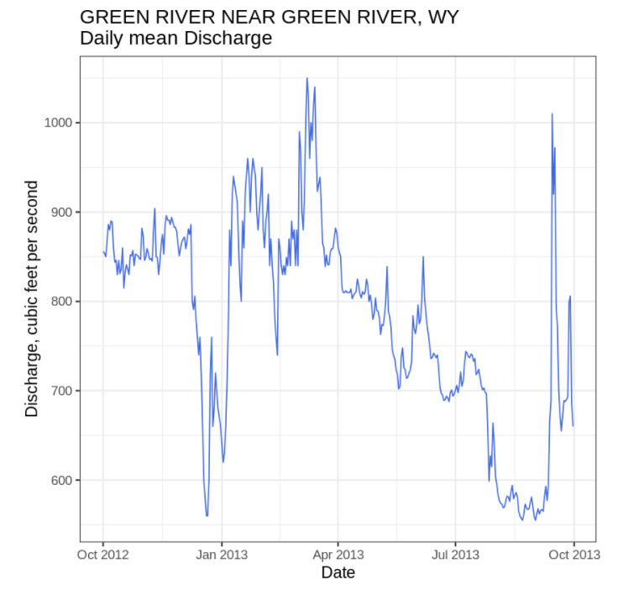

Figure 6. Gage #09217000 2013 Water Year

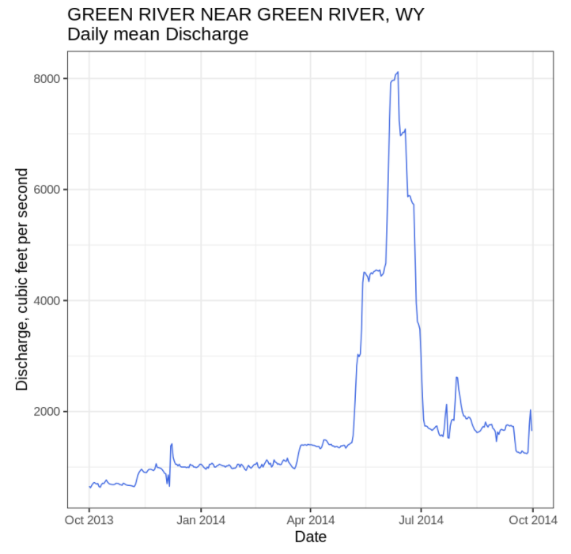

Figure 7. Gage #09217000 2014 Water Year

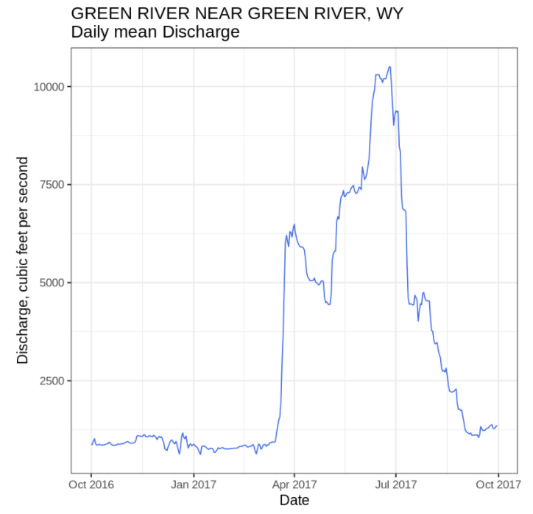

Figure 8. Gage #09217000 2017 Water Year

## Yampa River at Deer Lodge, CO (#09260050)

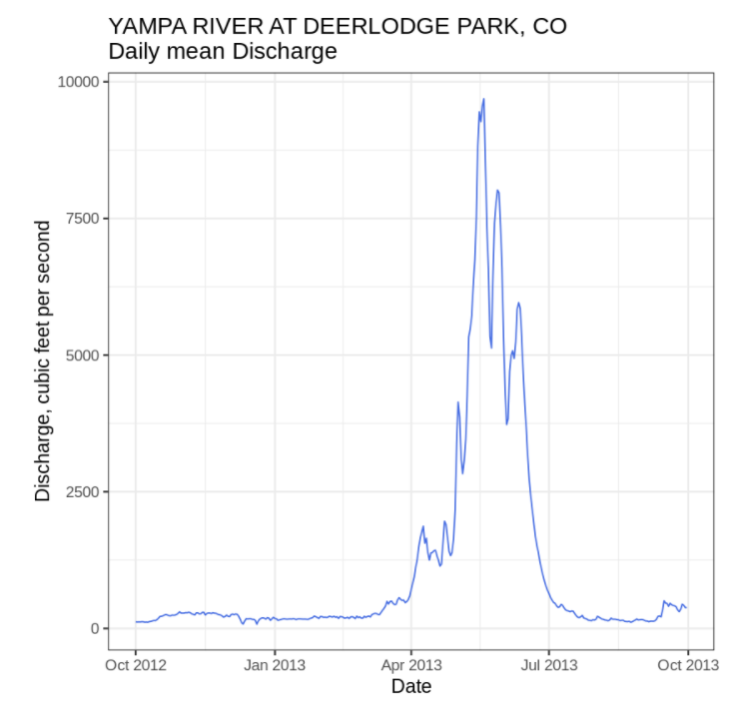

Figure 9. Gage #09260050 2013 Water Year

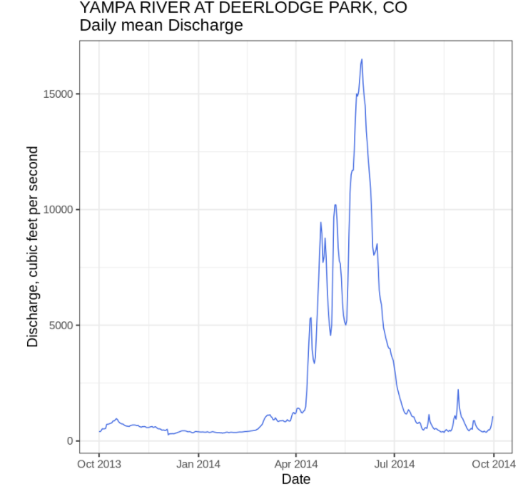

Figure 10. Gage #09260050 2014 Water Year

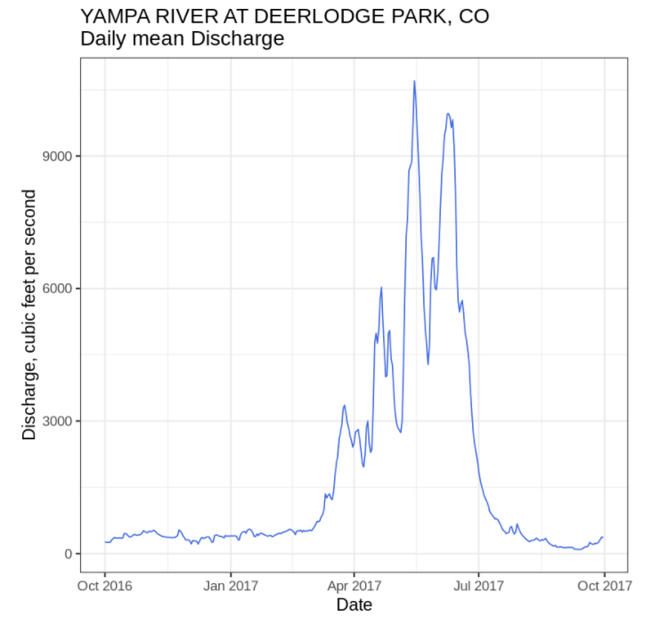

Figure 11. Gage #09260050 2017 Water Year

## Green River near Jensen, UT (#09261000)

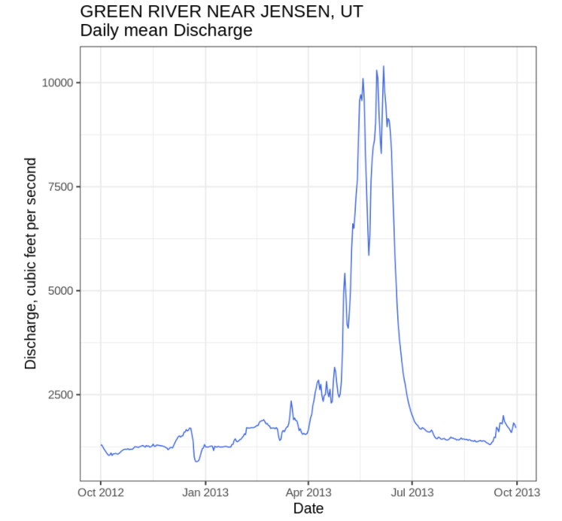

Figure 12. Gage #09261000 2013 Water Year

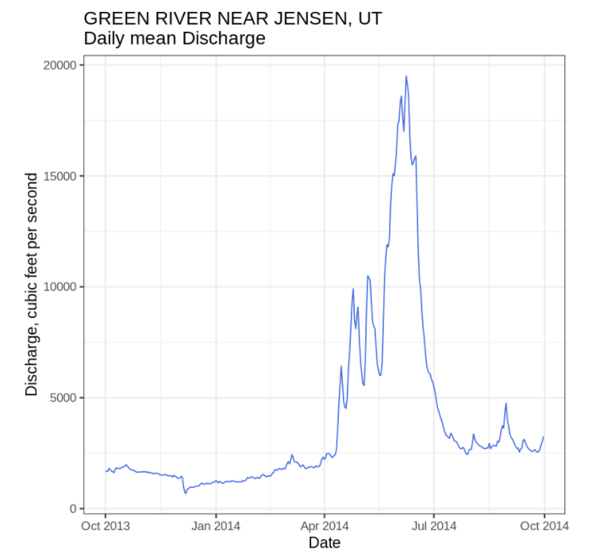

Figure 13. Gage #09261000 2014 Water Year

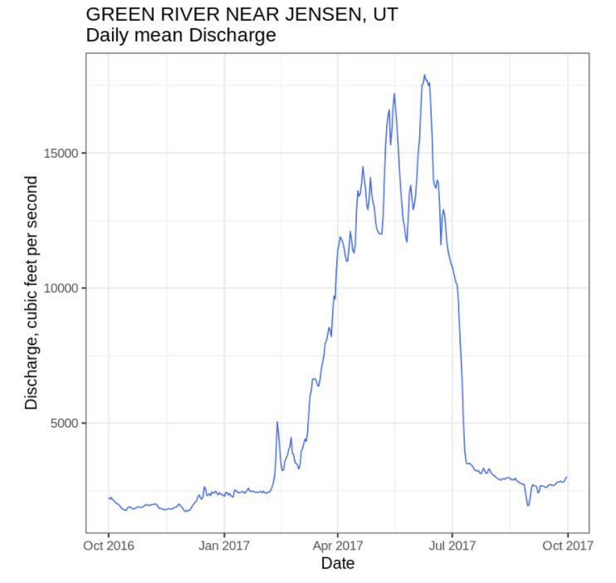

Figure 14. Gage #09261000 2017 Water Year

## Tabulated Total Monthly Flow Volume Water Year Data.



Figure 15. Water Year Total Monthly Flow Volume Tabulated Data

Appendix B Base Flow and Environmental Release Demands

The following tables contain the Flaming Gorge Dam total monthly flow demands for each hydrologic scenario.

Table 1. Wet Year



Table 2. Average Year



Table 3. Dry Year

