Hospitalised injuries from road crashes
The dashboard Hospitalised injuries from road crashes (Department of Infrastructure, Transport, Regional Development, Communications and the Arts, 2023) shows the total hospitalised injuries from road crashes in Australia each year from 2011 to 2021, so users can see where and whom injuries are most concentrated.
It serves data analysts and government road-safety policy staff well, because of its detail, its range of charts, and its many filters such as year, remoteness, road user and vehicle type, sex, age group and counterparty. Together these give the intended audience an overall view of the 2011 to 2021 data. Kirk (2016) argues that visualisation design should begin with the audience's information needs. Measured against that test, the dashboard suits a reader who already knows what to look for, and a casual reader gets little guidance on where to start.
A user usually arrives with a few questions: how many injuries occurred, whether the trend is rising, and which age groups, road users and regions are most affected. The dashboard answers these, but counts sit on one page and rates on another, so the answers can point in different directions. Major Cities has the most injuries (26,355), while Remote areas have the highest rate (224.6 per 100,000), and the two measures are never shown together.
The hospitalised injury counts, which exclude in-hospital deaths, come from the Australian Institute of Health and Welfare (2023), last updated with 2020 and 2021 statistics. Population data came from the Australian Bureau of Statistics (2023) as a custom data request in April 2023. Cause of injury is coded using the ICD-10-AM classification, and counts are converted to rates per 100,000 population. Bed days divide total patient days by injury cases, but because the transfer rule is removed for this measure, the bed-day figure uses a different case base from the headline count. The sex field includes an “unknown” category that also covers intersex and indeterminate cases, and unknown or other values are excluded from all rate calculations.
The report is open about its sources. Both data sets are public, a disclaimer is linked, and no personal information is shown, so privacy risk is low. Three issues nevertheless affect interpretation. A quieter bias sits in the coding. The glossary states that where a vehicle occupant cannot be determined, the person is coded as “Driver/Passenger”, which may inflate the driver category that the pie chart reports. The report does not say how many cases this affects. A driver campaign could then rest partly on a coding rule.
The first is unequal periods. Victoria changed its case inclusion criteria on 1 July 2012, and New South Wales did the same in June 2017. The apparent rise across 2011 to 2021 is therefore partly administrative, and it is easy to misread.
The second is a denominator mismatch. Counts include unknown and other values, while rates exclude them, so pages 1 and 2 are calculated on different bases. In the remoteness data the three bars total 38,876, but the headline card reports 39,505, which leaves 629 records out of the rate calculation (Figure 3).
The third is that remoteness measures usual place of residence, not where the crash happened. Major Cities also excludes Darwin and Hobart, so the chart should not be read as a map of crash locations.
These caveats are easy to miss. The break in series, the exclusions and the revision note are set out on the Glossary page (Figure 1), and the Data Dictionary repeats them. The counts page carries only one warning, which appears when the reader hovers over, or tabs to, the small info icon beside the trend title (Figure 2). It tells the reader to use caution because of the break in series, but it does not explain the break and refers the reader to the glossary. The trend line, bar charts and KPI cards carry no warning, so a reader who works from the default view sees a steady rise with no caveat.
Figure 1
The glossary page (page 3).
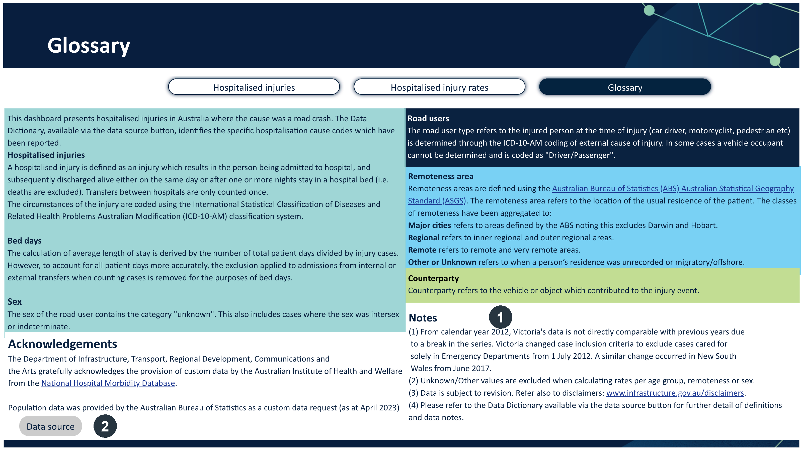
Note. Marker 1 is the Notes block, which states the break in series (Victoria from 1 July 2012, New South Wales from June 2017) and the exclusion of unknown and other values. Marker 2 is the Data source button, the only route to the Data Dictionary.
Figure 2
The break-in-series warning on the counts page.
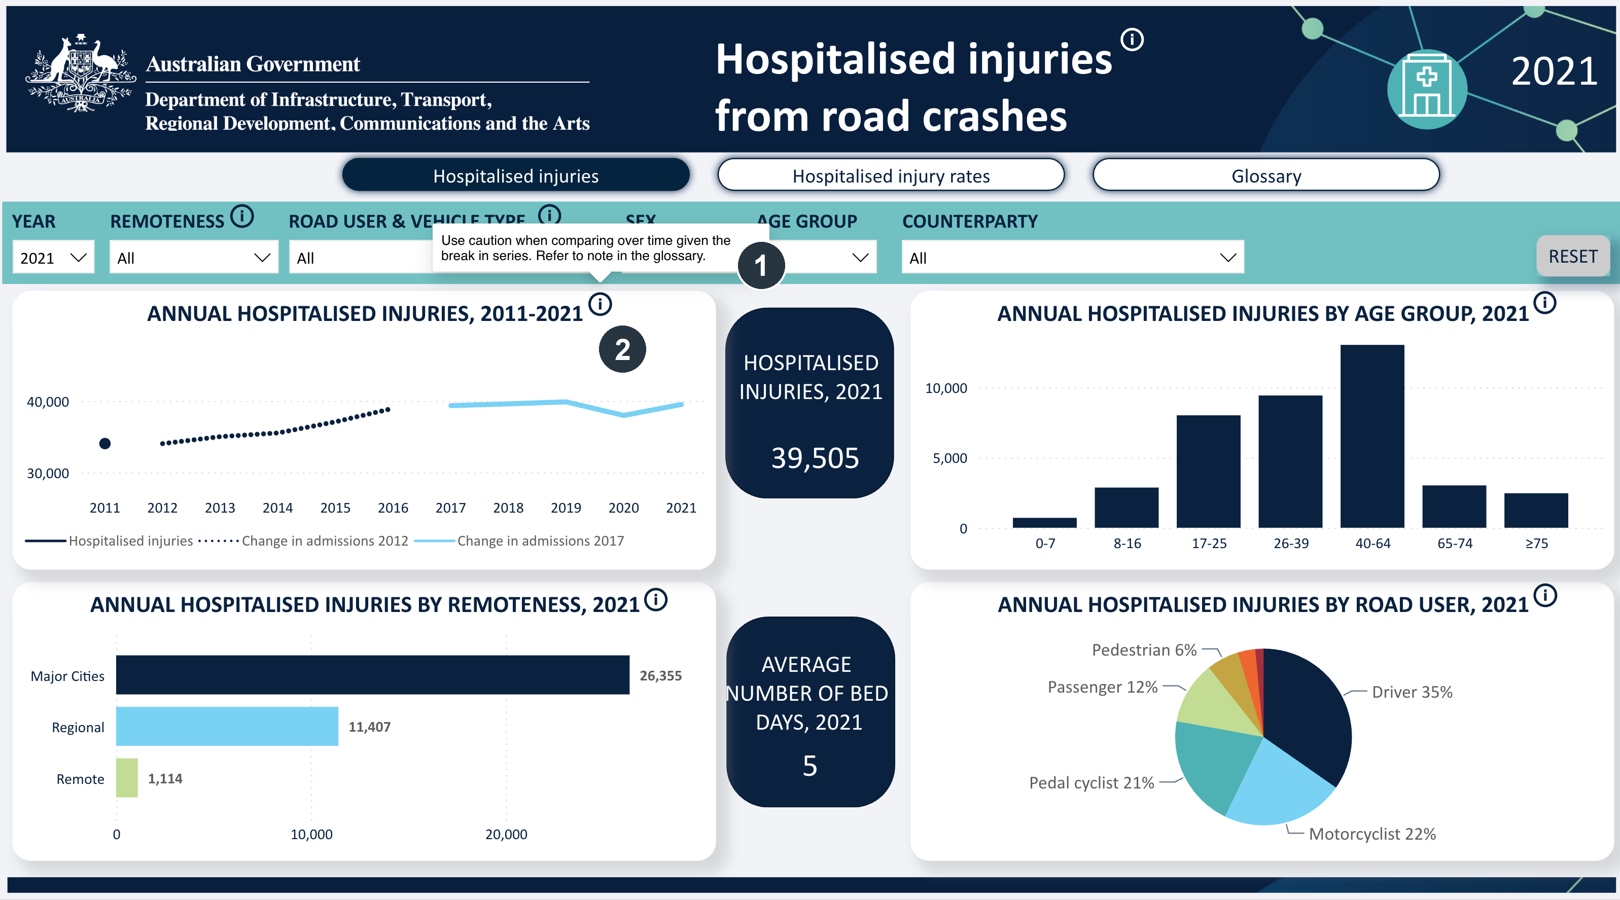
Note. Marker 1 is the warning. It appears only on hover or keyboard focus, and it points to the glossary rather than stating the break. Marker 2 is the info icon it belongs to.
The ethical concern is framing. Visual design can change how persuasive a chart is (Pandey et al., 2014), and a chart that looks plausible can give false reassurance about the data behind it (Correll et al., 2019). Here the headline line rises while the rate is nearly flat, so a reader who skims the counts may repeat a trend that is partly administrative. Showing the caveats on the chart itself would reduce that risk.
The dashboard uses a small set of encodings. The 2011 to 2021 series is a line chart, which uses position on a common scale, one of the most accurate ways to show a trend (Cairo, 2016; Munzner, 2014). Age group and remoteness use horizontal bars, which rely on length and suit comparison between categories. The road user breakdown is a pie chart, which relies on angle and area. Cleveland and McGill (1984) found that people judge angle and area less accurately than position and length, and Heer and Bostock (2010) replicated that test with crowdsourced participants, including a pie chart condition, and found the same advantage for position. The pie also has a labelling problem. Only five of the road-user groups are labelled, so the visible percentages total about 96%, and the remaining 4% (about 1,700 cases) has no label (Figure 3, marker 3). A sorted bar chart would show every category.
Figure 3
The counts page (page 1).
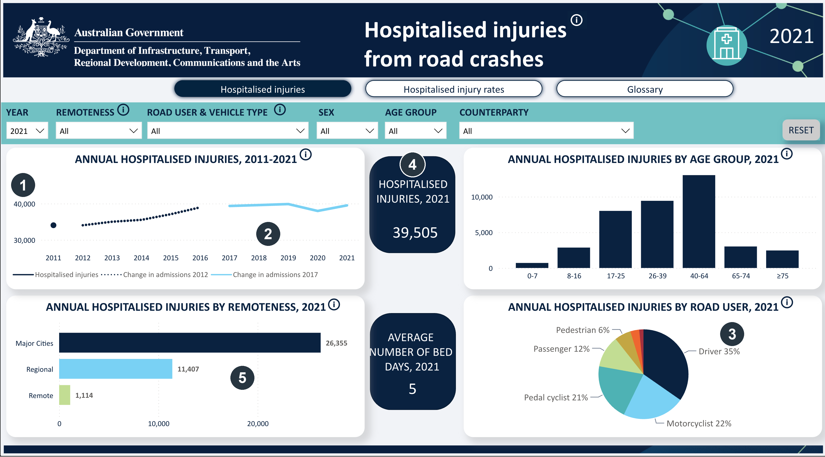
Note. Marker 1: the trend axis starts at 30,000, not zero. Marker 2: two change-in-admissions lines differ only by line style. Marker 3: five of seven road-user categories are labelled. Marker 4: the headline card reads 39,505. Marker 5: the three remoteness bars total 38,876.
Two choices distort the data. The counts axis does not begin at zero, and neither does the rate axis (Figure 3, marker 1; Figure 4, marker 1). Injuries rose 16%, from 34,033 in 2011 to 39,505 in 2021, while the rate rose about 1%, from 152.3 to 153.8 per 100,000, because the population grew about 15%. A truncated axis exaggerates small differences (Tufte, 2001), so the line looks steeper than the rate change justifies. The trend also overlays observed values with two “change in admissions” lines that differ only by line style, so measured and modelled values are hard to tell apart (Figure 3, marker 2).
The second distortion is fragmentation. Counts sit on page 1 and rates on page 2, so the report's most useful finding, that volume and risk point to different groups, is easy to miss. The 40 to 64 group has the highest count (13,026), while 17 to 25 has the highest rate, about 281 per 100,000 (Figure 4, marker 2). Remote areas have the highest rate (224.6) but the fewest injuries (Figure 4, marker 3). A paired chart of count and rate would make this visible at a glance.
Figure 4
The rates page (page 2).
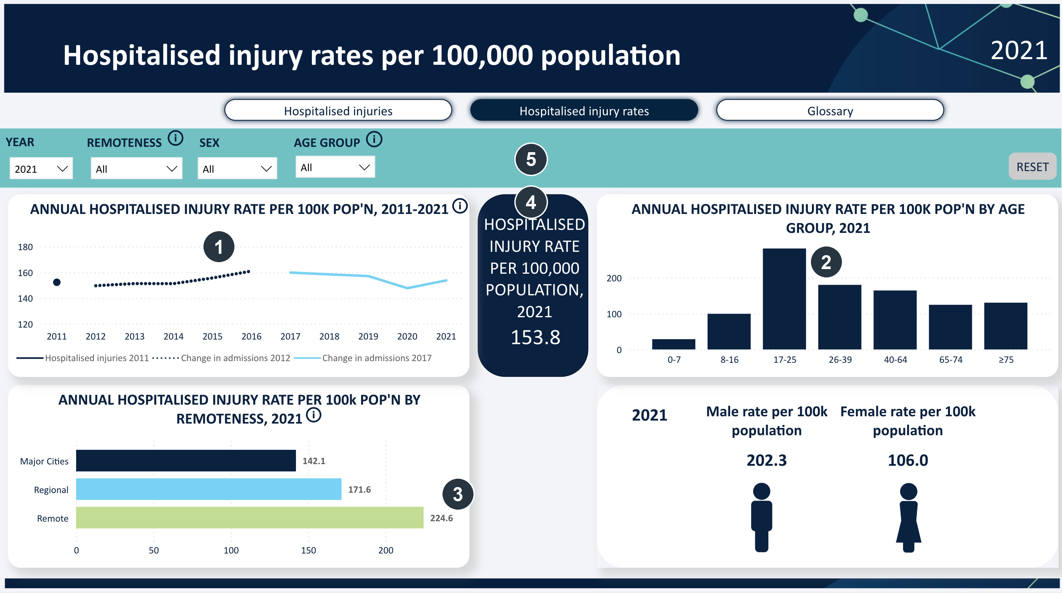
Note. Marker 1: the rate axis starts at 120. Marker 2: 17 to 25 has the highest rate. Marker 3: Remote areas have the highest rate with the fewest injuries. Marker 4: the KPI title wraps to five lines and crowds its value. Marker 5: the road user, vehicle type and counterparty filters are missing.
Colour is applied consistently in a restrained navy and teal palette that suits the subject. However, colour is sometimes the only cue that separates series, which disadvantages colour-blind readers (World Wide Web Consortium, 2025, success criterion 1.4.1). Labelling is weaker. On the rates page the KPI title wraps to five lines and crowds the value it labels (Figure 4, marker 4), while the same card fits three lines on page 1.
The filters and reset control respond promptly in normal use, so the interaction itself is smooth. The warning tooltip should also be checked against WCAG 2.1 success criterion 1.4.13, which requires hover or focus content to stay visible while the pointer moves onto it and to be dismissible (World Wide Web Consortium, 2025). Custom tooltips such as this one fall under that criterion. This report did not test that behaviour. Its depth is limited, however. Users can change which cases are shown, not how they are measured, so there is no way to switch between counts and rates on one page. The rate page also drops the road user, vehicle type and counterparty filters that page 1 provides (Figure 4, marker 5), so a reader cannot compare the same slice across both measures. Because the central comparison depends on those controls, the interactivity supports browsing more than understanding. Whether a screen reader can announce the chart values is a point I could not confirm from the standard view, so the report's accessibility is qualified until it is tested with assistive technology.
The most useful change would be to show counts and rates together, using a paired or dumbbell chart, with a toggle that switches the measure in place. The trend axis should start at zero, or state clearly that it does not, and the break in series should be marked with shaded bands at 2012 and 2017 with the modelled overlays labelled. The pie should become a sorted bar chart with every category labelled, or the smallest categories should be grouped under an explicit “Other”. The KPI titles should be shortened so they fit their cards. Finally, the caveats should appear on the charts themselves, and each series should pair colour with a label or line style.
The dashboard is well sourced, broadly accessible and mostly well encoded, and its weaknesses are presentational. By leading with counts, truncating both axes, placing the caveats behind an icon and separating risk from volume across pages, it risks telling a more dramatic story than the data support. The recommended changes are small, and they would bring the dashboard closer to the question its audience actually asks: who is most at risk, and is that changing?
References
Australian Bureau of Statistics. (2023). National, state and territory population. https://www.abs.gov.au/statistics/people/population/national-state-and-territory-population
Australian Institute of Health and Welfare. (2023). National Hospital Morbidity Database [Data set]. Australian Government. https://www.aihw.gov.au/about-our-data/our-data-collections/national-hospitals-data-collection
Cairo, A. (2016). The truthful art: Data, charts, and maps for communication. New Riders.
Cleveland, W. S., & McGill, R. (1984). Graphical perception: Theory, experimentation, and application to the development of graphical methods. Journal of the American Statistical Association, 79(387), 531–554. https://doi.org/10.1080/01621459.1984.10478080
Correll, M., Li, M., Kindlmann, G., & Scheidegger, C. (2019). Looks good to me: Visualizations as sanity checks. IEEE Transactions on Visualization and Computer Graphics, 25(1), 830–839. https://doi.org/10.1109/tvcg.2018.2864907
Department of Infrastructure, Transport, Regional Development, Communications and the Arts. (2023). Hospitalised injuries from road crashes [Data dashboard]. National Road Safety Data Hub. https://datahub.roadsafety.gov.au/reporting/hospitalised-injuries-road-crashes
Heer, J., & Bostock, M. (2010). Crowdsourcing graphical perception: Using Mechanical Turk to assess visualization design. In Proceedings of the SIGCHI Conference on Human Factors in Computing Systems (pp. 203–212). ACM. https://doi.org/10.1145/1753326.1753357
Kirk, A. (2016). Data visualisation: A handbook for data driven design. SAGE.
Munzner, T. (2014). Visualization analysis and design. CRC Press.
Pandey, A. V., Manivannan, A., Nov, O., Satterthwaite, M., & Bertini, E. (2014). The persuasive power of data visualization. IEEE Transactions on Visualization and Computer Graphics, 20(12), 2211–2220. https://doi.org/10.1109/tvcg.2014.2346419
Tufte, E. R. (2001). The visual display of quantitative information (2nd ed.). Graphics Press.
World Wide Web Consortium. (2025). Web Content Accessibility Guidelines (WCAG) 2.1 (W3C Recommendation). https://www.w3.org/TR/2025/REC-WCAG21-20250506/

