Recommend using Python version 3.12 or earlier. If you are using version 3.12 or later, please contact me for a new version of requirements.txt

Step1:
First, create a virtual environment in the folder; let's use vcsode as an example.:
- python -m venv venv
- .\venv\Scripts\activate
If you are still unable to activate it, please look up the error message for further instructions.

Step2:
Install requirements.txt
- pip install -r .\requirements.txt

Step3：
Running：

extract_features.py
train_model.py
main.py

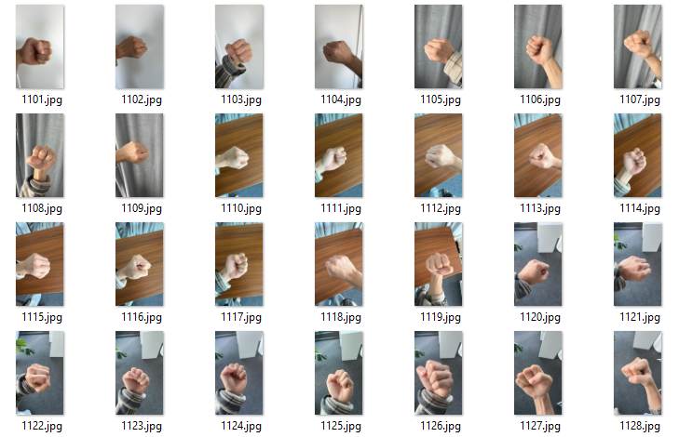
Since the “Rock” recognition wasn't very good, I added some data myself, and I also added a little bit for the “Scissors“.

