**Lab 1**

The purpose of this lab is to get your student machine setup.

**Setup**

Please ensure you have the following installed:

* Your preferred version of Visual Studio (I suggest 2019)
* SFML (I suggest we use at least version 2.5.1)
  + Please setup an environment variable called $SFML_SDK instead of hardcoding the SFML directories in the project settings i.e. SFML_SDK=C:\SFML-2.5.1 and when specifying the directories in the project properties use $(SFML_SDK)\include;%(AdditionalIncludeDirectories)
  + Tie the window size to the desktop size
* Doxygen ([www.doxygen.org](http://www.doxygen.org))
  + You will use this to document your projects

**Exercise**

Create a simple C++ / SFML program which will draw two sprites/characters on the screen.

The two objects should begin moving in any direction (but then continue in that direction indefinitely). One of the characters should respond to player inputs as follows: Up Arrow velocity increases, Down Arrow velocity decreases.

Note: The world in which they are moving is to be wrap-around.

I would expect to see:

* a **player** class and an **npc** class for the two characters.
* A main game loop which polls for input and updates the game objects

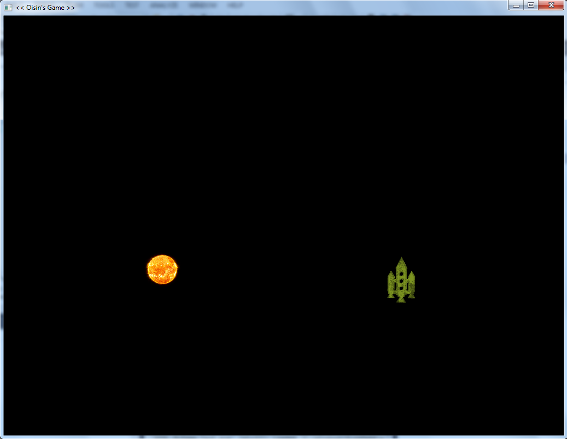

Figure 1. Sample output

Show me when you have it complete.