**Lab 2b**

1.

Revisiting your game from the previous two labs, modify it so that you create a **player** class and an **alien** class which hold and keep track of all the necessary kinematic data you will need to control the characters.

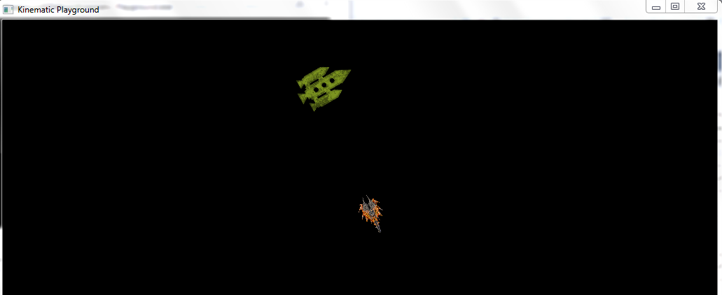

2.

Implement a **kinematicWander** function for the alien character. Remember we are not using any accelerations when implementing simple kinematic functions. The alien is **not** following the player around.

3.

Create a second alien and implement **KinematicSeek** and **KinematicArrive** functions. Demonstrate this alien using both these behaviours to follow the player.

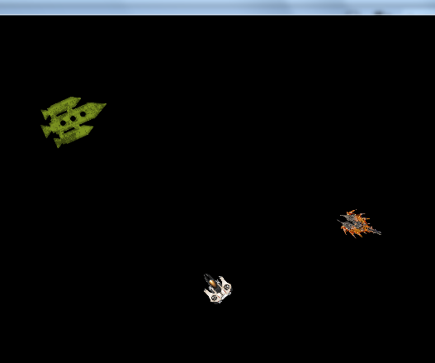

4.

Now implement a third alien character which performs a **kinematicFlee** algorithm away from the player. Its maximum speed should be low so we can observe the effect before it gets stuck on an edge!

