1. Suppose you play the game of shooting. You shoot 6 times, each time to a different enemy, and each shot has a 10% chance of success.

1. What's the probability of killing two enemies out of six?

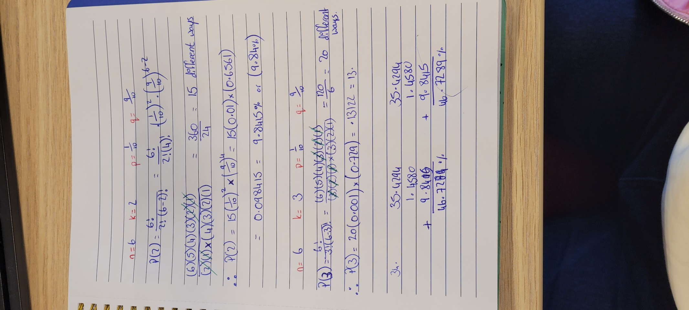

1. 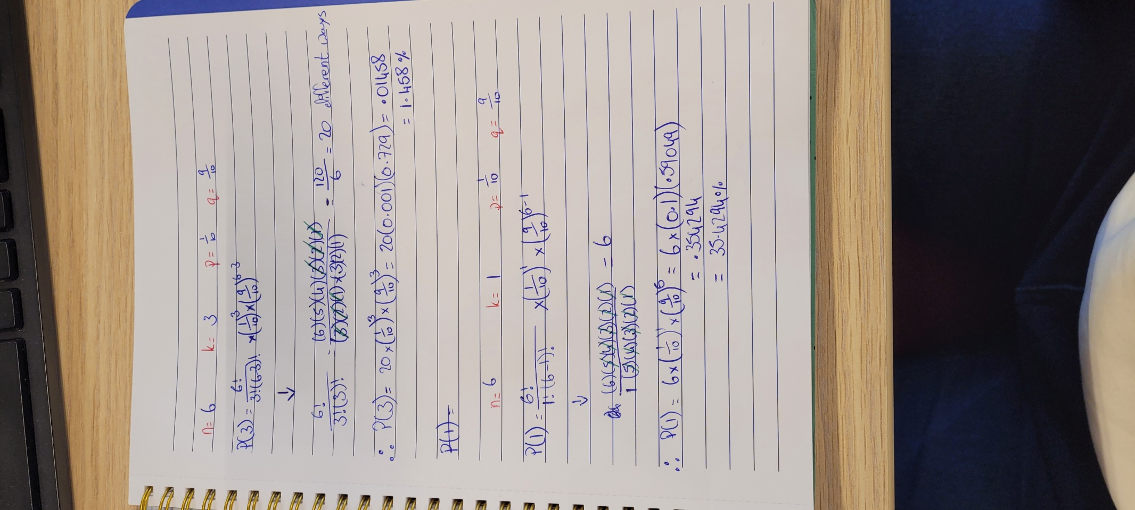What's the probability of killing at most three enemies out of six?
2. What's the maximum number of enemies we can kill with 90% probability?

2. Suppose there is only one enemy and two success shots can kill the enemy. Each shot has a 10% chance of success. How many times do you need to shoot to kill the enemy with 80% probability?