**DECLARATION**

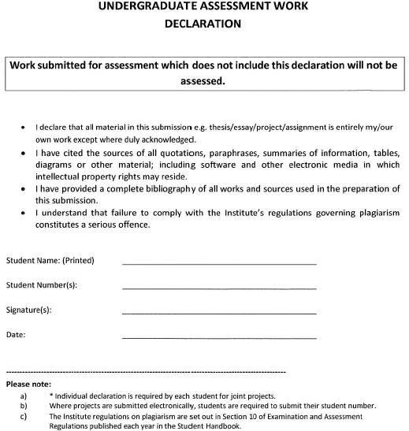

24/04/2023

*Patrick Donnelly*

C00236160

Patrick Donnelly