Portfolio Presentation Specification
Full-hero animated carousel with project selection below, plus projects archive, details, resume, and contact

Revised direction: the landing page begins with the carousel as the entire hero. Visitors should essentially land on layout 09 immediately. Project selection, curated sets, category filters, and broader browsing move below the carousel so the first viewport stays striking and focused.

Reference Direction
The chosen visual lineage is layout 09 for the landing hero, layout 06 for animated carousel behavior, layout 04 for the Projects page gallery, layout 05 for directory/table modes, and layout 07 for category browsing below the hero.
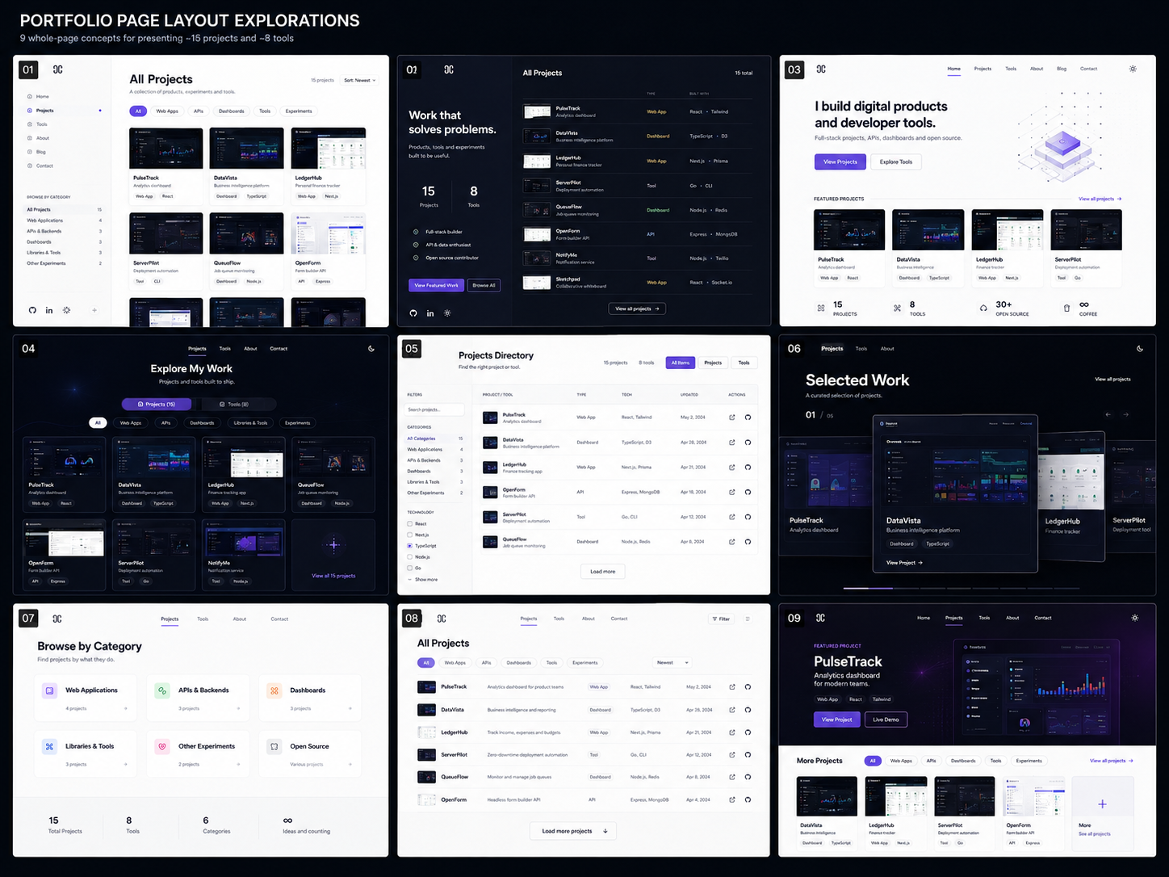
Reference board from the earlier layout exploration. The revised spec keeps 09 as the arrival experience and moves selection controls below it.

1. Core Presentation Principle
The portfolio should not start with a normal marketing hero followed by work. The work is the hero. The first screen should be an animated, informative featured-project carousel that immediately shows the best project, the visual quality of the work, the stack, and the key actions.
- The full first viewport belongs to the carousel.
- The carousel should be readable and useful without any click or scroll.
- Project selection and filters should appear directly below the carousel, not inside the main hero area.
- The first active project should default to the strongest, most representative project.
- The design should prioritize screenshots, proof points, clear links, and motion that supports comprehension.

2. Landing Page: Full-Hero Carousel
The landing page should open directly into a full-hero carousel experience. This is the main identity moment of the site and should feel closer to a product showcase than a resume page.
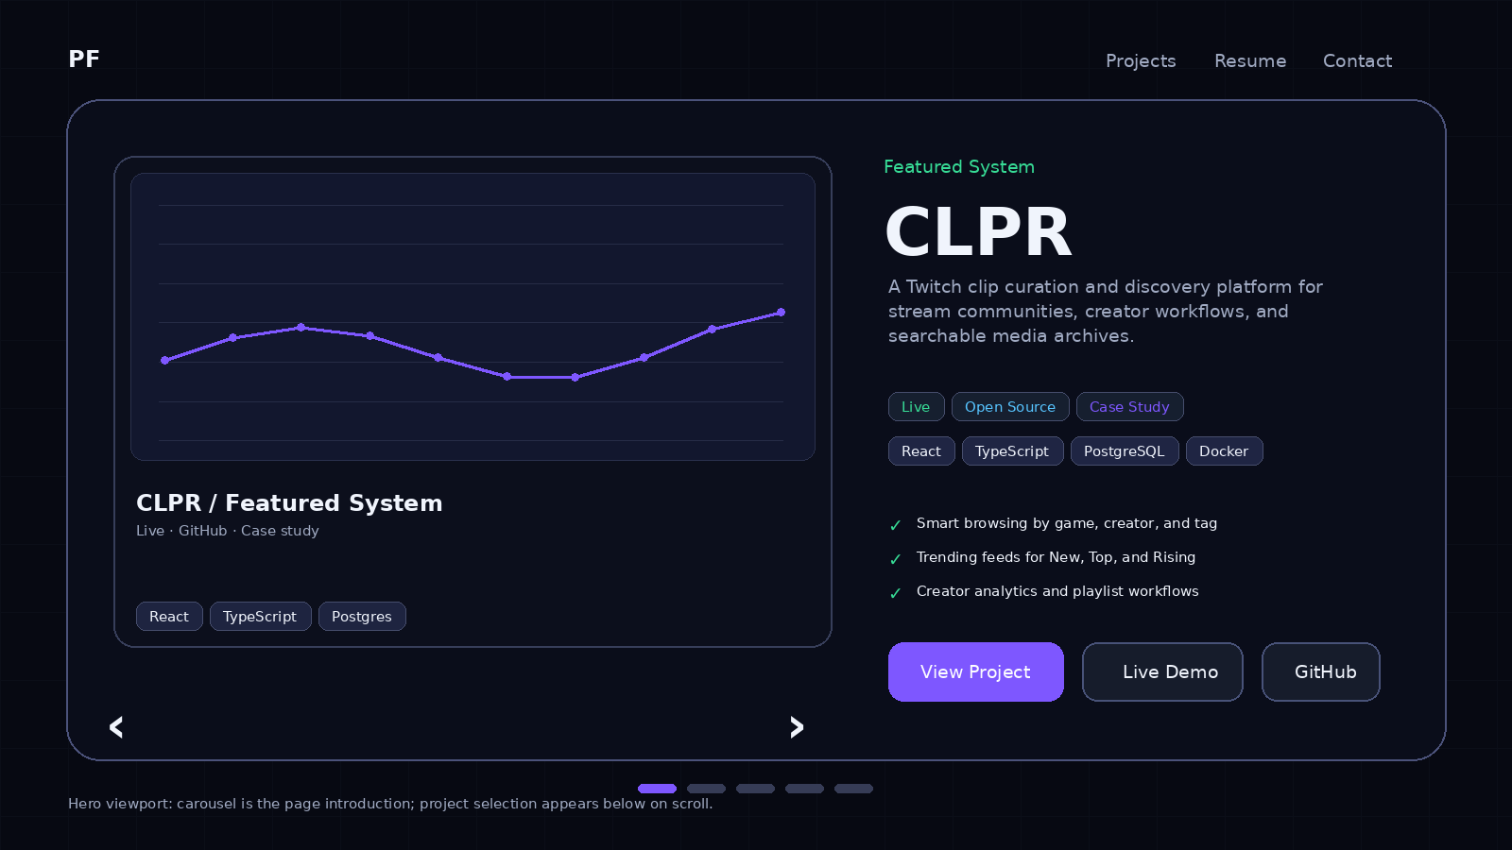
Hero Element | Presentation Requirement
Active project screenshot | Large, dominant, and high quality. It should read as a real product, not a thumbnail.
Project title and summary | Large title, short description, and enough context to understand what the project does.
Status and stack | Visible badges such as Live, Open Source, Case Study, React, TypeScript, PostgreSQL, Docker.
Proof points | Three short bullets explaining what makes the project impressive or useful.
Actions | View Project is primary. Live Demo and GitHub are secondary but always visible when available.
Carousel controls | Arrows, progress/dots, and adjacent previews are allowed, but they should not overpower the active slide.
Global nav | Small and quiet. The work should dominate the first viewport.

3. What Moves Below the Carousel
The project selection UI should live immediately below the carousel. This keeps the hero clean while still making the portfolio browsable as soon as the visitor scrolls.
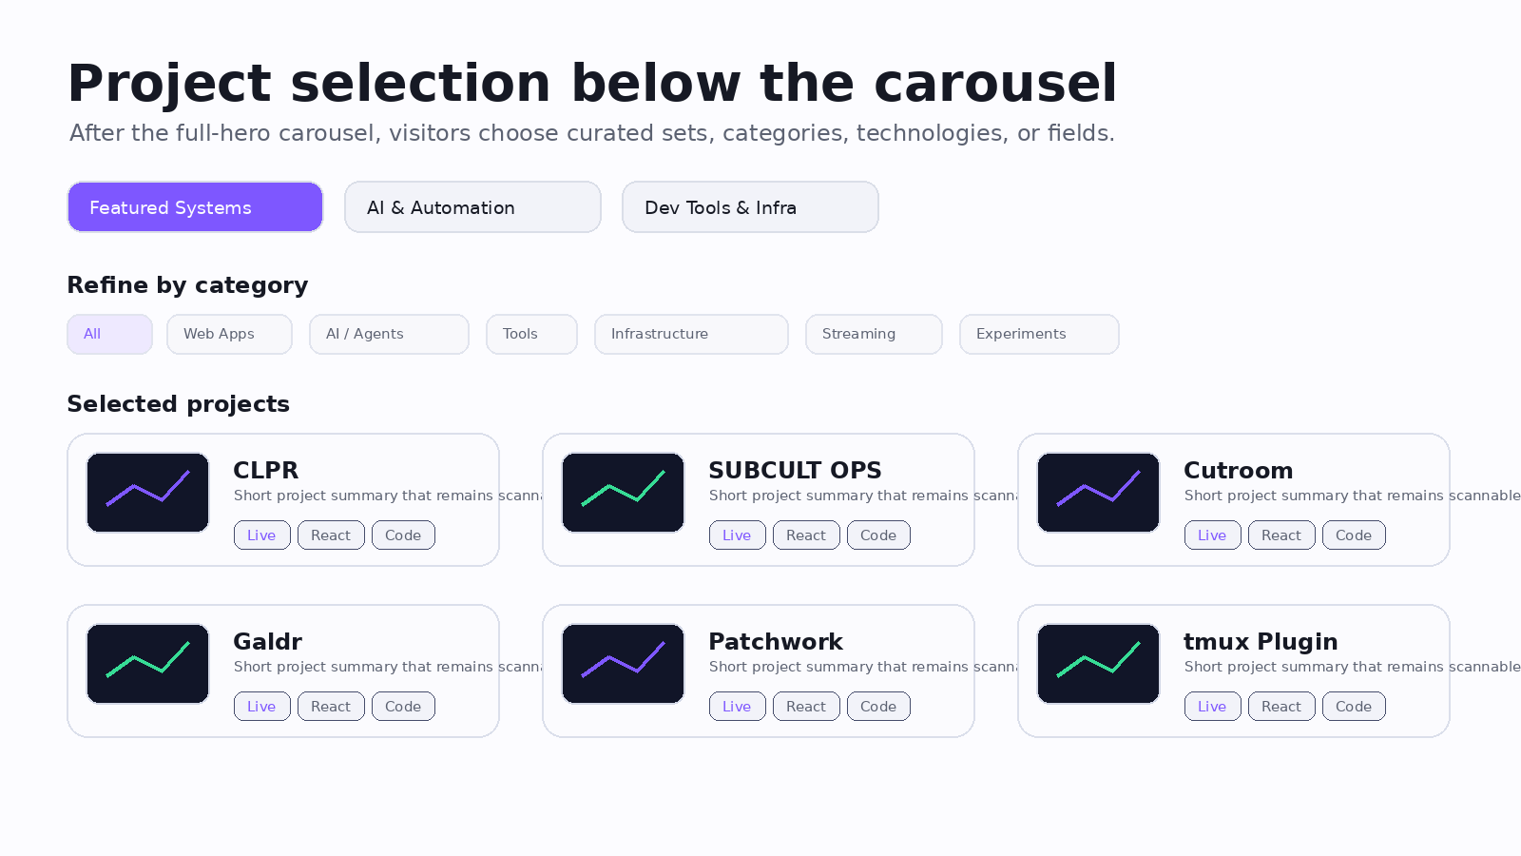
- Curated set selector: Featured Systems, AI & Automation, Dev Tools & Infrastructure.
- Category filters: All, Web Apps, AI / Agents, Tools, Infrastructure, Streaming, Experiments.
- Optional technology filters: React, TypeScript, Go, Python, PostgreSQL, Docker, LLMs.
- Selected project cards: 6-8 concise cards that update based on the selected set and filters.
- Every selected project card routes to its project detail page.
- A View All Projects card routes to the full Projects page.

4. Landing Page Vertical Flow
The page should move from high-impact presentation to increasingly practical browsing. The first screen creates interest; the next screen gives control.
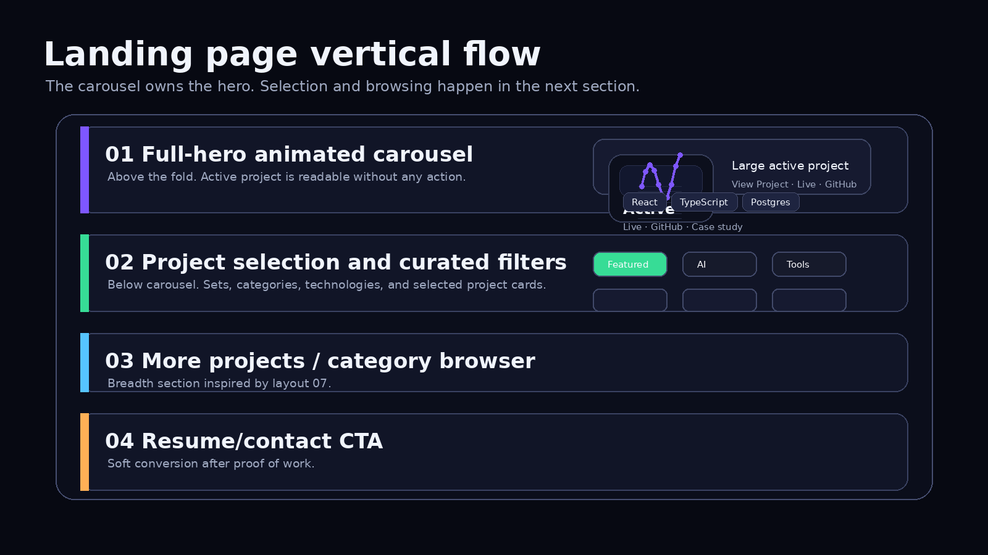
- Full-hero animated carousel: the landing experience and strongest work showcase.
- Project selection below hero: curated sets, filters, and selected cards.
- More projects and category browser: broader discovery inspired by layout 07.
- Tools preview or developer-tools strip: optional compact section for smaller utilities.
- Resume/contact CTA: professional next step after the visitor has seen the work.

5. Animation Direction
Animation should make the carousel feel alive and intentional, but it should never reduce readability. The motion should explain state changes: what is active, what is adjacent, what set is selected, and where the user goes after clicking.
Moment | Animation Direction | Notes
Initial load | Hero fades in; active screenshot subtly scales from 98% to 100%; text appears with a slight stagger. | Creates impact without delaying comprehension.
Slide change | Active slide glides aside or recedes; next slide expands into the main position. | Use spatial movement to clarify carousel state.
Adjacent preview hover | Preview lifts, brightens, and exposes title/status. | Signals that previews are selectable.
Scroll to selector | Hero gives way to the selection panel; selector can gently pin or fade into view. | The selector should feel connected to the carousel, not like a separate page.
Set/filter change below | Cards crossfade or reorder with a short stagger. | Avoid chaotic masonry jumps.
Open detail page | Shared-element-style transition from active screenshot to project detail hero. | Use if feasible; otherwise use a clean fade/slide.
Reduced motion | Disable large movement and use instant state changes or simple opacity transitions. | Required for accessibility.
Do not make the carousel auto-advance aggressively. If auto-advance exists, pause on hover/focus, respect reduced motion, and keep the active project visible long enough to read.

6. Curated Sets Below the Hero
The three curated sets should act like editorial lenses. They are not raw database filters; they are intentional collections that tell different stories about the work.
Set | Purpose | Example Projects | Visitor Takeaway
Featured Systems | Best overall product/system work. | CLPR, SUBCULT OPS, Cutroom, Galdr, Patchwork | This person can build complete, deployed systems.
AI & Automation | Modern technical depth and automation work. | Agent systems, eval tools, transcription/content pipelines, automation dashboards | This person can work with LLMs, workflows, orchestration, and evaluation.
Dev Tools & Infrastructure | Practical engineering and developer experience. | tmux plugin, CLI tool, observability dashboard, deployment utilities | This person understands tooling, infra, DX, and operations.

7. Active Carousel Slide Example
Field | Example Content
Eyebrow | Featured System
Title | CLPR
Description | A Twitch clip curation and discovery platform for stream communities, creator workflows, and searchable media archives.
Badges | Live, Open Source, Case Study
Stack | React, TypeScript, PostgreSQL, Docker
Proof points | Smart browsing by game, creator, and tag; trending feeds for New, Top, and Rising; creator analytics and playlist workflows.
Primary CTA | View Project
Secondary CTAs | Live Demo, GitHub

8. Project Selection Below Hero: Card Example
Card Area | Example
Title | SUBCULT OPS
Subtitle | A multi-agent office where autonomous agents debate, vote, execute missions, and form memories.
Type/Status | Project, Live, AI System
Chips | Next.js, Supabase, Workers, LLMs
Actions | View Project, Live, GitHub
Behavior | Card click opens project detail page; action buttons open direct destinations.

9. Projects Page
The Projects page remains the practical archive. It should not try to recreate the landing hero. It should be built for browsing, filtering, and comparing all projects and tools.
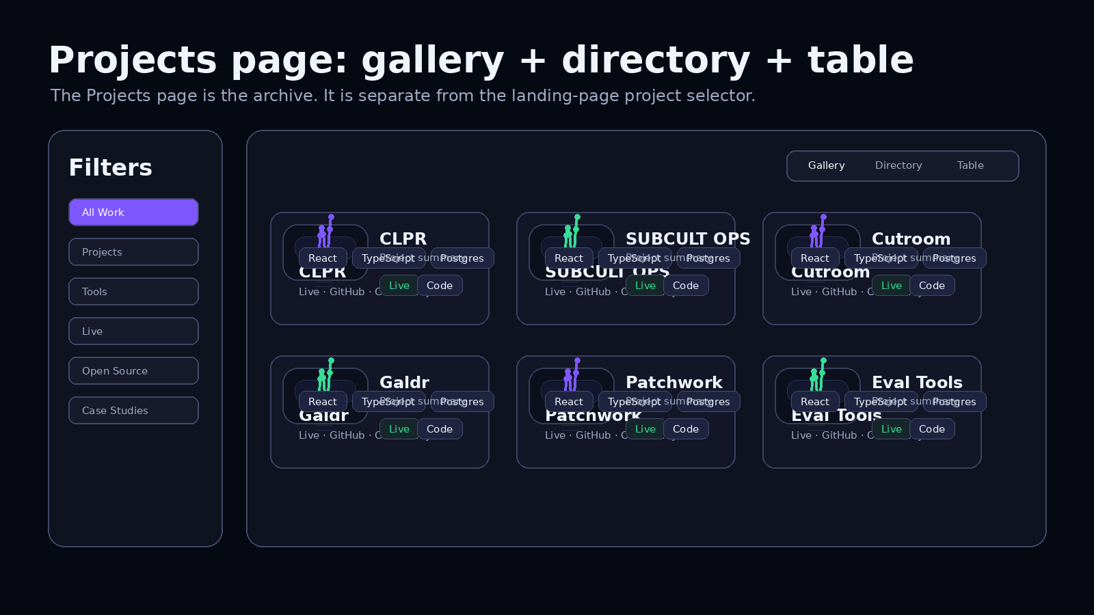
Mode | Purpose | Design Basis
Gallery View | Default visual archive with screenshot-heavy cards. | Layout 04
Directory View | Compact rows for faster scanning. | Layout 05
Table View | Dense technical comparison by stack, status, category, and links. | Layout 05 expanded
- Default to Gallery View for visual browsing.
- Provide a clear toggle for Gallery, Directory, and Table views.
- Use filters for type, category, technology, status, live/open-source, and search.
- Tools should appear in the archive as a distinct type, even if they also have a separate Tools page.
- Project and tool cards should route to detail pages when there is enough supporting information.

10. Incorporating Layout 07
Layout 07 should appear as a category-browsing layer below the hero or on the Projects page. It should not replace the carousel. Its job is to help visitors browse by mental model rather than by a long list of tags.
Category | Card Content
Web Applications | Count, product examples, primary frontend/backend stack.
AI / Agent Systems | LLM workflows, agents, automation, evaluation, orchestration.
Developer Tools | CLI tools, plugins, config packages, extensions, reusable utilities.
Infrastructure / Self-Hosting | Docker, monitoring, deployment, observability, homelab-related tooling.
Media / Streaming | Twitch, content tools, clips, overlays, automation, creator workflows.
Experiments | Smaller prototypes, visual systems, speculative or unfinished work.

11. Project Detail, Resume, and Contact Pages
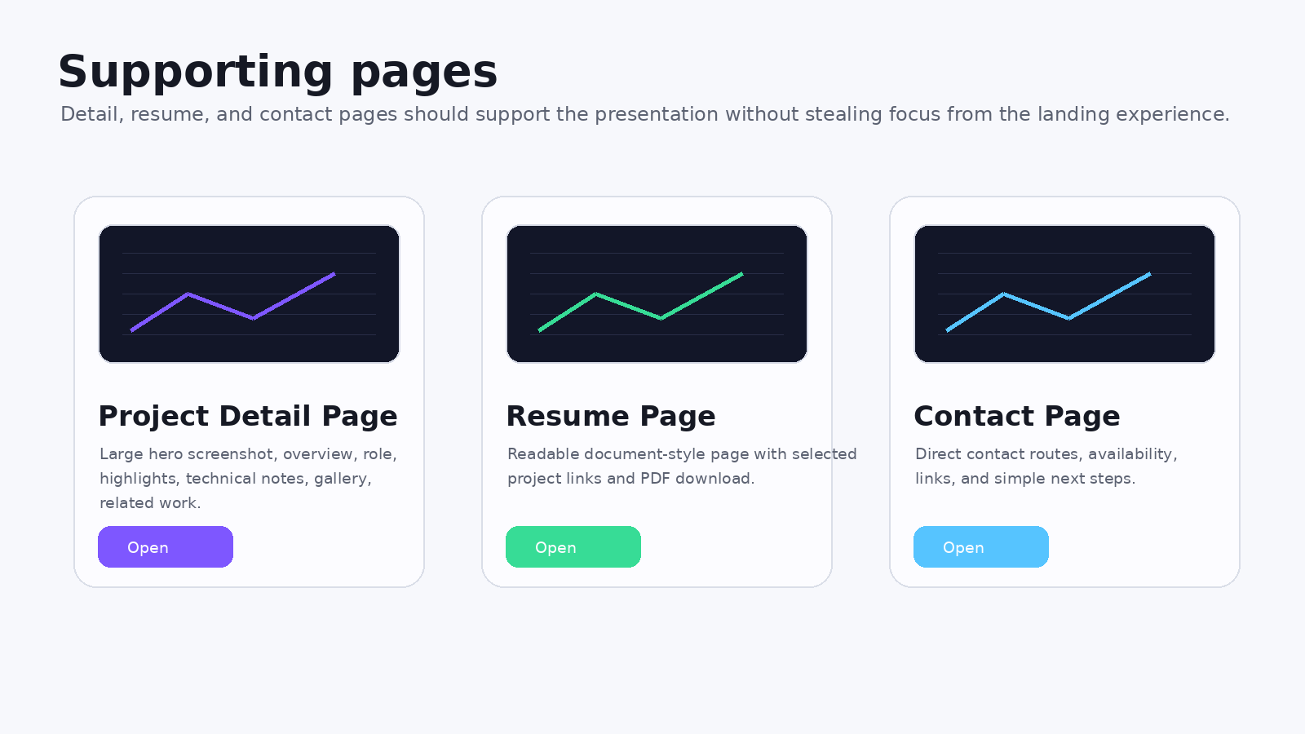
Page | Presentation Goal
Project Detail | A focused case-study page with hero screenshot, overview, role, proof points, technical notes, gallery, and related work.
Resume | A clean professional page with summary, skills, experience, selected project links, and downloadable PDF.
Contact | A direct page with email, GitHub, LinkedIn/social links, availability, reasons to reach out, and optional form.

12. Tools Presentation
Tools should stay distinct because a small utility is evaluated differently from a complete product. Tools can appear in the project archive, but they should have their own visual treatment.
- Use a Tool badge or icon treatment to distinguish tools from larger projects.
- Feature tools in the carousel only if they are especially strong or recognizable.
- Include tools in the project selection filters below the hero.
- Create a dedicated Tools page only if the tools have enough documentation, screenshots, or usage examples to justify it.
- Tool detail pages should emphasize what it does, how to use it, repo/docs links, and example commands or screenshots.

13. Final Recommended Structure
Landing page = full-hero animated carousel first, with no required action before seeing the strongest work.
Below hero = project selection, curated sets, category filters, selected project cards, and View All Projects.
Projects page = layout 04 gallery with layout 05 directory/table modes.
Project detail = case-study presentation with proof, links, screenshots, role, and technical notes.
Tools = distinct content type, optionally with a dedicated page, always filterable in the archive.

