07 Assignment 1
John Patrick H. Ilagan
TESDA AI LEVEL III

Instructions: (3 items x 10 points)

1.Consult three (3) people (friends, family, etc.) and ask about one (1) adverse impact of the technology they have experienced.
2.The adverse impacts should be unique from each other.
3.In at least three (3) sentences, provide possible solutions to prevent these adverse impacts of technology.

- Name: Rovert (Friend)
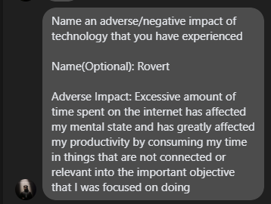
Adverse Impact:
Excessive amount of time spent on the internet has affected my mental state and has greatly affected my productivity by consuming my time in things that are not connected or relevant into the important objective that I was focused on doing

Solution:
Lessen internet/computer time and limit yourself by spending time to do other things such as the work that needs to be done. Stay away from social medias especially toxicity content that affects your mental state and take some time off. Have a priority list and make sure that your gadgets aren’t distracting you in the time of work, having more of a rewards based approach.

- Name: Mateo (Friend)
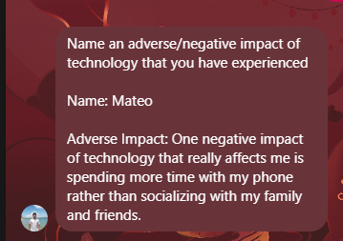
Adverse Impact:
One negative impact of technology that really affects me is spending more time with my phone rather than socializing with my family and friends.
Solution:
Limit yourself and the time you spend on the phone, spend more time doing outside activities like travelling or even simple things like meeting up. Set up a predetermined date and time that everyone agrees on for socializing or even setting up a no-phone time where all of you could meet. Impose family bonding time by playing board games, having a little bit of chat or even activities like swimming.

- Name: Jim (Brother)
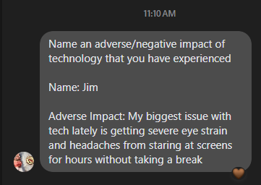
Adverse Impact:
My biggest issue with tech lately is getting severe eye strain and headaches from staring at screens for hours without taking a break
Solution:
Taking breaks from time to time to rest your eyes is very important especially with how bright lights could really damage your eyes. You could try using those blue light glasses when using your devices especially when you’re expose to prolonged use of these devices. Lowering your screen brightness or turning on dark mode could also go a long way in reducing that bright harsh light.

