**Queuing Management System with SMS Notification and Prioritization**

**A Capstone Project**

**presented to the**

**Department of Information Technology**

**Faculty of Engineering**

**University of Santo Tomas**

**in partial fulfilment**

**of the requirements in the degree of**

**Bachelor of Science in Information Technology**

**Saguinsin, Patrick Joshua B.**

**Diza, Justine Rianne R.**

**Santos, Maidy Precious Paula E.**

**Urzabia, Jasmine Eve T.**

**Santos, Anne Michelle**

**October 2014**

**Table of Contents**

Table of Contents

Chapter 1 Introduction 4

1.2 Purpose and Description 5

1.3 Objectives 6

1.4. Scope and Limitations 6

Chapter 2 Review of Related Literature, Studies, and Systems 9

Chapter 3 Technical Background 17

3.1 Design Methodology 17

3.2 Requirements Analysis 18

3.2.1 Functional Requirements: 18

3.2.2 Non-Functional Requirements: 18

3.3 Overview 19

3.3.1 System requirements 21

3.3.2 Prototype 23

Chapter 4 Implementation, Results and Discussion 35

Bibliography 37

# 

# 

# Chapter 1 Introduction

**1.1 Project Context**

Back in the day, when people would opt to execute some business transactions, most often you would find them falling in line. Whether they end up standing or sitting while waiting for their turn, this brings about a lengthy period of waiting resulting in low customer satisfaction and poor company image - based on a research conducted by Barclay and his fellow colleagues (2013), results showed that psychological morbidity worsened during the period of waiting also,David Maister in his theory *Psychology of Waiting Lines* stated that *waiting-line experience in a service facility significantly affects our overall perceptions of the quality of service provided*. These days, given the immensity of things that need be done, simple queueing systems have been the stagnant choice for handling lines of people for transactions in an organization - usually in the service-providing businesses.

Current queuing systems handle lines in a more effective way by providing a number and allowing the clients to wait. However, people must be physically present - which still brings the old issue of inconvenience to those who wish to do more productive acts for their time spent waiting instead of just staying in the queue. This brought about a solution for such a problem, instead of merely providing a number and letting the clients wait, an additional feature was implemented - a web application incorporated with SMS notifications. Now, people can spend their time productively while waiting for their turn in the queue. Also, another feature was added - Prioritization. Those who have certain privileges get instant access to the front of the queue, providing them with convenience and a higher rate of satisfaction. Not only does this make it more convenient for the client, the administrator of the transactions also have ease in completing the transaction since the purpose of their stay is indicated in the queue request. No more questions, no more indefinite waiting, convenience and ease are served.

F,{67c42a06-f3c9-4850-bb17-c58608b03f65}{15},11.97917,4.729167

## 

## 

## 

## 

## *Figure 1.1 – Block Diagram of the Queuing System*

## 1.2 Purpose and Description

The project aims to alleviate the problems existing in current typical queueing systems by adding features that will effectively solve time-consuming problems through SMS Notifications and Prioritization. Target beneficiaries include the clients and customers of an organization or a business entity. The project shall use the combination of general purpose computer systems to balance the required power over cost ratio requirements of each unit in the system. In addition, a Short Message Service Center (SMSC) will be used to accommodate the SMS feature of the new queueing system.

This is all in an effort to discard the dilapidated system of handling transactions - giving clients timeliness, to automate the action of ‘falling in line’ - allowing the clients to roam freely while waiting for their turn; getting rid of the stress and decreasing client dissatisfaction.

## 1.3 Objectives

The proposed project aims to implement queuing concepts meshed with two additional features - namely SMS Notifications and Prioritization - to provide practical benefits for the business' clients. Goals to meet the project expectations include: sending of SMS notifications to clients (who have availed for this type of service) of their current queue status, prioritizing VIP guests, senior citizens and people with disability, easing transaction handling in the case of the business administrator (ex. bank teller), minimizing the use of paper, and allowing the clients to spend their time productively while waiting for their turn.

## 1.4. Scope and Limitations

The system routine shall support basic functions and processes of receiving input from a client. The request shall be placed on the queue, depending on the priority status, whether to place it on the normal queue, or the priority “VIP”. The administrator’s computer unit has full control of the queue and devices/units connected in the system - having the ability to view, edit, and delete the queues in the database, and control the flow of operations and processes. System units, regardless of its hardware nature, will be programmed using Java language, and shall therefore be compatible to almost all devices capable of running Java Virtual Machine (JVM). The software will be in the form of a web app, and shall therefore be compatible to almost all devices with web browser and internet connectivity, including mobile devices. The input unit presents options for clients, that are dependent on what the implementing organization will include. This unit will forward all data to the server for the queuing process to begin. The display unit will only have the ability to output data sent by the server. The controller device will be any microcontroller that can support serial connection to a host computer. Queue controller can be the server, or an extension of it, with a limited functionalities, through a web browser, for security purposes. It can only call the next and the previous number in queue, as well as retrieve the information of the client to be served.. The previous button serves as an undo button in case of accidental key press on the next button.

The main server has the capability to send SMS notifications regarding the status of the clients and delivers them to their mobile phones. It will utilize Globe Labs API’s for handling SMS operations throughout the queuing process, thus, shall be limited to networks supported by the said API, and all its capabilities. The system shall only support local carriers, thus, carriers of other countries shall not be accommodated. As per Globe Labs API’s limitation, only Globe subscribers are entitled for the SMS Notifications feature. SMS Notifications are only applicable to certain transactions that have predictable time; transactions that have indefinite time, such as help support or customer service, are not covered by the said feature. Clients with VIP access are prioritized and are given a choice whether to stay in the queue and wait or to have instant access to the higher priority queue. VIP clients are to be entertained on a special counter where it doesn’t interfere with the normal queue’s calculated estimated time. For the presentation of this system, latecomers will be given a minute of grace period, however, policies regarding latecomers shall be administered by the implementing organization.

Overall, the system is only capable of getting and retrieving requests from users, processing the request, placing it on respective queues - whether it be a normal queue or a VIP queue, print tickets as requested, compute the approximate waiting time for each transaction, continue the flow by calling the next in line, send SMS notifications to its client as needed, display the number on the screen when called, delete the request from the queue database after the transaction is complete, and shall do nothing else but the activities stated preceding this sentence.

# 

# 

# Chapter 2 Review of Related Literature, Studies, and Systems

**Related Literatures and Studies**

“Waiting is frustrating, demoralizing, agonizing, aggravating, annoying, time consuming and incredibly inexpensive,” the Federal Express once stated.

From the article *Why Waiting Is Torture* (2012) by Alex Stone, roughly 37 billion hours each year of the Americans were spent waiting in line which causes stress, boredom and that nagging sensation that one’s life is slipping away. However, according to Rabbi Carl M. Perkins (2012) in his review of the said article, waiting is distressing not because of the time you spend waiting but because of doing nothing.

Waiting in line is already evident in our everyday lives. It is observed in many service settings where capacity is fixed as peak-time demand can exceed the available supply (Kokkinou & Cranage, 2013). Furthermore, results showed that mean scores for parameters of psychological morbidity worsened during the period of waiting and improved after the procedure or transaction (Barclay et al, 2013). Circumstances of people waiting in line hold a general principle: the experience of waiting is defined only partly by the objective length of the wait. Occupied time feels shorter than unoccupied time. Research on queuing has shown that, on average, people overestimate how long they’ve waited in a line by about 36 percent (Stone A., 2012). Besides, disregarding solutions on managing queues can lead to the combination of lost revenue and ill-will (Batt & Terwiesch, 2013). Likewise, David Maister in his theory *The Psychology of Waiting Lines* (1985) mentioned that waiting-line experience in a service facility significantly affect our overall perceptions of the quality of service provided. The psychology of waiting lines examines how waits are experienced and offers managerial advice to service organizations for the tools and techniques which they could use to influence the customer’s waiting time experience.

As a result of the never ending issues regarding waiting lines, technology offers solutions to it. From the article *Long Wait Times Harming Retail Experience: Survey Says* (2012)by Rieva Lesonsky, 87 percent of consumers are willing to use some type of technology just to keep them from waiting in line and 67 percent would prefer to use online check-in or down an application that saved their places in line at a retail business.

*Queuing Theory*

Queuing models have found widespread use in the analysis of service facilities, production and many other situations where congestion or competition for source resources may occur (Chowdhury, 2013). Behind these queuing models is a theory called the *Queuing Theory* discovered in 1900s by a Danish mathematician named Agner Krarup Erlang.

Queuing theory is the study of waiting lines (queues). This theory is applicable to a system with constant arrival of units (customers) and a specified number of servers (service facilities). It is used in measuring the flow of demands into and out of the queuing system, hence is also a tool to make decisions on the minimum number of resources needed (Thomopoulos, 2012).

Erlang, in his early works, stated the main elements of queuing theory: the (probabilistic) arrival process of requests (calls), the (probabilistic) service process of customers and, consequently, the departure process of customers, rejected/waiting customers, servers and etc. (Lakatos, Szeidl & Telek, 2013).

According to Lakatos, Szeidl and Telek (2013), the mathematical description of queuing systems must be in accordance with the following elements:

* Arrival process: the current system’s properties, e.g., the number of customers must be considered as customer arrivals might depend on it. But for some basic queuing models, the arrival process is identified by the interarrival time distribution.
* Service process: customer service is relevant for it could also depend on the current system’s properties and for the basic queuing models the service times are i.i.d. random variables.
* System structure: commonly the number of servers and the size of the waiting room. Thus, it talks about the resources of the queuing system.
* Service discipline: the service order and service mode of customers. It could be FCFS (first come, first served), FIFO (first in, first out), and LIFO (last in, first out). Since there are different types of customers that could arrive at the system, service order is really important. In this case, in order to provide faster service to one customer type, priority, with or without preemptions, will be helpful.
* Performance parameters: computing for the necessary performance parameters is essential in building a precise model of a system. System utilization, mean and distribution waiting time, loss probability (the probability that a customer will be rejected by the system), etc. are the most common performance parameters.

*Computing the Waiting Time*

Queue length is one of the most crucial performance measures for signalized intersections, which is also critical to signal optimization. It has been a long-standing research topic to estimate the average queue length using loop detector data and signal timing information. Many early studies assumed discrete arrivals and integer cycle lengths, and Markov chain or similar statistical analysis techniques were applied to estimate the mean or distribution of queue lengths proposed a scheme to estimate the average queue length of a fixed-time signal by assuming traffic flow and signal timing parameters are continuous variables. Since then, queue length estimation methods can be generally grouped into two categories (Liu et al., 2009): input-output models and shockwave models. The former derives queue lengths from cumulative arrivals and departures of an intersection, while the latter looks at how the queue forms and dissipates at the intersection.

InfraRed Integrated Systems Ltd. (Irisys) specialises in the development and manufacture of intelligent infrared detectors used in, people counting, queue management, thermal imaging, healthcare and security applications (Morrison, 2010).

Utilising unobtrusive ceiling mounted infrared detectors over checkout lanes, together with detectors counting the number of people entering the store, the Irisys system provides real time information on numbers and queuing behaviours of customers. Compared to other options, such as video or beam based people counting, the unique infrared technology detects customers by their body heat, thus protecting their privacy, and providing more accurate data. Available on either PC or PDA mobile device, the Irisys system dashboard displays the average queue length, average wait time, and overall store checkout performance in real-time. The Irisys predictor software will then calculate and display how many checkouts will be needed in 15 and 30 minutes time to meet customer demand, providing in-store management with advanced notice on when they need to open and close checkouts, ensuring that performance queue time metrics are met, and personnel are deployed in the right place at the right time (Clayson, 2010).

Moreover, indicators such as average waiting time for customers for a certain service since morning and in the light of average waiting time of the previous days are factors that could help in estimating the waiting time for the service selected by customers (www.rsiconcepts.com).

*Queue Management System*

Queue Management System’s top objective is to provide a better quality of service to customers. In its most basic and common form, a queue management system will issue a queue ticket to an arriving customer and later call the ticket when service is available. Customers can now sit comfortably or engaged in constructive activity while waiting for their ticket to be called thus queue management systems help to provide comfort as well as fairness to customers ([www.gms.com.m](http://www.gms.com.my)y).

Furthermore, aside from its benefits to customers, queue management system offers different kinds of advantages to the agents and to the management. The agents will have a clear picture of the customers in the queue waiting to be served through the figures shown in the system and these figures can be updated on real time clearing updating the agents about the change in flowing in and out of the organization. Moreover, the system is capable of keeping history of previous works sessions of each agent and the agent can go through this history to access the number of tickets they have served and their average serving time. Having an access to the number of tickets they have served and to the average serving time will allow agents to assess their performance and analyze their efficiency while serving different services. Managements really allocate budgets for the queue management system in order for them to get powerful indicators in the form of reporting which can be used to improve the effectiveness and efficiency of the business operations internally and externally in terms of dealing with customers, suppliers and other business associates ([www.rsiconcepts.com](http://www.rsiconcepts.com)).

*Queue Management System Applications*

Today, queuing theory and simulation provides basis for quantitative analysis and improvement of the customer flow management processes (Grabis, 2013). It is now considered as an important branch of operations research and can be observed in different fields (Thomopoulos, 2012).

Queuing management system is also into healthcare delivery systems, where patients are the customers and either outpatient clinics or diagnostic imaging centers or hospitals are the service facilities (Gupta, 2013).

In the Philippines, BPI Express Assist, or BEA of the Bank of the Philippine Islands is one example of a queuing management system. From the article *BPI rolls out new service* by Vanessa B. Hidalgo (2011), BEA is a system that allows bank customers to enter transaction data and needed service (cash and check deposits, withdrawals, bills payment, BIR and SSS payment) on touch-screen machines. Also, the system generates a queue number and customers can sit comfortably while waiting for their turn.

*Short Message Service (SMS)*

Short Message Service (SMS) is a text based message on mobile network, pioneered by Friedhelm Hillebrand (Mitatha et al., 2011). It is used to communicate information via mobile devices. It has a limit of 160 characters which was derived from analysis of postcards, random sentences, telegraph messages, and concerns bandwidth; and these characters are transmitted from the sender to the recipients via SMS centers. Due to its exponentially growth, SMS is used in different fields including retail, banking, calendar reminders and others (Joseph, Lee, 2013).

Since SMS are fast and they deliver time sensitive information, it has been utilized as a notification system. The International Business Machines Corporation (2012) defined SMS notification as the ability of a mobile device to receive notifications as SMS messages that are pushed from a server.

*Mobile Phone Users in the Philippines*

Growth in the mobile segment of the Philippines telecom market has been moderating after years of strong expansion. Initially the slowing in the market was partly due to a general downturn in the Philippine economy; however, even as the economy picked up, it became obvious that mobile subscriber numbers were continuing to increase but at a generally slower pace. Mobile revenue growth also down in what has for many years been a highly competitive market. Into 2013 the Philippines had over 100 million mobile subscribers (Evans, 2013).

It has become almost a standard for Filipinos to utilize the SMS capability of their mobile phones. Compared to most countries, the Philippines has high access and usage statistics: an average of 101 cellphone subscriptions (both postpaid and prepaid) per 100 people; 96% of total subscriptions are prepaid; and 99% of the country is covered by a mobile-cellular network. Also, results showed that 97% of Filipino mobile users use SMS. (Suarez 2012).

A new survey from consumer research firm Nielsen has found that the Philippines has the lowest smartphone adoption rate from among the Asian countries it polled recently. The study revealed that only 15 percent of mobile users in the Philippines are using smartphones while the rest are using feature phones. (Nielsen, 2014)

**Related Technologies**

*Context-Bounded Analysis of Concurrent Queuing Systems*

Multithreading is an important characteristic of server applications, especially for Java servers due to the lack of effective mechanisms in the current Java to share threads among client connections. In this paper of the proponents, they present the detailed workload characterization of two multi threaded Java server benchmarks. With increasing number of threads, the instruction behavior improves due to increased locality of access. All the aforementioned miss rates and stalls drop. Resource stalls in the processor increase with increased number of threads, and eventually exceed the diminishing I-stream stalls. When there are more connections/clients, number the of instructions that the processor executes per unit of work (e.g. one transaction) increases, which affects the scalability of the system negatively. Further enhancement in the operating system and the Java virtual machine may be expected to alleviate this problem (La Torre, Madhusudan & Parlato, 2008).

# 

# 

# Chapter 3 Technical Background

## 3.1 Design Methodology

The team decided to use Agile Development Model as an appropriate methodology for creating the system, as it allows the team to develop the system through small increments. The method is very flexible, and can easily adapt to new requirements.

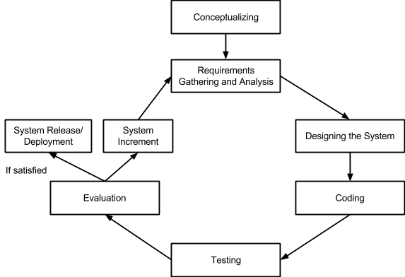

*Figure 3.1: Agile Development Model*

In the conceptualizing, the proponents will research on the present queuing management systems and will base the abstraction of the proposed system to it. The proponents will identify the deficit seen in the systems researched and use the findings to aid in improving the proposed system.

As for the requirements gathering and analysis, the proponents took into consideration the investigation of the essentials needed to complete the system such as the touch screen LCD, a dedicated thermal printer, a controller and a server.

Furthermore, the proponents will ask for support from the Short Message Service Center (SMSC) provider on how to utilize the Globe Labs API in handling SMS operations.

## 3.2 Requirements Analysis

### 3.2.1 Functional Requirements:

* The kiosk should allow clients to choose their desired transaction type
* The web app shall present an option whether the client should receive SMS notifications, and will only then allow clients to enter their mobile number
* Clients must be enqueued on the normal queue whenever they get a number
* VIP clients (includes senior citizens and people with disability) must be enqueued on the higher priority queue whenever they get a number
* System will print a number for client as requested
* The server must send SMS notifications to the clients as indicated
* Controllers can call the next and previous number
* Server must flash the called number on a separate screen visible to the clients
* Dedicated display system must flash the called number on a screen.
* Speaker should play a notification tone
* Server must dequeue the number after transaction

### 3.2.2 Non-Functional Requirements:

* SMS Latency must be less than a minute
* Controlling the queue should be instantaneous
* Calculating SMS Notifications depends on the accumulated/total time of transactions of the clients in queue and the actual clients being served
* System must support more than one controller
* Maintainability of the transaction options doesn’t require hardcoding or source code modification
* System has the ability to recover from power failure by keeping a nonvolatile backup copy of the queue

## 3.3 Overview

The structure of the system shall consist of four units: the mobile devices of the users or the kiosk machine for clients’ requests, a controller device for calling the next number, and a server computer that processes all data and a display screen which visually shows the sequence of activities in a process and the flow of the system. The client will start their transaction by selecting the start button that would then display input fields, where the client can enter their desired transaction type and other necessary data for processing transactions. Additionally, the system would ask if the client would like to be notified via SMS - if they had answered in affirmation, the client must enter their respective contact number. Also, if the client happened to be a privileged VIP guest, they would be requiredW to input a special PIN accessible only to VIP members. Printing the ticket will be optional if they opted to receive SMS notification. Without SMS Notification, the ticket will be printed without the need for further user input. After the client has completed their transaction with the kiosk machine, it will now provide a printed ticket containing the number and will be enqueued on the corresponding queue.

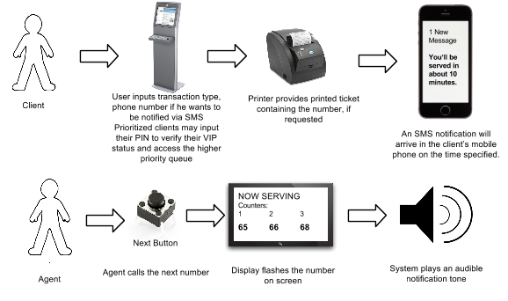

*Figure 3.2: Basic system operation*

*Figure 3.3: Context Diagram (Data Flow Diagram - Level 0)*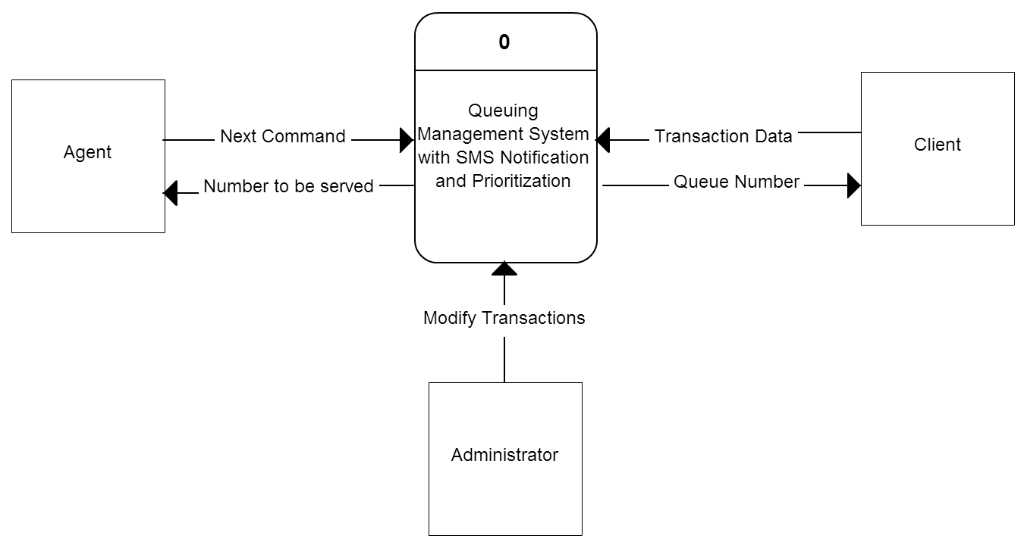

### 3.3.1 System requirements

The project consist of several units, operating as one complete system. Server software and web app will be programmed using Java Programming Language in Java EE (Enterprise Edition), JSP, and Java Servlets. The server must have an access to internet as it will be used to communicate with Globe Labs API. User’s mobile devices also must be connected to the internet, with an internet browser to access the web app.

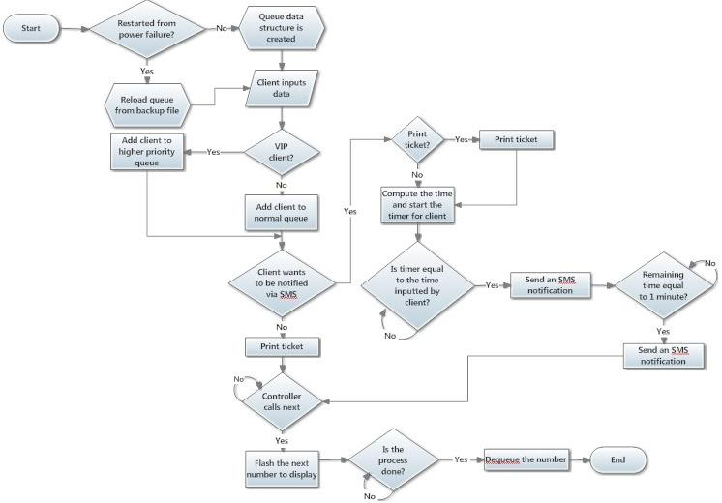

*Figure 3.3: Flowchart of the system*

The server is the datacenter of the system - responsible for processing all data flowing in the system. This server unit, despite of its name, doesn’t necessarily require a server hardware and a server operating system installed. The Java API used support server services at desktop OS level to provide server capabilities to a non-server system. The display is responsible for outputting the call request of the agents for the next person in the queue. Controllers are web interface, allowing the control of queue/ A network interconnecting device may be in the form of a switch or a hub if using wired connection, or a wireless access point, if using wireless connection for this system. It creates the Local Area Network (LAN) dedicated to the system, and is responsible for bridging connections among the units within the system as a pathway of data interchange. For the Wide Area Network (WAN), a router is necessary in order for the server to connect to the internet, and utilize Globe Labs API’s.

3.3.1.1 Hardware Specifications

The kiosk is composed of a touchscreen LCD which serves as an input device, and a dedicated thermal printer that generates the ticket number. Moreover, the server must have at least the following hardware requirements: a processor with at least 2 cores for an effective multithreading, 2GB of RAM, and a network interface card (NIC). A LAN Card is required if using wired connection, requiring a switch to bridge the network interconnection. Otherwise, Wi-Fi module shall be installed to use wireless connection, and a wireless access point (AP) will be required to accommodate the wireless needs. A video card with multi-monitor support is also required for separating the desktop of the server, and the display interface.

The controller is powered by an Intel 8051 Microcontroller with the necessary electronic parts to run the microcontroller. Serial port will be used for communication to computer. Controllers are used to remove and to call for numbers in the queue.

3.3.1.2 Software Specifications

Since the programming language to be used is Java, the software is available to run on any hardware that is capable of running Java Virtual Machine (JVM). According to Sun Microsystems, Java is *Write Once, Run Anywhere* (WORA), which means that it can be developed on any device, compiled into a standard [bytecode](http://en.wikipedia.org/wiki/Bytecode) and be expected to run on any device equipped with a [Java virtual machine](http://en.wikipedia.org/wiki/Java_virtual_machine) (JVM). JVM can run on virtually any desktop operating system. Java Swing GUI API will be used for the system’s user interface which would enable users to enter data, select buttons and interact with the system. Data flow shall start from the kiosk, that will send all information to the server. The server will process the data, and send necessary information back to the kiosk, such as the client number, its position in the queue, and the estimated length of time. The server then passes the message to Globe Labs API, the one responsible for sending it to the mobile phones through SMS. Controller hardware can send two input: Next and Previous command, to the server via serial port (RS232).

### 3.3.2 Prototype

The project prototype will initially run on the team’s personal devices. Figure 3.4 shows how hardware components shall be interconnected in the system.

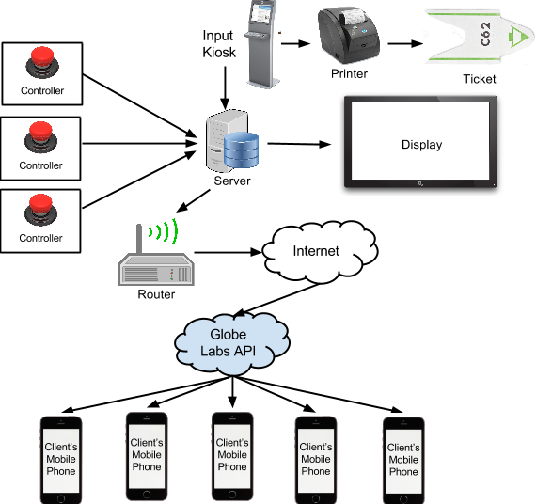

*Figure 3.4: System Architecture*

SMS operations are forwarded to Globe Labs API on the internet, and shall be the one responsible for message forwarding to mobile clients.

User interface of the kiosk and the server is provided by Java Swing GUI Framework. Below are the sample user interface designs to be implemented.

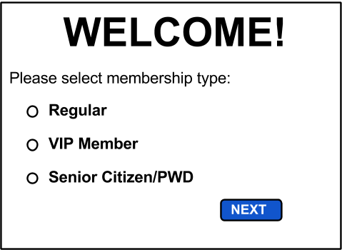

*Figure 3.5.1: Welcome Screen of Kiosk Machine*

A welcome screen is displayed at the kiosk, showing the three membership types; Regular, VIP or Senior Citizen/People with Disabilities, for prioritization concerns.

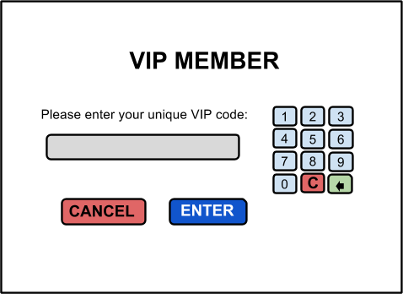

*Figure 3.5.1.1: VIP Code Prompt input screen*

VIP members can access higher priority queue by entering a unique code assigned by the implementing organization. Suggested codes may be in the form of their employee number or client ID.

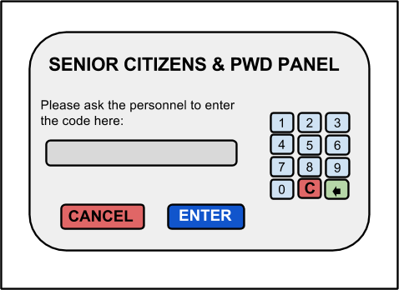

*Figure 3.5.1.2: Senior Citizens and PWD PIN input screen*

Senior citizens and People with Disability are prioritized through this screen. These clients are given the access to the higher priority queue through the personnel present after verifying their status (i.e. they have a valid senior citizen ID). The personnel will then enter the predefined special code that will successfully prioritize the involved client.

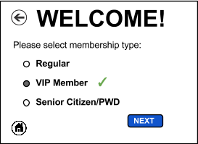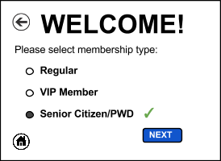

*Figure 3.5.1.3: Returning to the Welcome screen, confirming the correct PIN*

The interface shown in *Figure 3.5.1.3: Returning to the Welcome screen, confirming the correct PIN* will appear after entering the correct code for the VIP Member or Senior Citizen/PWD.

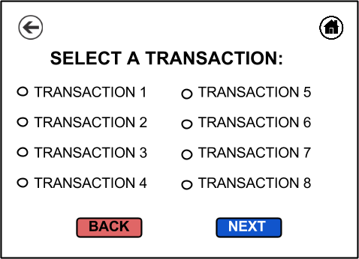

*Figure 3.5.2: Display for the list of available transactions*

In this screen, clients get to choose their desired transaction. Certain transactions contain their respective waiting time that the system will use for a cummulative waiting time computation that will then be applied to the SMS Notification feature. This list can be modified by the administrator shown in the server’s screen in Figure 3.6.2.

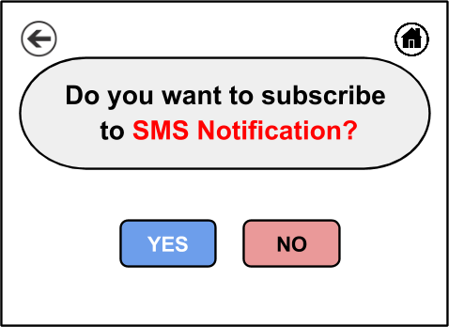

*Figure 3.5.3: Screen for confirmation on SMS subscription*

This window will only show after the client has selected a transaction that has a measurable waiting time. The screen will prompt a message informing how long will the client wait before his/her turn before subscribing to the SMS Notification.

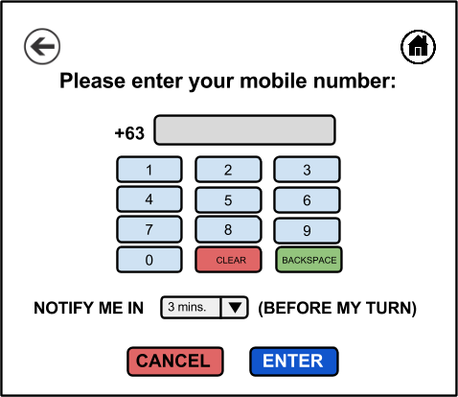

*Figure 3.5.3.1: Input Screen if SMS subscription is selected*

This screen allows clients to input their mobile phone and the time for SMS notification will be sent before being served. The drop down list of the time is dynamic and is dependent to the actual accumulated estimated time of the queue.

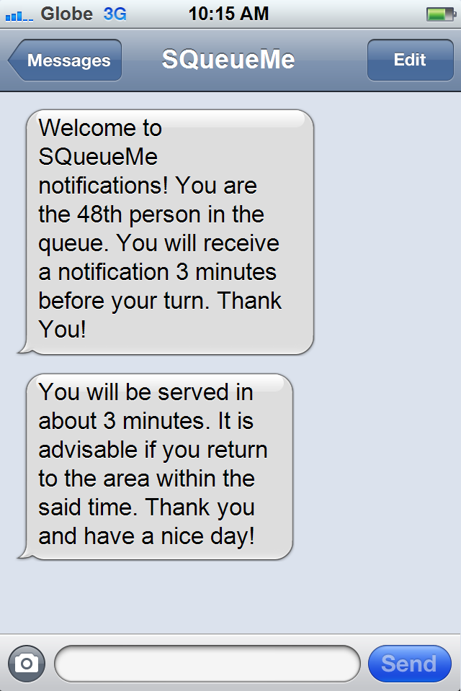

*Figure 3.5.3.2: SMS Confirmation & Notification received by the Client*

The image above emulates a user interface seen only by the client which is generated by the server containing information regarding the current position in the queue and how much time is left before the client's turn. The template is produced in a user friendly and straightforward format.

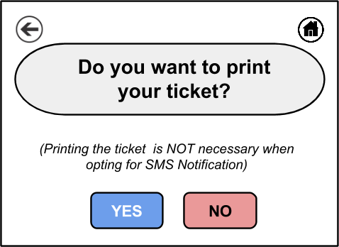

*Figure 3.5.4: Screen for confirmation on printing the ticket number*

This screen intellectively advises the client to abstain from printing if the SMS notification is enabled to promote minimizing the use of paper. Note that the system will only prompt for printing if SMS Notification is opted. Printing the ticket is automatically mandated if not opting for SMS.

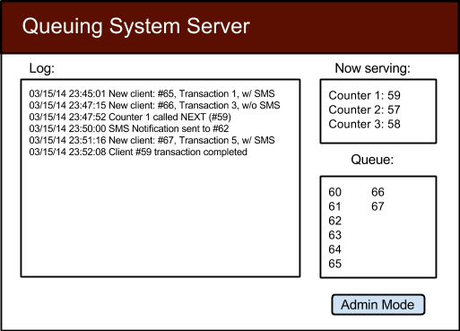

*Figure 3.6.1: Server Interface showing the log of all system activities*

The interface above is only seen by the administrator, mainly for monitoring purposes - the Log window shows the timestamp and information entered into the server, the Now serving window shows the real-time service to the clients via their respective queue number and Queue window shows the queue status. Also, the Admin Mode further enables interaction from the administrator to the system.

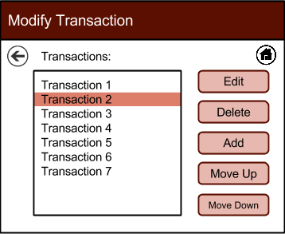

*Figure 3.6.2: Updating or modifying transaction list (Administrator panel)*

This screen allows the administrator to modify the transaction list’s i.e. to change transaction’s order and position, edit a transaction, or delete a transaction from the list.

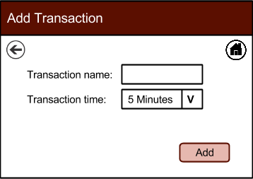

*Figure 3.6.2.1: Adding a new transaction*

A pop-up menu that allows administrator to input a new transaction name and its estimated waiting time, that will then be used by the system in computing the cummulative waiting time.

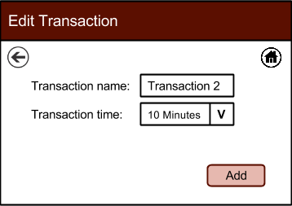

*Figure 3.6.2.2: Editing a transaction*

Same as *Figure 3.6.2.1: Adding a new transaction,* except that the transaction details are already in the fields for editing purposes.

# 

## Chapter 4 Implementation, Results and Discussion

**4.1 Requirements Documentation**

**4.1.1 Development Methodology**

The proponents decided to use the Agile Development Model approach as an appropriate methodology for the system. It could help the team satisfy its goals and objectives by developing the system in small increments. The method is very flexible that new features are delivered quickly and frequently, with a high level of predictability. Also, its iterative lifecycle and incremental nature makes any sorts of changes much less disruptive compared with other methodologies.

The first phase is the conceptualizing, the proponents studied the nature of present queuing management systems and based the abstraction of the proposed system to it. The proponents checked on the strengths and weaknesses of the systems researched and used the findings to aid in improving the proposed system.

The requirements gathering and analysis phase was done for the investigation of the essentials needed to complete the system such as the touch screen LCD, a controller, and a server. The proponents observed the behaviour of different queuing management systems by visiting banks, hospitals, and other business establishments that integrate the said system in their daily operation. Moreover, requirements gathered during this stage guided the proponents to determine the features of the project and to draw the boundary line. At this point of study, the proponents analyzed the scope and limitation of the project that could be found on the first chapter of this project.

The next phase which is designing the system comes after having the right concept and when there is enough requirements to create the system. During this phase, the proponents visualize how the project will look like and what will be the core processes and modules. The proponents used different web development tool and photo editing software such as Adobe Dreamweaver and Adobe Photoshop to help the team envision the design of the system. This is a substantial phase of the development as the proponents need to picture out the project and how the design shall be executed.

After designing the system and how data will be managed, coding comes next.

Testing is the next phase after a successful coding.

The proponents will now evaluate the system after exposing it to different tests.

## 

## 

## 

## 

## 

## 

## 

## 

## 

## 

## 

## 

## Bibliography

Barclay J. L., Gibson P. H., Lewis A., Wilson C., Affolter J. T., Patel J. C., Scott N. W...Broadhurst P. A. (2013). Adverse psychological effects and costs associated with waiting for radiofrequency ablation. *Wiley Periodicals, Inc., 2013,* 36(6), 719-26. doi: 10.1111/pace.12099

Batt, R. J. & Terwiesch, C. (2013). Waiting Patiently: An Empirical Study of Queue Abandonment in an Emergency Department. The Wharton School, University of Pennsylvania, Philadelphia.

Chowdhury, M. (2013). Queuing Theory Model Used to Solve the Waiting Line of a Bank –A Study on Islami Bank Bangladesh Limited, Chawkbazar Branch, Chittagong. Department of Business Administration, International Islamic University, Chittagong, Bangladesh.

Evans, P. (2013). Philippines - Telecoms, Mobile, Broadband and Forecasts. *Bubble Comm.* Retrieved from: http://www.budde.com.au/Research/Philippines-Telecoms-Mobile-Broadband-and-Forecasts.html

General Microsystems Sdn Bhd. (n.d.). *Queue Management.* Retrieved from <http://www.gms.com.my/GMS_Home/concept.htm>

Grabis, J. (2013). *Perspectives in Business Informatics Research.* Berlin Heidelberg: Springer.

Gupta, D. (2013). *Handbook of Healthcare Operations Management: Methods and Applications*. New York: Springer.

Hidalgo, V.B. (2011, September 04). BPI rolls out new service. *Inquirer.net.* Retrieved from <http://business.inquirer.net/16795/bpi-rolls-out-new-service>

International Business Machines Corporation. (2012). *SMS notifications.* Retrieved from http://public.dhe.ibm.com/software/mobile-solutions/worklight/docs/v600/09_05_SMS_notifications.pdf

Kokkinou, A., & Cranage, D. (2012). Using self-service technology to reduce customer waiting times. *International Journal of Hospitality Management, 33, 435-445.*

La Torre, S., Madhusudan, P. & Parlato, G. (2008). Context-Bounded Analysis of Concurrent Queue Systems. In Ramakrishnan, C. R. & Rehof, J. (Eds.), *Tools and Algorithms for the Construction and Analysis of Systems* (pp. 299-314). Berlin Heidelberg: Springer.

Lesonsky, R. (2012, June 11). Long Wait Times Harming Retail Experience. *The Huffington Post.* Retrieved from http://www.huffingtonpost.com/2012/06/11/survey-says-long-wait-times-harm-retail_n_1577898.html

L. Lakatos et al. (2013). *Introduction to Queueing Systems with Telecommunication Applications.* US: Springer.

Maister, D. (2005). *The Psychology of Waiting Lines.* Retrieved from <http://davidmaister.com/articles/the-psychology-of-waiting-lines/>

Perkins, R. (2012). *Why Waiting is Torture*. Retrieved from <http://www.templealiyah.com/sites/default/files/uploaded_documents/erev_rh_2012_.pdf>

RSI Concepts FZE. (n.d.). *Why Queue Management System.* Retrieved from http://www.rsiconcepts.com/why-queue-management-system.php

Stone, A. (2012, August 18). Why Waiting Is Torture. *The New York Times*. Retrieved from <http://www.nytimes.com/2012/08/19/opinion/sunday/why-waiting-in-line-is-torture.html?pagewanted=all&_r=1&>

Suarez, KD (2012, July 18). ‘Mobile revolution’ changing the world. *Rappler.* Retrieved from <http://www.rappler.com/life-and-style/technology/8786-it-s-a-mobile-world>

SWNS Reporter (2012, September 27). Wait in line: Nearly a year of our life is spent in QUEUES. *SWNS.* Retrieved from <http://swns.com/news/wait-in-line-nearly-a-year-of-our-life-is-spent-in-queues-24514/>

The Nielsen Company. (2014). *The Asian Mobile Consumer Decode.* Retrieved from http://www.nielsen.com/content/corporate/ph/en/insights/news/2014/asian-mobile-consumers.html

Thomopoulos, N. (2012). *Fundamentals of Queuing Systems: Statistical Methods for Analyzing Queuing Models*. New York: Springer US.