|  |
| --- |
| Final Project |

|  |
| --- |
| Group 4  Date: April 27, 2022  Website: [Website Here] |

|  |  |
| --- | --- |
| Foundation of Web Development |  |

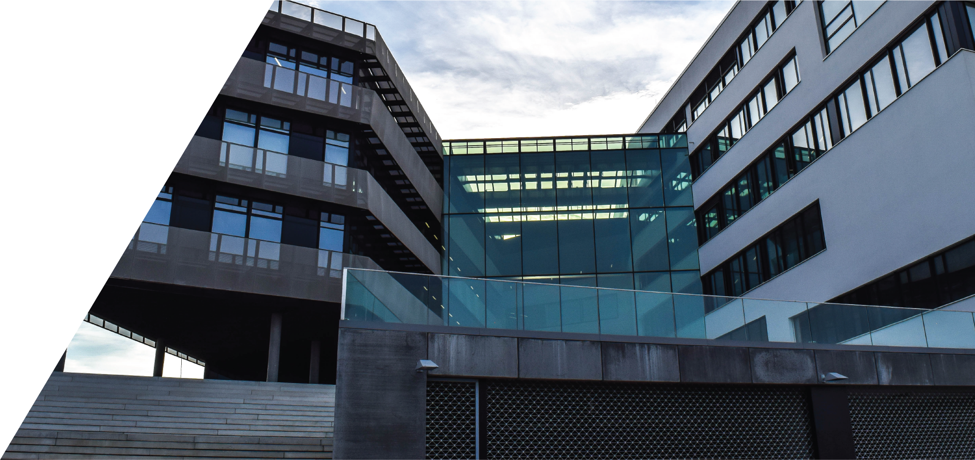

|  |
| --- |
|  |

|  |
| --- |
| V-Shape Model |

## Software Development Plan

The process for selecting the appropriate software development plan was done in considering all the available plans. We first had to highlight the project requirements.

The requirements for the project are the following:

1. Create a curriculum website for one of the team members.
2. Create an excel document tracking all the hours put into the project by every team member.
3. Create a Visio diagram to visibly demonstrate the progress made and write a summary on the decisions made for the project.
4. Create a PowerPoint incorporating all the elements above and present it in a professional manner.

Once the requirements were clear and understood, we discussed possible models. The first in consideration was the Waterfall model. The Waterfall model seemed ideal, because it would be easy to implement and follow through each phase. With a small project, and well-defined goals, each stage could be managed and completed on time. The tasks would be easy to implement and designate to each team member. With all these benefits, there was one main issue that worried the team; how do we complete one phase without stalling the other team members? If one member must wait for another to complete his/her task, that could cause issues on delivering the project on time. Also, with the constant changes occurring between each member tasks, we felt the Waterfall model would not be adequate for this project. After reviewing other plans, we decided that the V-Shape model was the best suited for us. In addition to the benefits mentioned above, the V-Shape would also address delays and overlap between tasks. Each member can now work separately on their respective task and test it until the results are satisfactory. After unit testing, the main risk of error lies in integration testing for this project. But once the errors are ironed out, we believe the system and acceptance phases would be quickly accomplished successfully. Each member was designated his/her tasks and we agreed to meet periodically throughout the day to update members on the progress, with one hard lined meeting for the final integrations of all the tasks.