Patrick Morley

Professor Holden-Gouveia

Linux Administration

Networking

Ubuntu:

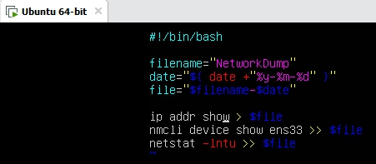

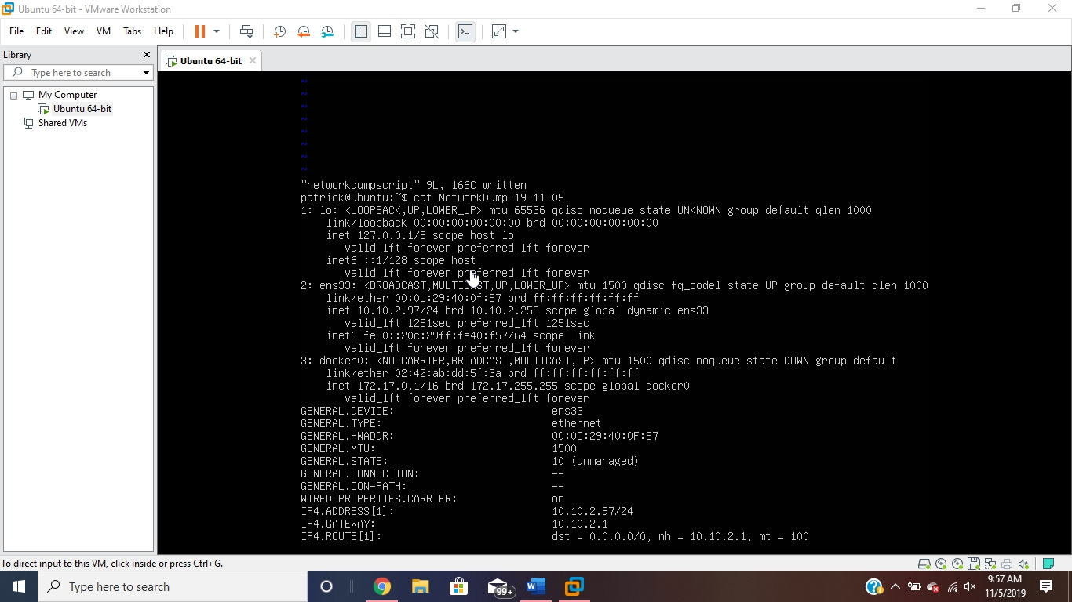

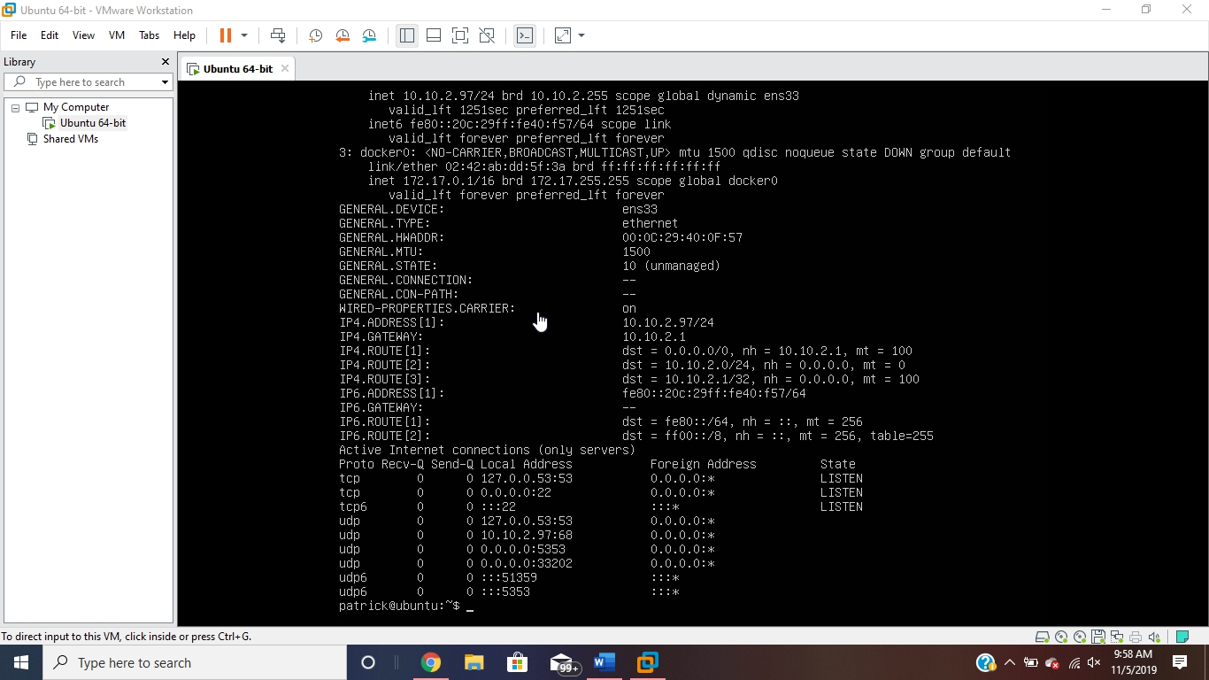

CentOS: