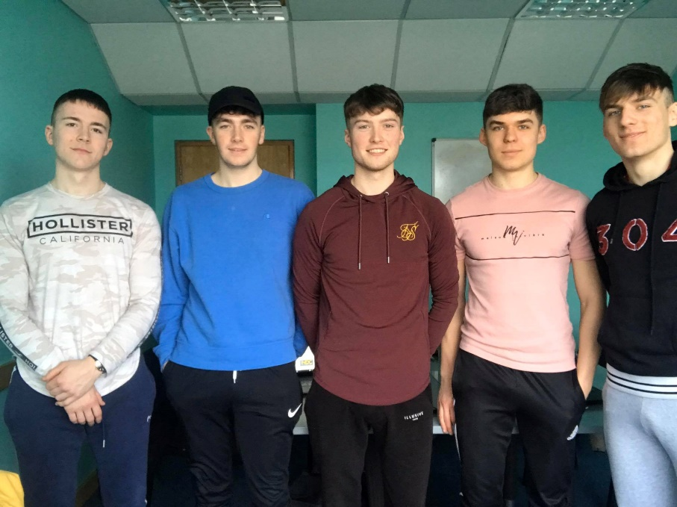**Illusive**

Team Member Names

* Patrick Murray – G00344530
* Cory O Donoghue – G00376678
* Kealan O Callaghan – G00373834
* Kacper Grzenda – G00373427
* Oskar Grzenda – G00373428

Team Roles

* Product Owner – Kealan
* Scrum Master – Cory
* Tester – Oskar
* Engineer 1 – Paddy
* Engineer 2 – Kacper

Hobbies

* Patrick Murray – Soccer
* Cory O Donoghue – Gym
* Kealan O Callaghan – Gaelic
* Kacper Grzenda – Football
* Oskar Grzenda - Gym

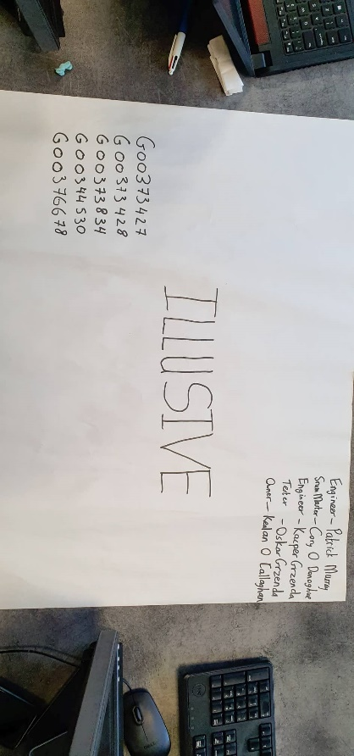Github Project Location

https://github.com/PatrickMurray78/Illusive-Fitness.git