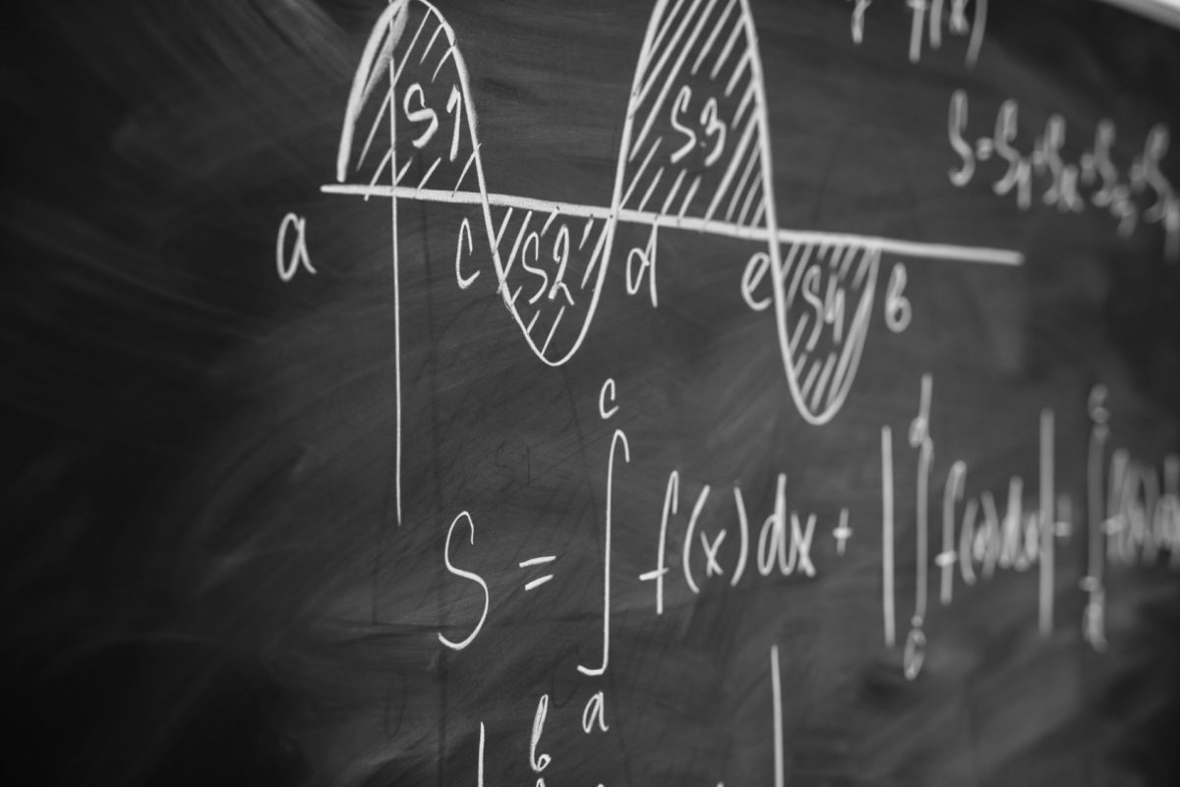

# Chapter 1: Introduction to Calculus

## 1.1 What is Calculus?

This is a paragraph with exactly 20 pt line spacing.

## 1.2 History of Calculus

This is a paragraph with exactly 20 pt line spacing.

## 1.3 Importance of Calculus

This is a paragraph with exactly 20 pt line spacing.

# Chapter 2: Differentiation

## 2.1 Understanding Derivatives

This is a paragraph with exactly 20 pt line spacing.

## 2.2 Rules of Differentiation

This is a paragraph with exactly 20 pt line spacing.

## 2.3 Applications of Differentiation

This is a paragraph with exactly 20 pt line spacing.

# Chapter 3: Integration

## 3.1 Understanding Integrals

This is a paragraph with exactly 20 pt line spacing.

## 3.2 Techniques of Integration

This is a paragraph with exactly 20 pt line spacing.

## 3.3 Applications of Integration

This is a paragraph with exactly 20 pt line spacing.

# Chapter 4: Limits and Continuity

## 4.1 Limit Definition

This is a paragraph with exactly 20 pt line spacing.

## 4.2 Properties of Limits

This is a paragraph with exactly 20 pt line spacing.

## 4.3 Continuity of Functions

This is a paragraph with exactly 20 pt line spacing.

# Chapter 5: Advanced Topics in Calculus

## 5.1 Sequences and Series

This is a paragraph with exactly 20 pt line spacing.

## 5.2 Multivariable Calculus

This is a paragraph with exactly 20 pt line spacing.

## 5.3 Differential Equations

This is a paragraph with exactly 20 pt line spacing.