Testing Plan for Orinoco

Prepared for: Sheila, Founder

P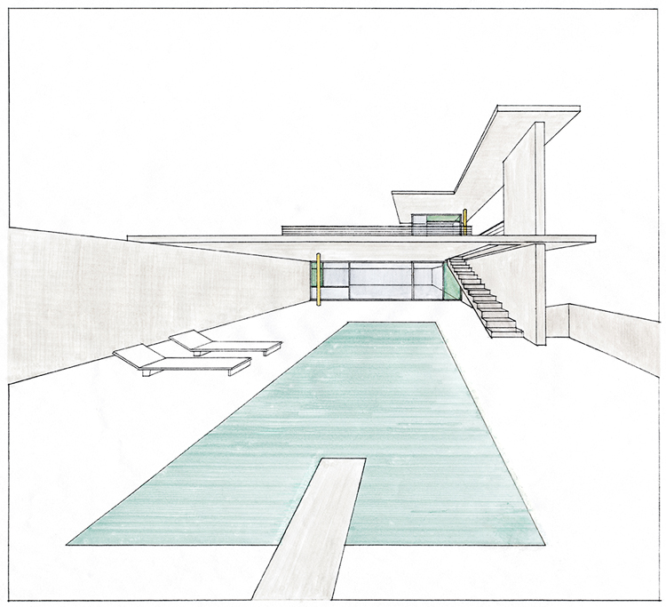repared by: Patrick Olaniyan, Web Developer

company name

February 3rd, 2021

Proposal number: 123-4567

# Overview

## Introduction

This plan describes the testing approach that will serve as the fundamental strategy for our Orinoco website. The purpose of this website is to provide the user with a list view page showing all the available items for sale. A single product page which will dynamically show the item selected by user, display a description and price in dollars, and allow user to personalize the product and add it to their cart. Also a cart page showing a summary of the products in the cart, the total price, and a form with which to submit an order and lastly an order confirmation page thanking the user for their order, a total price and order ID.

The product requirements for the Orinoco are as follows:

A user can view and select item.

A user can personalize item as well as add to cart.

A user can view selected item in cart and the total price.

A user can view total price and order ID.

## Features to Test

1. A user can view and select item.

* + Frontend:
    - User can click on wanted item to view item information

2. A user can personalize item as well as add to cart.

* + Frontend:
    - User can click and personalized item and add highlighted style and item to cart.

3. A user can view selected item in cart and price

* + Frontend:
    - User can view items in cart and total calculated price

## Features not Test

* + Backend:

company name

* + - Calling API endpoint adds item to database that persists between sessions and return correct JSON data
    - Verify API endpoint removes existing item from database