Beyond Accuracy: Evaluating Classic Machine Learning Models on an Imbalanced Fake Job Posting Dataset
Machine Learning Project Report

Dataset: Fake Job Postings
Primary task: binary classification of real vs fraudulent job postings

Executive Summary
This project evaluated fake job posting detection as an imbalanced binary classification problem. The dataset contains 17,880 job postings, of which 866 are labeled fraudulent. Fraudulent postings therefore represent approximately 4.84% of the dataset. Because the positive class is rare, accuracy alone is not sufficient for evaluating model performance.
The model comparison used stratified 5-fold cross-validation and evaluated several classic machine learning models. Average precision, fake-class precision, fake-class recall, fake-class F1, balanced accuracy, and ROC AUC were used to evaluate performance beyond accuracy. The balanced Linear SVM had the highest average precision among the main model comparison runs for both the cleaned and original datasets.
Additional error analysis was performed on the cleaned dataset using the balanced Linear SVM. The analysis examined false positives, false negatives, feature-level error rates, text-length error rates, model score distributions, confident mistakes, borderline cases, and threshold tradeoffs.

Research Questions
- How imbalanced is the dataset, and why does that matter for model evaluation?
- Is accuracy misleading for fake job detection?
- Which classic machine learning model performs best on the minority fake class?
- Does the cleaned and feature-engineered dataset improve performance compared with the original dataset?
- How do class weighting, thresholds, and error patterns affect interpretation of the model results?

Dataset Description
Two versions of the dataset were used. The original dataset is `fake_job_postings.csv`. The cleaned dataset is `fake_jobs_cleaned.csv`, which includes additional feature-engineered columns such as text lengths, word counts, and binary indicators for missing or present fields.
Dataset | Rows | Columns | Real Count | Fake Count | Fake Rate
cleaned | 17,880 | 32 | 17,014 | 866 | 4.84%
original | 17,880 | 18 | 17,014 | 866 | 4.84%

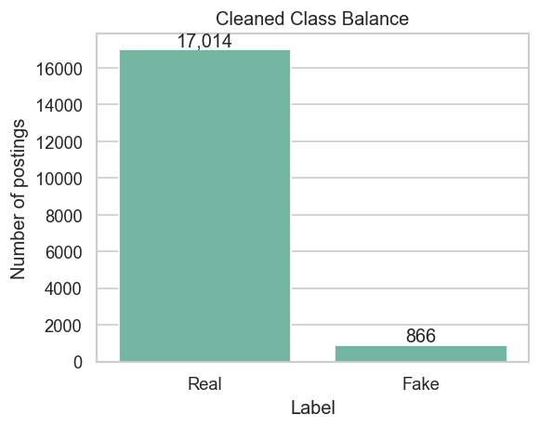
Figure 1. Class balance in the cleaned dataset.
The class distribution shows the main modeling challenge. A classifier that predicts every posting as real would achieve approximately 95.16% accuracy while detecting no fake postings.

Exploratory Data Analysis

Missing Values
Missingness was examined for both dataset versions. Salary range was missing in approximately 83.96% of rows in both datasets.
Column | Missing Rate
salary_range | 83.96%
benefits | 40.34%
company_profile | 18.50%
requirements | 15.08%
location | 1.94%
description | 0.01%
job_id | 0.00%
department | 0.00%

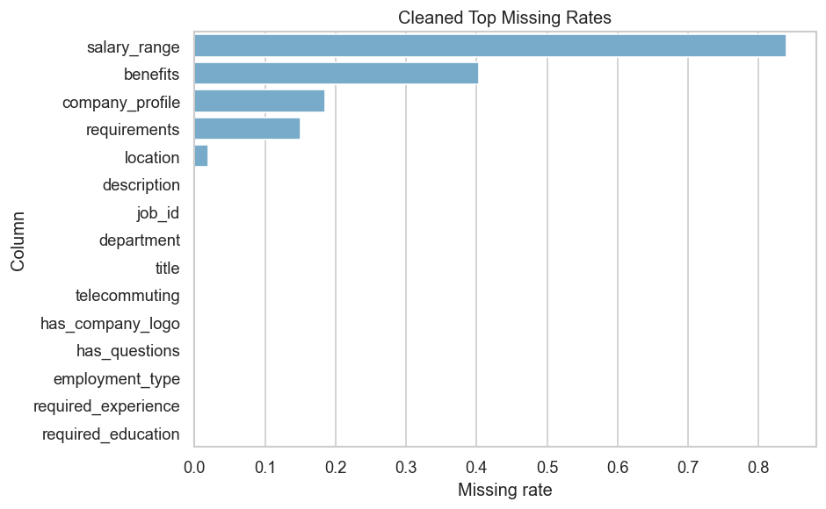
Figure 2. Top missing-value rates in the cleaned dataset.

Text and Categorical Patterns
Text fields were important because the strongest models used TF-IDF features from title, company profile, description, requirements, and benefits. Categorical fake-rate summaries were also generated to identify categories with higher observed fake rates.
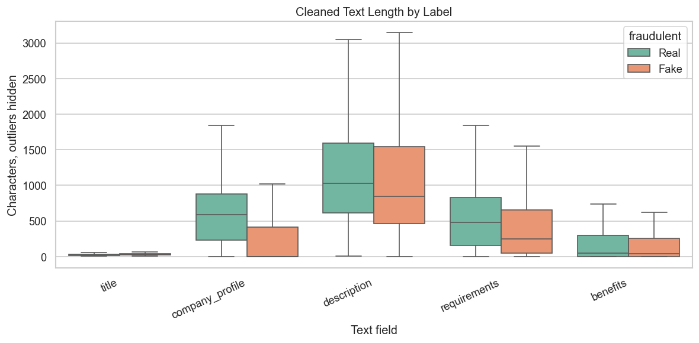
Figure 3. Text length distributions by label in the cleaned dataset.
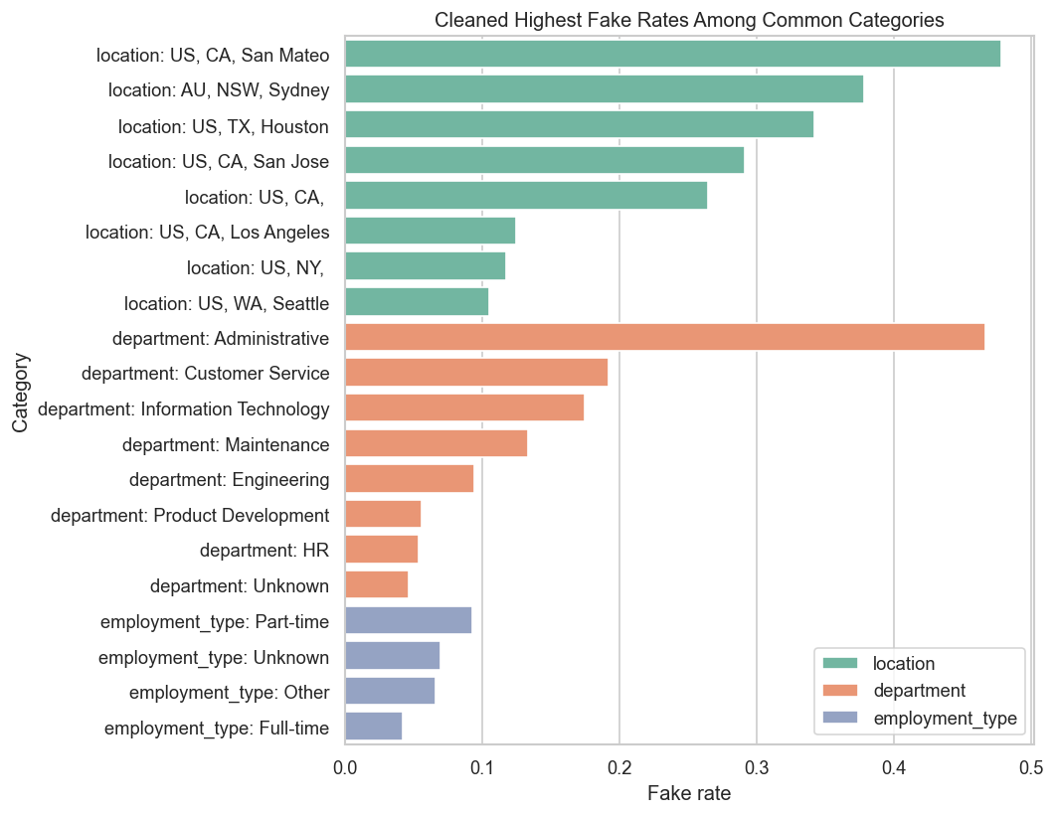
Figure 4. Categories with high observed fake rates in the cleaned dataset.

Modeling Approach
The modeling pipeline combined text features, categorical metadata, and numeric features where available. Text fields were combined into a single text field and transformed with TF-IDF. Categorical variables were imputed and one-hot encoded. Numeric variables were imputed and scaled.
The following models were evaluated using stratified 5-fold cross-validation:
- Dummy majority-class baseline
- Balanced Logistic Regression
- Balanced Linear SVM
- Complement Naive Bayes using text features only
- Random Forest using metadata only
The primary comparison metric was average precision because the fake class is rare. Accuracy was reported, but it was not used as the main model-selection metric.

Model Comparison Results
Dataset | Model | Accuracy | Balanced Acc. | ROC AUC | Avg. Precision | Fake Precision | Fake Recall | Fake F1
cleaned | Linear SVM balanced | 0.9858 | 0.9164 | 0.9890 | 0.9140 | 0.8636 | 0.8395 | 0.8512
cleaned | Logistic Regression balanced | 0.9706 | 0.9325 | 0.9884 | 0.8810 | 0.6430 | 0.8903 | 0.7464
cleaned | Complement Naive Bayes text only | 0.8261 | 0.8714 | 0.9539 | 0.7387 | 0.2084 | 0.9215 | 0.3398
cleaned | Random Forest metadata only | 0.9145 | 0.8899 | 0.9651 | 0.7145 | 0.3469 | 0.8626 | 0.4947
cleaned | Dummy majority baseline | 0.9516 | 0.5000 | 0.5000 | 0.0484 | 0.0000 | 0.0000 | 0.0000
original | Linear SVM balanced | 0.9858 | 0.9147 | 0.9880 | 0.9128 | 0.8665 | 0.8361 | 0.8508
original | Logistic Regression balanced | 0.9730 | 0.9338 | 0.9876 | 0.8850 | 0.6666 | 0.8903 | 0.7620
original | Complement Naive Bayes text only | 0.8261 | 0.8714 | 0.9539 | 0.7387 | 0.2084 | 0.9215 | 0.3398
original | Random Forest metadata only | 0.9199 | 0.8845 | 0.9569 | 0.7143 | 0.3604 | 0.8453 | 0.5053
original | Dummy majority baseline | 0.9516 | 0.5000 | 0.5000 | 0.0484 | 0.0000 | 0.0000 | 0.0000

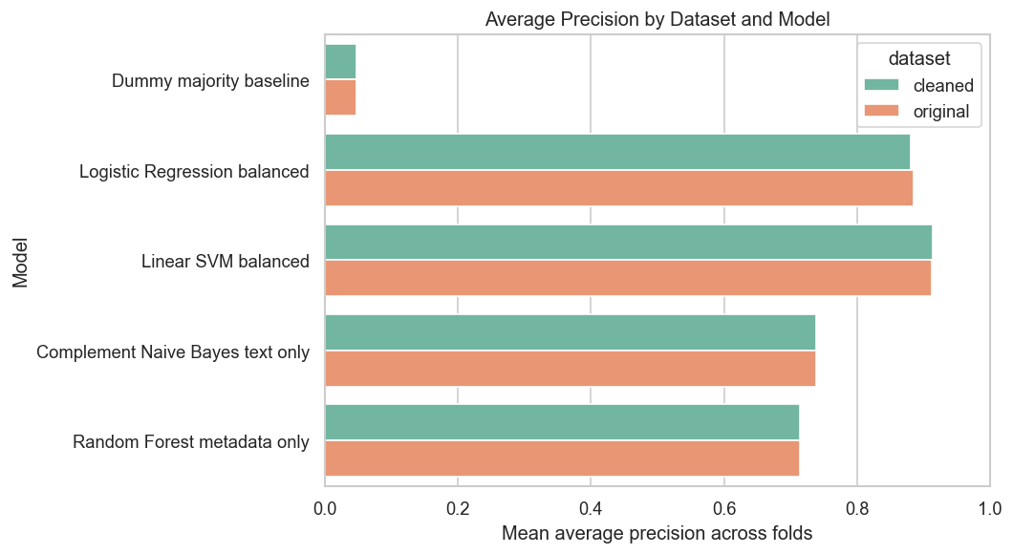
Figure 5. Average precision by dataset and model.
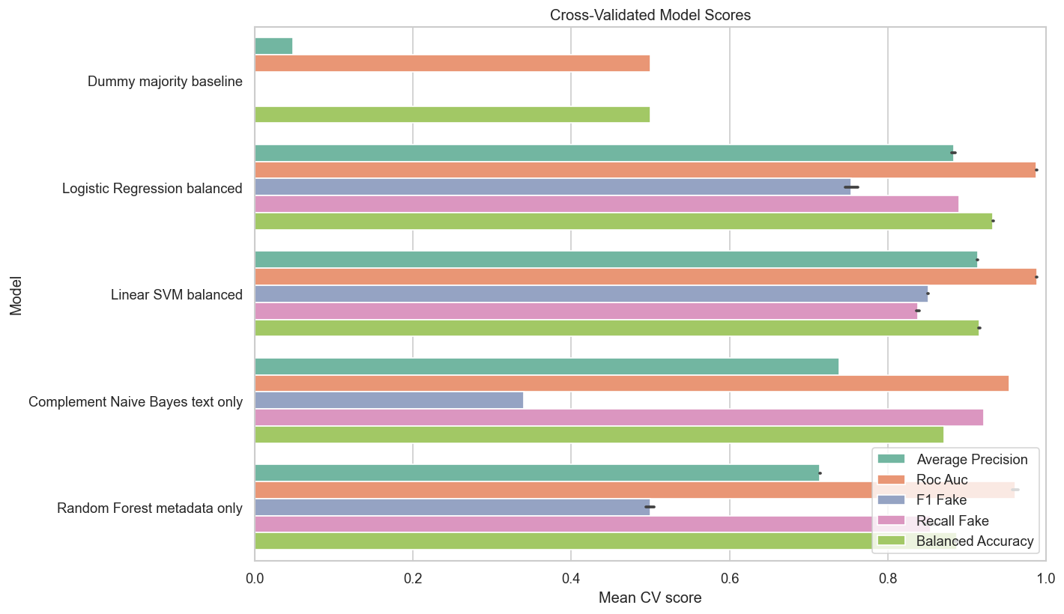
Figure 6. Cross-validated model scores across evaluation metrics.
The dummy baseline achieved 95.16% accuracy, but fake-class recall and fake-class F1 were both 0.00 because it never predicted the fake class. This confirms that accuracy is misleading for this imbalanced dataset.
The balanced Linear SVM had the highest average precision in the main model comparison for both the cleaned and original datasets. Balanced Logistic Regression had higher fake recall but lower fake precision. Complement Naive Bayes had high fake recall but low fake precision.

Selected Model
The selected model for detailed analysis was the balanced Linear SVM trained on the cleaned dataset. This model was selected because it had the highest average precision in the main cleaned-dataset comparison while maintaining strong fake-class precision and recall.
Class | Precision | Recall | F1 | Support
Real | 0.9918 | 0.9932 | 0.9925 | 17,014
Fake | 0.8634 | 0.8395 | 0.8513 | 866

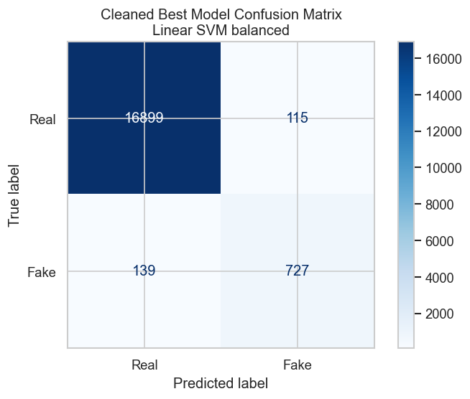
Figure 7. Confusion matrix for the selected cleaned-dataset model.
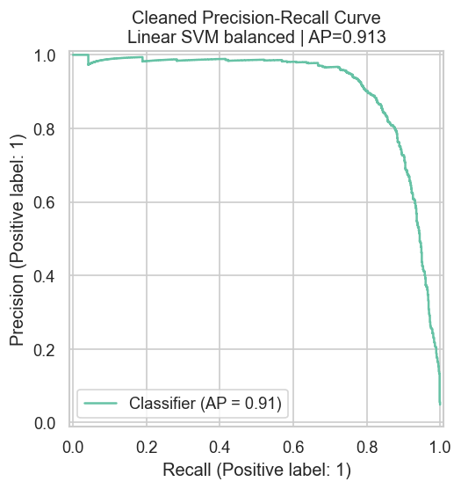
Figure 8. Precision-recall curve for the selected cleaned-dataset model.

Weighted vs Unweighted Linear Models
Dataset | Model | Avg. Precision | Fake Precision | Fake Recall | Fake F1
cleaned | Linear SVM unweighted | 0.9181 | 0.9301 | 0.7933 | 0.8559
cleaned | Linear SVM balanced | 0.9140 | 0.8636 | 0.8395 | 0.8512
cleaned | Logistic Regression balanced | 0.8810 | 0.6430 | 0.8903 | 0.7464
cleaned | Logistic Regression unweighted | 0.8679 | 0.9292 | 0.6340 | 0.7527
original | Linear SVM unweighted | 0.9168 | 0.9361 | 0.7910 | 0.8570
original | Linear SVM balanced | 0.9128 | 0.8665 | 0.8361 | 0.8508
original | Logistic Regression balanced | 0.8850 | 0.6666 | 0.8903 | 0.7620
original | Logistic Regression unweighted | 0.8680 | 0.9316 | 0.6271 | 0.7487

Class weighting changed the model prediction behavior. The unweighted Linear SVM produced fewer fake predictions, resulting in higher fake precision and lower fake recall. The balanced Linear SVM produced more fake predictions, resulting in higher fake recall and lower fake precision.
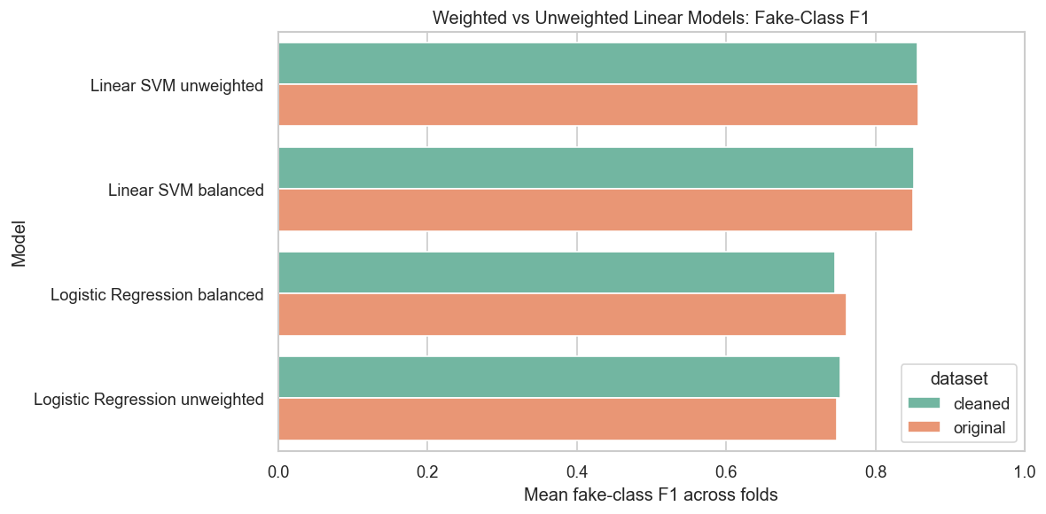
Figure 9. Fake-class F1 for weighted and unweighted linear models.
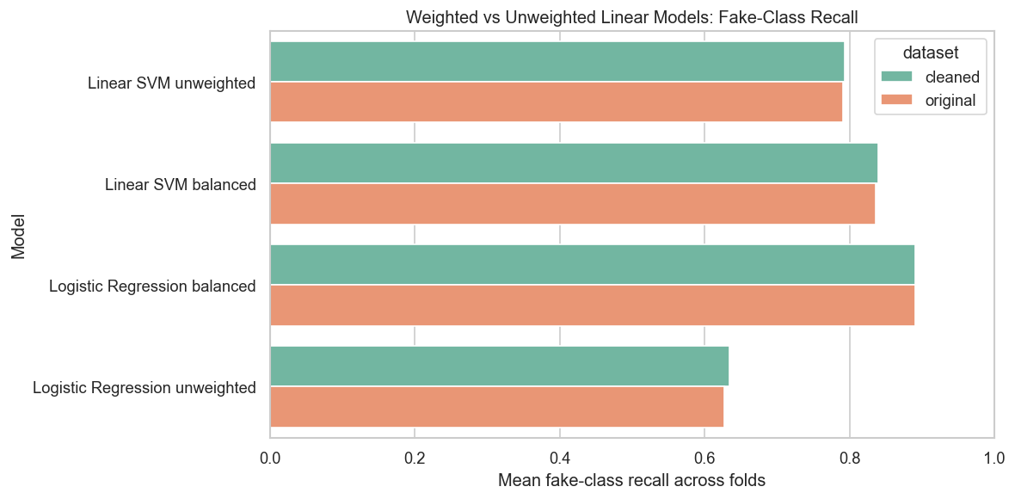
Figure 10. Fake-class recall for weighted and unweighted linear models.

Feature Interpretation
The Linear SVM coefficients were inspected to identify features associated with fake and real predictions. Positive coefficients moved predictions toward the fake class, while negative coefficients moved predictions toward the real class.

Top Features Associated With Fake Postings
Feature | Coefficient
text: link | 2.0230
category: department_Information Technology | 1.5334
category: location_US, TX, AUSTIN | 1.5306
category: location_US, OH, Groveport | 1.4451
text: money | 1.4260
category: department_Sales and Research | 1.3807
text: american | 1.3081
text: duration | 1.2949
text: earn | 1.2023
category: department_Biotech | 1.1549

Top Features Associated With Real Postings
Feature | Coefficient
text: client | -1.1843
text: experience | -1.1665
text: basic computer | -1.1084
text: english | -1.0241
text: growing | -0.9402
text: companies | -0.9377
text: fun | -0.9375
text: expected | -0.9135
text: 50 | -0.9019
category: industry_Restaurants | -0.8988

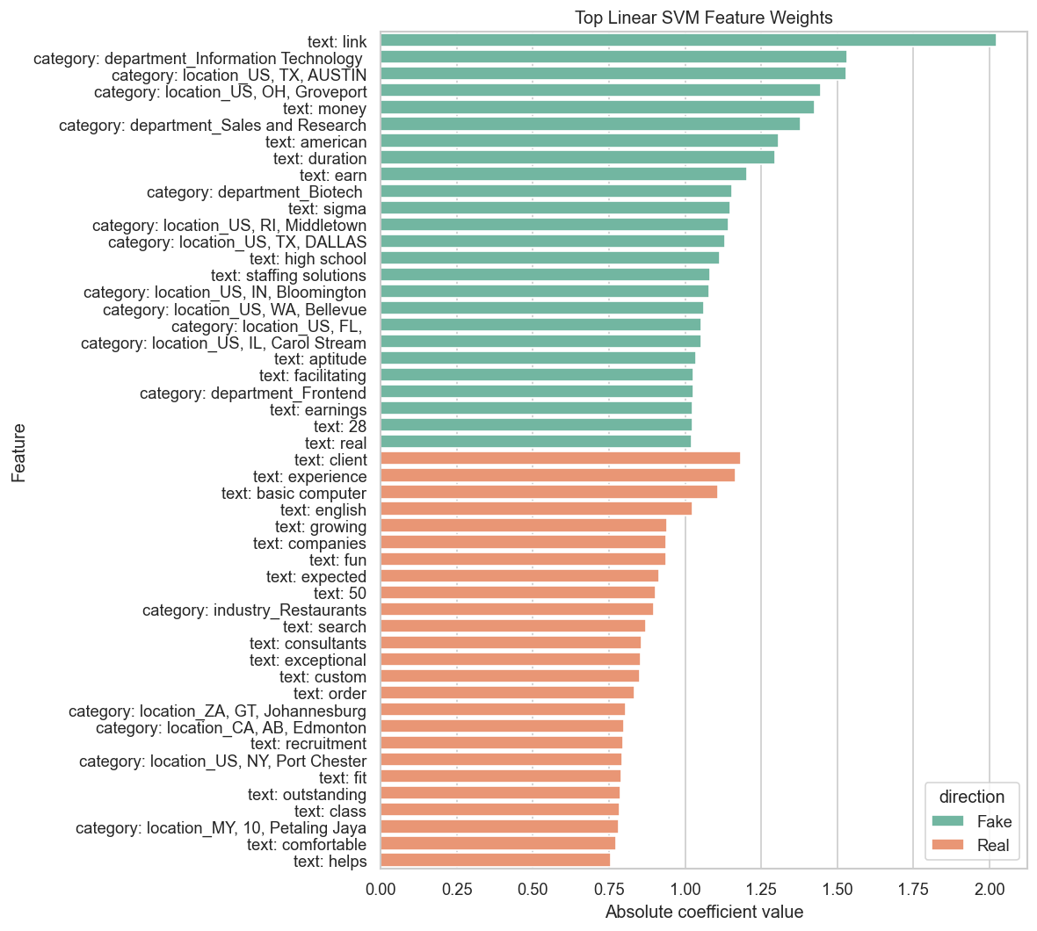
Figure 11. Top Linear SVM feature weights.

Error Analysis
Error analysis was performed using cross-validated predictions from the selected balanced Linear SVM on the cleaned dataset. The analysis examined false positives, false negatives, four prediction groups, binary feature error rates, text-length error rates, decision score distributions, confident mistakes, borderline cases, and threshold tradeoffs.
Error Type | Count
False positives | 115
False negatives | 139

Prediction Group | Count | Mean Fake Score | Mean Desc. Chars | Mean Req. Chars | Logo Rate | Company Profile Rate
True positive | 727 | 0.9380 | 1,154 | 441.3010 | 0.3380 | 0.3310
False negative | 139 | -0.5450 | 1,157 | 470.8850 | 0.2660 | 0.2730
False positive | 115 | 0.2890 | 981.3300 | 404.3300 | 0.1830 | 0.1650
True negative | 16899 | -1.7460 | 1,223 | 598.7800 | 0.8230 | 0.8450

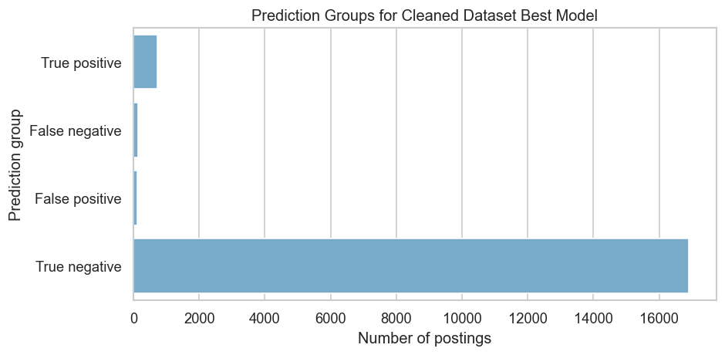
Figure 12. Prediction group counts for the selected model.
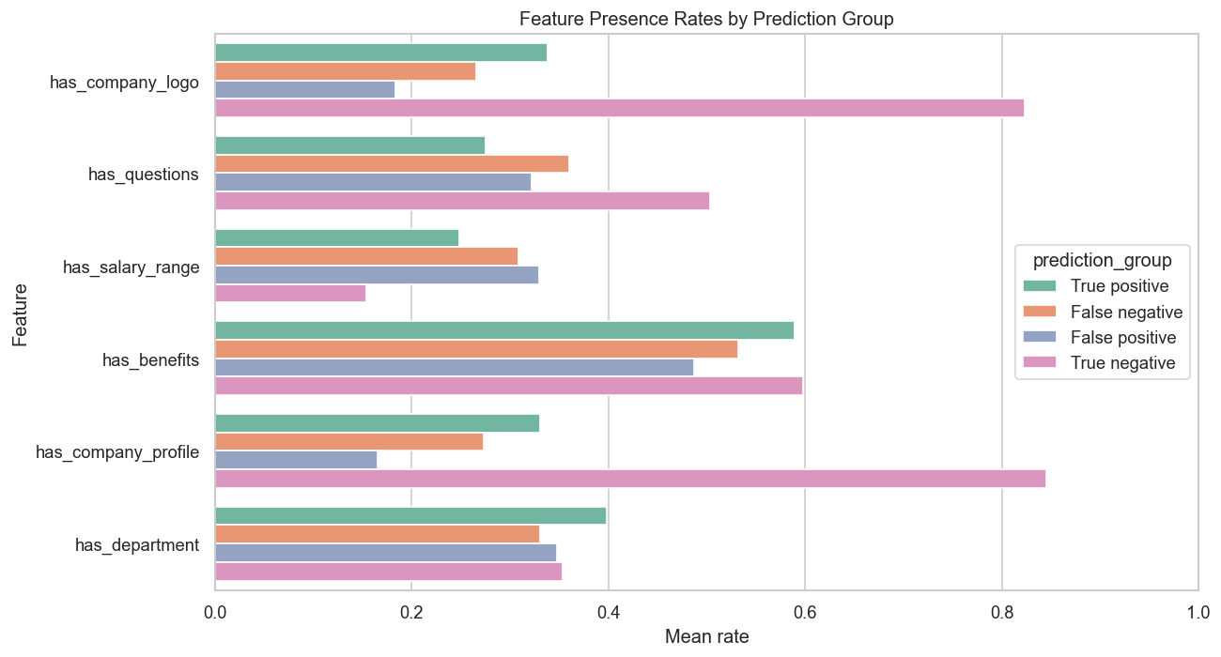
Figure 13. Feature presence rates by prediction group.
Among real postings, the rows incorrectly predicted as fake had lower company logo and company profile rates than rows correctly predicted as real. The false-positive group also had shorter average descriptions, requirements, company profiles, and benefits than the true-negative group. Among fake postings, the rows missed by the model had negative decision scores and were therefore predicted as real.

Feature-Level Error Analysis
Feature | Value | Rows | FP Rate Among Real | FN Rate Among Fake
has_company_logo | 0 | 3660 | 0.0305 | 0.1750
has_company_logo | 1 | 14220 | 0.0015 | 0.1307
has_questions | 0 | 9088 | 0.0092 | 0.1445
has_questions | 1 | 8792 | 0.0043 | 0.2000
has_salary_range | 0 | 15012 | 0.0054 | 0.1493
has_salary_range | 1 | 2868 | 0.0144 | 0.1928
has_benefits | 0 | 7212 | 0.0086 | 0.1786
has_benefits | 1 | 10668 | 0.0055 | 0.1474
has_company_profile | 0 | 3308 | 0.0353 | 0.1721
has_company_profile | 1 | 14572 | 0.0013 | 0.1362
has_department | 0 | 11547 | 0.0068 | 0.1751
has_department | 1 | 6333 | 0.0067 | 0.1373
telecommuting | 0 | 17113 | 0.0065 | 0.1596
telecommuting | 1 | 767 | 0.0128 | 0.1719

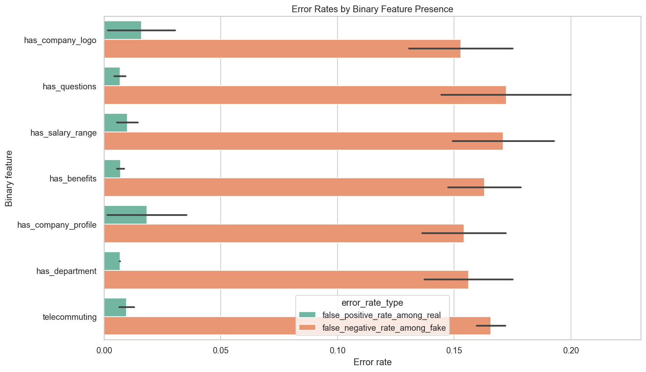
Figure 14. Error rates by binary feature presence.
Among real postings, false positive rates were higher when company logo or company profile information was absent. For example, real postings with `has_company_profile = 0` had a false positive rate of 0.0353, compared with 0.0013 when `has_company_profile = 1`.

Text-Length Error Analysis
Text fields were divided into length buckets. False positive and false negative rates were then calculated within each bucket.
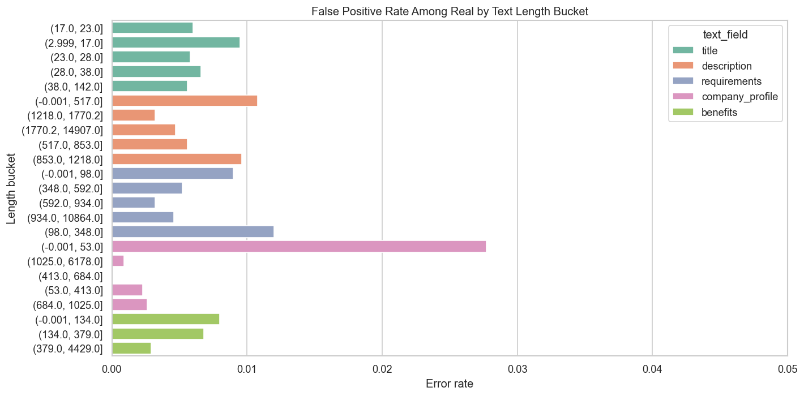
Figure 15. False positive rates by text length bucket.
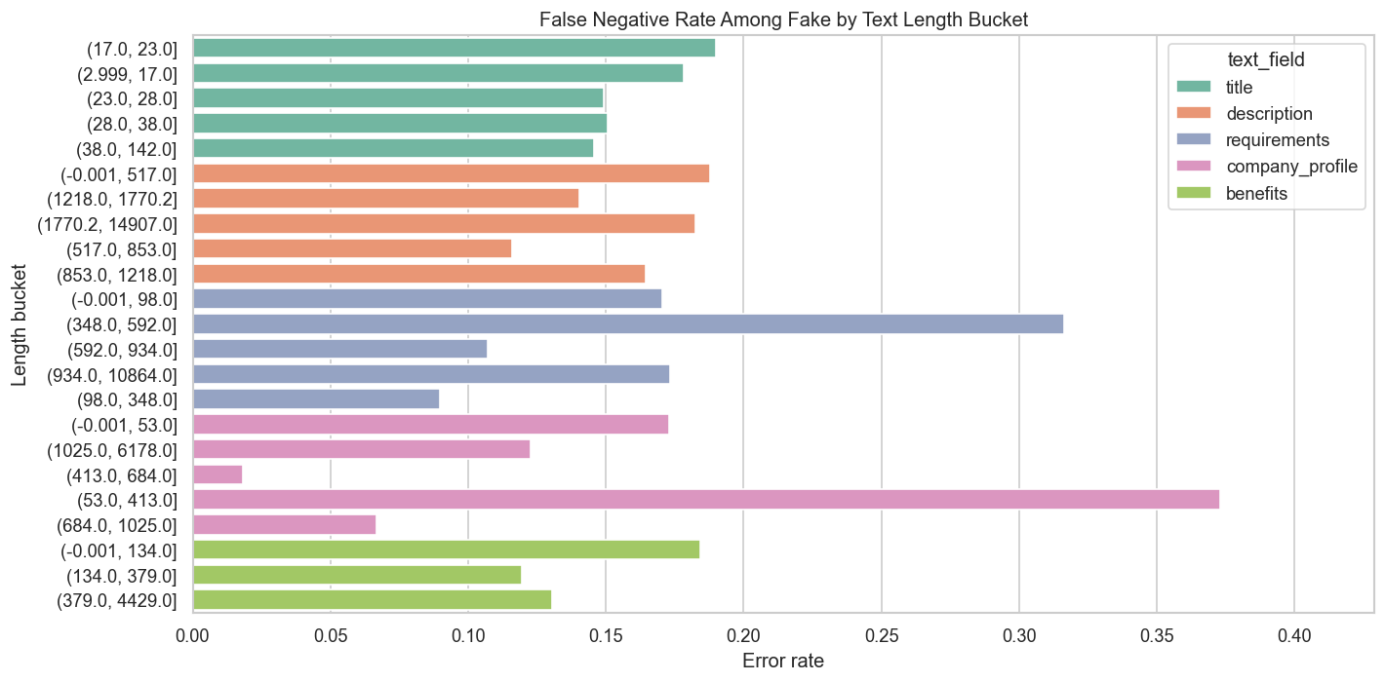
Figure 16. False negative rates by text length bucket.
Among real postings, the shortest company profile bucket had a higher false positive rate than longer company profile buckets. Among fake postings, false negative rates varied across text fields and buckets, so missed fake postings were not explained by one text-length feature alone.

Score Distribution and Confidence Analysis
Prediction Group | Count | Mean | Median | Std. Dev. | Min | Max
True positive | 727 | 0.9380 | 0.9534 | 0.4736 | 0.0042 | 2.7637
False negative | 139 | -0.5447 | -0.4215 | 0.4260 | -2.4067 | -0.0090
False positive | 115 | 0.2891 | 0.1980 | 0.2916 | 0.0045 | 1.8085
True negative | 16899 | -1.7461 | -1.7392 | 0.6197 | -4.3400 | -0.0024

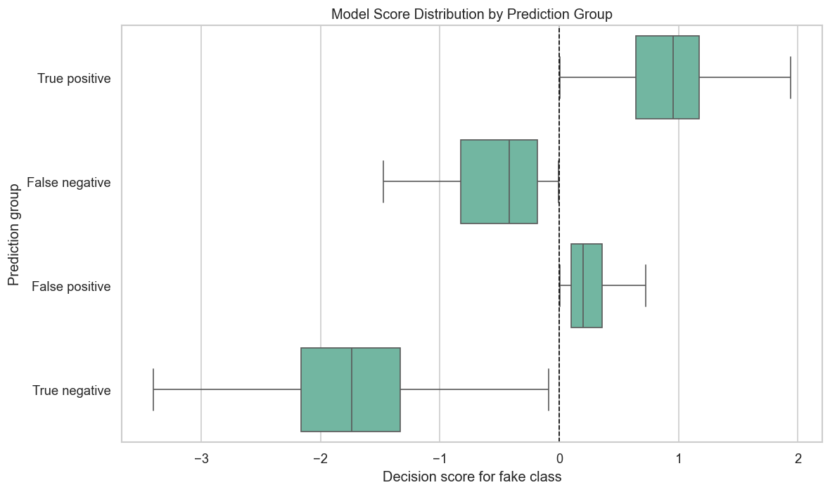
Figure 17. Model score distribution by prediction group.
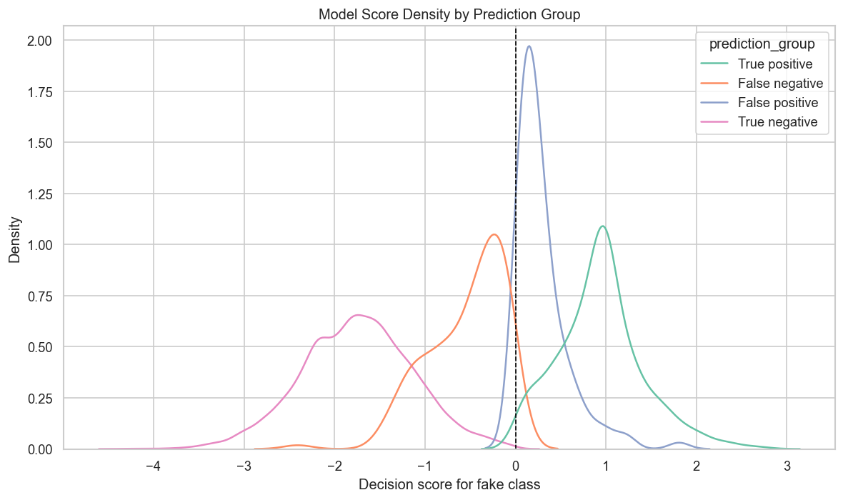
Figure 18. Model score density by prediction group.
False positives had positive decision scores because they were predicted as fake, but their average score was lower than the average score for true positives. False negatives had negative decision scores because they were predicted as real. Some errors were close to the zero decision threshold, while others were made with higher model confidence.

Threshold Analysis
Threshold | Flagged Rate | TP | FP | FN | Fake Precision | Fake Recall | Fake F1
-0.9649 | 0.1500 | 839.0000 | 1,843 | 27.0000 | 0.3128 | 0.9688 | 0.4729
-0.7289 | 0.1000 | 823.0000 | 965.0000 | 43.0000 | 0.4603 | 0.9503 | 0.6202
-0.5056 | 0.0750 | 807.0000 | 534.0000 | 59.0000 | 0.6018 | 0.9319 | 0.7313
-0.0870 | 0.0500 | 742.0000 | 152.0000 | 124.0000 | 0.8300 | 0.8568 | 0.8432
0.0000 | 0.0471 | 727.0000 | 115.0000 | 139.0000 | 0.8634 | 0.8395 | 0.8513
0.2374 | 0.0400 | 670.0000 | 46.0000 | 196.0000 | 0.9358 | 0.7737 | 0.8470
0.6742 | 0.0300 | 527.0000 | 10.0000 | 339.0000 | 0.9814 | 0.6085 | 0.7512

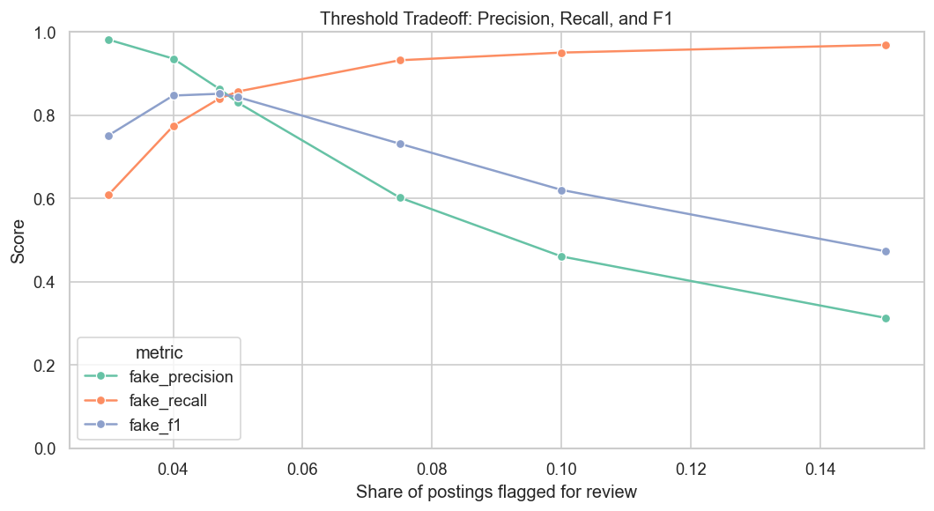
Figure 19. Threshold tradeoff for precision, recall, and F1.
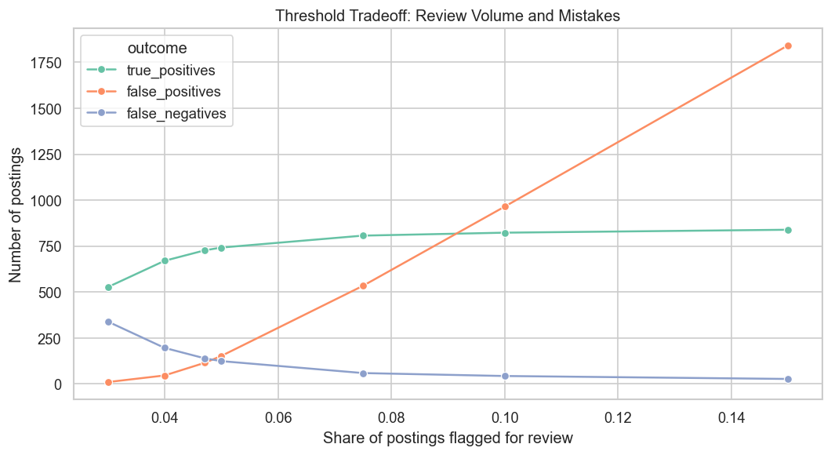
Figure 20. Threshold tradeoff for prediction outcomes.
As the threshold decreased, more postings were predicted as fake. This increased fake recall and also increased false positives. As the threshold increased, fewer postings were predicted as fake. This increased fake precision and also increased false negatives.

Original vs Cleaned Dataset Comparison
Dataset | Model | Avg. Precision | ROC AUC | Fake F1 | Fake Recall | Fake Precision
cleaned | Linear SVM balanced | 0.9140 | 0.9890 | 0.8512 | 0.8395 | 0.8636
original | Linear SVM balanced | 0.9128 | 0.9880 | 0.8508 | 0.8361 | 0.8665

The cleaned dataset performed only slightly better than the original dataset. This indicates that the original text fields carried most of the predictive signal. The engineered features supported EDA and interpretation, but they did not substantially change model performance.

Conclusions
- The dataset is highly imbalanced, with fake postings representing approximately 4.84% of all rows.
- Accuracy is misleading because a majority-class model can achieve high accuracy while detecting no fake postings.
- Linear SVM models had the highest average precision values in the model comparison.
- Class weighting changed the precision-recall tradeoff: balanced models had higher fake-class recall, while unweighted models had higher fake-class precision.
- The cleaned dataset performed only slightly better than the original dataset.
- Error analysis showed that missing company logo/profile information was associated with higher false positive rates among real postings.
- Threshold analysis showed that lower thresholds increased fake recall and false positives, while higher thresholds increased fake precision and false negatives.

Appendix: Generated Outputs
The full notebook and generated result files are available in the project repository. Key output folders are:
- `results/tables/`: CSV tables generated by the notebook.
- `results/figures/`: PNG figures generated by the notebook.
- `job_postings_eda_model_comparison.ipynb`: executed local notebook with outputs.
- `job_postings_eda_model_comparison_colab.ipynb`: Colab-compatible notebook.
- `results_analysis.md`: Markdown results and analysis summary.

